TESTING DURING IMPLEMENTDATION:

07/09/2026

Today, I’ll mainly focus on building the main skeleton/baseplate of the application, including the window, sidebar and dashboard to give the window some shape.
To begin, I will use a class to make the main window. This window should:
- Be 1100x700px in size
- The window name being “Hardware Monitor”
- The background should be a dark colour (customtkinter’s default dark-mode colour)
- The application should run indefinitely until the user closes the window.
Here is the code I plan to test to build the main window:
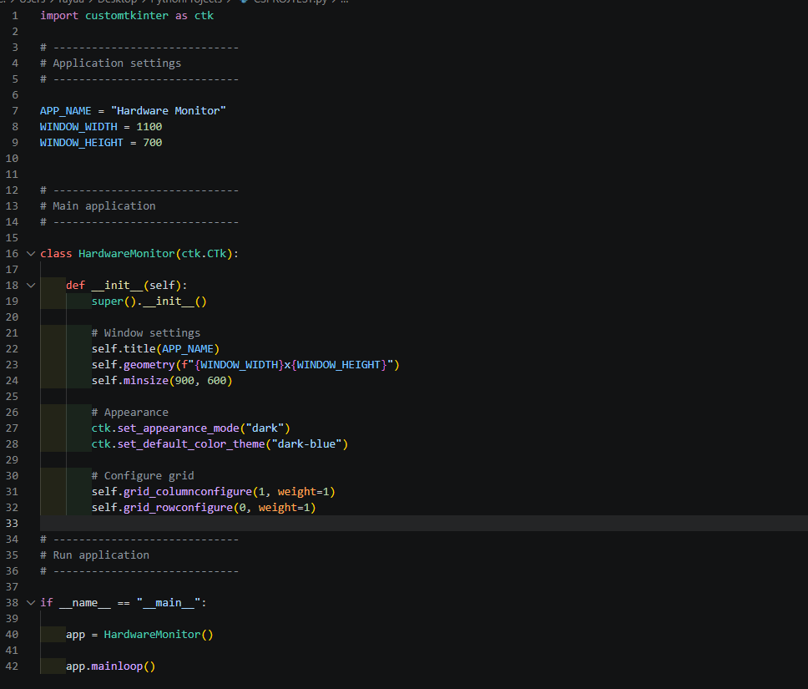
And after running the program, I got the results I wanted, which ticked all the boxes on what I expected it to do:
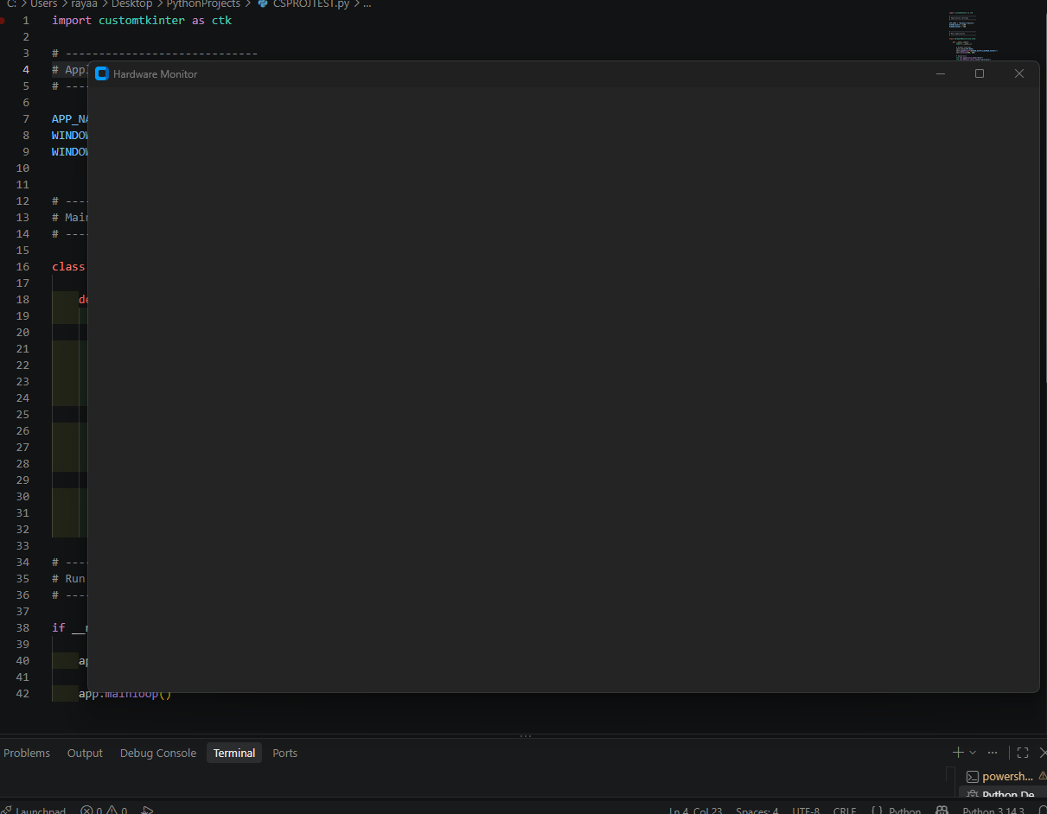

This is stage one complete, now I will add a sidebar, which should include:
- Create a section on the left of the window, which includes a title “Hardware Monitor” on the top.
Here is the code I added. I created the function that will build the side bar, and a new section in my class that will call the function to create it.
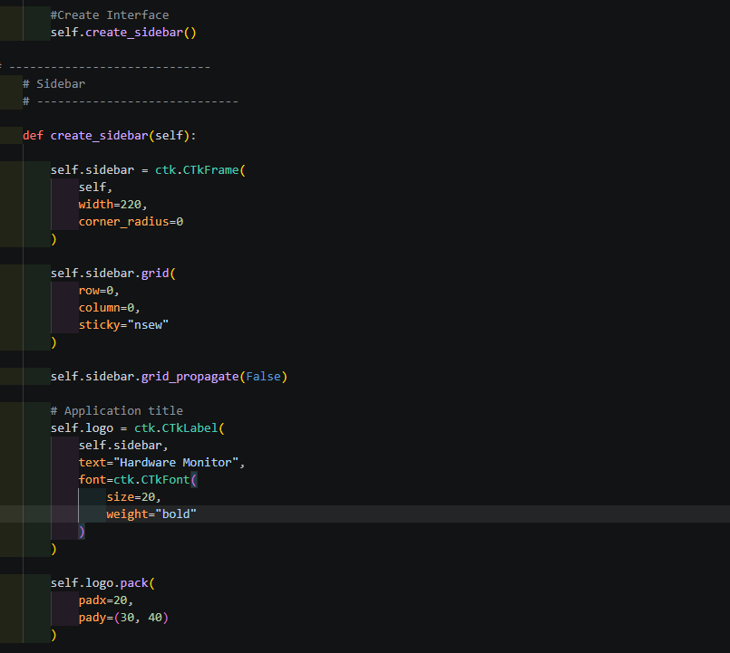
The code did as plan and built the sidebar on the left side of the window:
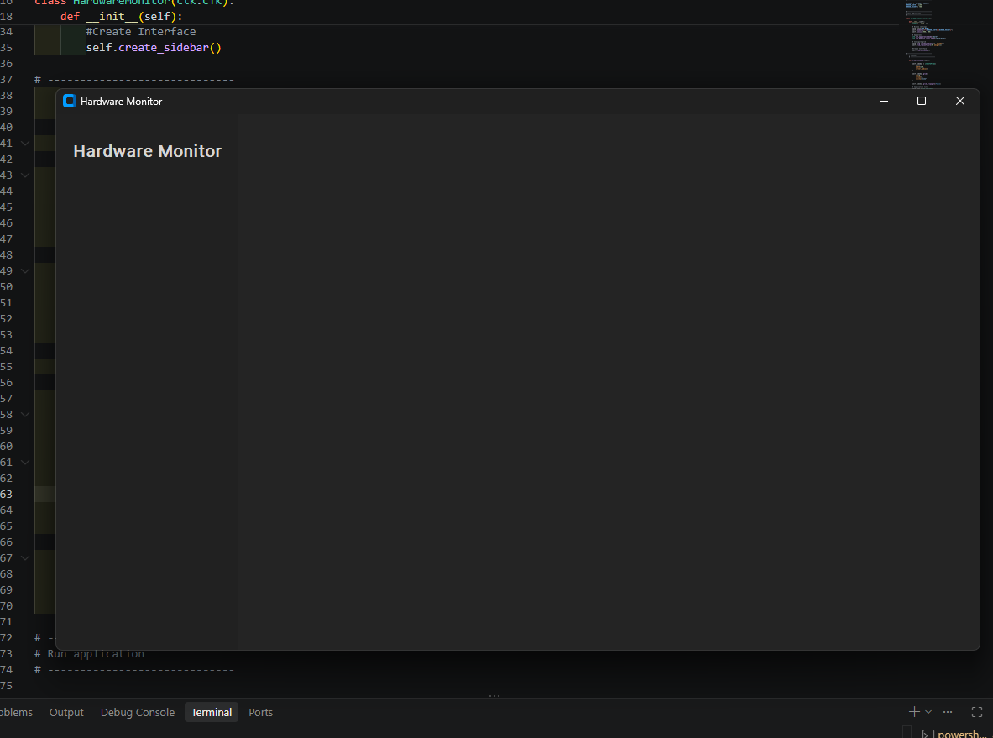
Now onto building the dashboard, which will take up the remaining space on the right side of the window that the sidebar did not use, which will contain:
- A title named “Dashboard”
- A subtitle that will describe the purpose of the dashboard
- A new section on the window should appear
The format for making this will be similar to how I created the sidebar, creating the function to build the section using customtkinter, and calling the function in my class:
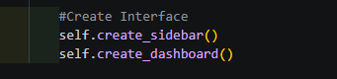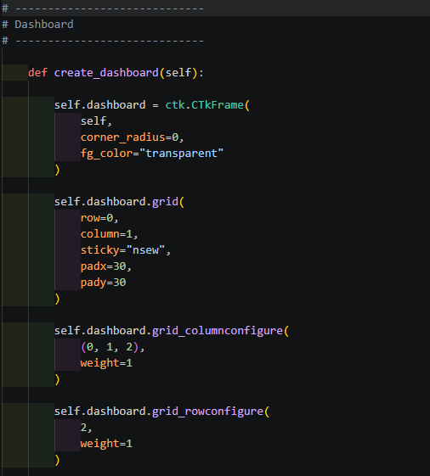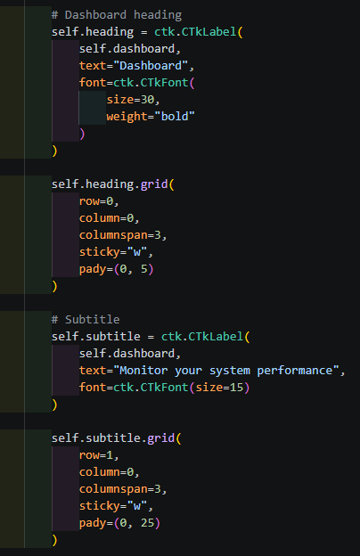

And it worked! Now I have a window with a sidebar and a separate area for a dashboard that I can add things in:
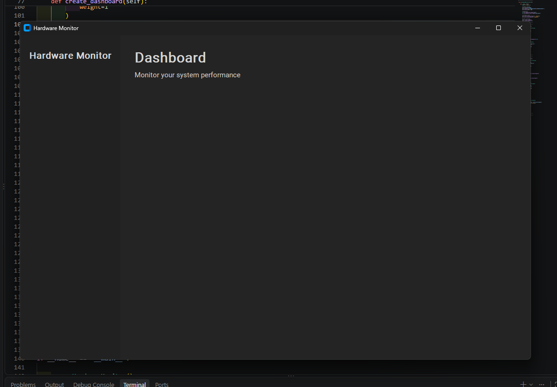

Next, I will go ahead and add named buttons on the sidebar, which should match the default “dark-blue” colour scheme of the application by being blue. Just to make sure they work, I will add a function that returns a message in the terminal if a button is clicked. These buttons should:
- Be blue
- Be on the sidebar
- Have the names “Dashboard, CPU, Memory, Storage”
- One should return an indication that it has been clicked
The code for each button will follow the same structure, except their names and variables will be named differently. Only the dashboard button will respond when clicked by executing the command in the “show_dashboard(self)” function, and should output “Dashboard Selected” in the terminal:
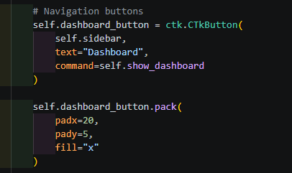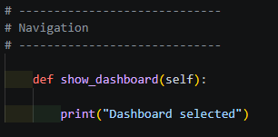

The buttons do in fact appear now, presented in a column in the sidebar, and by pressing the “Dashboard” button, it now returns “Dashboard Selected”:
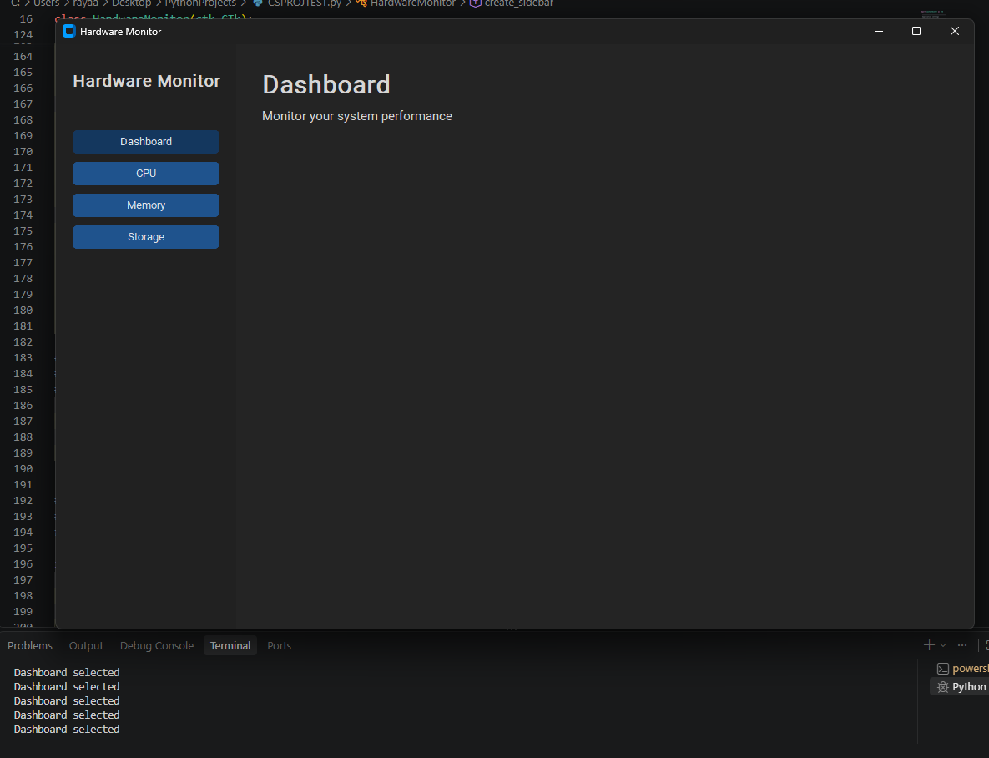

For the settings button, I decided to place it at the bottom of the sidebar, and look similar to the rest of the buttons while being named “Settings”. The code used is similar to the other buttons, except I specifically added a line that puts the button at the bottom:
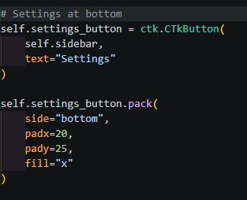
And the result was as I expected:
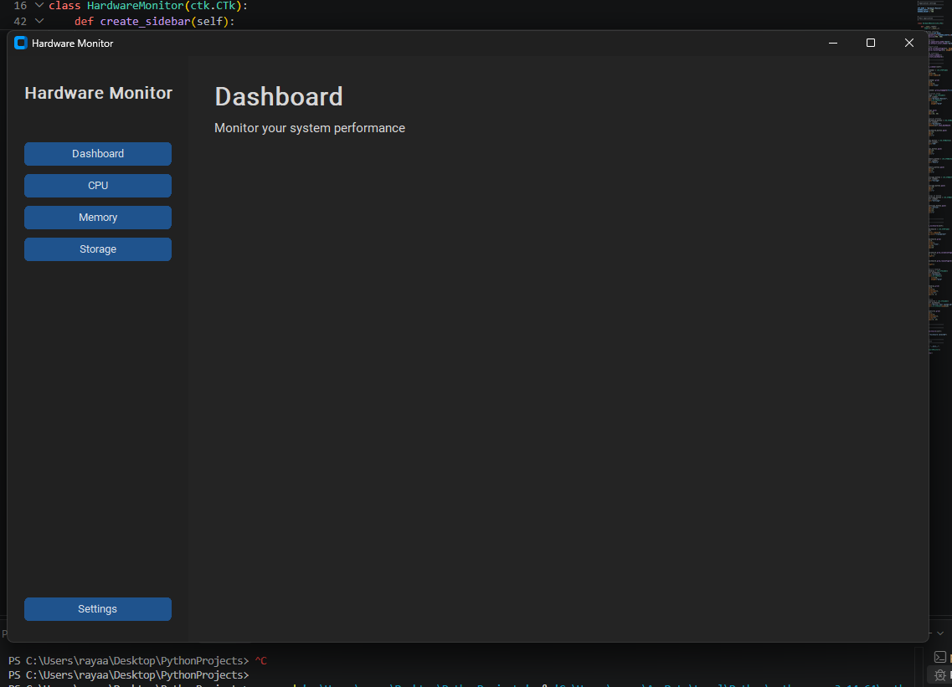

Now to add the cards containing placeholder values for the percentage usage of the CPU and RAM, and a value for storage installed.

There should be:
- 3 smaller cards on the top row
  - 1 labelled “CPU usage” with a dummy value
  - 1 labelled ”Memory usage” with a dummy value
  - 1 labelled “Storage” with a dummy value
- 1 large card on the bottom row for graphs
Here is the code I plan on using:
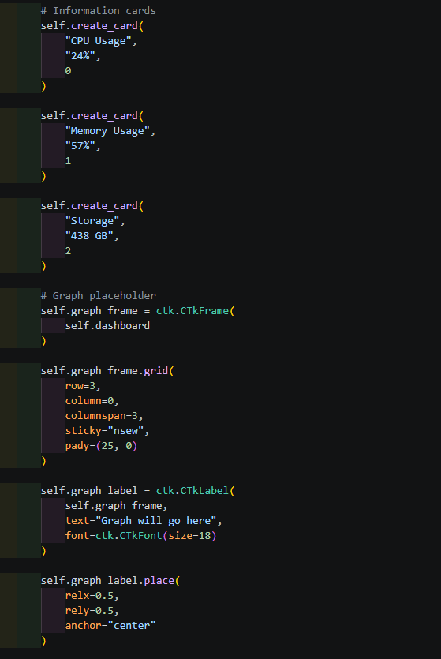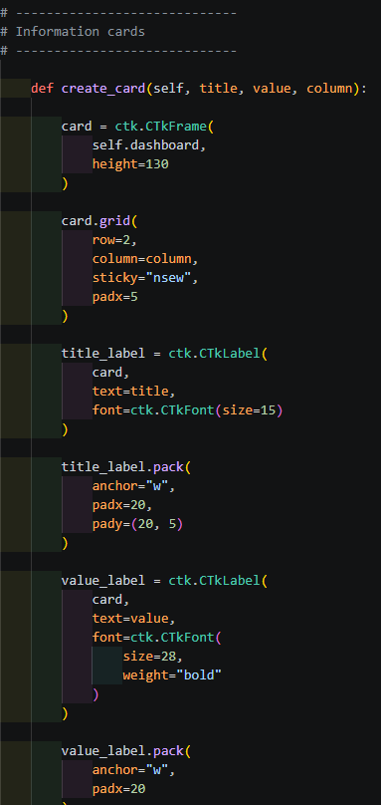

And the output was:

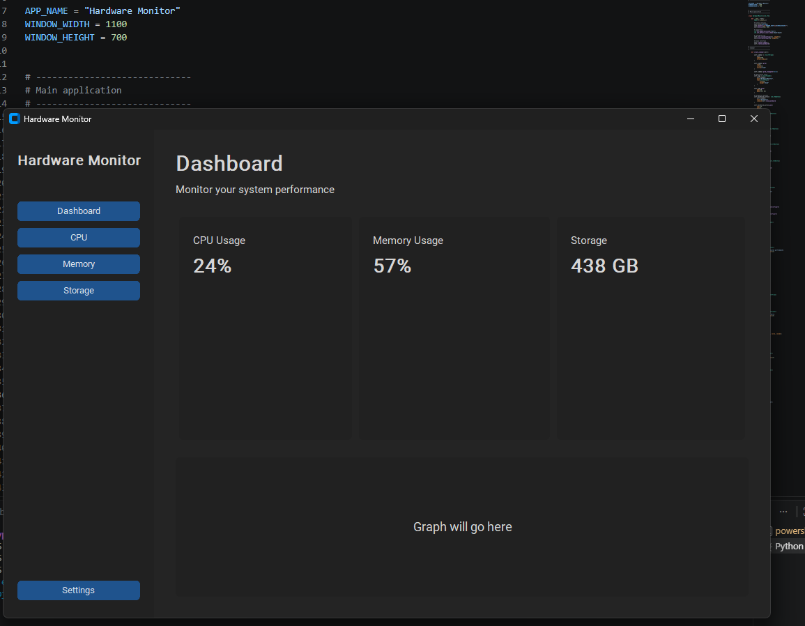
This was successful in ticking off all the boxes for what I wanted done for this main window.
8/09/2026
Today, I added a little more regarding the buttons on the sidebar. I added functions in #Navigation, similar to what show_dashboard() did they all presented the exact same output in terminal when pressed as the dashboard did.
14/09/2026
Today, I will begin adding functionality to the buttons. I chose to start off with making settings present the settings page and the dashboard button bring back the dashboard page.
Here is the code I used to create the settings page first:

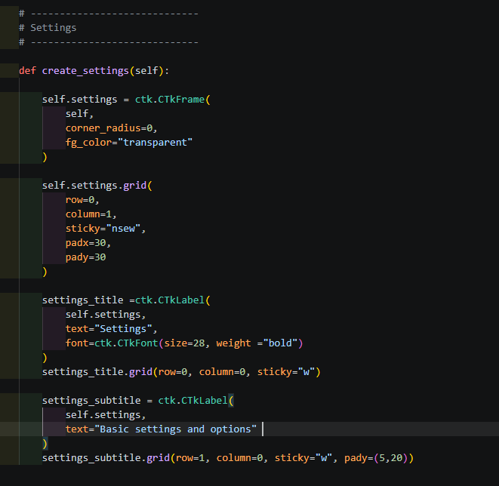
This page should replace dashboard and present an empty page with a title “Settings”, and a subtitle under it.
To make the settings button actually switch to settings, I changed the “show_settings()” function within #Navigation, and added a command to the settings button to call the function, which hides dashboard and shows the settings grid:
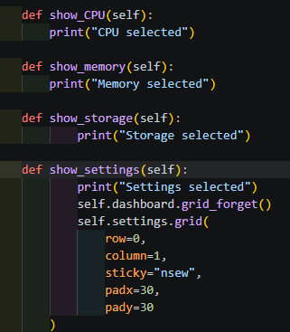
When I run the program, the settings button should now:
- Replace dashboard
- Displays an empty page with a title and subtitle
The results where displeasing. However, the settings page did appear as I expected it to:
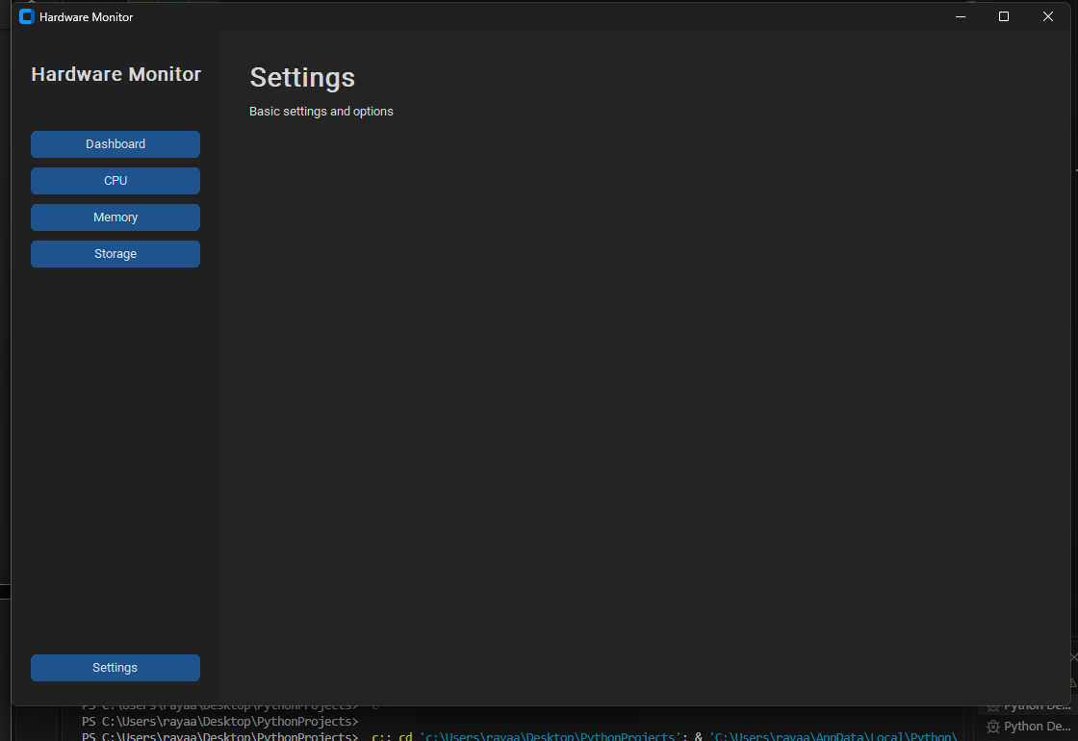
The issue was that when the application opened, settings now shown up by default, whereas I wanted dashboard to show up on startup.
Luckily, after making the show_dashboard() function functional, I can place a new line of code in my class: “self.show_dashboard()” in the interface section.
Now, after pressing run, the app should:
- Start off with dashboard
- Let me switch between the dashboard and settings page by pressing the buttons

After executing the new code, the results were much better than before:
- The program now shows the dashboard on startup:
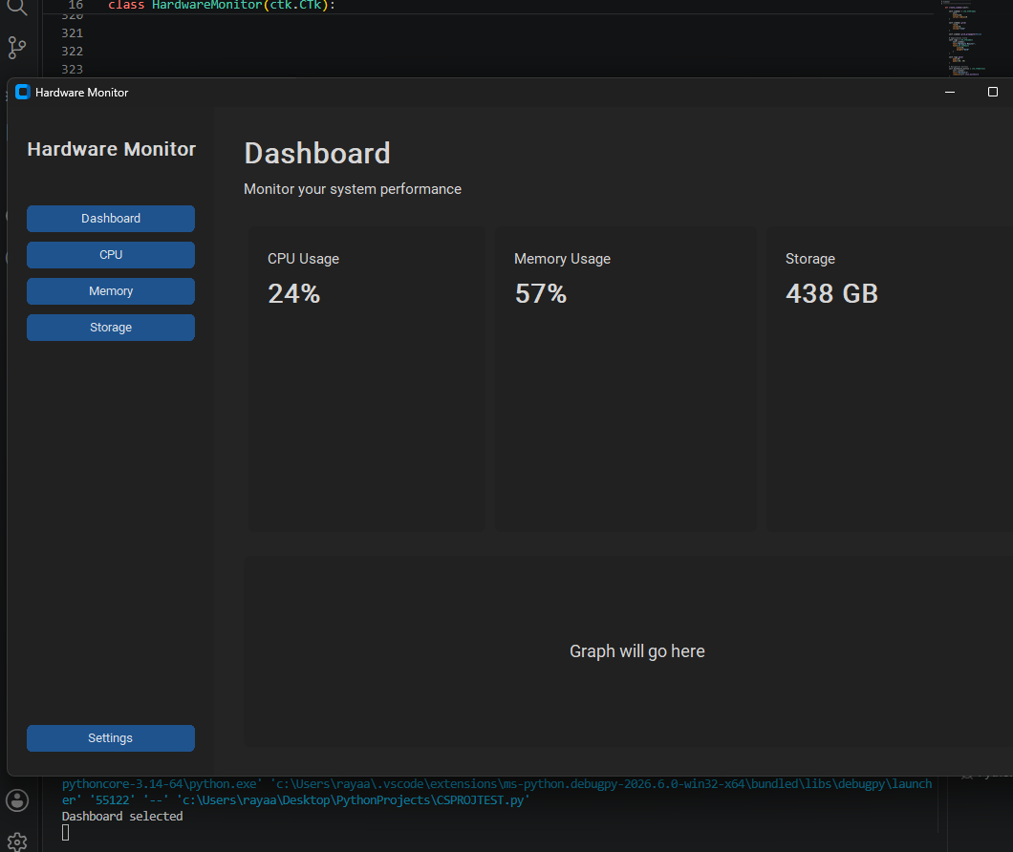
- Pressing the settings button now opens the settings grid:
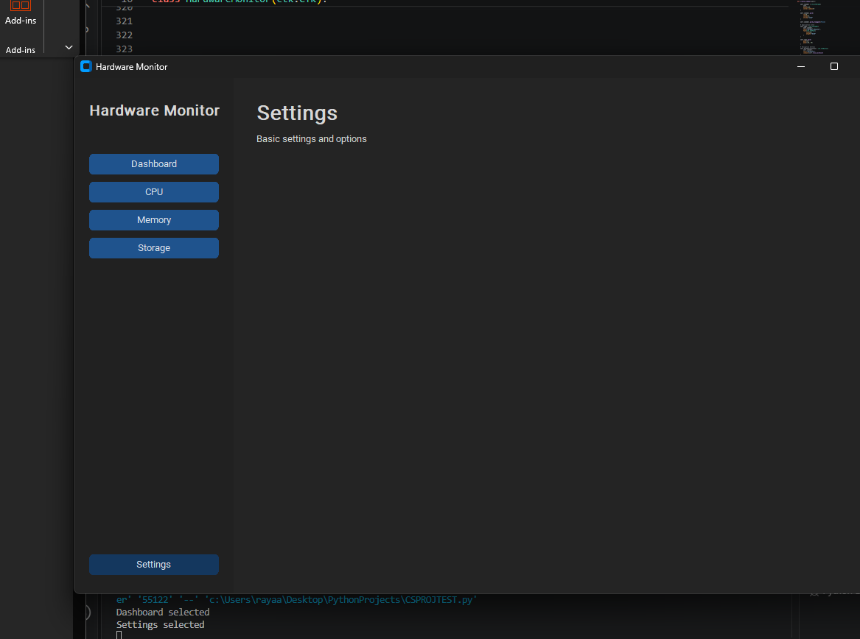
- And selecting the dashboard button now returns to the dashboard:
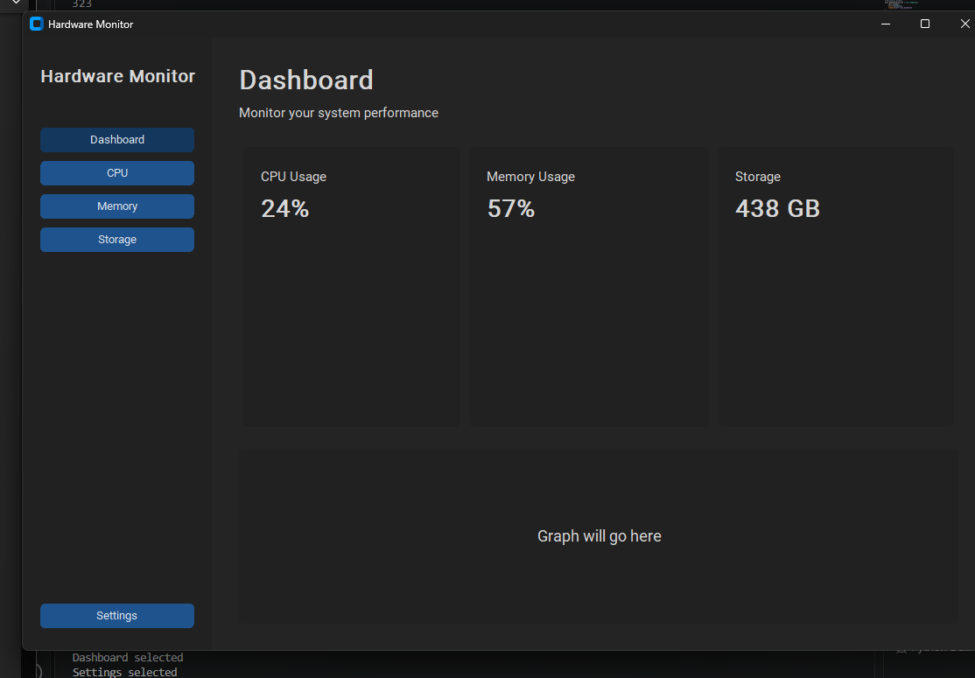

Now that some buttons work, I thought I’d begin on some settings functions.

I’ll begin with a function to change the colour of the buttons. To do this, I used tkinter’s colourchcooser library, which opens a separate window that lets the user choose a colour and save its hexadecimal value as a varible.
Before that, I will make a row that will contain the appearance options, similar to how I made the rows for the information cards on the dashboard.
Here is the code I plan on running.
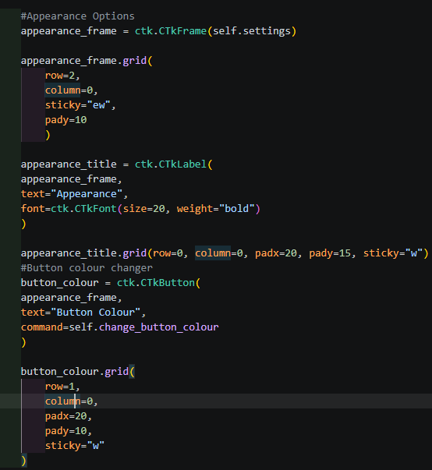
I also imported colorchooser from tkinter and made a new function in my class:
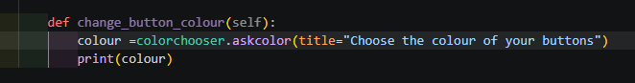

There will be:
- A new row labelled “Appearance”
There should be:
- A new button in the appearance section that opens colorchooser
- Lets the user pick a colour
- Saves the hexadecimal and RGB values of the chosen colour as “colour”
- Prints the values of “colour” into the terminal
There is now a new button under Appearance:
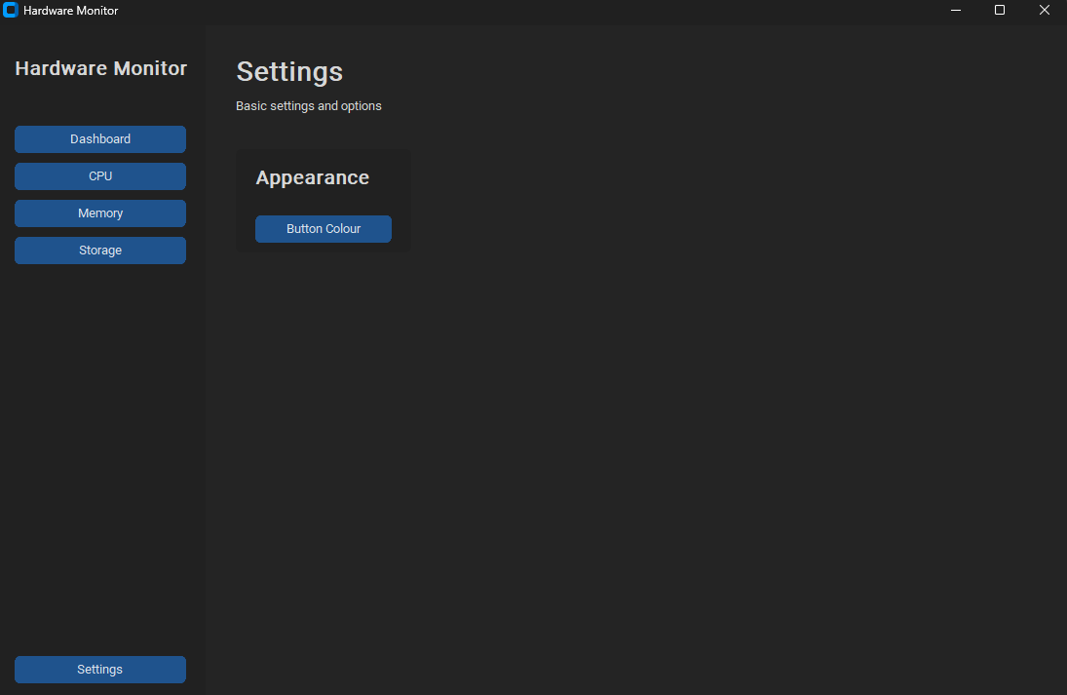
Pressing it also opened colorchooser (After fixing the indentation for the change_button_colour(self) function:
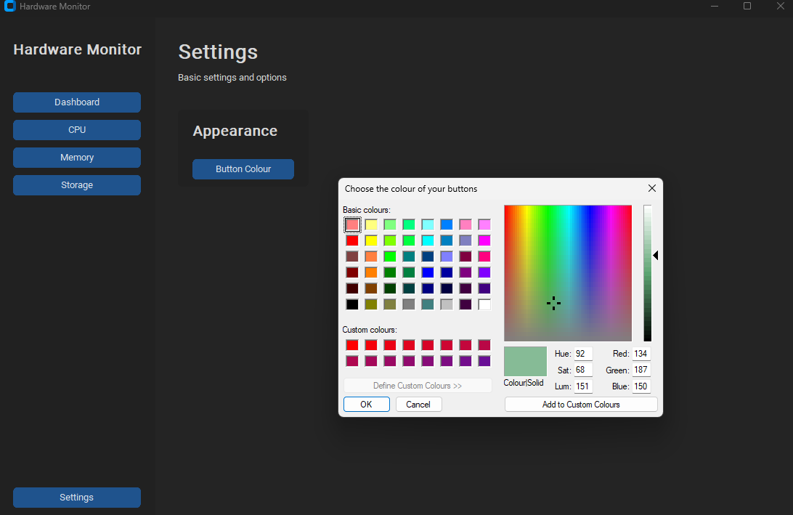
And after selecting a colour, this was outputted in terminal:
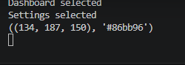
Now that works, all I have to do is add a few lines of code to the change_button_colour function that configures the colour of the buttons on the sidebar:
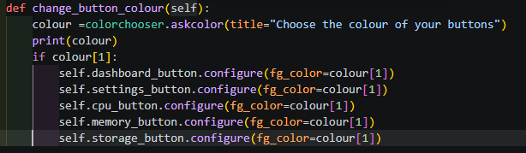
The buttons should now change colour when I pick a colour, which turned out to be successful:
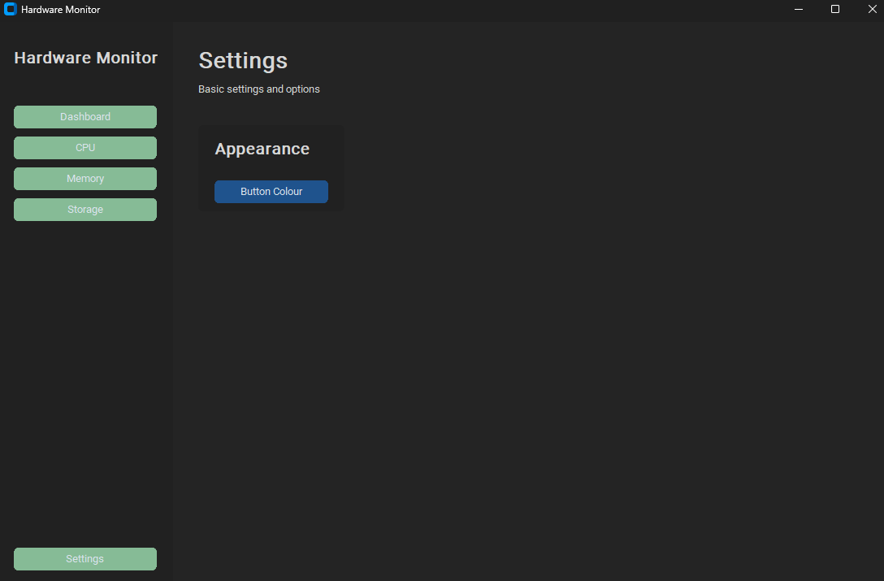
However, there is an issue with this. The button within the settings page did not change colour and will take a different approach to get it to change. I will save this problem for another day.

17/09/2026
I am planning to something that can change the colour of the background. Instead of letting the user choose any colour like I did for the buttons, I only allowed for two options, light and dark. Instead of a button, I though of using one of those dropdown menus, similar to when you choose the size of your text in Word. This makes use of customtkinter’s built in dark and light modes.
Here is the code I wrote in Settings>Appearance:
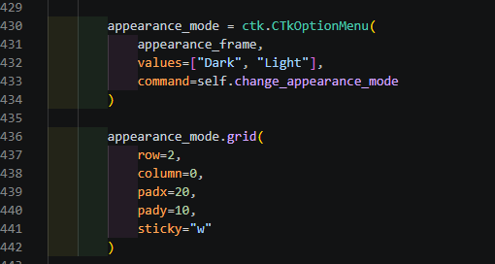
And the function in my class that takes the user’s selection and sets it as the background:
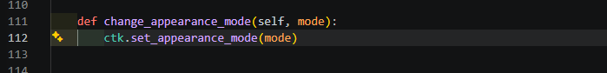
This should:
- Create a dropdown menu in the appearance section of settings
- Let the user pick from light or dark
- Set the background theme as the chosen option
The dropdown menu is now displayed under the button colour button and shows the options to choose from when pressed:
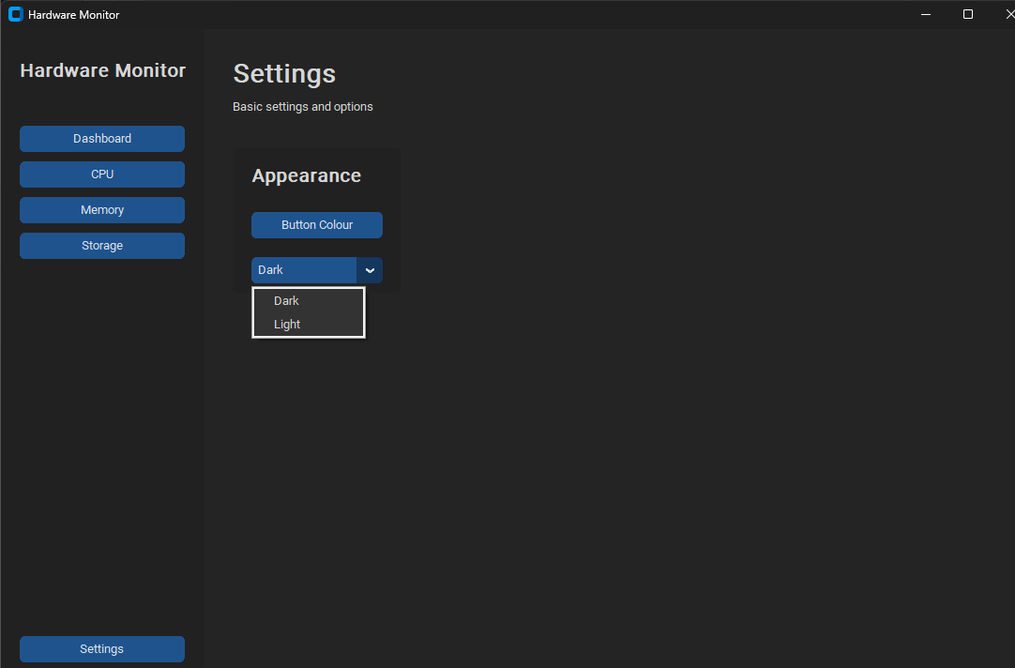
After selecting “Light”:
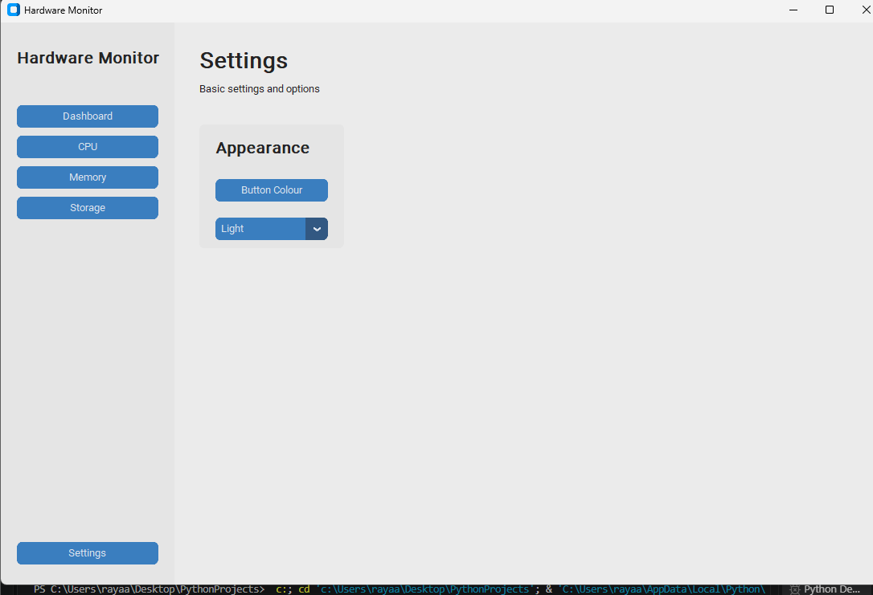

And selecting “Dark” again:
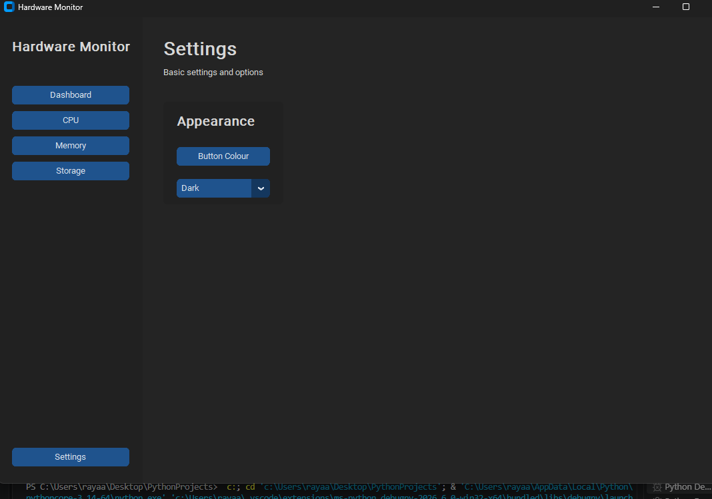

Next, I will move onto the dashboard’s features.
I plan on making a function that will show live CPU and memory usage, updated every second, as well as the total storage capacity compared to the amount used.
To do this, I made a new function in my class that gets the CPU/memory usage percentages and configures the information card labels to be those values.
Storage took more than just that. I used the bytes_to_human function to change the default units (psutil returns storage information in bytes) into a simplified unit.
I did this for both total storage and used storage.
After that, I added another line that updates all of these values every 1000 milliseconds.
Lastly, I added the new labels (e.g. self.cpu_value_label) to the beginning of the information card code.
Here is the resulting code:
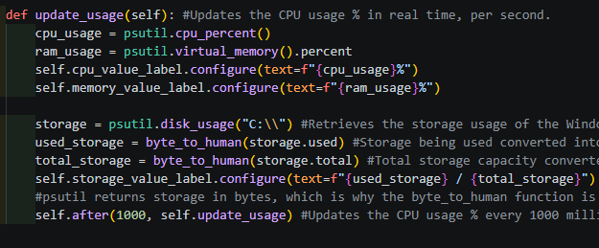
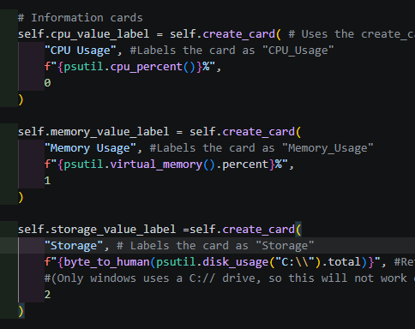
This will only work on windows, since no other operating system refers to the hard disk as “C://”.
After executing, what should happen is:
- The static data in the information cards will now change to new data every second (1000 milliseconds)
Results:
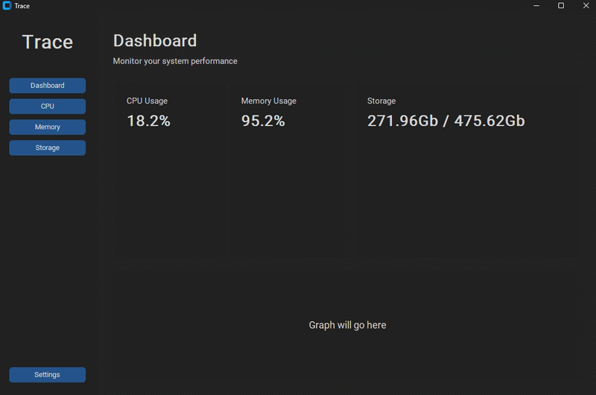
(I used ezgif.com to create this gif.)
Now the dashboard is another step closer to looking like a proper dashboard containing information.

24/09/2026
Today I plan on making the usage graph for the dashboard.

Here is what I used to build the graph:
self.figure, self.ax = plt.subplots()
self.canvas = FigureCanvasTkAgg(
self.figure,
master=self.graph_frame
)
self.canvas.get_tk_widget().pack(
fill="both",
expand=True
)

After implementing the code, the results should be as followed:
- A graph with two lines should appear
- The graph should fit in the reserved space
- The graph should update every second
Results:
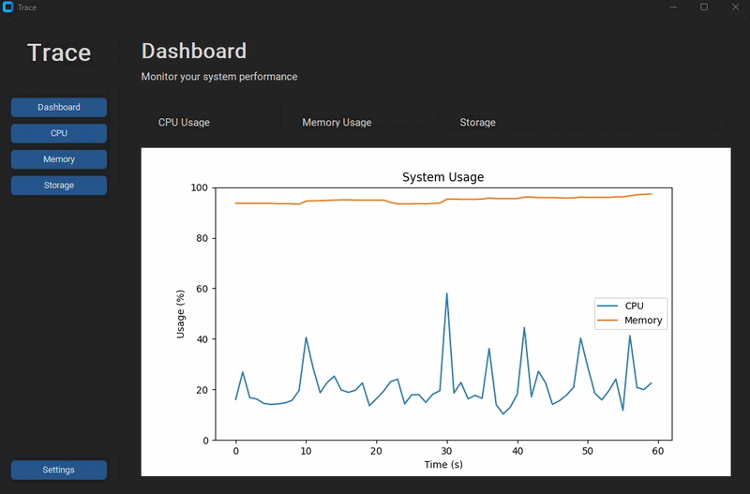

It worked; however, it’s taking up the entire dashboard page. (I have about 9 apps open right now; the graph readings are correct.)
The root of the problem was “.pack”. It let the graph resize itself on the window. So I changed the block of code surrounding that to:
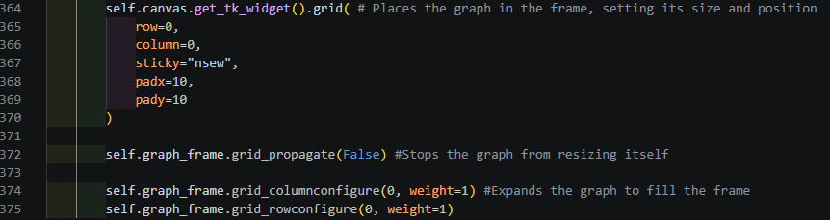
By setting the canvas to .grid, and setting the propagation to “False”, the graph will no longer resize itself and fit into its designated place:
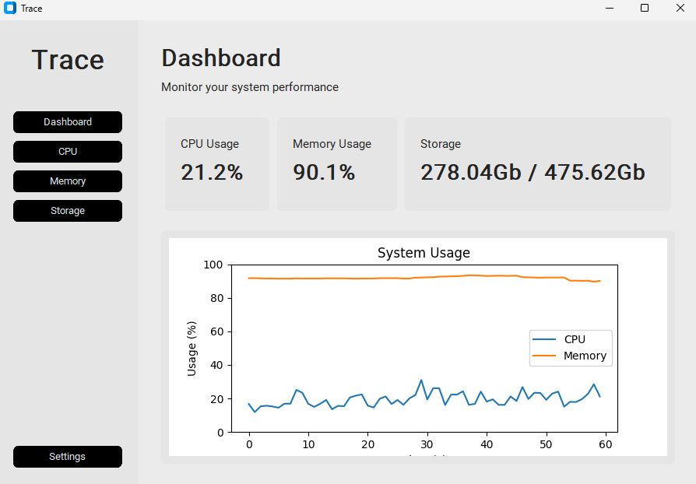

Now to change the colour of the background of the graph:
Here is the code I implemented into the #Create graph and the update_graph() sections:
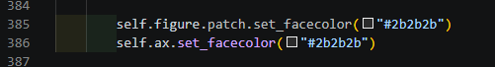
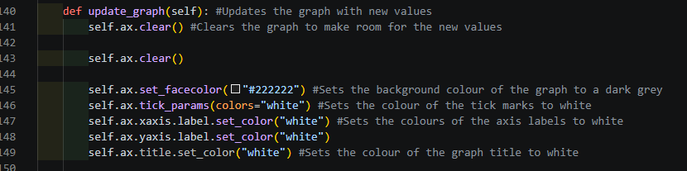
This should make the graph, by default when running the application:
- Sets the background colour as a dark grey
- Sets the important text related parts of the graph to white to make them visible
Results:
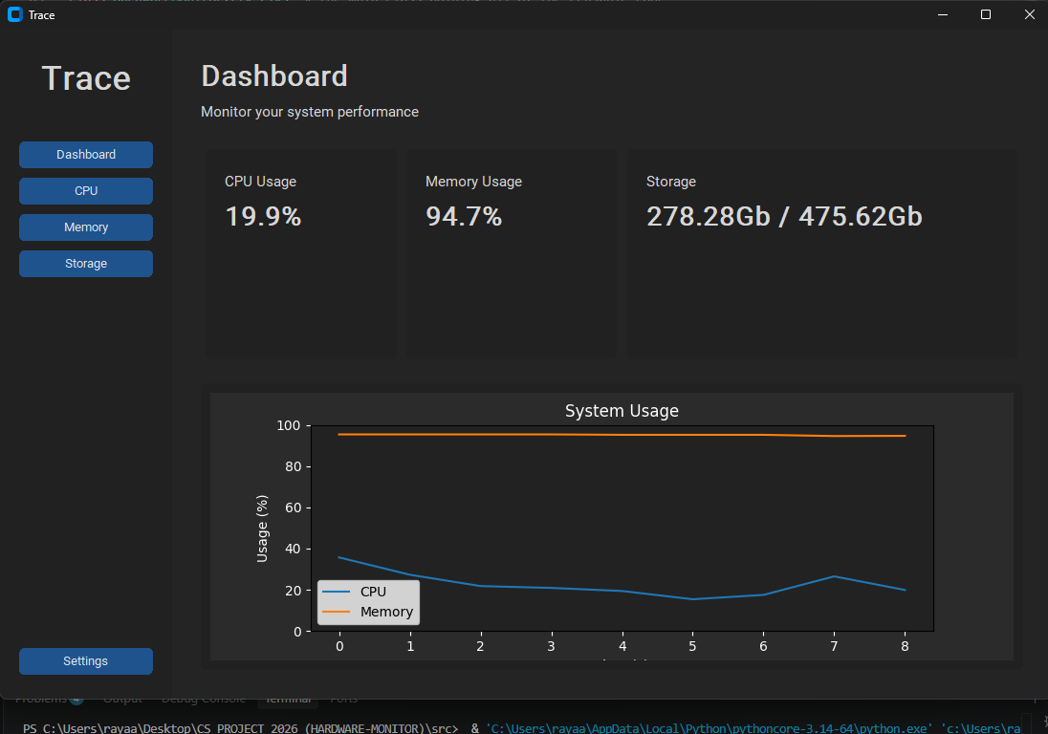

This was a success. Now to go onto making the colour scheme change based on the background colour of the application. So, when choosing a colour theme in settings:
- Dark should turn the colour of the graph into a dark colour scheme like shown earlier.
- Light should change the colour of the graph to a white colour scheme like how it was at default.
Here is the If-Else statement I put in my update_graph() function:
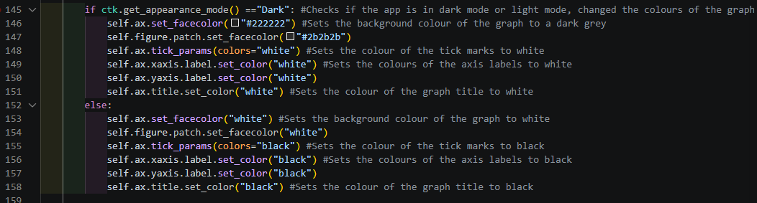
After executing, I encountered a problem left behind by the default colouring I left in the #Create Graph section. The graph remained in its dark colour scheme after switching to light. After removing the lines of code that set the default colour scheme, I got is result:
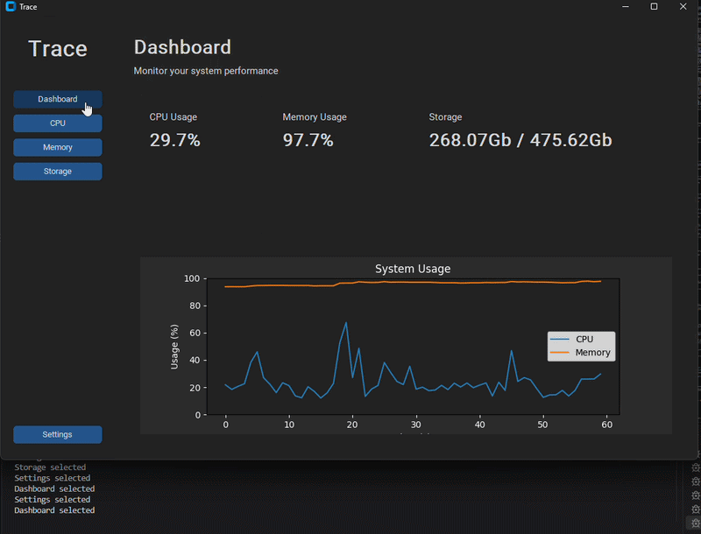

28/09/2026
Today, I decided to finish up the dashboard by adding colour indicators to the usage percentages on the dashboard. At first, it was going to be a coloured icon below the percentage, now I decided on changing the text colour.
Here is the code I added:
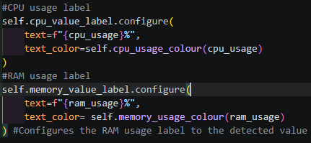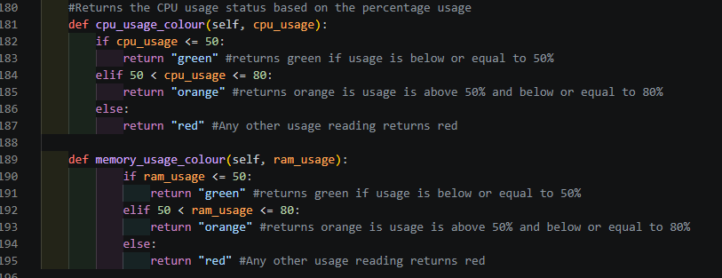
This should:
- Change text colour to green if usage is below or equal to 50%
- Change text colour to orange if usage is above 50% and less than or equal to 80%
- Change text colour to red if usage is any other value (below 0 is a worry sign, above 80% is considered running out of space in memory or high usage of the CPU)
Results:
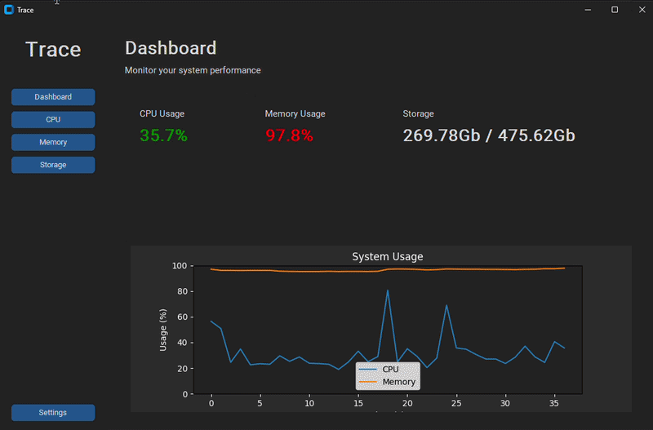
I also did the same for storage:
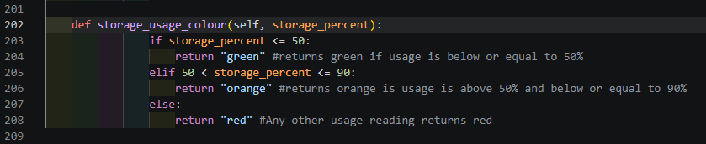
Now the storage ratio should do the same as the CPU and RAM indicators:
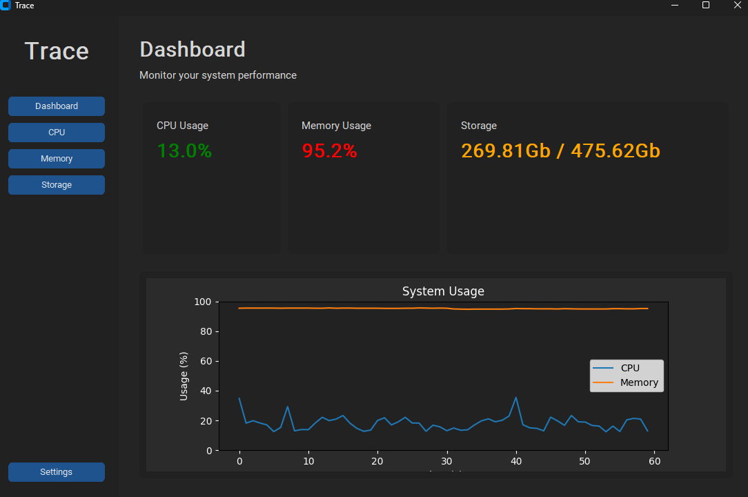
29/09/2026
Today, I plan to work on making the dedicated component buttons that currently do not do anything on the sidebar display their own page.
Here is the function I made to create the CPU page. The other two pages follow the exact same format as this one, just with different variable names:
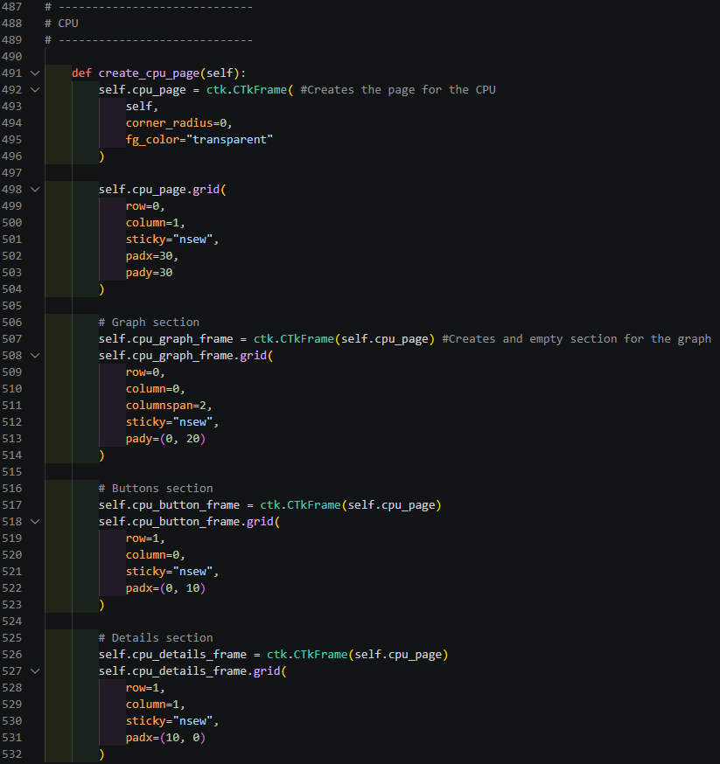
This should:
- Cause each button to open their own page when clicked.
- Each page should have the same format, one long frame at the top for the graph, one on the bottom right for the buttons, another on the bottom left for the component details.
After executing the program, the buttons did not work. Right after executing I realised I had forgotten to create the pages under __init__, so I fixed that:
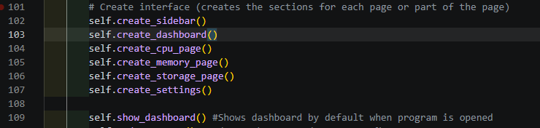
I also had forgotten to adjust the button functions under #Navigation, so I adjusted those too:
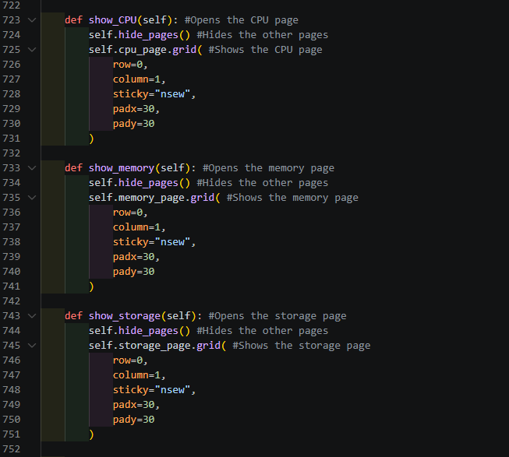

After debugging, the buttons now indeed work:
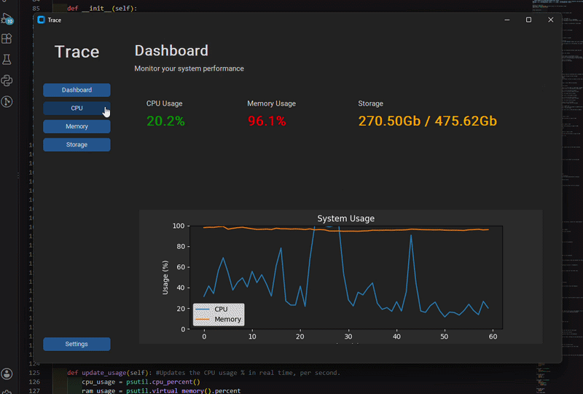

01/10/2026
This is a continuation from last time; I will be working on the dedicated component pages again.
I started off with making the titles for each page. The code I used is the same for each page, except the names are different:

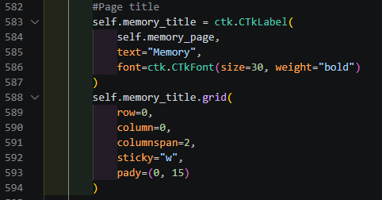

This should show the title at the top of the page, exactly the same way it worked for the dashboard and settings page.
After executing, the title did not appear. Then I had realised that the graph frame was also on the highest row, which was why the title would not appear.
After increasing the number beside “row=” by one for all of the frames, the title did eventually appear:
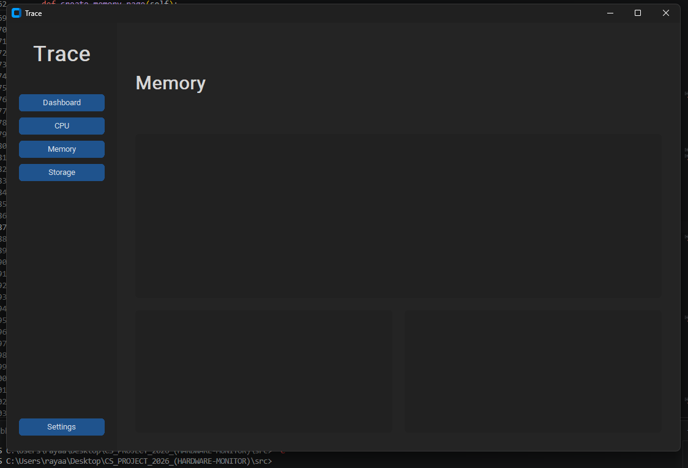
Next, the buttons. After implementing the code to place both buttons in the space reserved for the buttons, what should happen is:
- Buttons should go in the bottom left section of the page.
- Each button should have text with them to say what they do.
Code:
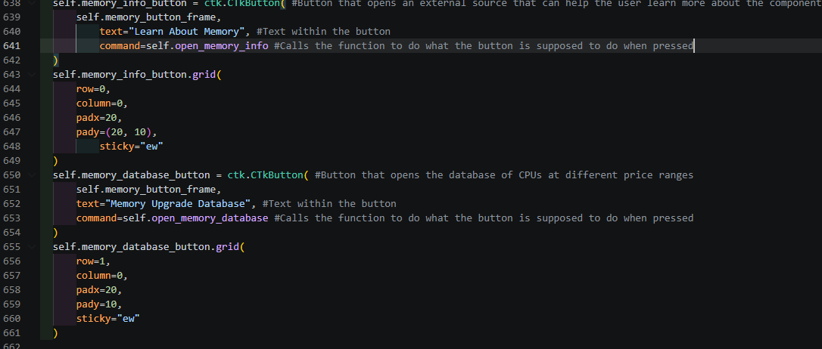
Result:
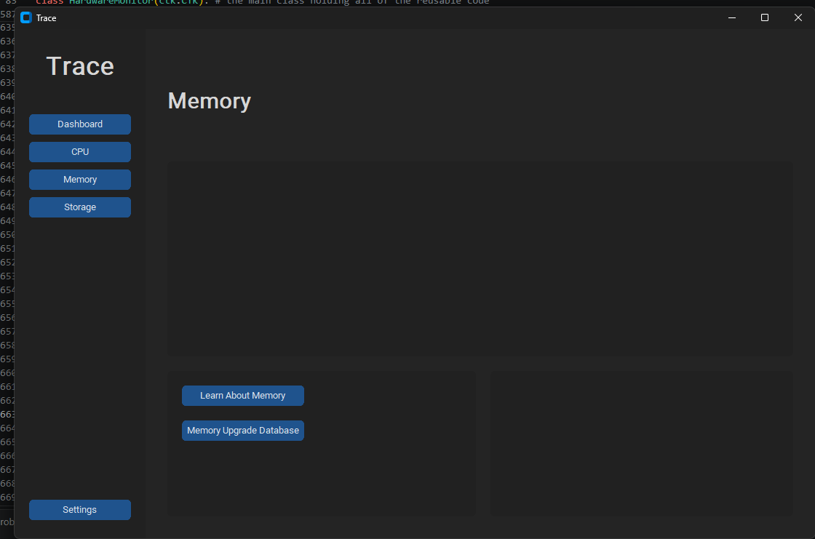
It worked, however, the size difference between the frame and the buttons results in a lot of empty space. I added a line of code under the code for the buttons to resize the buttons to fit well into the frame:
New result: 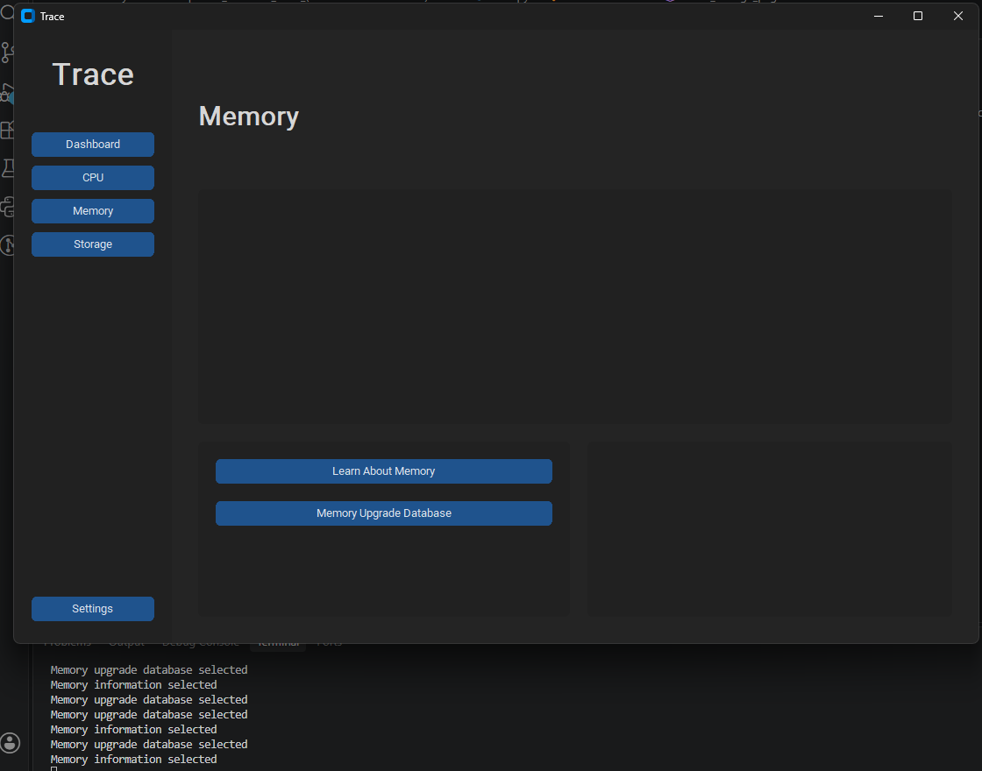
Next, I planned to add an uptime value in the empty space underneath the buttons.
Here is the code I added to update_usage to get the device uptime to calculate the uptime:
Then to set the label as that uptime value:
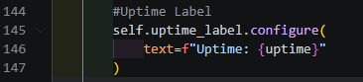
And underneath where I made the buttons in the create_cpu_page() function, I added a part where the label will show on the row below the buttons:
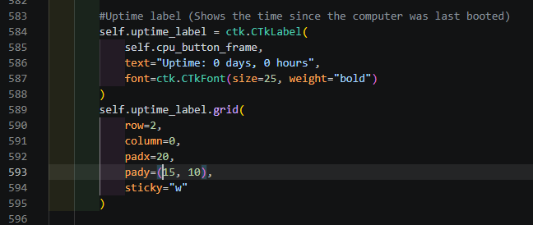
Results:
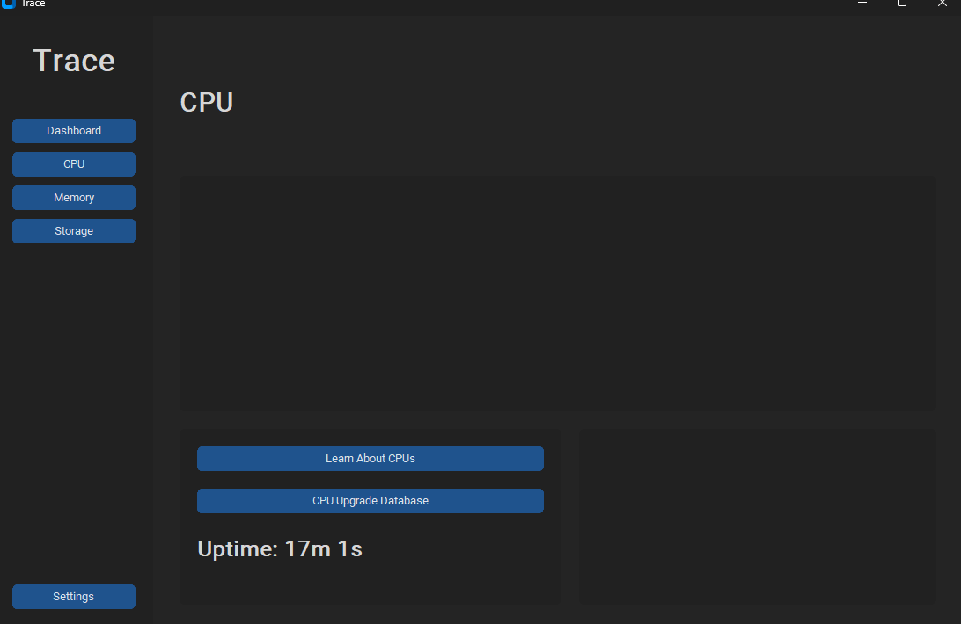
It worked; however, it only worked for the CPU page, the other pages only displayed “Uptime: 0 days, 0 hours”.
To fix this, I decided to just make three separate uptime labels, one for CPU. Memory and storage:
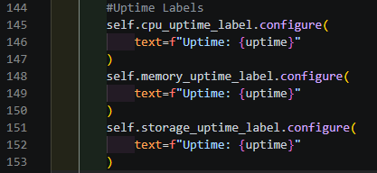
Then I updates the “self.uptime_label” for each page.
Results:
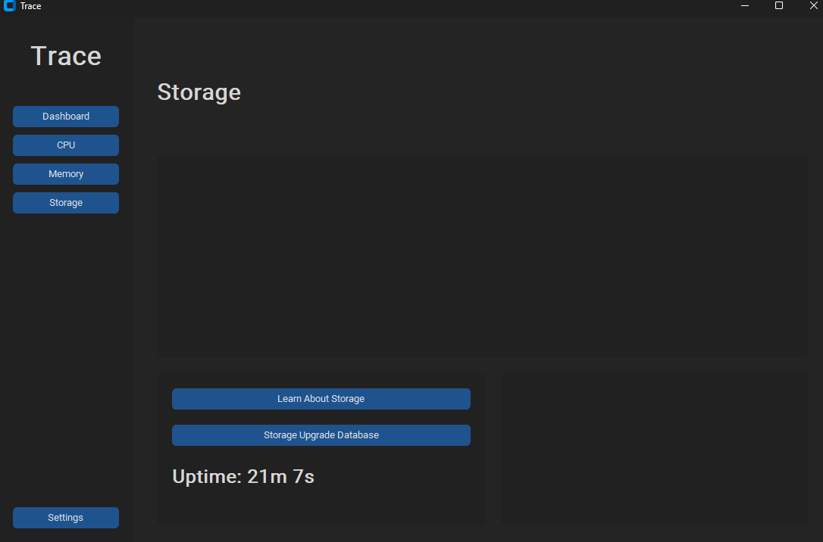

03/10/2026
Today, I plan to add details regarding the CPU’s performance, such as:
- Current frequency
- Maximum frequency
- No. cores
- No. logical cores
- Name of the CPU
Code:
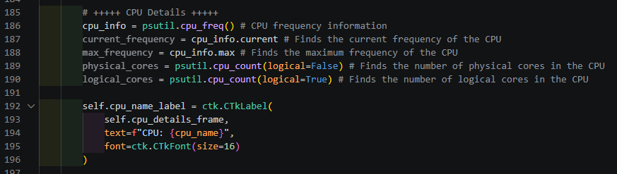
This should return the information I need.
On SysDetailsTEST.py, in the file labelled “tests”, I tested what these commands would return in terminal. For the name, using platform returned a generic name for Intel CPUs:
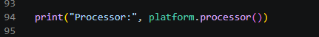
I used subprocess instead to get the name of the CPU from Powershell terminal:
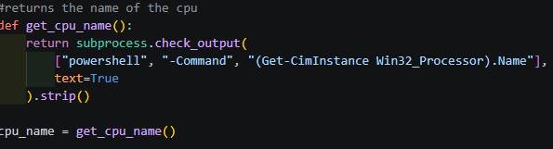
Then I created the labels for each value:
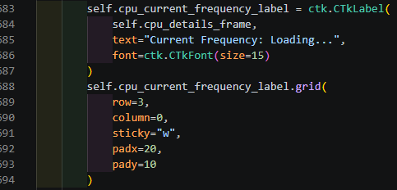
(Each used similar code)
After executing, this should:
- Display the CPU name. current frequency, max frequency, number of cores and logical cores in the bottom left frame.
- Current frequency should be a live, updating value.
Results:
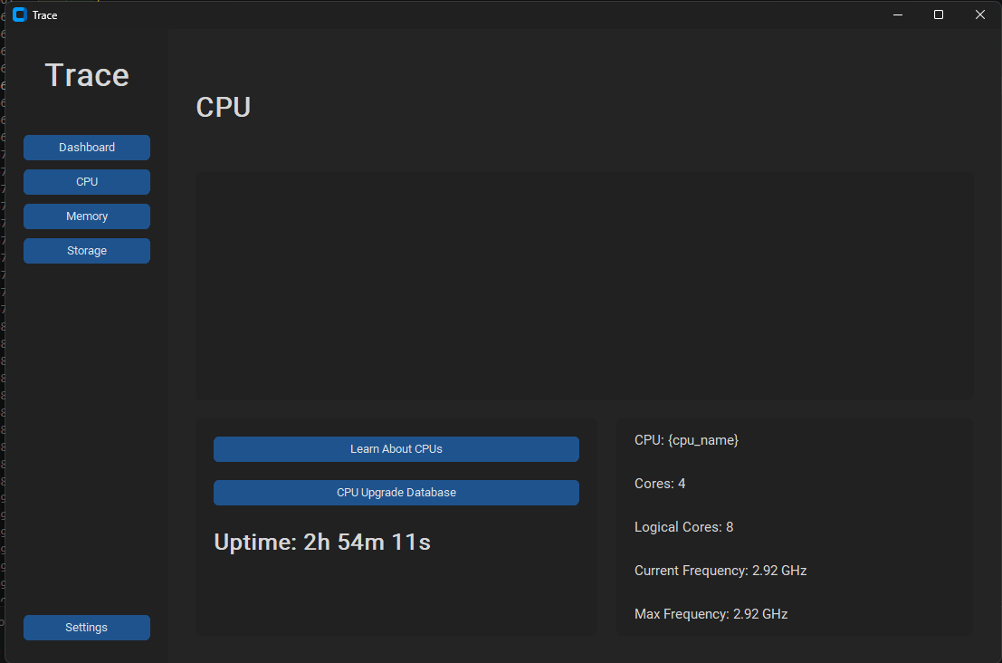
It worked, however the CPU name did not, most likely because I tried to insert it into the “text=” part of the code for the label, which does not work.

Instead of subprocess, I decided to use winreg, which can let me retrieve the CPU name through the Windows Registry. So I removed all the code relating to the subprocess version of returning the CPU name to this after importing winreg instead:
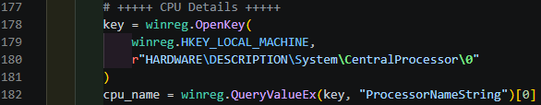
Then I set the cpu_name label as cpu_name, so now, the name of the detected CPU should be displayed:
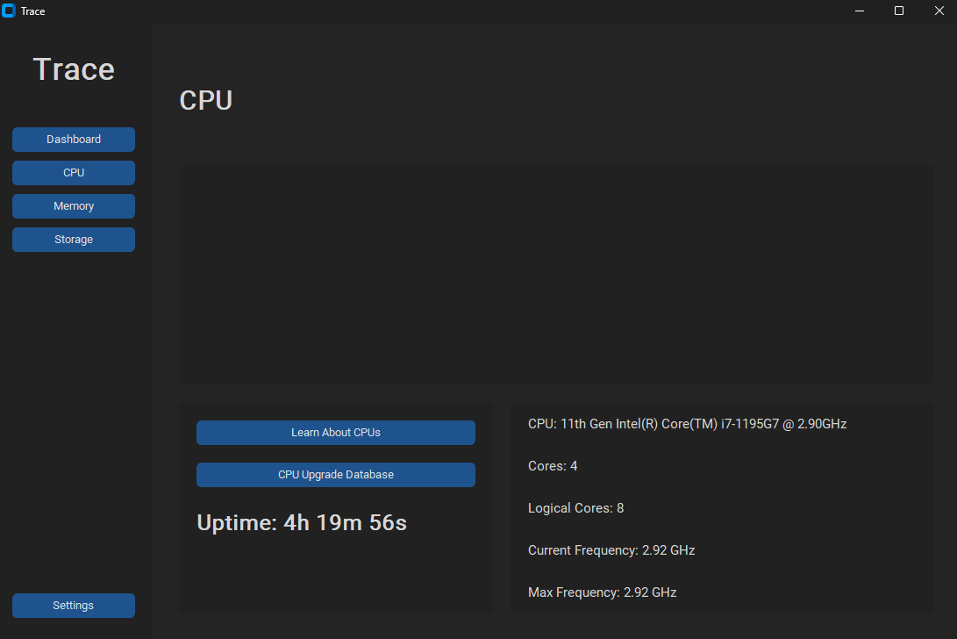

05/10/2026
Today, I will be making the graph for the CPU usage on the CPU page.
I started with building the graph:
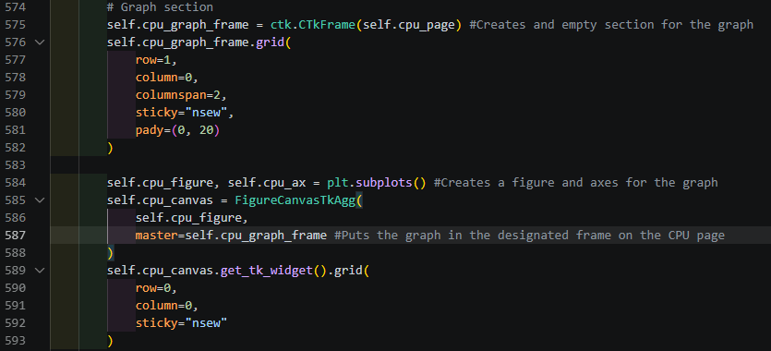
This should:
- Create a graph with two axes
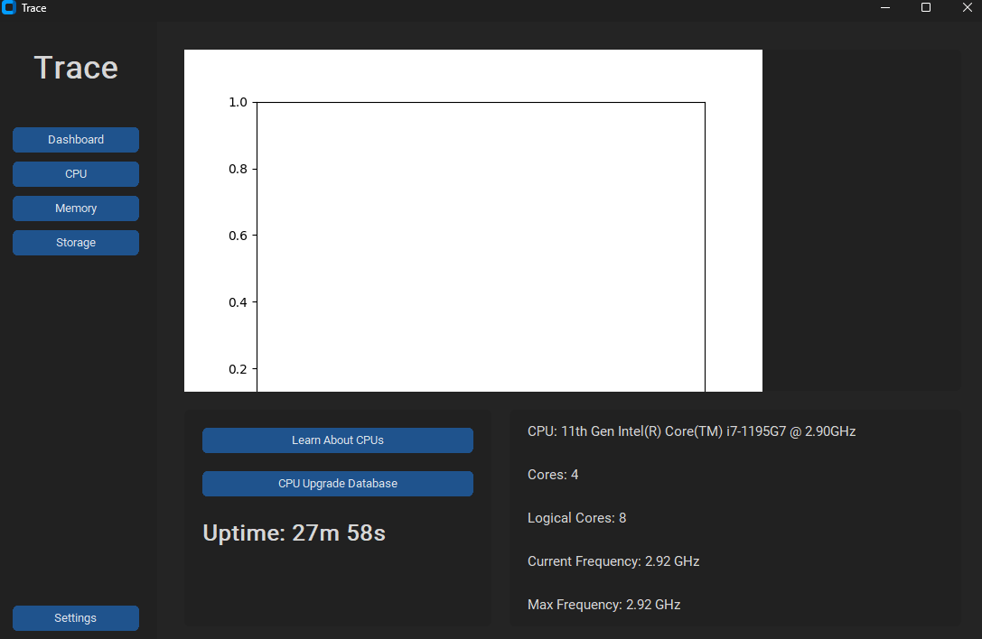
The graph did not fit in the frame properly, so I reused some code that was used to prevent the dashboard graph from resizing itself and make it fit correctly:
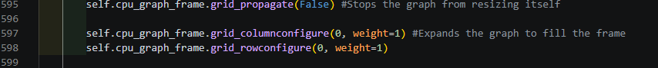
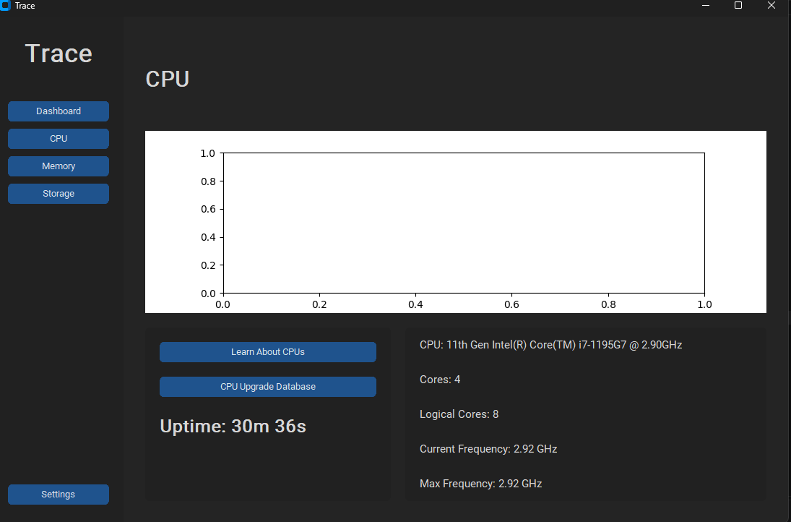Next, I made a function to update the graph:
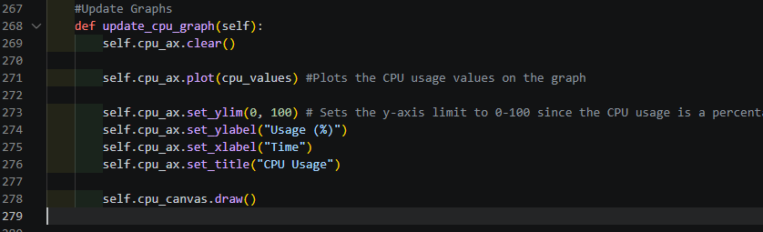
And called that function in update_usage() to update the graph with new values every 1000ms:
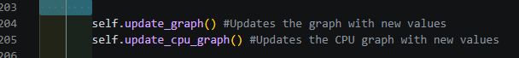
Now the graph should:
- Update every 1000milliseconds
- Show live CPU usage values as a percentage

Result:
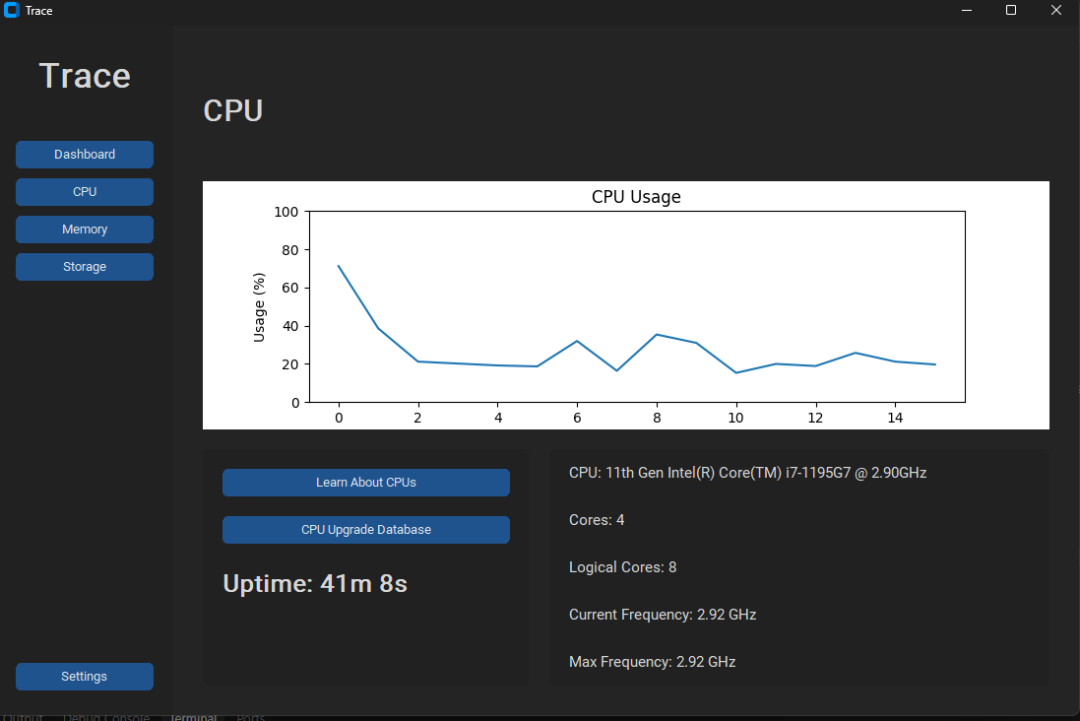
Next, I added code to change the colours of the graph to match the window’s background theme inthe CPU graph updating function:
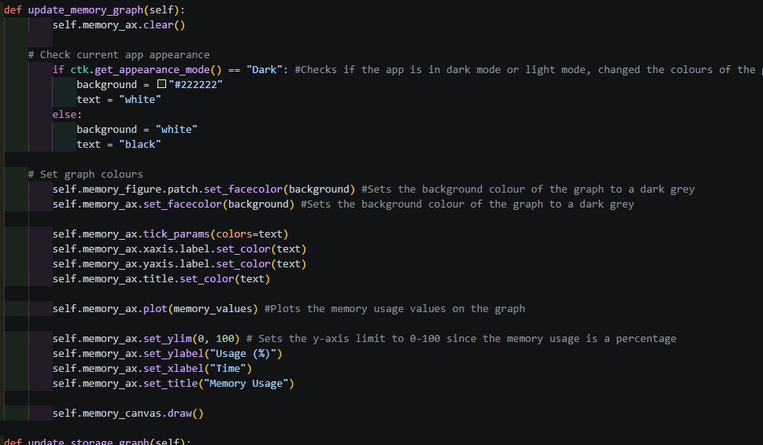

Now, the function should:
- Detect which theme the window is currently using
- Changes the colours to a darker theme if the “Dark” window theme is chosen
- Changes the colours to the default light them if the “Light” window theme is chosen
Results: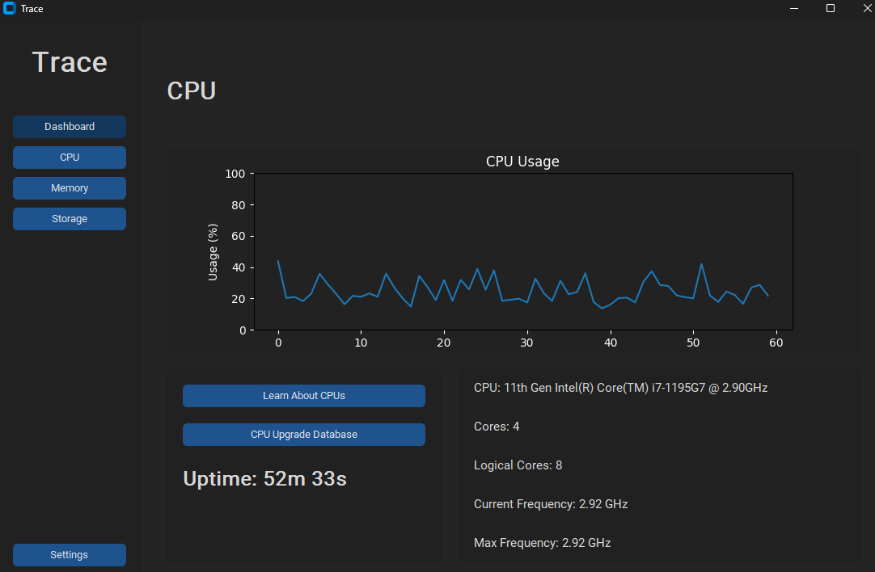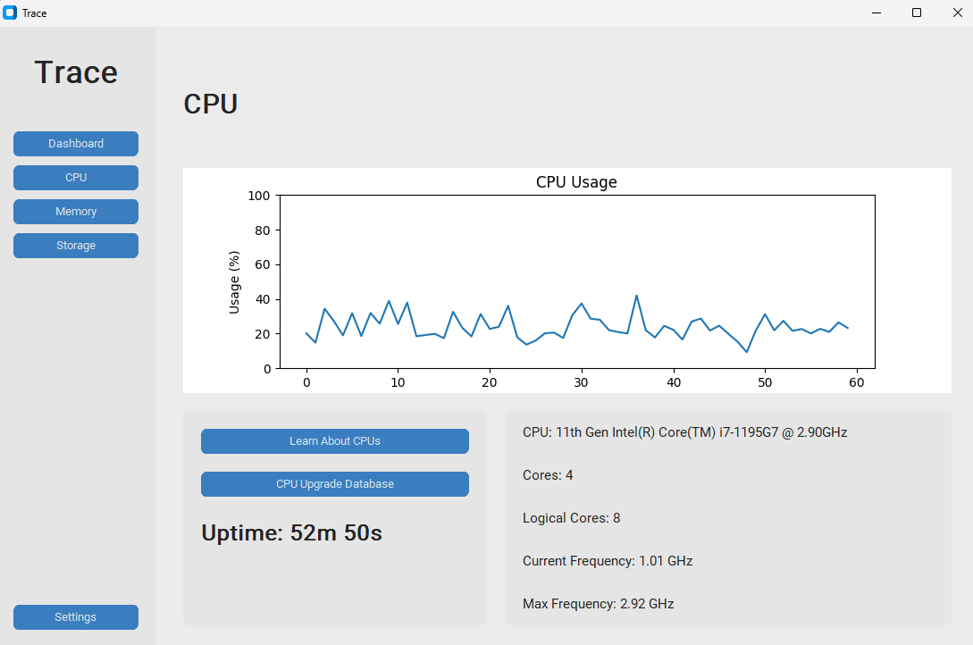
I reused the code for this graph to make the graphs for the Memory and Storage page, since all I had to do was change the “cpu” in the code to “memory” or “storage”:
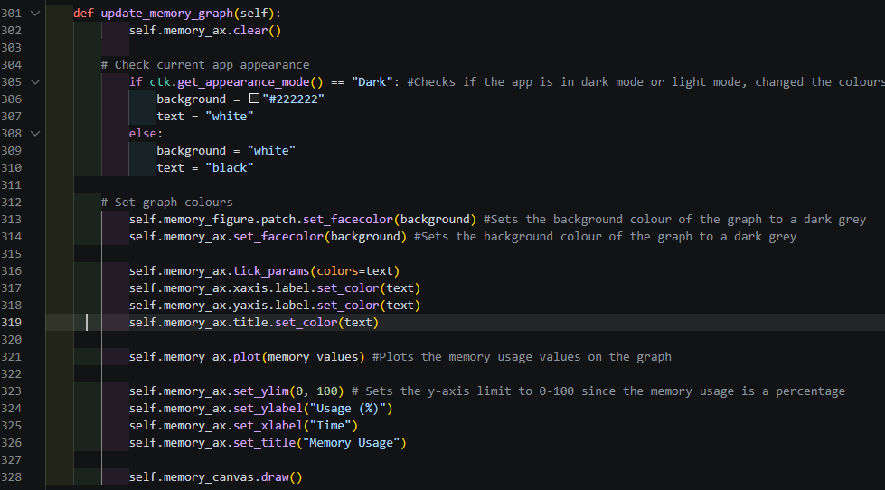
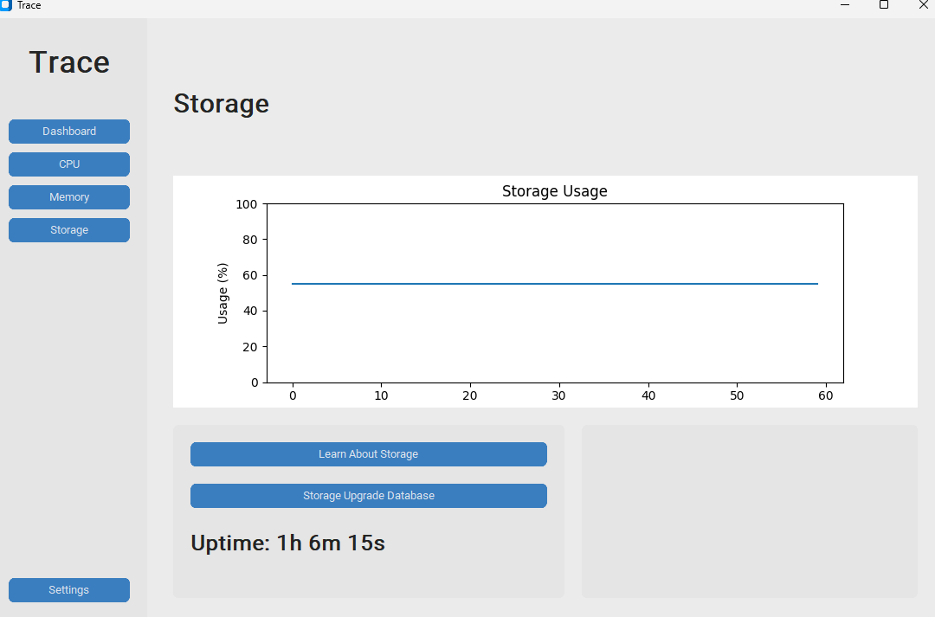

07/10/2026
Today, I will work on adding the details to do with Memory in the memory page.
First, I will create the label for RAM usage, in the format RAM used / total RAM, as well as include the amount for RAM currently available in GB.
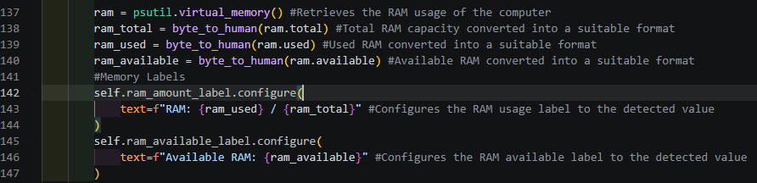
Byte_to_human() had to be used to convert the long, unsimplified value returned by psutil into GB so the label would be displayed neater rather than having a very large number that the user would have to read.

I did the same for swap memory too:
And I then implemented the labels in the details section of the of the Memory page to see if they return the desired values. I expect the label to return a value of around 8GB as the total. For swap, I do not know which value it will return since I don’t know how much swap memory my device utilises.
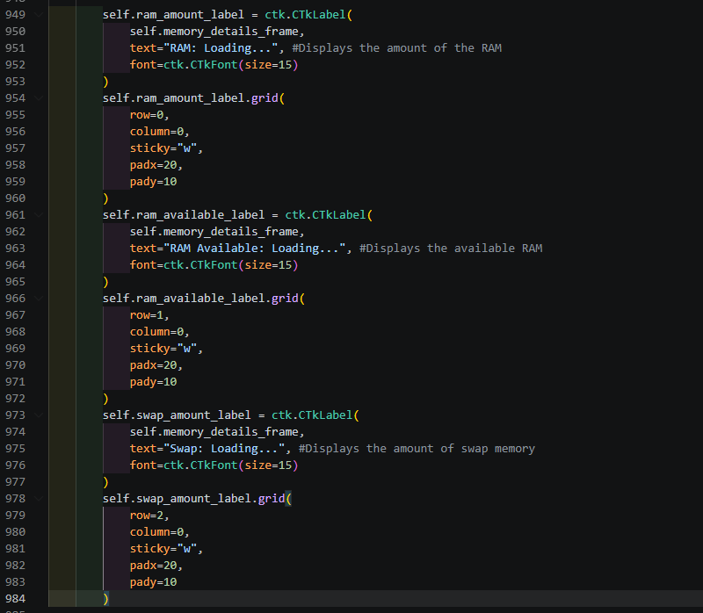
This could should;
- Return total RAM with an amount of RAM being used beside it
- Return the total swap memory and how much of it is being used beside it.
- Return values in the format {Name}; {Value} in the bottom right box of the Memory page.
Result:
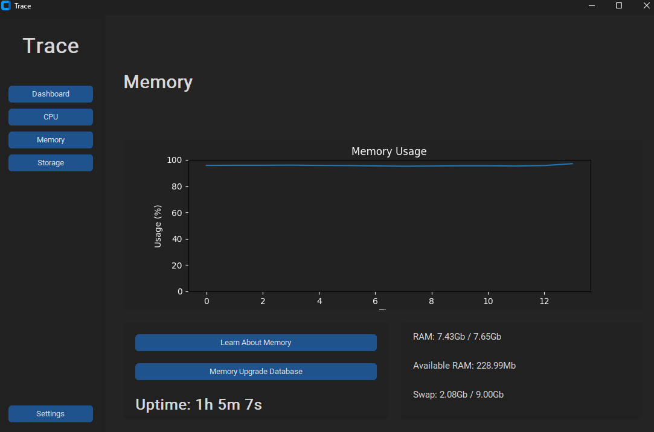
Now I know how much swap memory my device uses, 9GB.
Next, I will use subprocess to return the number of RAM slots on the motherboard and the form factor of the device’s RAM.
The RAM slots should be presented as a value out of another value. For example, in my case:
- 2 out of 2 slots used
The Windows terminal command to find the number of slots on the motherboard will be:
- (Get-CimInstance Win32_PhysicalMemoryArray).MemoryDevices
Returns: (2)
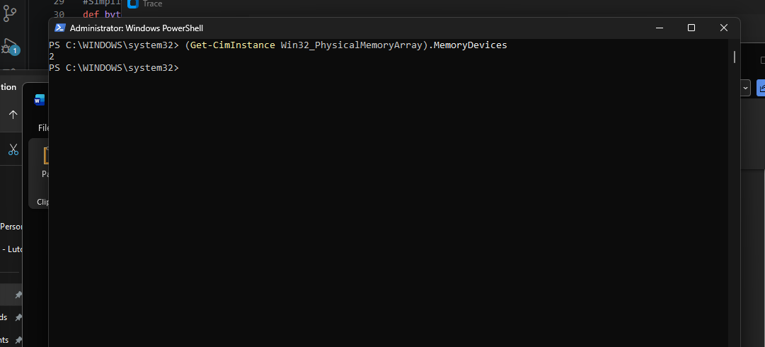
The form factor should return either SODIMM (for laptops), or DIMM for desktops. In my case it should return SODIMM.
The command will be:
Get-CimInstance Win32_PhysicalMemory | Select-Object -ExpandProperty FormFactor
Result: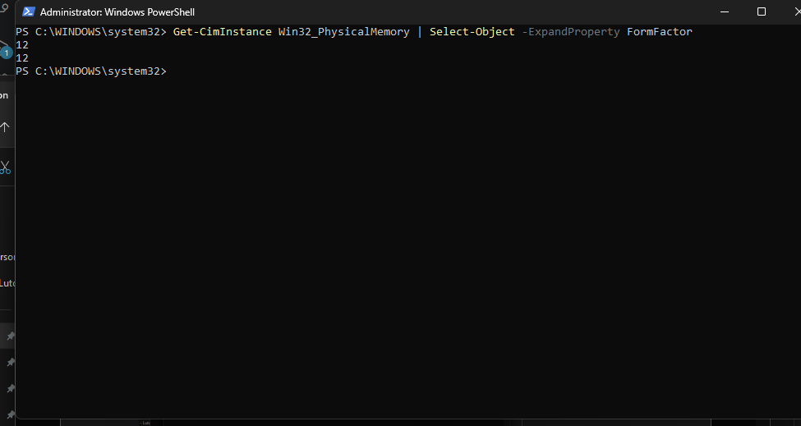
The number 12 indicates SODIMM, whilst 8 indicates DIMM (desktop RAM)
To get the DDR generation, I will make another subprocess which runs the command:
- “Get-CimInstance Win32_PhysicalMemory | Select-Object SMBIOSMemoryType”
This will also return a number, for example, 20 for DDR, 26 for DDR4, 34 for DDR5.
In my case:
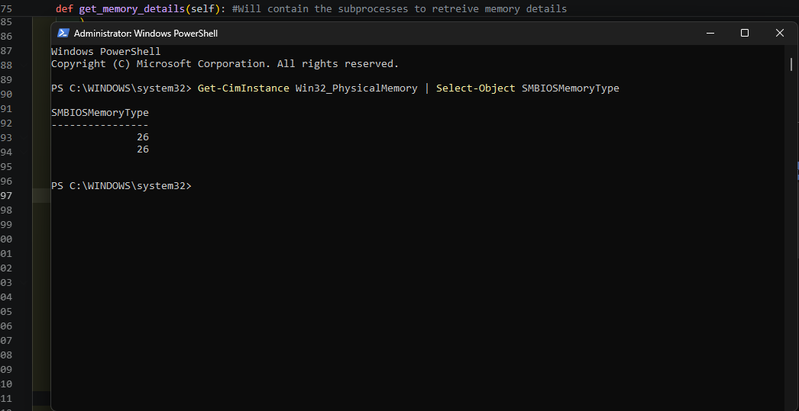
The value 26 corresponds to DDR4. It returned two values since I have two sticks installed, which are both DDR4.
First, I created the subprocesses, for commands in total in a new function called “get_memory_details()”:
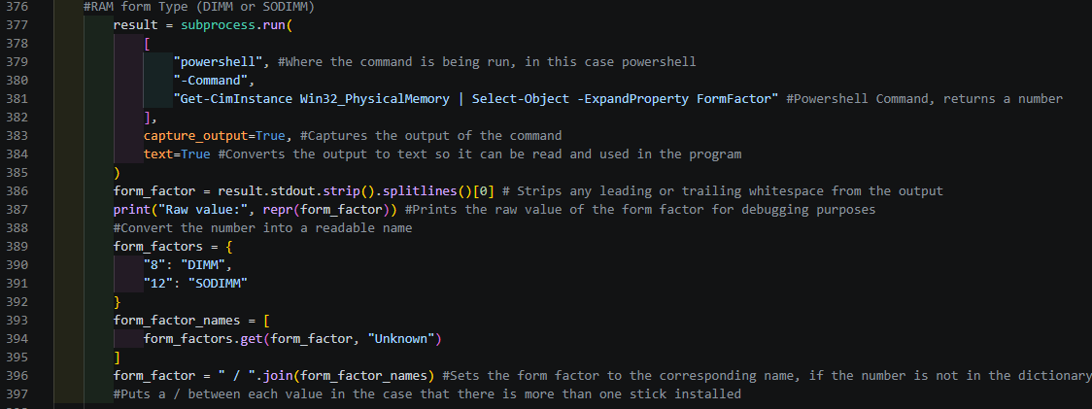
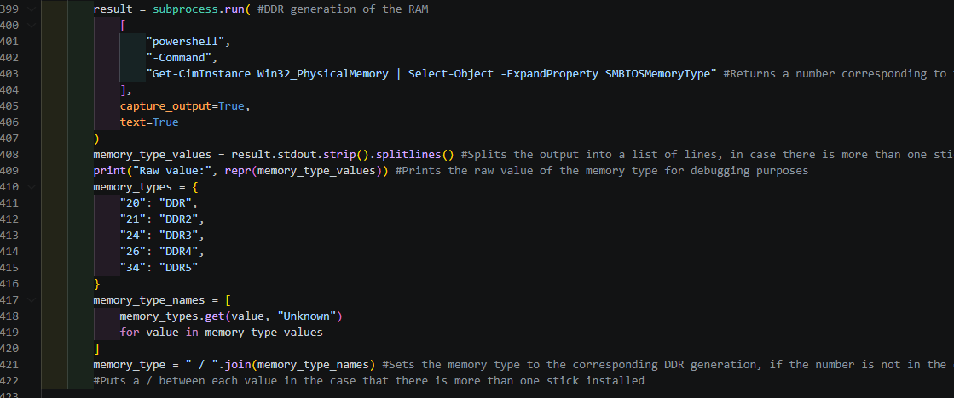
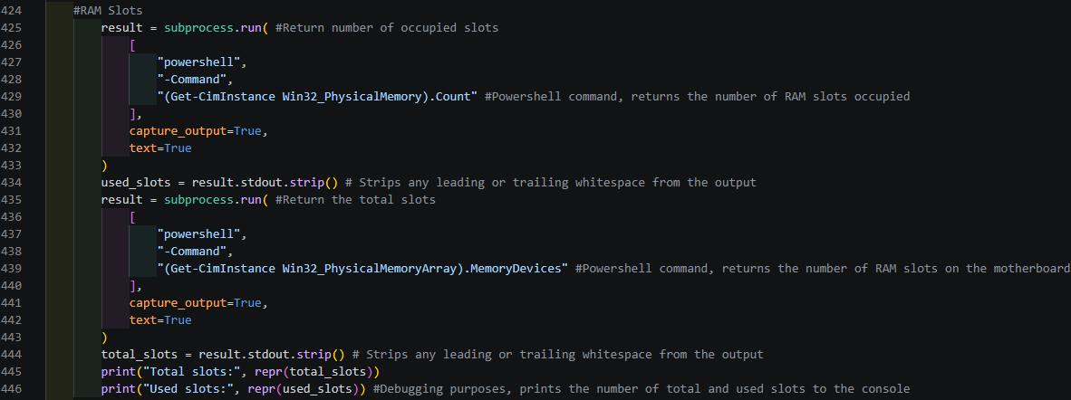

Then I made the labels underneath #Memory Details in the memory page function:
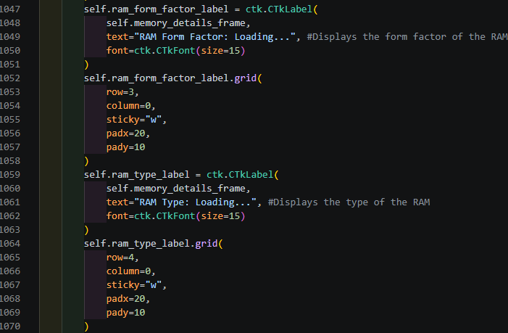
Then I configured the labels in “get_memory_details()”:
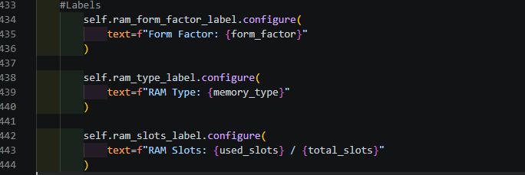
At first, the command to return the total number of RAM slots was misspelt, therefore returned nothing, so I fixed it.
Now, this should return:
- Form Type : SODIMM
- Type : DDR4 / DDR4
- Slots : 2 / 2
Results:
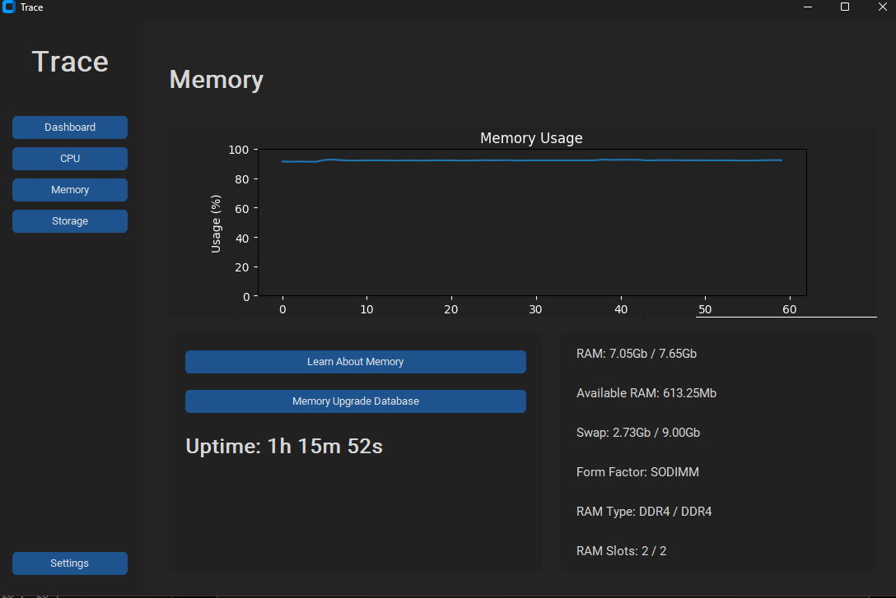
Before that, instead of returning a value, the displayed text would say “Loading…”:
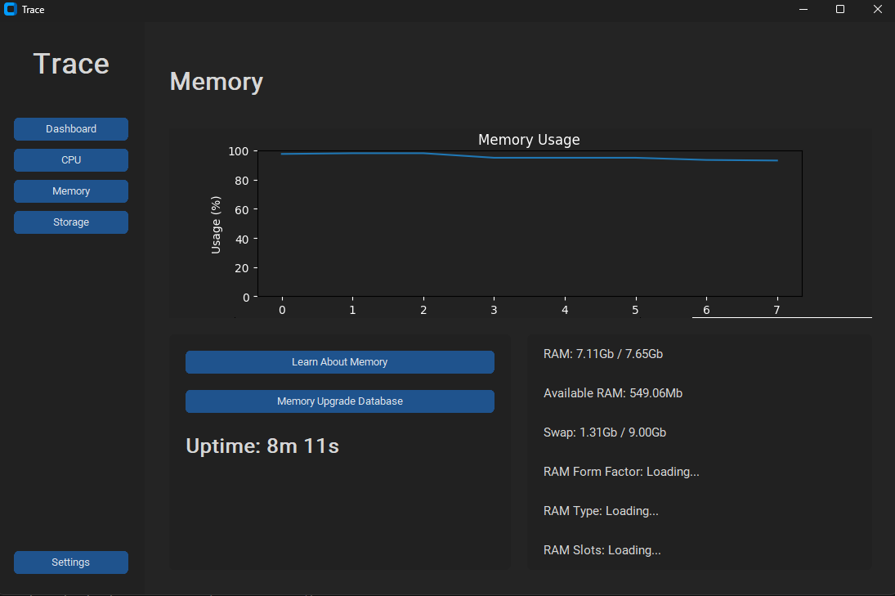

Then I realised that I had not called the function. So, at the bottom of the details section, I put:
- self.get_memory_details()
Which fixed the issue.

09/10/2026
Today, I will work on the details section for the storage page.
The details I want to display will be:
- Read speed
- Write speed
- Type of secondary storage
- Used capacity
- Total capacity
I used “subprocess” to run an external command in Windows powershell to get the type of the secondary storage since psutil is unable to return that value:
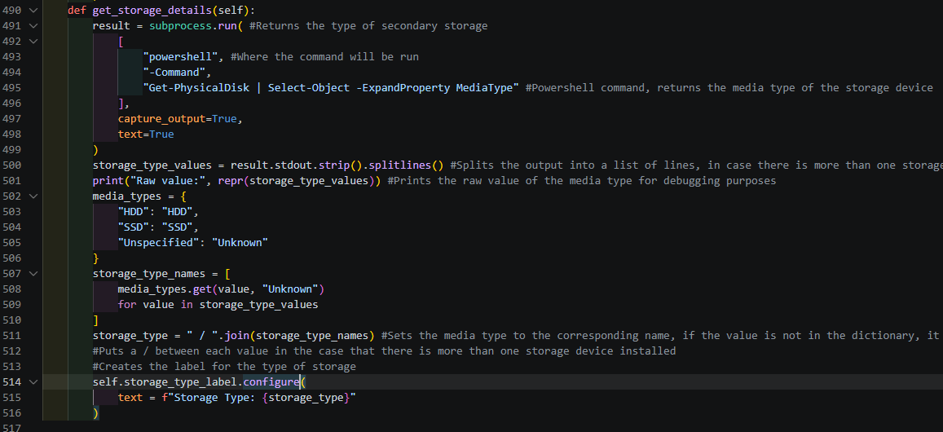
Putting the command into powershell returned:
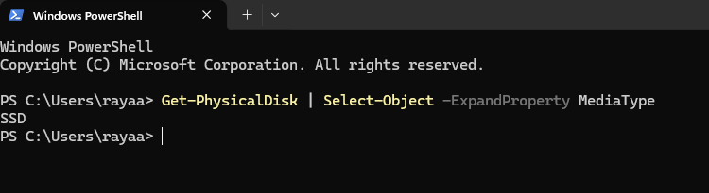
So the command worked properly.
Next, I calculated the read/write speeds by finding the difference between the new input/output bytes and the previoys bytes that were read and written.
Then, since they are in bytes and the default unit to present read/write speeds is MB/s, I divided the returned value by 1024 twice. When configuring the label, I converted the new value to be displayed to two decimal places:
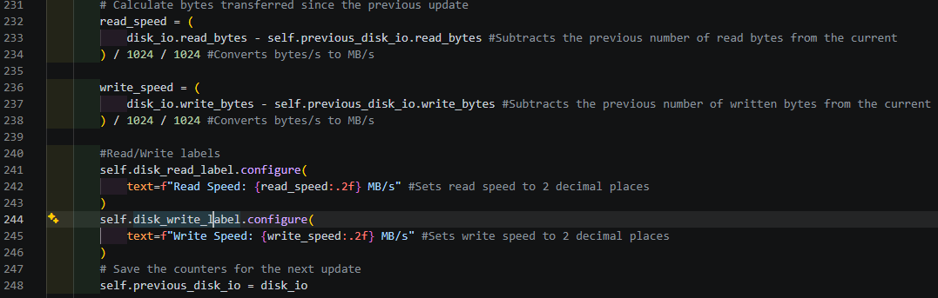
Before testing, I created the label for the storage capacity since the way I planned to display it was the exact same way I did it for the dashboard:
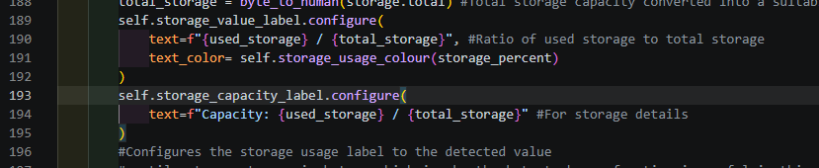
This will return capacity as used/total.
Results:
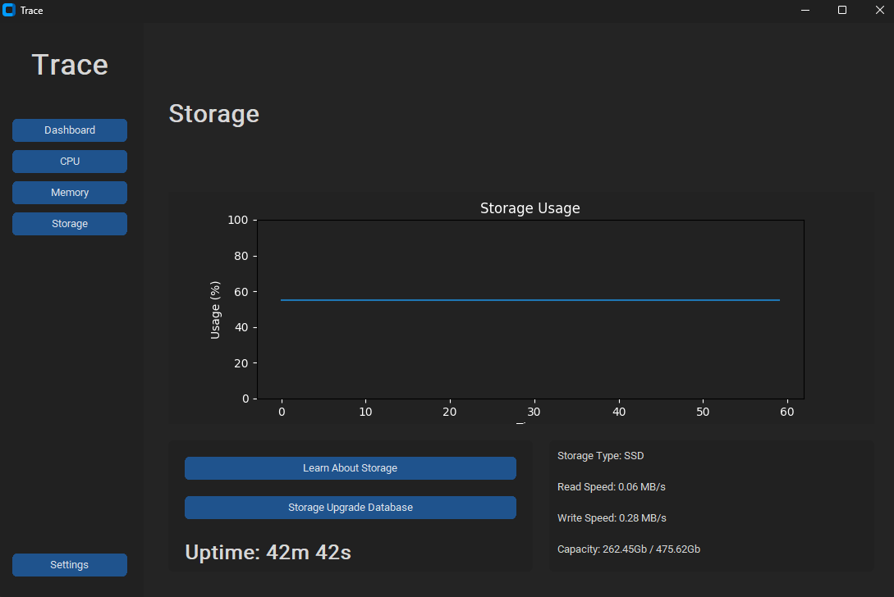

12/10/2026
Today, I plan on adding some tweaks to the storage section.
The changes will include:
- Addition of the name of the drive to the details section
- Adjusting the graph to display read/write speeds rather than the used storage amount
I began with the subprocess to get the name of the drive.
I do not know the name of my drive, all I do know is that it begins with NVMe.
The command I intend to use is:
- Get-PhysicalDisk | Select-Object -ExpandProperty FriendlyName
In powershell, this returns:
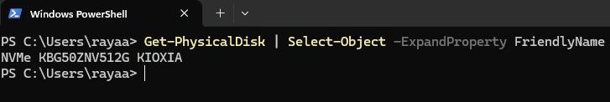
So I built the subprocess in get_storage_details() and set the label:
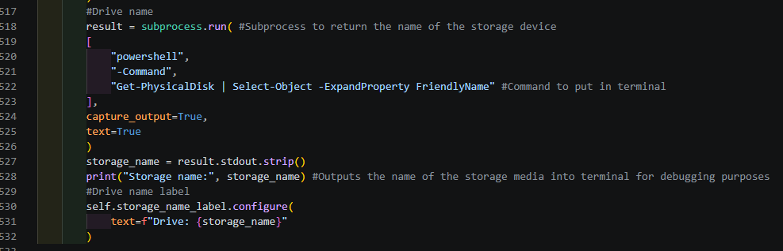
Then created the label under #Details for the storage page:
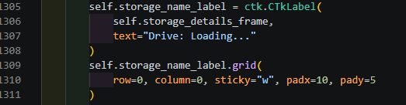

Result:
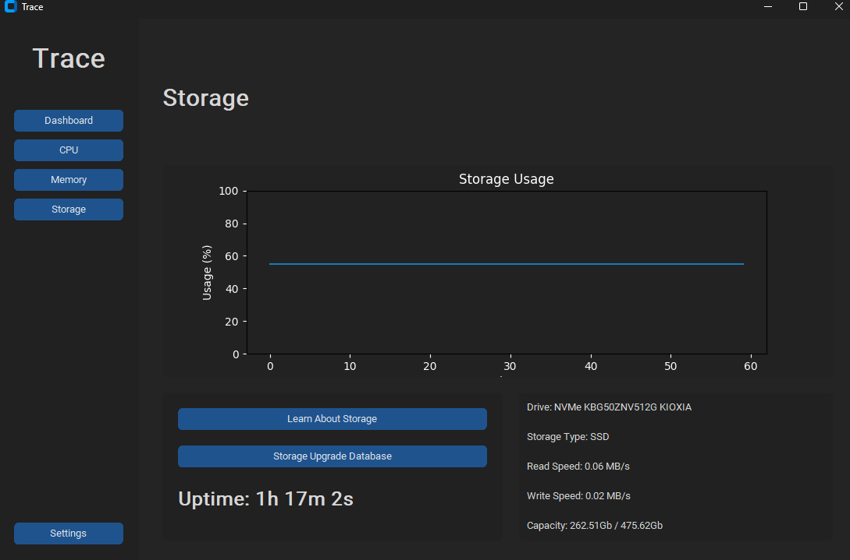
Now I know the name of my SSD; NVMe KBG50ZNV512G KIOXIA.

For the graph, I had to remove the existing code for updating the graph to replace it to display the read and write speeds.
To begin, I created two new queues to store a maximum of 60 read/write values to display on the graph:
After that, I added two lines of code in update_usage() to append the read/write values which are already retrieved from when I made the details for the storage page:
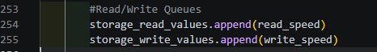
Next, I created the new graph after removing all of the contents update_storage_graph() function. The new graph used similar code however, only a couple of parts were tweaked to accommodate the two values on one graph:

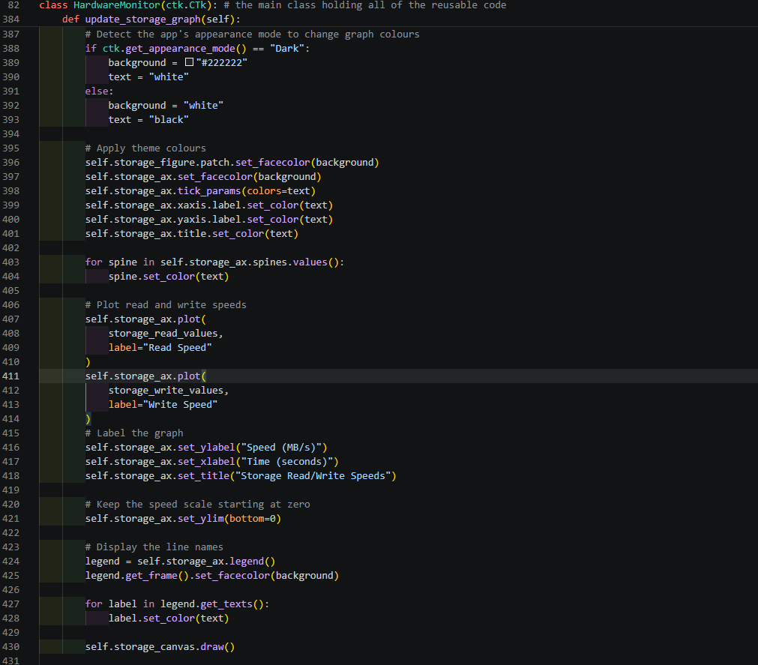
Within this, I added the feature that lets the graph theme changed based on the window theme once again. I had the read/write values stored in the queues to be plotted on the graph. I labelled the y-axis as the Speed of the read/write speed in MB/s and the x-axis as Time in seconds, maxing out at 60 seconds.

Now this should:
- Plot the saved readings of the retrieved read/write speeds
- Include a key labelling which colour line indicates what speed
- Make the colour scheme of the graph change alongside the window’s theme

Results:
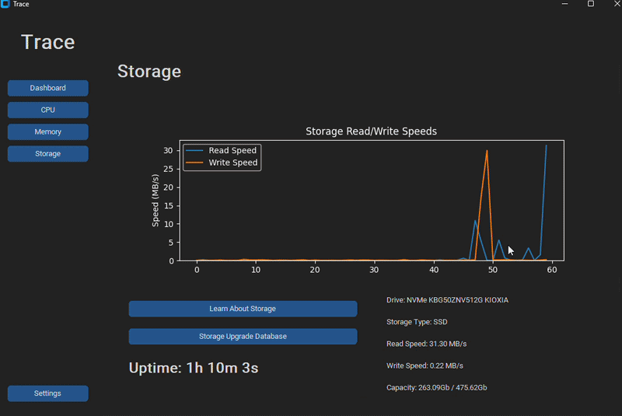

13/10/2026
Today I plan on turning main.py into an executable file so it can launch without the requirement of Virtual Studio Code.
To do this, I will make use of:
- Pyinstaller
- The requirements.txt file
Pyinstaller will be used to convert the python file into a .exe, whilst requirements.txt will be a text file containing the names of the external libraries I installed to make the program usable, consisting of:
- Matplotlib
- Psutil
- Customtkinter

In the end, this should result in:
- External libraries installed
- Trace opening without VS Code
In requirements.txt:
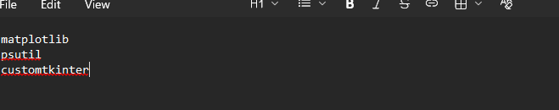
Then, after installing pyinstaller by running the command:
- py -m install pyinstaller
Into VS Code terminal. Next, I ran another command into terminal to convert main.py into an executable file using:
- py -m PyInstaller --onefile --windowed --name Trace src/main.py
The parts of the command that begin with “--” ensures that one .exe file is made, that no other window opens and sets the name of the .exe file as “Trace”.
Results after running the Trace.exe file in “dist”:

Now, the libraries in requirements.txt are installed in the command windows that open after launching. After that the application opens without opening any other window, meaning that my application is independent of VS Code.

15/10/2026
Today, I plan on making the component information buttons functional.
These buttons should:
- Open the user’s default browser
- Open the link inside the open_{component}_info() in the webbrowser
First, I imported webbrowser, then adjusted the code for the existing open_cpu_info()
function:
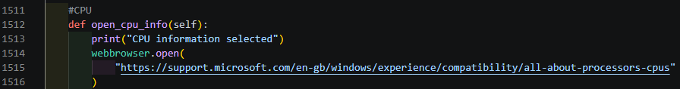
Result:
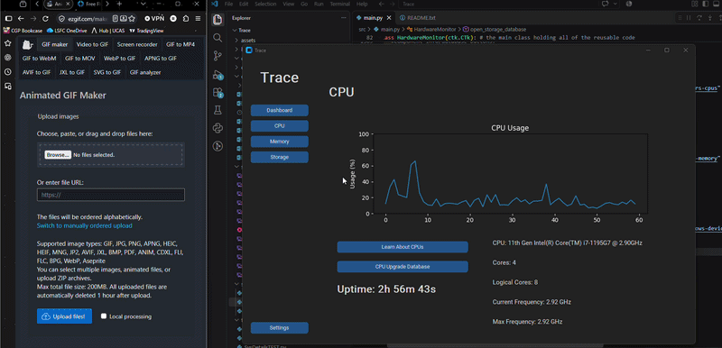

Next, I created the tables for the databases I planned to use using SQL in SQLLite:
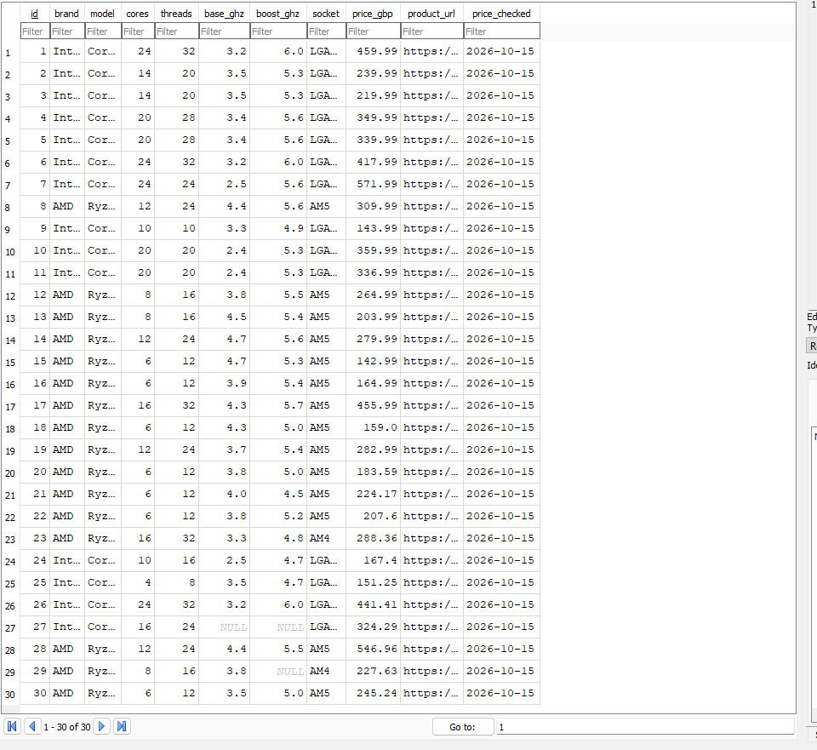
(CPU database)
After making the other databases, one for RAM, one Laptop and one Desktop storage, I imported sqlite3 and connected the database:
To test that the program recognised the database, I added:
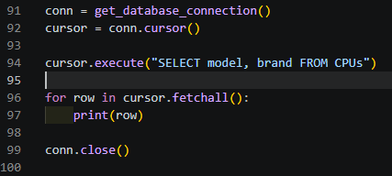
To print some attributes into terminal, which returned:
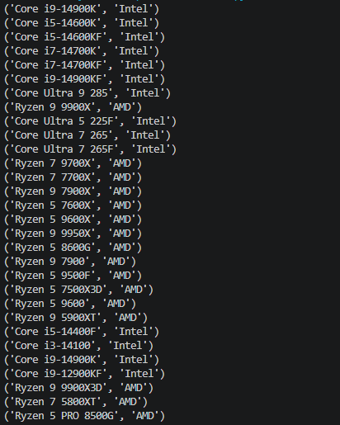
Next, I created the function to open a separate window to display the records in the chosen table of the database. I began with Storage, since it will require two separate sections for laptop and desktop storage.
After implementing the database and python code, the database buttons should:
- Open a new window
- Display the records in the specified table
Code: 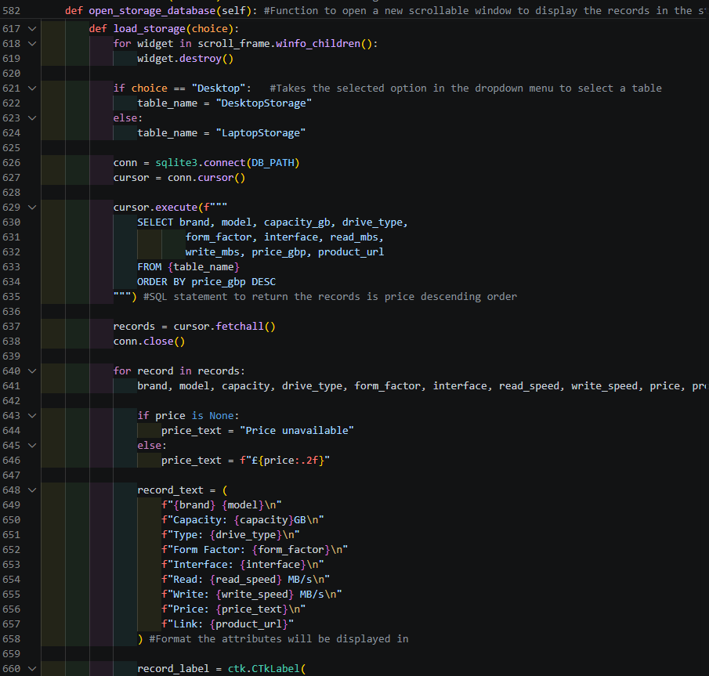
After executing, the results are:
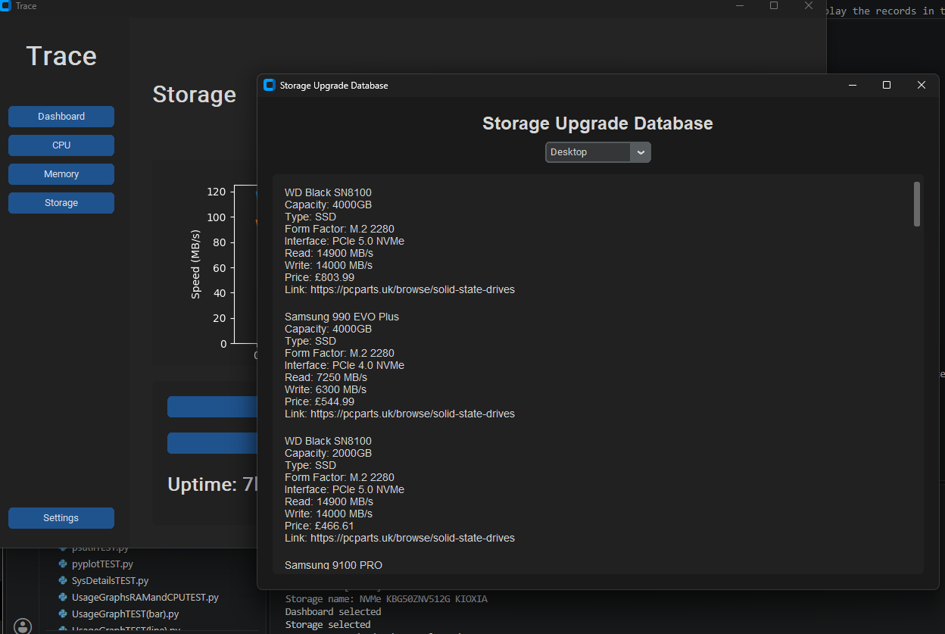
After that worked, I did the same for the RAM and CPU databases, which worked very similarly, just without the dropdown menu.

END OF TESTING DURING IMPLEMENTATION

