**TNF induced death and survival model**

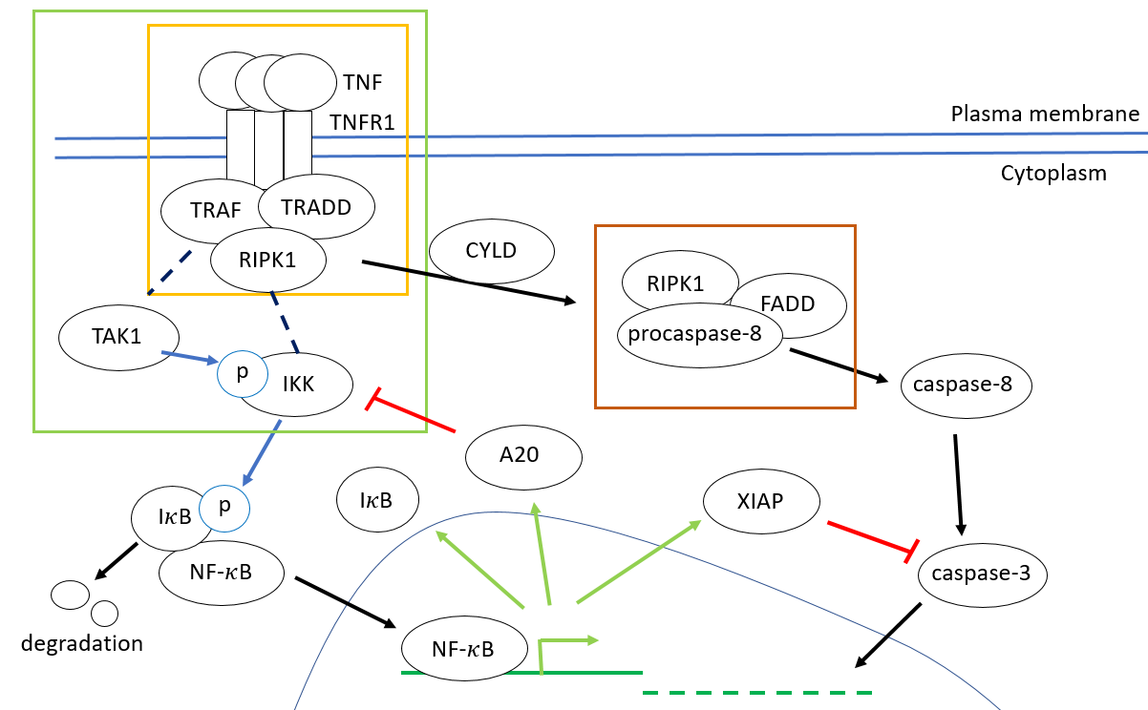

Fig. 1. The TNF survival and death signaling pathway network

The TNF binding its receptor, TNFR1, promotes the recruitment of a survival and inflammation complex (TNF complex I) that contains the proteins TNFRSF1A-associated via death domain (TRADD), receptor-interaction protein kinase 1 (RIPK1) and TNF receptor-associated factor 2 (TRAF2) and I $κ$ B kinase (IKK).

|  |  |
| --- | --- |
| TNF + TNFR1 ⟺ (TNF_TNFR1) | (1) |
| (TNF_TNFR1) + TRADD ⟺ (TNF_TNFR1_TRADD) | (2) |
| (TNF_TNFR1_TRADD) + TRAF2 ⟺ (TNF_TNFR1_TRADD_TRAF2) | (3) |
| (TNF_TNFR1_TRADD_TRAF2) + RIPK1 ⟺ (TNF_TNFR1_TRADD_TRAF2_RIPK1) | (4) |
| (TNF_TNFR1_TRADD_TRAF2_RIPK1) + IKK ⟺ (TNF_TNFR1_TRADD_TRAF2_RIPK1_IKK) | (5) |

After that, the transforming growth factor-β (TGF-β)-activated kinase 1 (TAK1) phosphorylate the IKK. Next, IKK results in phosphorylated I $κ$ B, in Nuclear factor- $κ$ B (NF- $κ$ B) complex, leading to I $κ$ B degradation. The released NF- $κ$ B translocate into the nucleus and transcribe the pro-survival gene.

|  |  |
| --- | --- |
| (TNF_TNFR1_TRADD_TRAF2_RIPK1_IKK) $⇒$ IKKa + TNF_TNFR1_TRADD_TRAF2_RIPK1 | (6) |
| IKKa + (IκB_NFκB) $⇔$ (IκB_NFκB_IKKa) | (7) |
| (IκB_NFκB_IKKa) $⇒$ IKKa + NFκB | (8) |
| NFκB $⇒$ cIAP + IκB | (9) |

However, IκB, a downstream protein of NF-κB signaling pathway, is inhibitor by directly binding NF-κB to silence the transcription activity. This negative feedback keeps cell survival and brings a system closer to a target of stability or homeostasis.

|  |  |
| --- | --- |
| IκB + NFκB $⇒$ (IκB_NFκB) | (10) |

In the apoptosis process, the ubiquitin carboxyl-terminal hydrolase (CYLD) deubiquitinating RIPK1, thereby it is release from TNF complex I and bind the FAS-associated death domain (FADD) and procaspase-8 to constitute complex II (ref). The complex II cause procapase-8 cleaved to active caspase-8, starting the cascades of caspases, and then activate the caspase-3. Finally, cell goes to the life end.

|  |  |
| --- | --- |
| (TRADD_TRAF2_RIPK1) + FADD ⇔ (TRADD_TRAF2_RIPK1_FADD) | (11) |
| (TRADD_TRAF2_RIPK1_FADD) + Caspase8 ⇔ (TRADD_TRAF2_RIPK1_FADD_Caspase8) | (12) |
| (TRADD_TRAF2_RIPK1_FADD_Caspase8) $⇒$ Caspase8a + TRADD_TRAF2_RIPK1_FADD | (13) |
| Caspase8a + Caspase3 $⇔$ (Caspase8a_Caspase3) | (14) |
| (Caspase8a_Caspase3) $⇒$ Caspase3a + Caspase8a | (15) |

Furthermore, the inhibitor of apoptosis protein (cIAP), a downstream protein of NF-κB signaling pathway, could binding caspase-3 directly and to inhibit both the initiation and the execution phase of apoptosis.

|  |  |
| --- | --- |
| Caspase3a + XIAP ⇒ (Caspase3a_XIAP) | (16) |

It lets the cell be alive in a robust system, but also be flexible to respond to the infection by programmed death for saving other cells.

**Reaction Rate of Stochastic System**

We consider the reaction system consisting of N $≥$ 1 molecular species $\left\{S_{1},…, S_{N}\right\}$ and reaction channels R $≥$ 1 $\left\{R_{1},…, R_{M}\right\}$ in fixed volume V, and specify the dynamic state of this system $X\left(t\right)≡\left\{X_{1}(t),…, X_{N}(t)\right\}$, where $X_{i}\left(t\right) \left(i=1,…,N\right)$ are random variables. However, It exist well-defined function $a_{j}$, as propensity function for $R_{j}$, which is such that

|  |  |
| --- | --- |
| $a_{j}\left(x\right)dt≡$ the probability, given $X\left(t\right)$ = $x$, that one $R_{j}$ reaction will occur somewhere inside V in the next infinitesimal time interval [t, t + dt ) (j =1, …, N) | (17) |

The propensity function and the state change vector $ν_{j}$, whose ith element is defined by

|  |  |
| --- | --- |
| $ν_{ij}$ $≡$ the change in the number of molecules produced by on $R_{i}$ reaction  (i = 1, …, M: j = 1, …, N) | (18) |

The species population evolve deterministically according to the set of ordinary differential equations (ODEs), where the elements of $X\left(t\right)$ are regarded as sure, real variable functions. Combining the Eq. (17) and (18), the ODEs could present as

|  |  |
| --- | --- |
| $$\frac{dX_{i}(t)}{dt}=\sum_{j=1}^{M}{ν_{ij}a_{j}\left(X\left(t\right)\right)} \left(i=1..N\right)$$ | (19) |

The mean behavior of survival and death model could be found by solving ODEs by forward Euler method.

**Chemical Langevin Equation of Stochastic System**

The ODE could extend to thestochastic differential equation (SDE), except that adds randomness to the propensity function.

|  |  |
| --- | --- |
| $$X_{i}\left(t+dt\right)=X_{i}\left(t\right)dt+\sum_{j=1}^{M}{ν_{ij}P(a_{j}\left(X\left(t\right)\right)dt) }$$ | (20) |

Where the randomness term is Poisson random variable, $P(a_{j}\left(X\left(t\right)\right)dt)$. If the mean of Poisson random variable, $a_{j}\left(X\left(t\right)\right)dt≫1,$ the $P\left(a_{j}\left(X\left(t\right)\right)dt\right)$ could approach to the norm random variable $N(a_{j}\left(X\left(t\right)\right)dt, a_{j}\left(X\left(t\right)\right)dt)$, According the linear combination theorem of norm random variable,

|  |  |
| --- | --- |
| $$N\left(a_{j}\left(X\left(t\right)\right)dt, a_{j}\left(X\left(t\right)\right)dt\right)= a_{j}\left(X\left(t\right)\right)dt+{(a_{j}\left(X\left(t\right)\right)dt)}^{1/2} N\left(0,1\right)$$ | (21) |

Where ${dt}^{\frac{1}{2}}N\left(0,1\right)$ is temporally, statistically independent Gaussian white-noise, and $N\left(0,1\right)$ is Gaussian distribution with mean = 0 and variance = 1. The randomness in Eq. (20) is replaced by Eq. (21)

|  |  |
| --- | --- |
| $$X_{i}\left(t+dt\right)=X_{i}\left(t\right)dt+\sum_{j=1}^{M}{ν_{ij}a_{j}\left(X\left(t\right)\right)dt}+ \sum_{j=1}^{M}{ν_{ij}{\left(a_{j}\left(X\left(t\right)\right)dt\right)}^{\frac{1}{2}} N\left(0,1\right) }\left(i=1..N\right)$$ | (22) |

The Eq. (22) is called “white-noise form” Langevin Equation.It could be calculated by the stochastics Euler method which allows to do Monte Carto simulations in the system, and the parameters and initial conditions are following with them in ODEs system. It would run 1000 time for to get distribution of mean and variance. We can use the mean pattern to explain how a cell do a fate decision.

**Programming:**

I would program ODEs “white-noise form” Langevin Equation by Python 3.7.3 in the platform, Spyder 4 under setting of the Anaconda and CentOS Linux 7.

We include 6 short python programs with the present work.

1. survial_death_model_conc.py

2. survial_death_model_molecule.py

3. survial_death_model_molecule_nImpluse.py

4. survial_death_model_molecule_CLE.py

5. survial_death_model_molecule_CLE_multiple.py

6. read_survial_death _model_multiple.py

**survial_death_model_conc.py**

reproduce the result of reference in concentration (nM)

Input:

ODEs descript

output:

SDE_ODE.npy

result (folder):

all molecule trajectory figures (.png)

**survial_death_model_molecule.py**

reproduce the result of reference in molecules

we estimated the molecule number of 1 nM in 1 pl (mammal cell volume 1 ~ 4 pl) is approximately 600 molecules.

Input:

ODEs descript

output:

SDM_ODE_molecule.npy

result (folder):

all molecule trajectory figures (.png)

**survial_death_model_molecule_nImpluse.py**

Multiple impulse of TNF in different time point (in hours)

Input:

ODEs descript

output:

SDM_ODE_molecule_nImpluse.npy

result (folder):

all molecule trajectory figures (.png)

**survial_death_model_molecule_CLE.py**

To extend the noise term in ODEs, we need to decompose ODEs into stoichiometric and propensity, and also using the standard Gaussian distribution in noise term.

Input:

ODEs descript

Output:

SDM_CLE.npy

result (folder):

all molecule trajectory figures (.png)

**survial_death_model_molecule_CLE_multiple.py**

It would run 1000 time to get distribution of trajectories, and calculate the mean and the variance.

Input:

ODEs descript

Output:

SDM_CLE_multiple.npy

**read_survial_death _model_multiple.py**

Reading the data in SDM_CLE_multiple.npy create the figure for basic analysis

Input:

SDM_CLE_multiple.npy

Output:

result (folder):

all molecule trajectory figures (.png)

NFkB_IkB_comp.png

TNF_NFkB_IkB.png

survival_and_death_complex.png

caspase3_Caspase3_IAP.png

**References**

1. Rangamani P, Sirovich L. Survival and Apoptotic Pathways Initiated by TNF-a: Modeling and Predictions. *Biotechnol. Bioeng.* 97: DOI 10.1002/bit.21307
2. Gillespie DT. 2000. The Chemical Langevin Equation. *J. Chem. Phys.* 113: 297–306