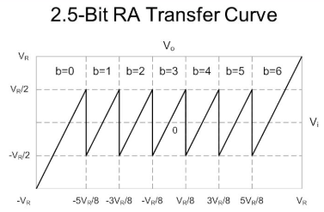
Input Signal | Priority Encoder
Vin (-0.9~0.9) | X2 | X1 | X0
0.562<Vin<0.787 | 1 | 1 | 0
0.337<Vin<0.562 | 1 | 0 | 1
0.112<Vin<0.337 | 1 | 0 | 0
-0.112<Vin<0.112 | 0 | 1 | 1
-0.337<Vin<-0.112 | 0 | 1 | 0
-0.526<Vin<-0.337 | 0 | 0 | 1
-0.787<Vin<-0.526 | 0 | 0 | 0

Vo= 4Vi- (Va+Vb+Vc)
Vi | Thermal  e6e5e4  e3e2e1 | Encode  X2X1X0 | DAC | Va Vb Vc | Vo
Vi <  -0.562 | 000000 | 000 | -0.675 | -1,-1,-1 | 4(vi+0.675)
-0.562 < Vi  < -0.337 | 000001 | 001 | -0.45 | -1,-1,0 | 4(vi+0.45)
-0.337 < Vi  < -0.112 | 000011 | 010 | -0.225 | -1,0,0 | 4(vi+0.225)
-0.112 < Vi  < 0.112 | 000111 | 011 | 0 | 0,0,0 | 4(vi)
0.112 < Vi  < 0.337 | 001111 | 100 | 0.225 | 1,0,0 | 4(vi-0.225)
0.337 < Vi  < 0.562 | 011111 | 101 | 0.45 | 1,1,0 | 4(vi-0.45)
Vi > 0.562 | 111111 | 110 | 0.675 | 1,1,1 | 4(vi-0.675)
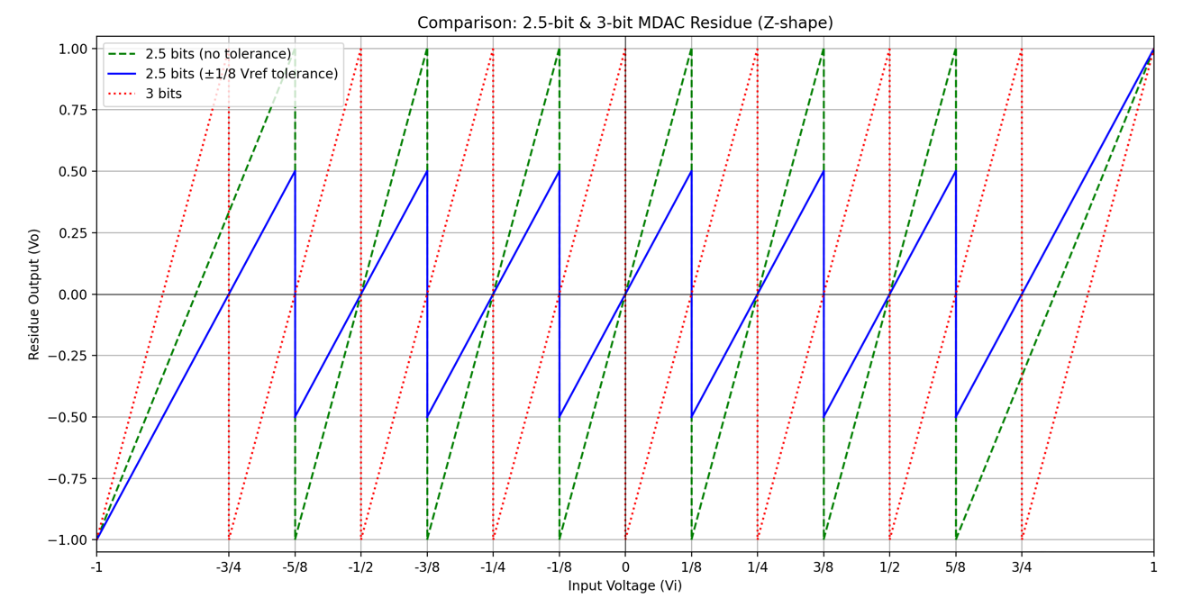
Blue (2.5-bit ADC): Gain=4, less comparators and can tolerate offset
Red (3-bit ADC): No matter if Gain=4 or 8 (Gain=8 than can’t tolerate offset) still need more comparators
Green(2.5-bit ADC no tolerance): Gain=8, can’t tolerate any offset (Vo will goes over Vref)

