**6.4** What advantage is there in having different time-quantum sizes at

different levels of a multilevel queueing system?

The priority of each queue is different. The higher the priority, the smaller the time-quantum size is, and the lower priority, the bigger the time-quantum size is. The purpose of this is to promote small jobs whose CPU burst time is short to be finished by CPU quickly. In order to facilitate the completion of those large jobs whose CPU burst time is long, the time-quantum size of last queue (the lowest priority queue) is generally large, even the last queue can use FCFS to schedule jobs.

**6.17** The following processes are being scheduled using a preemptive, round-robin

scheduling algorithm. Each process is assigned a numerical

priority, with a higher number indicating a higher relative priority.

In addition to the processes listed below, the system also has an ***idle***

***task*** (which consumes no CPU resources and is identified as *Pidle* ). This

task has priority 0 and is scheduled whenever the system has no other

available processes to run. The length of a time quantum is 10 units.

If a process is preempted by a higher-priority process, the preempted

process is placed at the end of the queue.

a. Show the scheduling order of the processes using a Gantt chart.

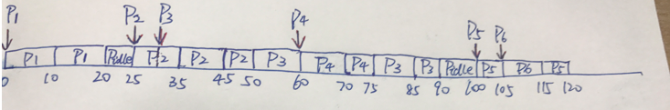

b. What is the turnaround time for each process?

P1:20-0=20

P2:50-25=25

P3:90-50=40

P4:75-60=15

P5:120-100=20

P6:115-105=10

c. What is the waiting time for each process?

P1:0

P2:0

P3:75-60+50-30=35

P4:0

P5:115-105=10

P6:0

d. What is the CPU utilization rate?  
105/120=87.5%

**6.31** Consider two processes, *P*1 and *P*2, where *p*1 = 50, *t*1 = 25, *p*2 = 75, and

*t*2 = 30.

a. Can these two processes be scheduled using rate-monotonic

scheduling? Illustrate your answer using a Gantt chart such as

the ones in Figure 6.16–Figure 6.19.

b. Illustrate the scheduling of these two processes using earliest deadline-

first (EDF) scheduling.

**a.**

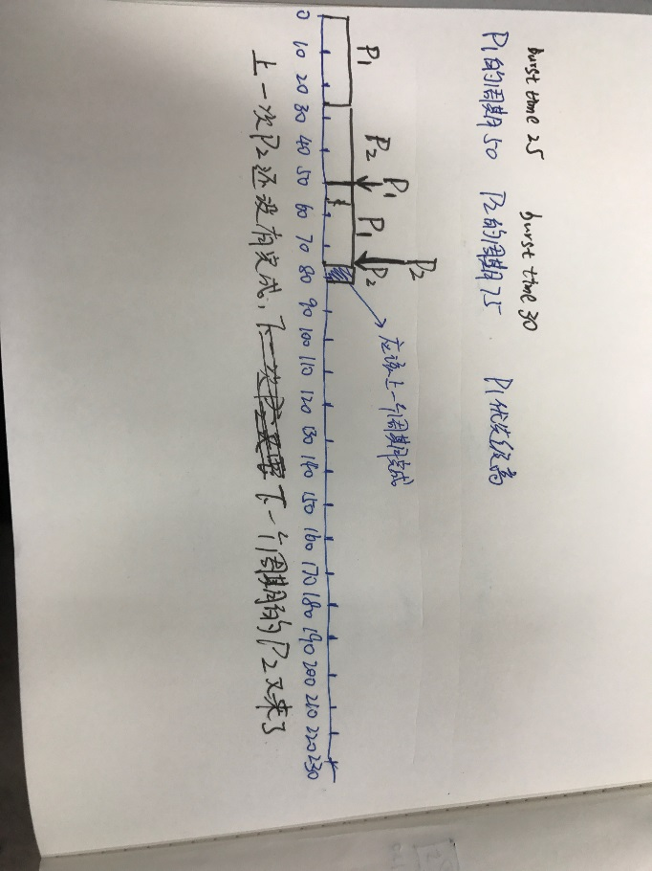

**b**

