National Cheng Kung University
Department of Electrical Engineering

Introduction to VLSI CAD (Spring 2019)

Lab Session 6

Design of Finite State Machines and Memories

Name | Student ID
Practical |  | Points | Marks
Lab A |  | 10
Lab B |  | 15
Lab C |  | 25
Lab D |  | 50
Notes

Due: 15:00 April 3, 2019@ moodle

Deliverables
- All Verilog codes including testbenches for each problem should be uploaded.
NOTE: Please DO NOT include source code in the paper report!
- All homework requirements should be uploaded in this file hierarchy.
- NOTE: 1. Please DO NOT upload waveforms (.fsdb or .vcd)!
- If you upload a dead body which we can’t even compile, you will get NO credit!
- All Verilog file should get at least 90% nLint Coverage.
- All homework requirements should be uploaded in this file hierarchy or you will not get full credit.
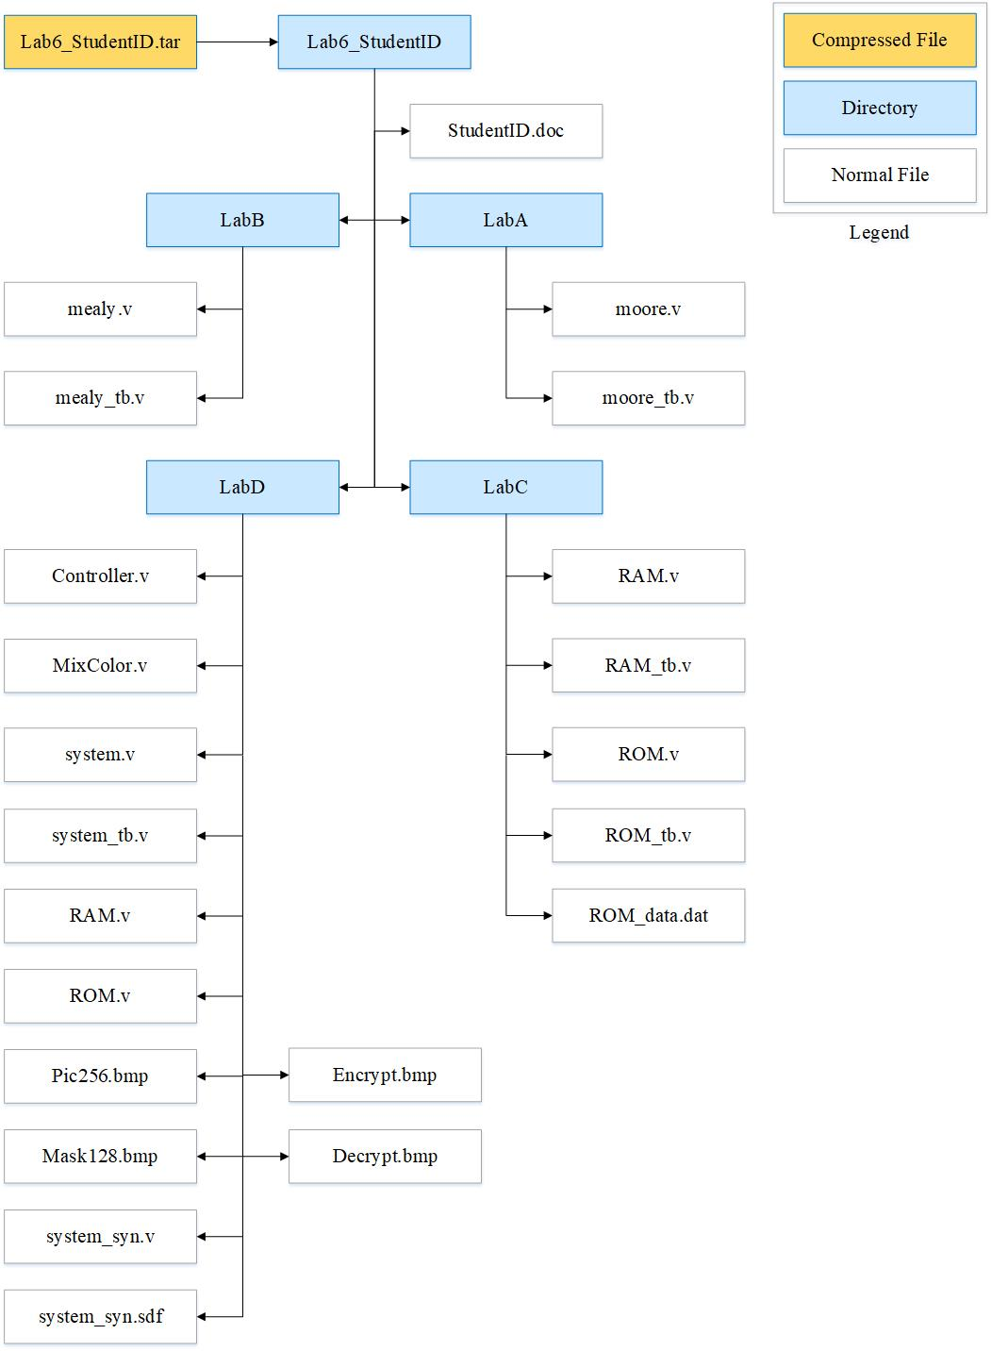

Fig.1 File hierarchy for Homework submission
Objectives:
To learn how to design the finite state machine and the mini system.

Lab A: Moore Machine
- Observe the given state diagram
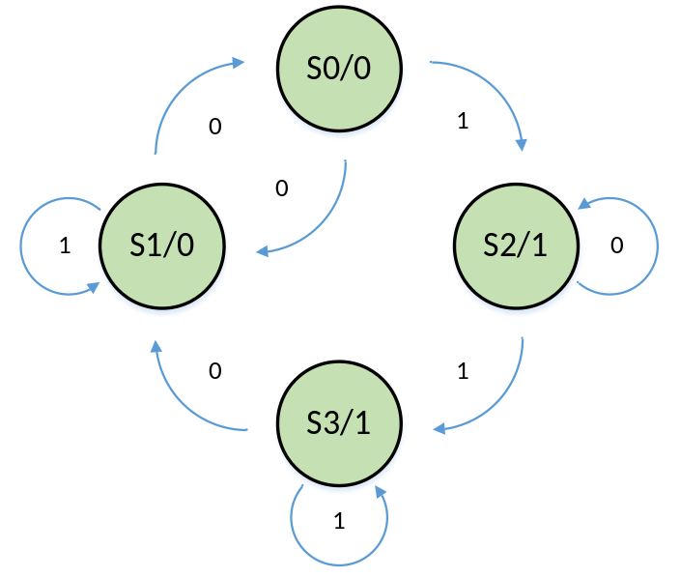

Current State | Next State |  | qout
Current State | din=0 | din=1 | qout
S0=00 | S1 | S2 | 0
S1=01 | S0 | S1 | 0
S2=10 | S2 | S3 | 1
S3=11 | S1 | S3 | 1

Table1. Moore state table

- Write Verilog code for this FSM based on the Moore Machine. And you should name all your I/O ports according to the naming specification.

Port name | input/output | # bit
rst | input | 1
clk | input | 1
din | input | 1
qout | output | 1
Table2. I/O Naming Specification
- Compile the verilog code and write a testbench to verify the operations of this module works properly.

- Please attach your waveforms and specify your operations on the waveforms.
1cycle:reset,在s0狀態，輸出為0
2:posedge觸發到狀態s2(din=1)，因此輸出由0變1
3:din=0，因此狀態仍在s2
4:din=1，狀態變s3，輸出為1
5:din=1，狀態仍是s3
6:din=0到s1，輸出為0
7~10:s1→s1→s0→s1→s0，輸出皆為0

- Show nLint coverage (moore.v)
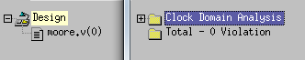
100%

Lab B: Mealy Machine
- Observe the given state diagram
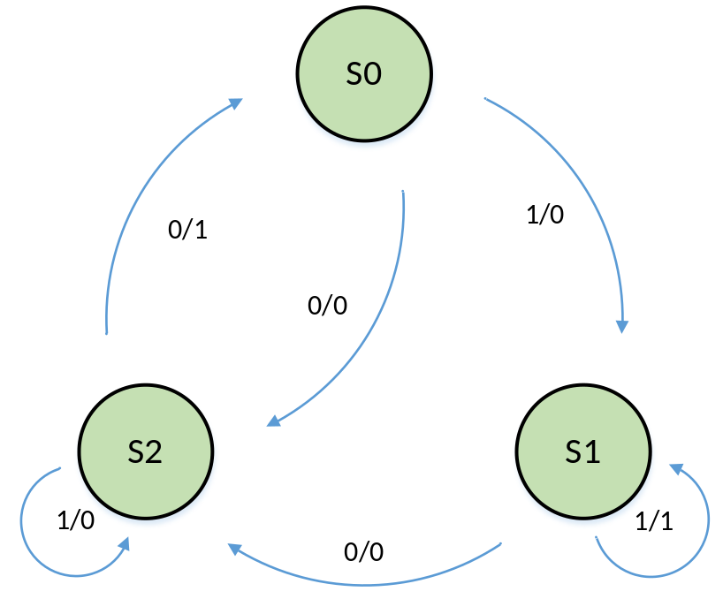

Current State | Next State
Current State | din=0 | din=1
S0=00 | S2,0 | S1,0
S1=01 | S2,0 | S1,1
S2=10 | S0,1 | S2,0

Table3. Construct the state table

- Write Verilog code for this FSM based on the Mealy Machine. You should name all your I/O ports according to the naming specification.

Port name | input/output | # bit
rst | input | 1
clk | input | 1
din | input | 1
qout | output | 1
Table4. I/O Naming Specification

- Compile the verilog code and write a testbench to verify the operations of this module works properly.

- Please attach your waveforms and specify your operations on the waveforms.
1:rst，s0，qout=0
2:din=1，s0→s1，前半周還在s0因此qout=0，後半周圍s1因此qout=1
3:仍在s1
4:din=0，前半周仍為s1，qout=0，後半周到s2，qout=1
5:din=1，仍在s2
6~8:在s2和s0間來回

- Show nLint coverage (mealy.v)
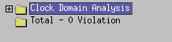
100%

Lab C: Memory
- Understand the function of memory
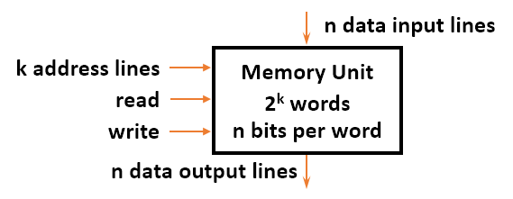
Please fill the blanks :
- Memory is a collection of binary storage cells together with associated circuits needed to transfer information
- During read operation, a specific word is selected by applying k-bit address and the selected word will be put on Data Output
- During write operation, the input address selects the memory location to be written with the data appear at the Data Input

- Design a 65536x24 bits random-access memory which consists of :
- Data depth = 65536, Data width = 24,
- Working at positive edge of clock
- When WE is high, D is stored into the memory as pointed by A. When OE is high, the data will be put on Q as pointed by A.
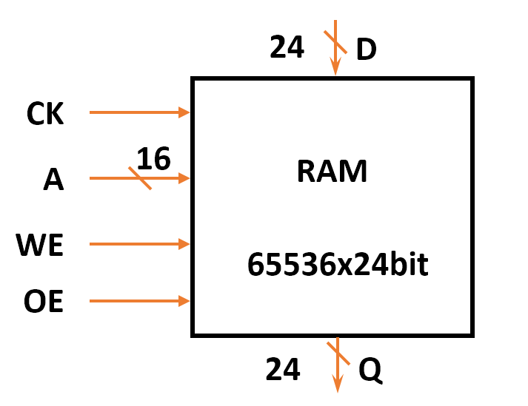
- Compile the RAM code and write a testbench to observe the operation of this module using the following rules (All data value is hex ):
- Write data (0x00_0afc, 0x00_b031, 0xf0_0005, 0x00_0246, 0x00_00a9, 0x00_006e, 0xff_ffff, 0x00_046a, 0xc1_0dd3) into addr (0, 1887, 22453, 308, 74, 299, 51, 16388, 65535) (dec).
- Read data from addr (70, 299, 0, 1888, 308, 51, 22453, 97) (dec).
- Write data (0x00_1fc3, 0xed_2a24) into addr (74, 1888) (dec).
- Read data from addr (16388) (dec).
- Write data (0x00_0123) into addr (65535) (dec).
- Read data from addr (74) (dec).
- Write data (0x00_00cc) into addr (45294) (dec).
- Read data from addr (65535, 45294) (dec).

- Please attach your waveforms and specify your operations on the waveforms.

- Design a 16384x24 bits read-only memory which consists of :
- Data depth = 16384, Data width = 24,
- Working at positive edge of clock
- When OE is high, the data will be put on Q as pointed by A.
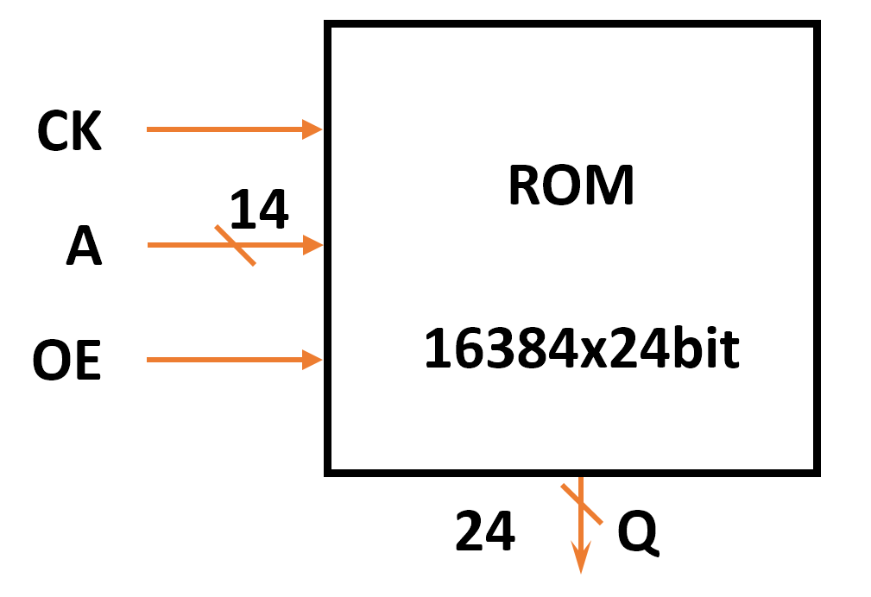

- Compile the ROM code and write a testbench based on the conditions to prove that the operations of this module work properly:
- Write a file named ROM_data.dat and then load the ROM_data.dat into ROM module. Please read data from A = 16368 to 16383.
- The data should equal to its address number. EX: (A,Data) = (0,0), (1,1), …, (16383,16383)

- Please attach your waveforms and specify your operations on the waveforms.
1.RAM:
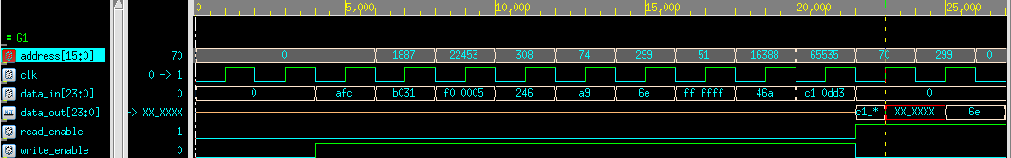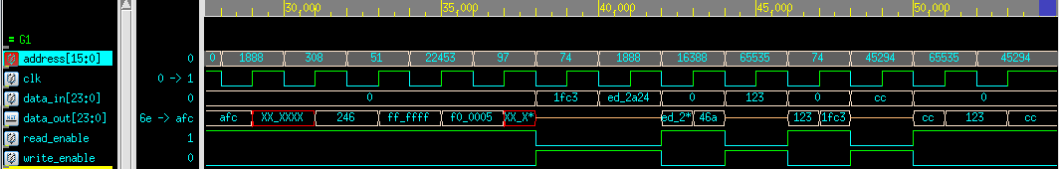
Write_enable=1時寫資料，Read_enable=1讀資料。讀資料時因為正緣觸發，所以地址晚半周變化。X訊號部分代表該地址未被寫進資料過，所以無值讀出。
2.ROM:
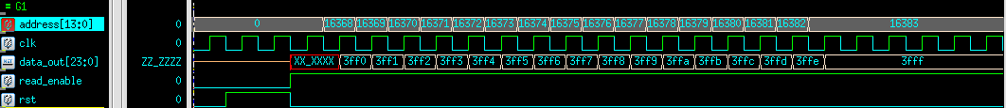
正緣觸發時讀出，從地址16368~16383

- Show nLint coverage (RAM.v) (ROM.v)
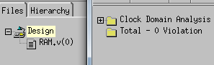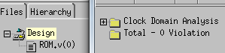
100%

Lab D: A mini system
You are about to integrate all components that you have learned so far to form a mini system (system). The system will be the framework for your final design lab. The block diagram of system is as shown in Fig1.
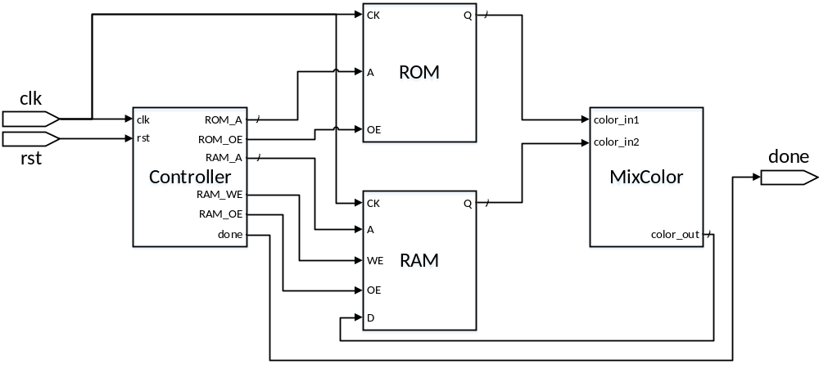
Fig1. The block diagram of system

- Understanding the function:
Once system is initialized, it
  - reads pixel from the ROM and RAM;
  - uses MixColor component to compute the new color of the pixel;
  - writes the new color of the pixel back to the RAM;
  - repeats the process step (a)-(c) until the last pixel of RAM is updated;
  - flags “done” when step (d) is completed

- Know the basic design rules
  - All operations initiated on the positive edge trigger of the clock
  - Xor the value of two colors to mix them
  - Be aware of the size difference of two images (memories)
  - Control signals:
    - ROM_OE: To read data from ROM
    - RAM_WE: To store the data to RAM
    - RAM_OE: To read data from RAM
    - done: Stop the process

- Observe the state diagram
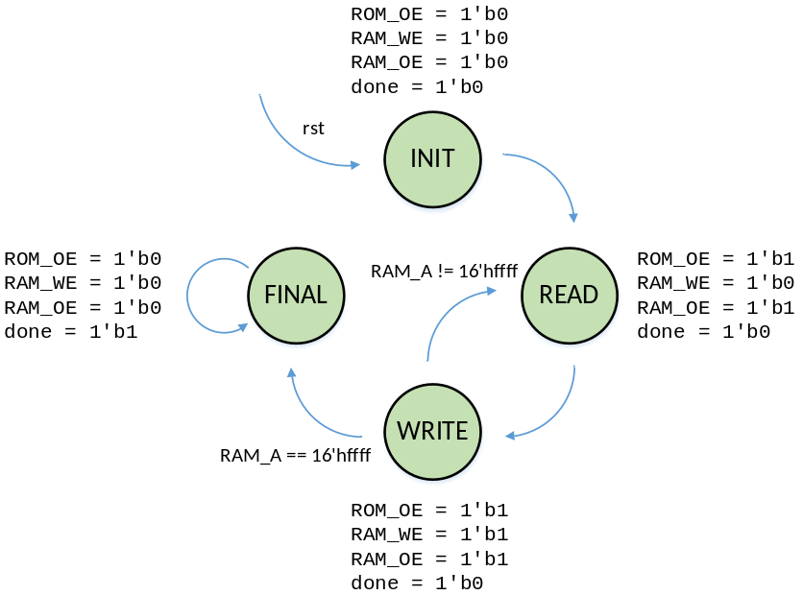

- Complete all components in the system.
- Mix Pic256.bmp with Mask128.bmp.
- Compile the verilog code and write a testbench to verify the operations of this module works properly.
- Synthesize your system.v with following constraint:
- Clock period: no more than 20 ns.
- Don’t touch network: clk.
- Operating condition: slow (max); fast (min).
- Wire load model: tsmc13_wl10 (slow).
- Synthesized verilog file: system_syn.v.
- Timing constraint file: system_syn.sdf.
- Please attach your screenshot of Encrypt.bmp and Decrypt.bmp.
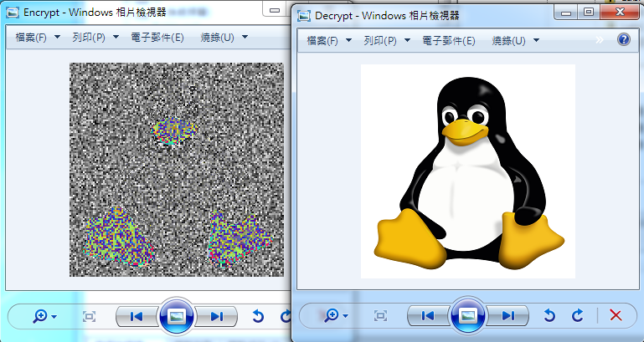
- Please attach your waveforms and specify your operations on the waveforms.
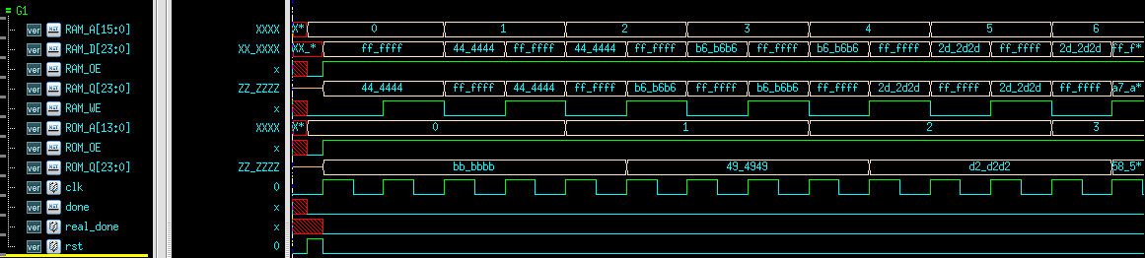
因為橫向兩格mask對應1格原圖pix，因此ROM地址變化週期為RAM兩倍。直向兩格mask也對應1格原圖pix，因此RAM到256倍數時，ROM減127(圖沒截到)。RAM的read和write在同一個地址，因此一個地址訊號持續2clk。
- Show nLint coverage (system.v) (controll.v)
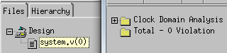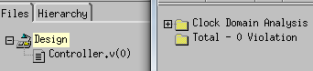
100%

At last, please write the lessons learned from this lab session, or some suggestions for this lab session, thank you.
這次配合有限狀態機和記憶體，終於輸出實際圖檔了。透過這次Lab，我更了解序向電路、阻礙和無阻礙指定等等的用法了。

Please compress all the following files into one compressed file (“.tar “ format or “.zip” format) and submit through Moodle website:
a) Verilog codes, testbench and any other files to support your testbench
LabA: moore.v, moore_tb.v
LabB: mealy.v, mealy_tb.v
LabC: RAM.v, RAM_tb.v
ROM.v, ROM_tb.v, ROM_data.dat
LabD: Controller.v
MixColor.v
system.v
system_tb.v,
RAM.v
ROM.v
Pic256.bmp
Mask128.bmp
Encrypt.bmp
Decrypt.bmp
system_syn.v
system_syn.sdf
※ NOTE:
- If there are other files used in your design, please attach the files too and make sure they’re properly included.
- Simulation command
Problem | Command
LabA | ncverilog +access+r moore_tb.v +define+FSDB
LabB | ncverilog +access+r mealy_tb.v +define+FSDB
LabC-1 | ncverilog +access+r RAM_tb.v +define+FSDB
LabC-2 | ncverilog +access+r ROM_tb.v +define+FSDB
LabD-RTL | ncverilog +access+r system_tb.v +define+ENCRYPT+FSDB  ncverilog +access+r system_tb.v +define+DECRYPT+FSDB
LabD-SYN | ncverilog +access+r system_tb.v +define+syn+ENCRYPT+FSDB  ncverilog +access+r system_tb.v +define+syn+DECRYPT+FSDB

