**資工三 109590004 呂育瑋 計算機網路 Homework 4**

1. What is the problem of NAT used in the P2P application? How can this problem be avoided? (You may check the approach used by Skype application.)

A: 1. NAT會隱藏內網IP並由同一個公用IP但不同Port設定傳輸資料，如果不在NAT的IP轉換表單內，資

料會被屏蔽，P2P需要雙方都能建立連線，這對建立連結上會有很大的困難。

2. 解決方法有利用NAT穿隧技術或UPnP。

1. Consider a router that interconnects three subnets: Subnet 1, Subnet 2, and Subnet 3. Suppose all of the interfaces in each of these three subnets are required to have the prefix 223.3.16.0/24. Also suppose that Subnet 1 is required to support up to 120 interfaces, and Subnets 2 and 3 are each required to support up to 50 interfaces. Provide three network addresses (of the form a.b.c.d/x) that satisfy these constraints.

A:   
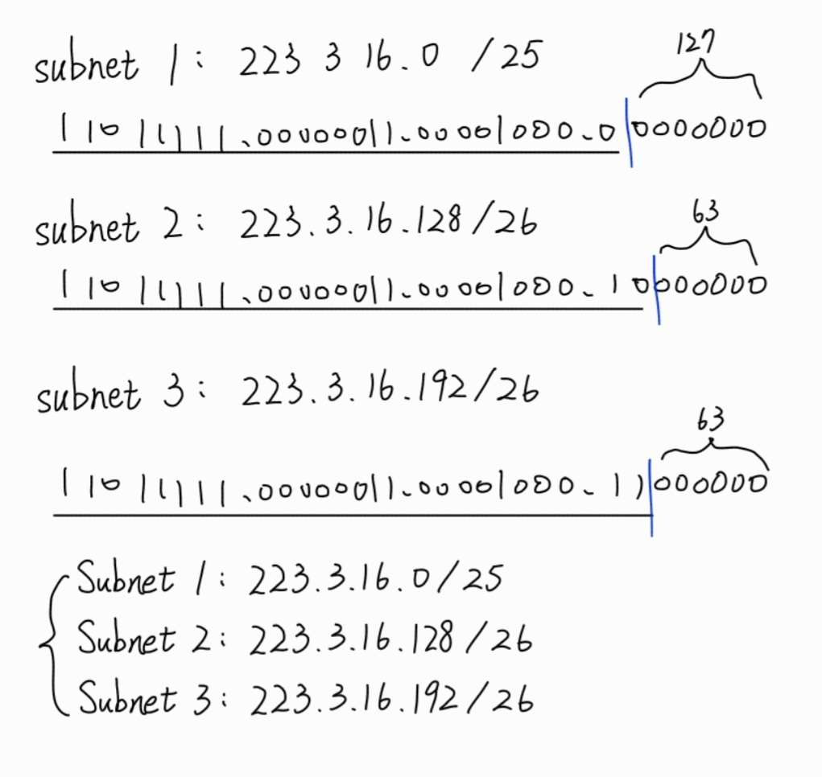

1. What is a private network address?

Should a datagram with a private network address ever be present in the larger public Internet, why or why not?

A: 1. 在NAT設備或路由器下內網中使用的IP地址。

2. 內網的IP地址不應該出現在公用網路中，它們會在各自的私有網路中使用。

1. (a) Explain the tunneling technique used for the IPv4-to-IPv6 transition.

(b) Do you agree with the following statement: when IPv6 tunnels through IPv4 router, IPv6 treats the IPv4 tunnels a link-layer protocols?

A: (a)將IPv6的資料封裝在IPv4的內容中，經過IPv4路由器時，能由IPv4 Header知道要傳往哪裡，進而

將資料傳送至正確的IPv6位置。

(b)同意，在資料傳輸過程中的行為類似於連結層的功用，因為IPv6被封裝進IPv4中進行傳輸。

1. What is the meaning of “match plus action” operation of a router or switch?

In the case of destination-based forwarding packet switch, what is matched and what is the action taken? In the case of an SDN, name 2 fields that can be matched and 2 actions that can be taken.

A:

1. 路由器或交換器會根據封包的Header做解析，並將封包傳送至指定的接口或者做其他操作。

2. 交換器由封包Header提供的目的端IP去匹配，做接口轉發。

3. 在SDN中可以有很多字段去匹配，像是source IP address、TCP source port、Ethernet type、

VLAN Priority ……等等，可以轉發、刪除或修改封包內容。