**資工三 109590004 呂育瑋 計算機網路 Homework 5**

1. True or false: When an OSPF router sends its link information, it is sent only to those nodes directly attached neighbors. Explain the reason.

A: False，OSPF router sends its link information to all other routers, not only to those nodes directly attached neighbors.

1. Will a BGP router always choose the loop-free route with the shortest AS path length? State your reason.

A: No，BGP router還會考量其他因素如origin code, local preference, MED來確保最好的路由選擇。

1. It is preferable to send SNMP messages in unreliable UDP datagram. Why do you think the designers of NMP chose UDP rather than TCP as the transport protocol of choice for SNMP?

A: 為了做到分布式管理以及多種大量資料傳輸的效率，UDP能在SNMP條件下正常運作。

1. Use the Dijkstra's link-state algorithm to find the least-cost paths from Node 1 to all other nodes of the following graph. The number above each link is the associated cost of the link. Show your results step by step.

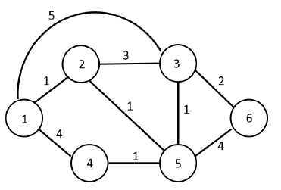

A:

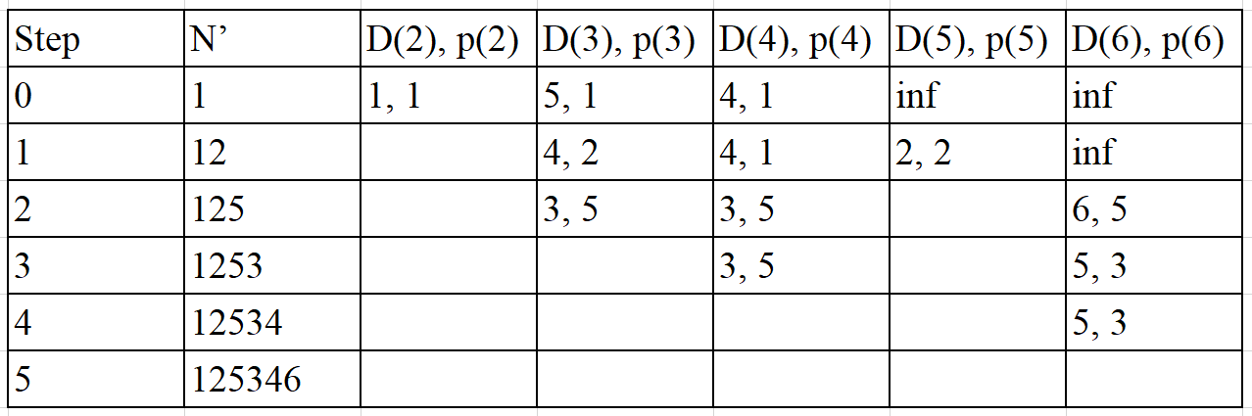

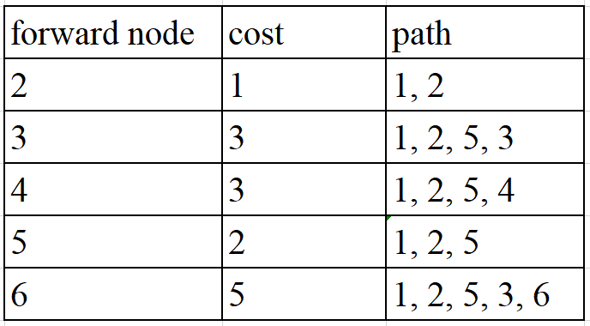

1. Consider the network fragment shown below. x has only two attached neighbors, w and y. w has a minimum-cost path to destination u (not shown) of 5, and y has a minimum-cost path to u of 6. The complete paths from w and y to u (and between w and y) are not shown. Assume all link costs have strictly positive integer values.

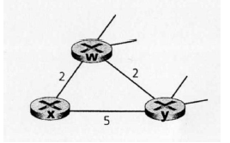

a. Give x’s distance vector for destinations w, y and u.

b. Discuss the condition where a link-cost change for either c(x,w) or c(x,y) will trigger x

to inform its neighbors of a new minimum-cost path to u after executing the distance-

vector algorithm.

A: a. Dx(w) = 2, Dx(y) = 4, Dx(u) = 7

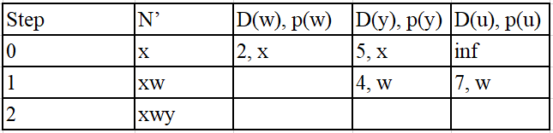

b.

當c(x, y)變更

如果 c(x, y) < 1 則路徑改由 x → y → u, cost = c(x, y) + 6

如果 c(x, y) >= 1 則路徑不變 cost = 7

當c(x, y)變更

如果 c(x, y) <= 6 則路徑不變 cost = 7

如果 c(x, y) > 6 則路徑改由 x → y → u, cost = 11