**資工三 109590004 呂育瑋 計算機網路 Homework 6**

1. If all the links in the Internet were to provide reliable delivery service, would the TCP reliable delivery service be redundant? Why or why not?

A: 雖然每條link都能夠確認單筆資料是否遺失、正常被接收，但卻無

法確保多筆資料傳輸順序正確，TCP能夠偵測並處理不正確順序的

資料傳輸，因此TCP的服務並非是多餘的。

1. Why is an ARP query sent within a broadcast frame? Why is an ARP

response sent within a frame with a specific destination MAC address?

A: 當ARP 表格中沒有該 IP 位址的實體位址時，會發送一個全為

1(FFFF.FFFF.FFFF)的目標實體位置廣播，給所有在LAN上的設備，找尋擁有請求中的目標IP位址。而ARP請求中IP位置相同的設備，會回傳他的實體位址，因為在ARP請求中已有Source IP，可以做為ARP回應的Destination IP，故只需要回應給發送端的Frame即可，其中包含設備的實體位址。

1. In CSMA/CD, after the fifth collision, what is the probability that a node

chooses *K* = 4? The result *K* = 4 corresponds to a delay of how many seconds on a 10 Mbps Ethernet?

A: 第五次碰撞時，NIC會從{0 ~ 2^5-1} = {0, 1, 2, …, 31}中選擇，選擇

到4的機率是 4/32 = 1/8。在10 Mbps Ethernet的bit time = 1/10M = 0.1

micro second，delay time = 4*512*0.1 = 204.8 micro second。

4. Consider the CRC code. If the generator, G=1001, and suppose that D has

the value of 11010111011. What is the value of R=? What is the actual bit

pattern sent by the transmitter.?

A: R = 101, sent bits = 11010111011101

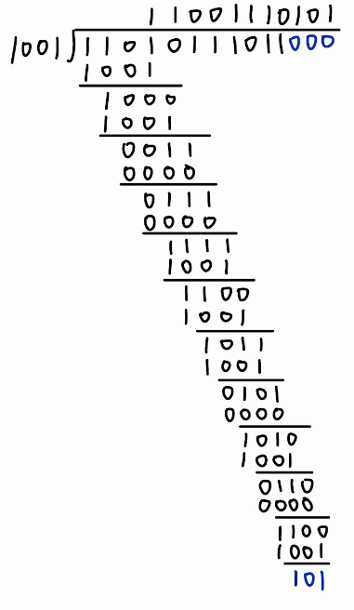

1. In the textbook, we provided an outline of the derivation of the efficiency

of slotted ALOHA. In this problem we’ll complete the derivation.

a. Recall that when there are *N* active nodes, the efficiency of slotted ALOHA is *Np*(1 - *p*)*N*-1. Find the value of *p* that maximizes this expression.

b. Using the value of *p* found in (a), find the efficiency of slotted ALOHA by letting *N* approach infinity. *Hint*: (1 — 1/*N* )*N* approaches l/*e* as *N* approaches infinity.

