計算機網路 Lab1 資工三 109590004 呂育瑋

_______________________________________________________________________________________

Q1.

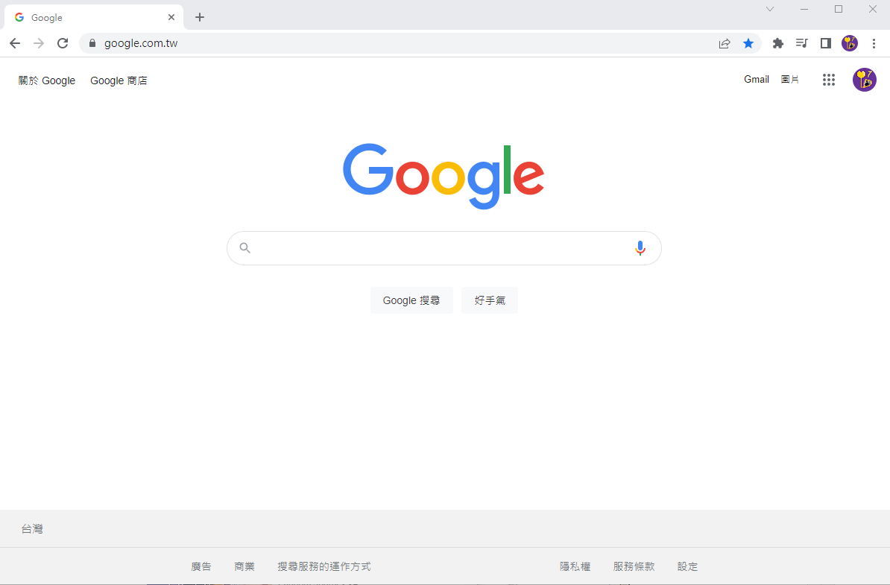

_______________________________________________________________________________________

Q2.

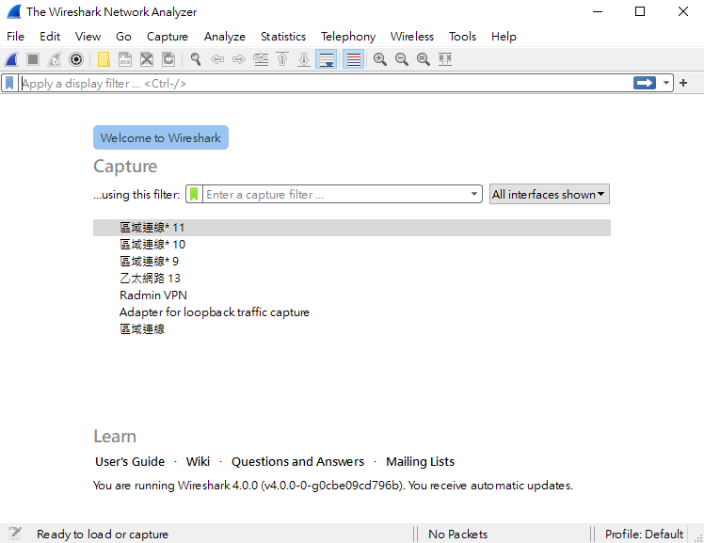

_______________________________________________________________________________________

Q3.

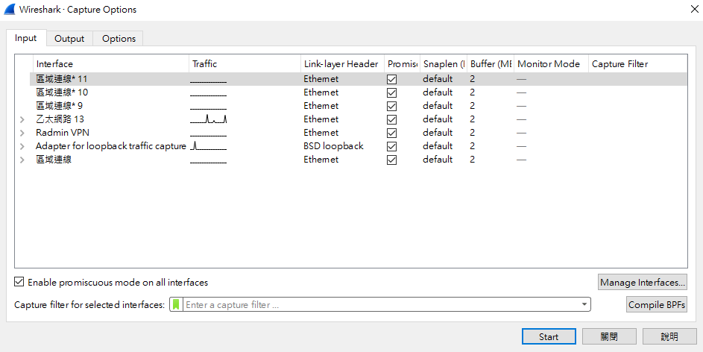

_______________________________________________________________________________________

Q4.

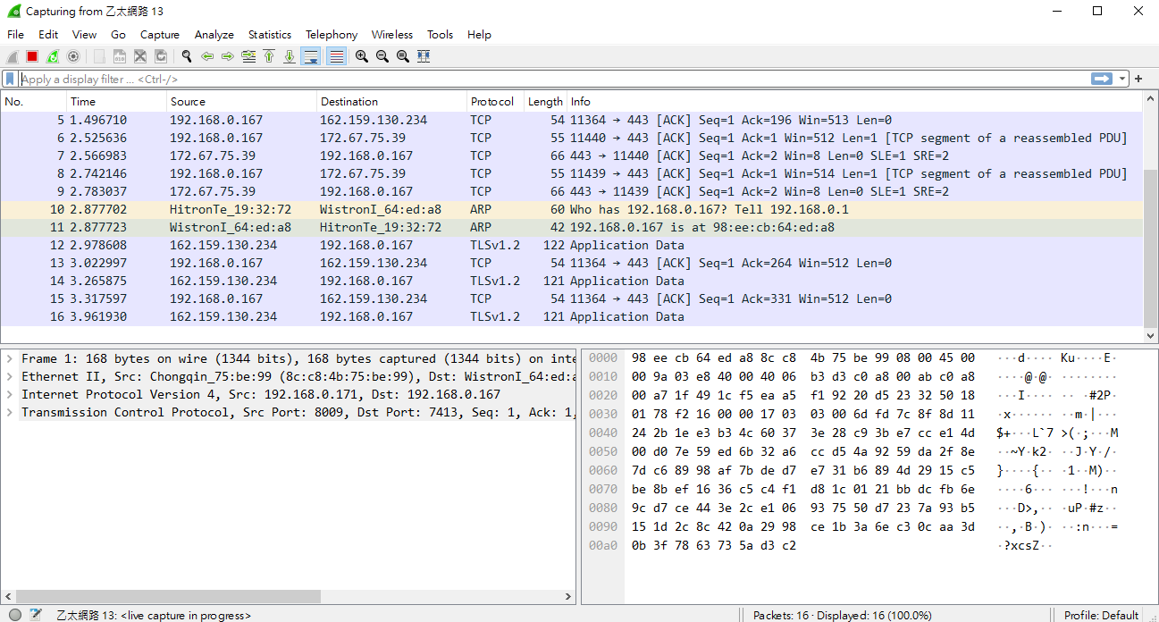

_______________________________________________________________________________________

Q5 ~ Q6.



_______________________________________________________________________________________

Q7 ~ Q9.

