計算機網路 Lab2 資工三 109590004 呂育瑋

_______________________________________________________________________________________

Q1. What is the IP address of your computer?

A: Client IP address: 192.168.48.90

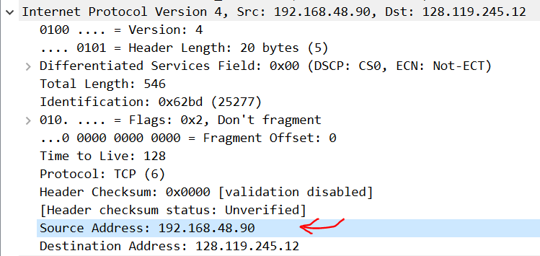 HTTP GET packet

_______________________________________________________________________________________

Q2. What is the IP address of the server?

A: Server IP address: 128.119.245.12

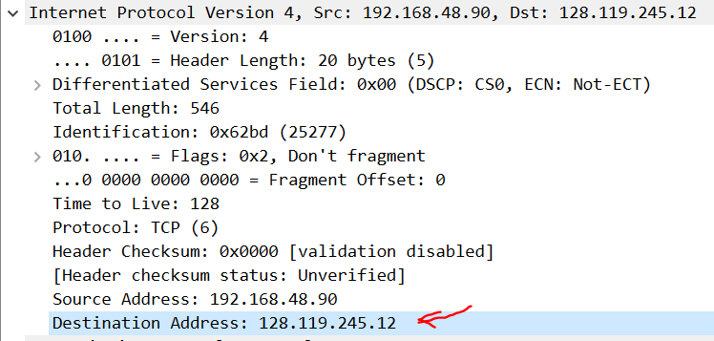 HTTP GET packet

_______________________________________________________________________________________

Q3. What version of HTTP are your browser and the server running?

A: Version: HTTP/1.1

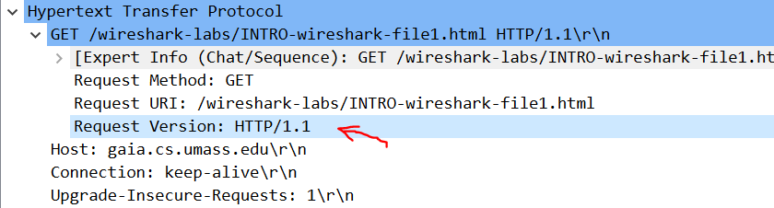 HTTP GET packet

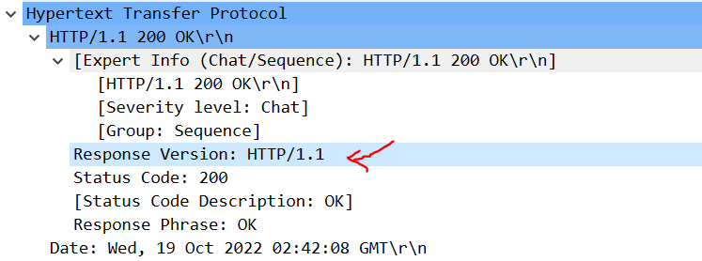 Response packet _______________________________________________________________________________________

Q4. What languages does your browser indicate that it can accept to the server?

A: zh-TW, zh; q = 0.9, en-US; q = 0.8, en; q = 0.7, zh-CN; q = 0.6

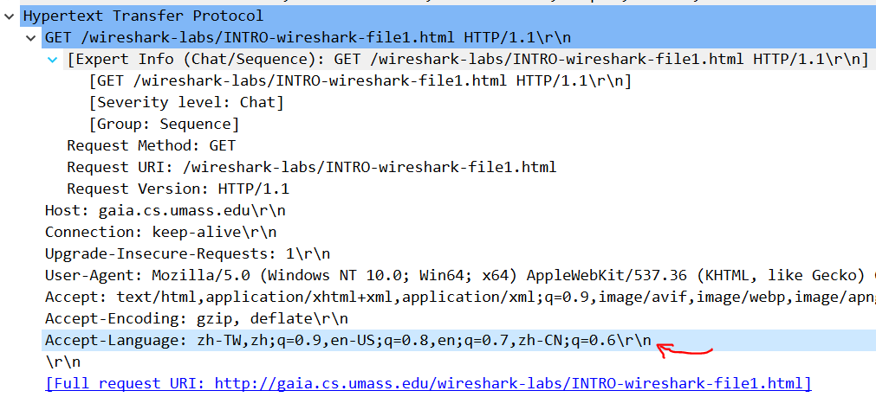

_______________________________________________________________________________________

Q5. What is the status code for the first response message?

A: Status code: 200

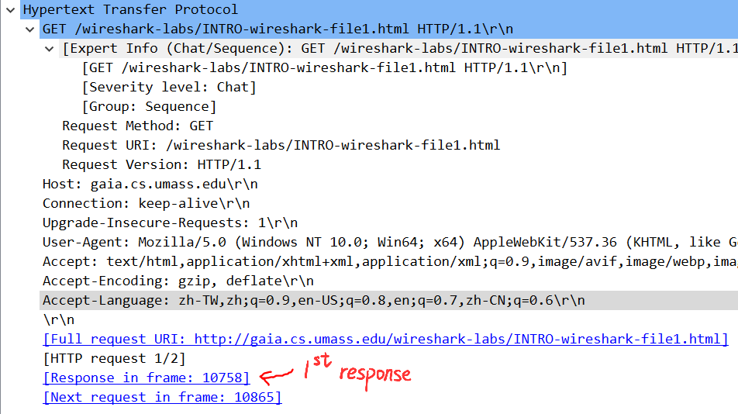 HTTP GET packet

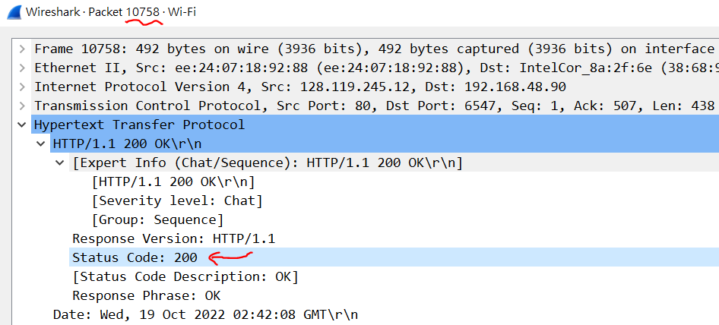 1st response packet