計算機網路 Lab3 資工三 109590004 呂育瑋

_______________________________________________________________________________________

Q1. What is the host name?

A: DESKTOP-H8O0JIR

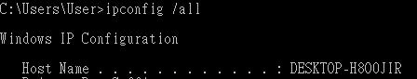

_______________________________________________________________________________________

Q2. What is the physical (data-link) address?

A: 98-EE-CB-64-ED-A8

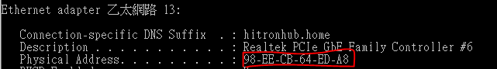

_______________________________________________________________________________________

Q3. What is the IP address?

A: 192.168.0.167



_______________________________________________________________________________________

Q4. What is the IP address of the default gateway?

A: 192.168.0.1



_______________________________________________________________________________________

Q5. Locate the DNS query and response messages for the Web

page:www.ntut.edu.tw. Are they sent over UDP or TCP?

A: UDP

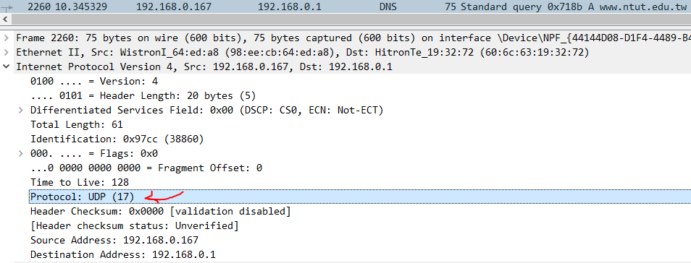

_______________________________________________________________________________________

Q6. What is the destination port for the DNS query message? What is the source port of DNS response message?

A: DNS query message destination port: 53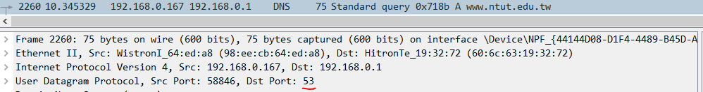

A: DNS response message source port: 53

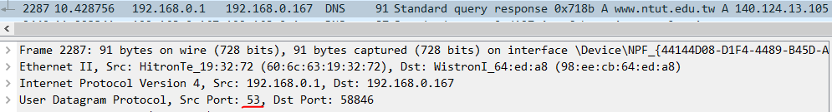

_______________________________________________________________________________________

Q7. To what IP address is the DNS query message sent? Use ipconfig to determine the IP address of your local DNS server. Are these two IP addresses the same?

A: 192.168.0.1, same as my local DNS server



_______________________________________________________________________________________

Q8. Examine the DNS response message. How many “answers” are provided? What do each of these answers contain?

A: 1 answer

