計算機網路 Lab4 資工三 109590004 呂育瑋

_______________________________________________________________________________________

Q1. What is the IP address and TCP port number used by the client computer?

A: client computer IP: 192.168.0.167 Port: 4368

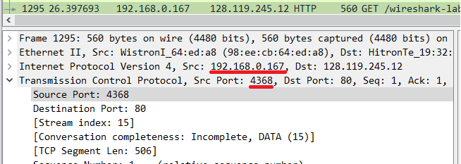

_______________________________________________________________________________________

Q2. What is the sequence number of the TCP SYN segment that is used to initiate the TCP connection between the client computer and server? What is the value in the segment that identifies the segment as a SYN segment?

A: Sequence number: 0, SYN segment value: Syn: Set (1)

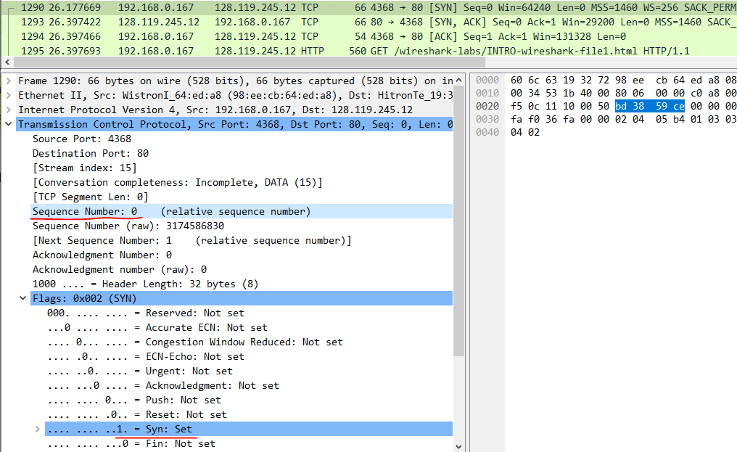

_______________________________________________________________________________________

Q3. What is the value of the ACKnowledgement field in the SYNACK segment? How did server determine that value?

A: ACKnowledgement value: 1, ACKnowledgement value = Sequence number + 1 = 0 + 1 = 1

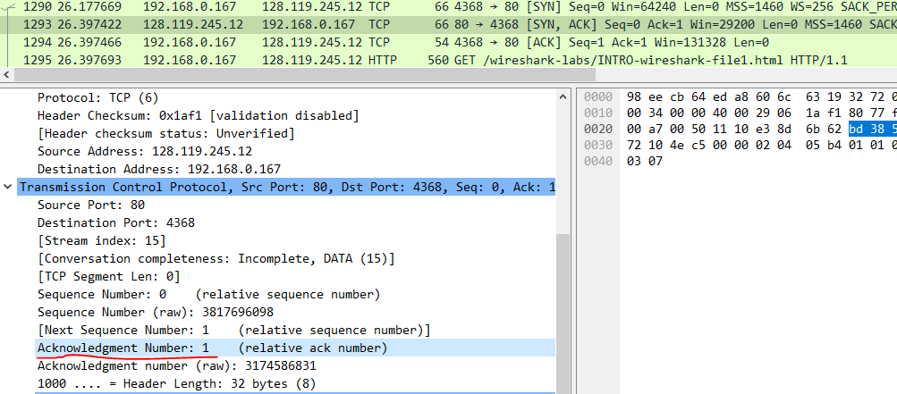

_______________________________________________________________________________________

Q4. What is the amount of available buffer space advertised at the web server for the connection?

A: 29200 bytes

