資工三 109590004 呂育瑋

_______________________________________________________________________________________

Q1.

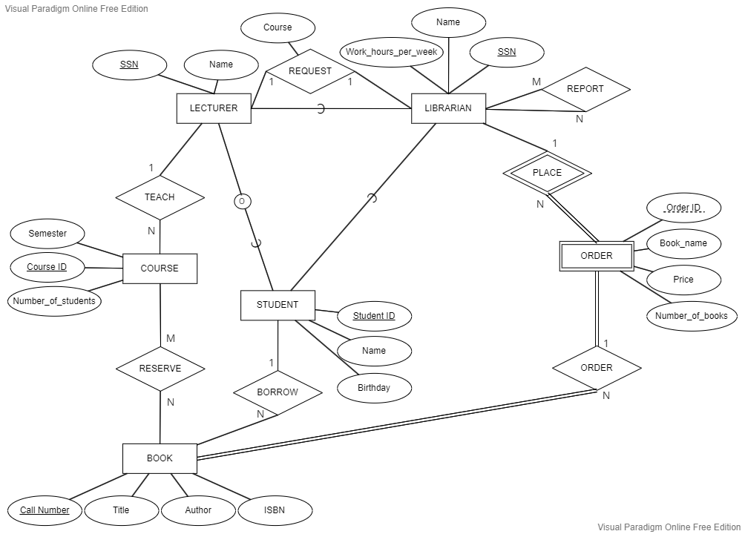

_______________________________________________________________________________________

Q2.

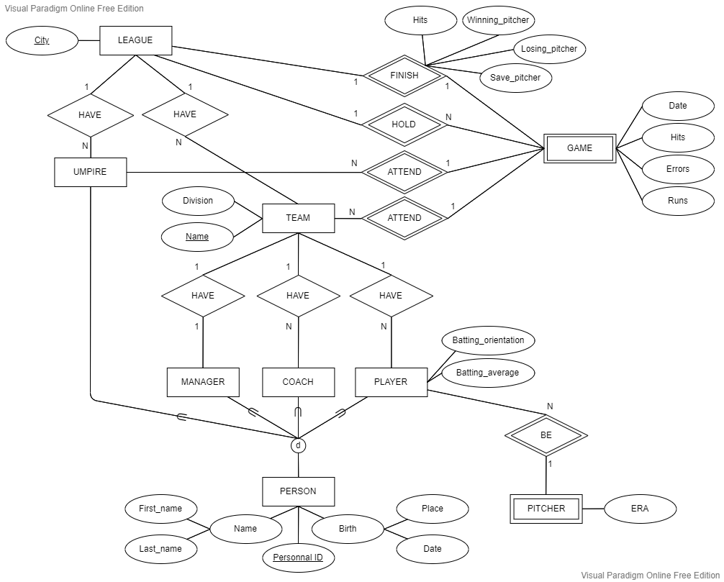

_______________________________________________________________________________________

Q3(a).

沒有任何錯誤

Q3(b).

Insert tuple中Dnum為2的Department不存在，解決方式為新建一個Department其Dnum為2且合理tuple；或拒絕這個Insert operate。

Q3(c).

沒有任何錯誤

Q3(d).

Delete tuple中的Pnumber一旦刪除，會影響到Works_on的表格中reference Pno = 1的 tuple，需要將Works_on Pno = 1的tuple都Delete來避免問題產生；或者拒絕這個Delete operate。

Q3(e).

違反referential integrity，Employee中並不存在於super_ssn = 943775543的employee，需要Insert一個ssn為943775543的tuple來避免問題產生；或者拒絕這個Modify operate。

Q3(f).

沒有任何錯誤(CASCADE)

_______________________________________________________________________________________

Q4.

