資工三 109590004 呂育瑋

_______________________________________________________________________________________

Q1(a).

UPDATE COURSE

SET CreditHour = 3

WHERE CourseName = 'Database Systems'

AND Department = 'EECS';

_______________________________________________________________________________________

Q1(b).

DELETE FROM STUDENT

WHERE `Name` = 'Edward'

AND StudentNumber = '001';

_______________________________________________________________________________________

Q1(c).

SELECT CourseName

FROM COURSE

WHERE CourseNumber IN (

SELECT CourseNumber

FROM SECTION

WHERE Instructor = 'Liu'

AND `Year` IN (2020, 2022)

);

_______________________________________________________________________________________

Q1(d).

SELECT CourseNumber, Semester, `Year`, COUNT(*) AS Students

FROM SECTION AS SEC

INNER JOIN GRADE_REPORT AS GR USING(SectionNumber)

WHERE Instructor = 'Liu'

GROUP BY CourseNumber, Semester, `Year`;

_______________________________________________________________________________________

Q1(e).

SELECT PREREQUISITE.PrerequisiteCourseNumber, PRECOURSE.CourseName AS PrerequisiteCourseName

FROM COURSE

INNER JOIN PREREQUISITE USING(CourseNumber)

INNER JOIN COURSE AS PRECOURSE

ON PREREQUISITE.PrerequisiteCourseNumber = PRECOURSE.CourseNumber

WHERE COURSE.CourseName = 'Web Programming'

AND COURSE.Department = 'EECS';

_______________________________________________________________________________________

Q1(f).

SELECT `Name`, COURSE.CourseNumber, CourseName, CreditHour, Semester, `Year`, Grade

FROM STUDENT

INNER JOIN GRADE_REPORT USING(StudentNumber)

INNER JOIN SECTION USING(SectionNumber)

INNER JOIN COURSE USING(CourseNumber)

WHERE Class = 3;

_______________________________________________________________________________________

Q1(g).

SELECT `Name`

FROM STUDENT

WHERE StudentNumber IN (

SELECT StudentNumber

FROM GRADE_REPORT

WHERE

Grade >= 80

);

_______________________________________________________________________________________

Q1(h).

SELECT `Name`, Major

FROM STUDENT AS ST

WHERE NOT EXISTS (

SELECT StudentNumber

FROM GRADE_REPORT AS GR

WHERE ST.StudentNumber = GR.StudentNumber

AND Grade < 60

);

_______________________________________________________________________________________

Q1(i).

SELECT `Name`, Major

FROM STUDENT AS ST

WHERE EXISTS (

SELECT StudentNumber

FROM GRADE_REPORT AS GR

WHERE ST.StudentNumber = GR.StudentNumber

AND Grade < 60

)

ORDER BY ST.StudentNumber ASC;

_______________________________________________________________________________________

Q1(j).

SELECT `Name`, AVG(Grade) as AverageGrade

FROM GRADE_REPORT AS GR

INNER JOIN STUDENT AS ST USING(StudentNumber)

INNER JOIN SECTION AS SEC USING(SectionNumber)

WHERE `Year` = 2022

GROUP BY ST.StudentNumber HAVING AverageGrade > 80;

_______________________________________________________________________________________

Q1(k).

SELECT Major, COUNT(*)

FROM (

SELECT Major, AVG(Grade) AS AverageGrade

FROM GRADE_REPORT AS GR

INNER JOIN STUDENT AS ST USING(StudentNumber)

GROUP BY Major, ST.StudentNumber HAVING AverageGrade < 60

) AVGTABLE

GROUP BY Major;

_______________________________________________________________________________________

Q1(l).

CREATE VIEW STUDENT_INFO_VIEW

AS

SELECT StudentNumber, `Name`, CourseName, Semester, `Year`, Grade

FROM STUDENT

INNER JOIN GRADE_REPORT USING(StudentNumber)

INNER JOIN SECTION USING(SectionNumber)

INNER JOIN COURSE USING(CourseNumber);

_______________________________________________________________________________________

Q2(a).

CREATE TABLE STUDENT

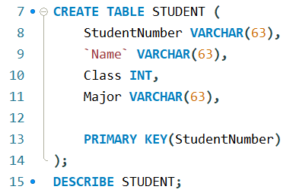

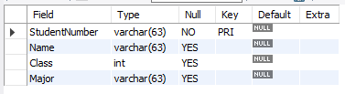

CREATE TABLE COURSE

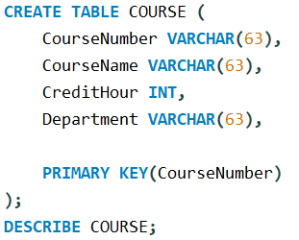

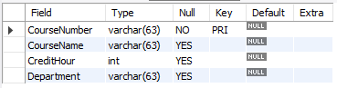

CREATE TABLE SECTION

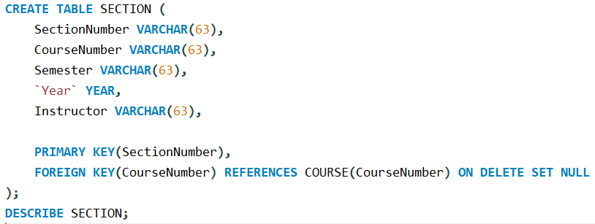

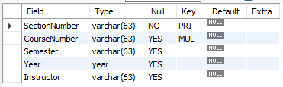

CREATE TABLE GRADE_REPORT

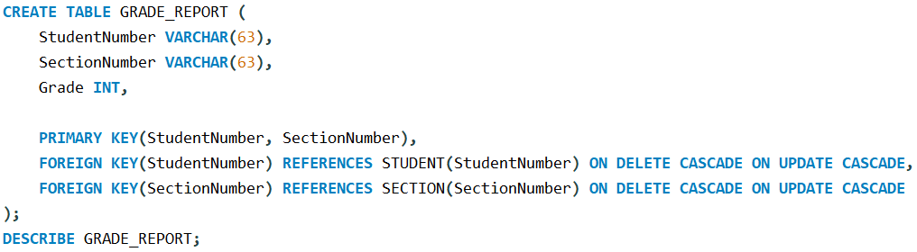

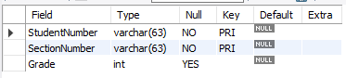

CREATE TABLE PREREQUISITE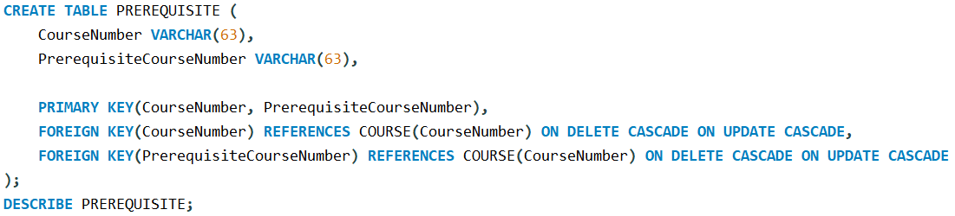

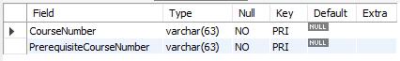

_______________________________________________________________________________________

Q2(b).

INSERT INTO STUDENT

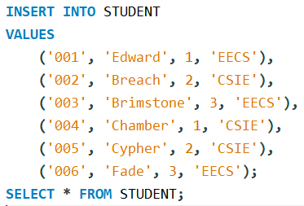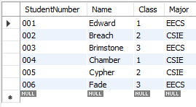

INSERT INTO COURSE

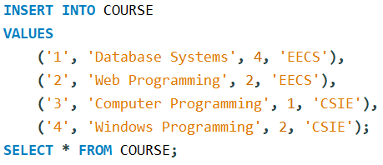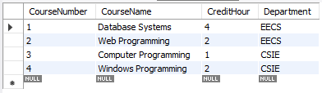

INSERT INTO SECTION

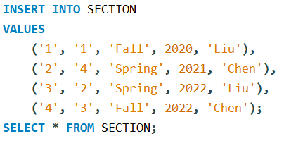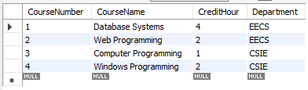

INSERT INTO GRADE_REPORT

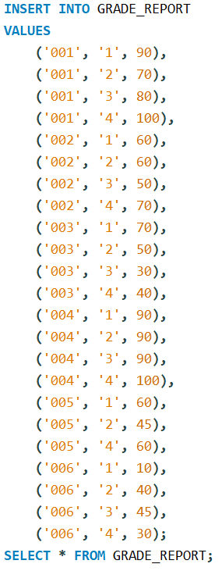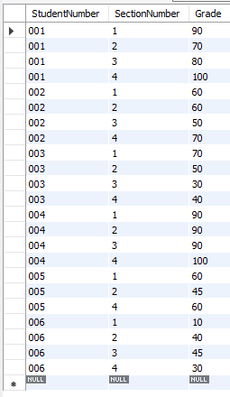

INSERT INTO PREREQUISITE

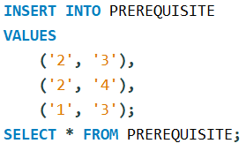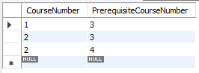

_______________________________________________________________________________________

Q2(c).

1(a)

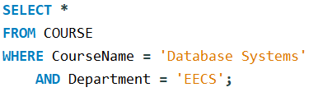



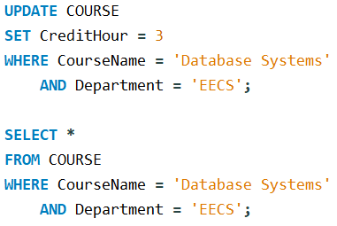



1(b)



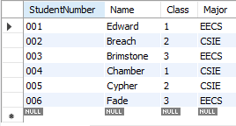

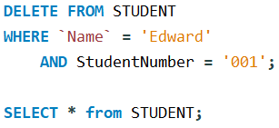

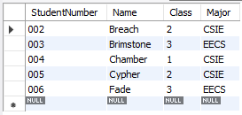

1(c)

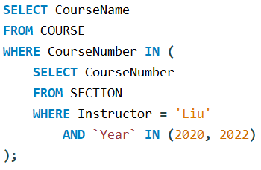

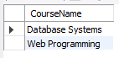

1(d)

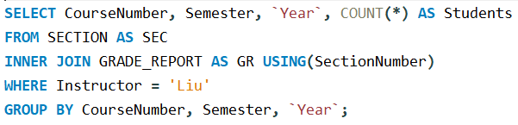

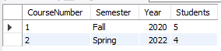

1(e)

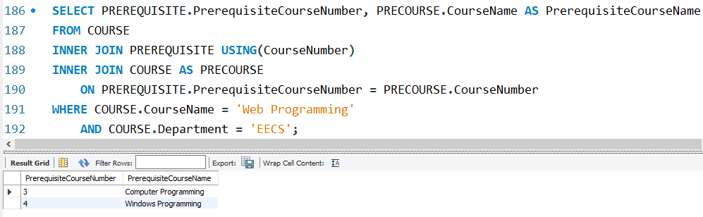

1(f)

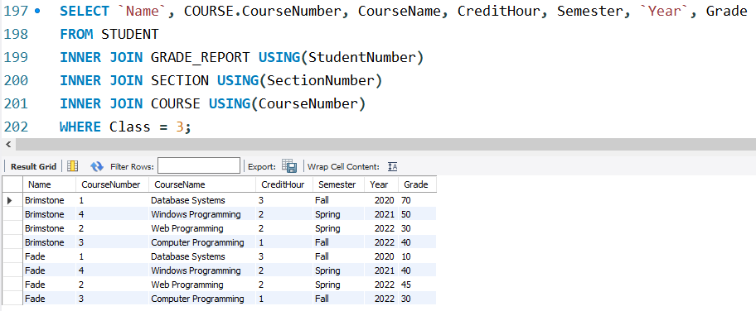

1(g)

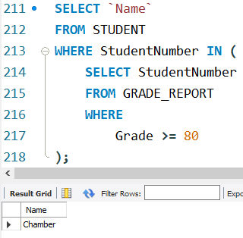

1(h)

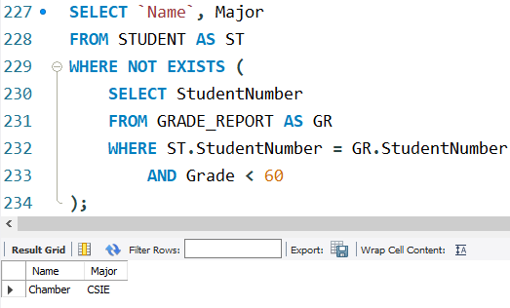

1(i)

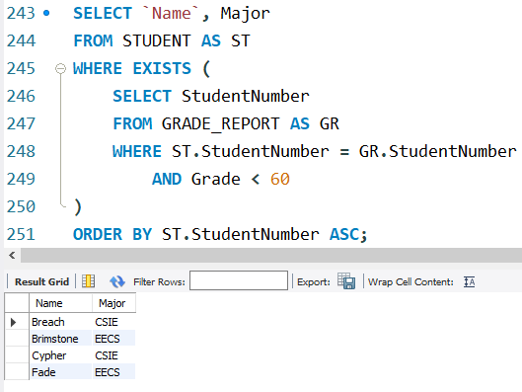

1(j)

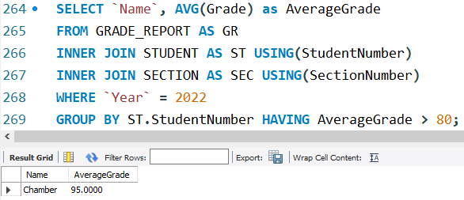

1(k)

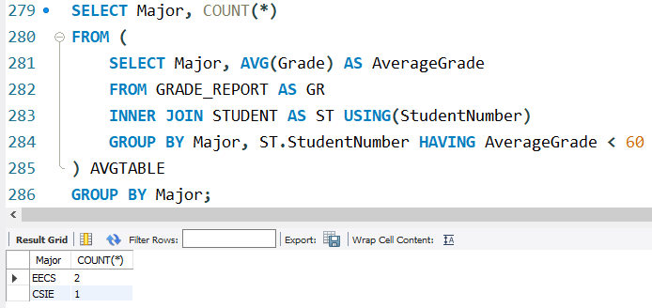

1(l)

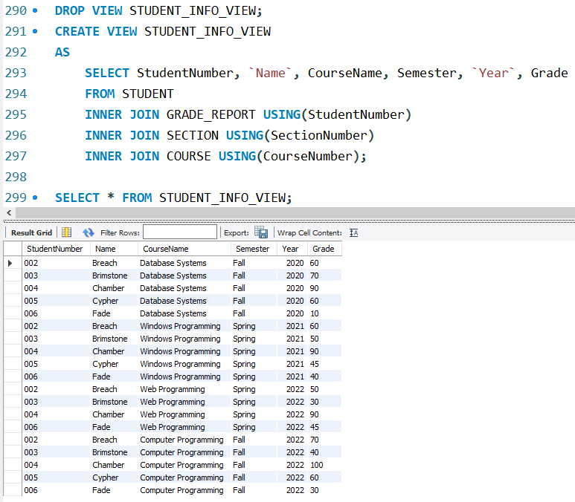

_______________________________________________________________________________________

Q2(d).

