**Lecture 2- Thinking Like an Economist**

Dear Students,

Lecture 1 introduced us to ten principles of economics that will be revisited throughout the semester. Lecture 2 explores how economists approach economic problems. We will examine how economists employ the scientific method, the role of assumptions in model building but the main focus of this chapter will be on the application of two specific economic models: Circular Flow Model and Production Possibilities Frontier (or Production Possibilities Curve).

**The Economist as Scientist**

While we often think of scientists as those working in laboratories with microscopes and test tubes. It's important to recognize that economists, too, address their subject with a scientist’s objectivity. This approach allows them to develop and test theories (or models) about how economies function, much like scientists in other fields.

The starting point for any scientific inquiry, including economics, is **observation.** Economists observe real-world events, trends, and behaviors. For instance, they might note trends in consumer spending, or the impact of policy changes on economic growth. These observations are crucial because they form the basis for developing hypotheses and theories. For example, an economist might observe that increases in the minimum wage seem to coincide with higher levels of unemployment among teenagers. This observation could lead to a theory about the relationship between minimum wage and employment levels.

Once a theory is developed, the next step is to **collect data** that can be analyzed to test this theory. Economists collect a wide range of data, from inflation rates to detailed consumer behavior surveys. They use econometric models to analyze this data, looking for patterns that support or not their theories. For example, if an economist's theory suggests that tax cuts should stimulate economic growth, they will analyze data from periods following tax cuts to see if there is a corresponding increase in economic activity.

However, applying the scientific method in economics comes with challenges. Unlike physical scientists, economists cannot conduct controlled experiments in a laboratory setting. They cannot, for example, randomly assign different tax rates to different countries to see which policy works best. Instead, economists must work with the data that are historically available (which often means dealing with incomplete or imperfect information). Given the constraints on generating new data, economists place great importance on the real-world situations provided by history where external factors have created conditions similar to a controlled experiment. Historical events such as the Great Depression, the oil shocks of the 1970s, or the financial crisis of 2008 offer data that help economists understand how different factors influence economic outcomes. By analyzing these historical data, economists can understand cause-and-effect relationships that are otherwise difficult to isolate.

**The Role of Assumptions**

Assumptions are crucial tools that help economists create models and theories that can be more easily understood and analyzed. When economists analyze complex economic problems, they often start by making certain assumptions. These assumptions simplify reality, allowing economists to focus on the most important elements of an issue without getting overwhelmed by every possible variable. For example, let's consider the study of international trade. Imagine trying to understand trade dynamics involving hundreds of countries and thousands of goods. This would be an overwhelming task with countless variables to consider. Instead, economists often begin with a simplified model: They assume that there are only 2 countries in the world and that these 2 countries produce only 2 goods. We will see this simplified model in the next chapter. By using this simplified scenario, economists can more easily analyze the fundamental principles of trade, such as comparative advantage, opportunity cost, and the benefits of specialization and trade. Once these basic principles are understood in a simplified model, the analysis can be extended to more complex and realistic scenarios involving multiple countries and goods.

**Economic Model**

A model is a simplified description of reality. To understand this, think of a road map. The road map (or GPS) does not show where all of the stop signs, gas stations, or restaurants are located. It assumes that the earth is flat and two-dimensional. But, despite these simplifications, a map usually helps travelers get from one place to another. Thus, it is a good model. As we mentioned above assumptions play a crucial role in model building. The primary goal of any economic model is to simplify reality. Real-world economies are incredibly complex, with various variables interacting in many ways. By focusing on the most critical aspects and ignoring less relevant details, models make it possible to analyze these interactions systematically. This simplification is where the use of assumptions becomes valuable.

Economic models typically consist of diagrams and equations. **Diagrams** are visual tools that help illustrate concepts and relationships. For example, supply and demand curves graphically represent how the quantity of a good supplied and demanded changes with price. **Equations** provide a mathematical framework to quantify economic relationships. They allow for precise calculations and predictions. For instance, an equation might express the relationship between consumer income and spending, helping to forecast changes in consumption behaviour in response to income fluctuations.

Our First Model: **The Circular Flow Diagram** (Figure below)

This diagram is a very simple visual model of how the economy is organized. In this model there are

**two participants** (decision makers)-households and firms and

**two markets**- the market for goods and services and the market for factors of production.

Households and firms interact in the two markets. Firms are sellers in the market for goods and services and buyers in the market for factors of production. Households are buyers in the market for goods and services and sellers in the market for factors of production.

These interactions are shown through the two flows:

**The inner flow** represents the flows of inputs and outputs between households and firms. In the market of factors of production, households provide the inputs (land, labor, capital) that firms use to produce goods and services (output) that is sold in the market of goods and services, bought by the households.

**The outer flow** represents the flows of dollars between households and firms. Firms use some of the revenue from the sales of goods and services to pay wages and rent for the factors of production (inputs-land, labor, capital) to the households. Households use that money to buy goods and services and the process starts over. The money that households pay for goods and services is revenue for the firms.

As we can see, the circular Flow Model gives a basic understanding of how the economy operates and how buyers and sellers interact with each other. In reality, the economy involves more players and activities, including the government, financial institutions, and international trade. However, the Circular Flow Model provides a foundational understanding of how money and resources move through an economy, which can then be expanded to include these additional complexities.

In conclusion, we can say that the circular flow model is based on the assumption that there are only two participants (households and firms), leaving out the government. Additionally, household spend all their income to buy goods and services (Income=Expenditure), ignoring taxes and savings.

Example: Iris spends $40 for a haircut.

Identify the part of the model that corresponds to the flow of goods and services and the flow of dollars for the above activity.

Iris represents the Household sector spends money on a service (a haircut in the market of goods and services)-Buyer

Hair Salon represents the Firm sector provides the service in the market of goods and services (Seller)

Flow of dollars (outer flow) from Iris (Household) to the Hair Salon (Firm) through the market of goods and services.

Flow of goods and services (inner flow) from Firm (providing a haircut) to Iris (Household) through the market of goods and services.

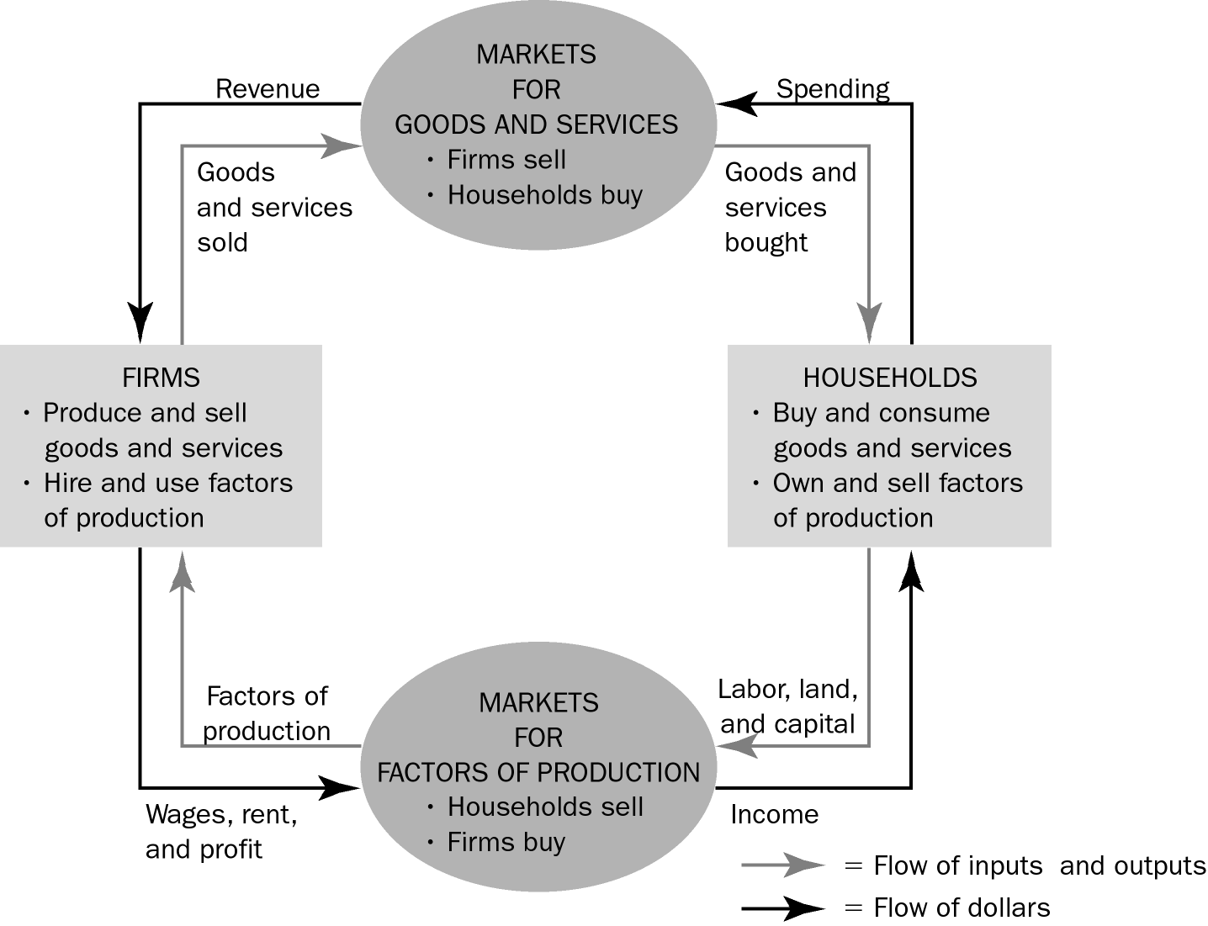

**Second Model: The Production Possibilities Frontier (PPF) or Production Possibilities Curve (PPC)**

**Production Possibilities Frontier (or Curve)** is a graph that shows the combinations of output that the economy can possibly produce given the available factors of production and the available production technology.

This model is based on two assumptions:

A country is producing only two goods

Fixed resources and technology

Let’s assume a country is producing only 2 goods: Military Goods (guns) and Consumer Goods (butter). If this economy uses all its resources to produce military goods, it can produce a maximum of 160 units of military goods (it can be guns) and 0 units of consumer goods (it can be butter). Another possibility can be that the economy uses all the resources to produce consumer goods, in this case it can produce a maximum of 100 billion units of consumer goods and 0 military goods. Other combinations of production lie between the two extremes. Below find the table that shows different combinations of production possibilities for this economy:

|  |  |  |  |  |
| --- | --- | --- | --- | --- |
| Output Combinations | A | B | C | D |
| Military Goods | 160 | 140 | 80 | 0 |
| Consumer Goods | 0 | 40 | 80 | 100 |

Different points show different combinations of output. For example, Combination B shows that when the economy uses all available resources, it produces 140 billion units of military goods and 40 billion units of consumer goods. Combination C shows that when the economy uses all available resources, it produces 80 billion units of military goods and 80 billion units of consumer goods.

We can use the table above to draw the Production Possibilities Frontier (in the figure below). One good is placed in one axis, and the other good in the other axes (military goods on the Y-axis and Consumer Goods on the X-axis). Let’s plot the different points (A, B, C, D) that correspond to different combinations of productions that the country can produce using all available resources, then connect these points. This is how we draw the Production Possibilities Frontier (PPF). All points along the production possibilities frontier are maximum possible combinations of military goods and consumer goods and are **efficient** points since the economy is using all the available resources. If the economy fails to use all the available resources, the result is an **inefficient** point (U). For example, some workers may not find work (unemployment). Such an economy is underproducing (80 billion of military goods and 40 billion of consumer goods) because it is not using all available resources.

The points on the PPF represent the maximum combination of goods that can be produced with the available resources meaning that points outside PPF are impossible combinations. Point Z in the graph represents an **unattainable** point (it is impossible to produce 140 billion units of military goods and 80 billion units of consumer goods because the economy does not have sufficient resources). Society would prefer that combination to any combination along or inside PPF, but the economy cannot reach that point with the available technology and resources.

A movement between any two efficient points on the PPF means that more of one product is being produced only by producing less of the other. For example, if we move from Combination B to Combination C, the country is increasing production of consumer goods from 40 billion to 80 billion units, but at the cost of producing fewer military goods. Military goods production decreases from 140 billion to 80 billion units. To explain this, we need to revisit the concept of scarcity discussed in Chapter one. Scarcity means that society does not have enough resources to produce all the goods and services necessary to satisfy all human wants. As a result, society is always confronted with the problem of making choices. In our example, we have a fixed amount of resources (scarcity), deciding to produce more of one good means sacrificing some production of the other good. We are making the choice to sacrifice one good to increase production of the other.

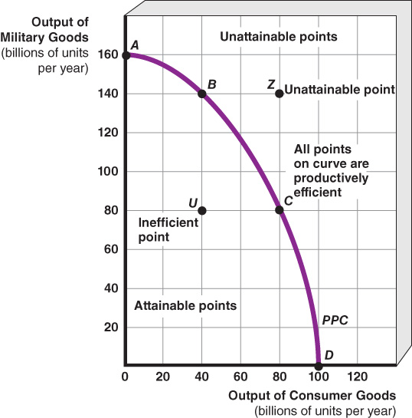

**The Law of Increasing Opportunity Cost**

How can we explain the bowed- out shape of the production possibilities frontier? The table and figure below will help us answer that question.

|  |  |  |  |  |
| --- | --- | --- | --- | --- |
| Output (thousands per year) | A | B | C | D |
| Tanks | 80 | 70 | 50 | 0 |
| Sailboats | 0 | 20 | 40 | 60 |

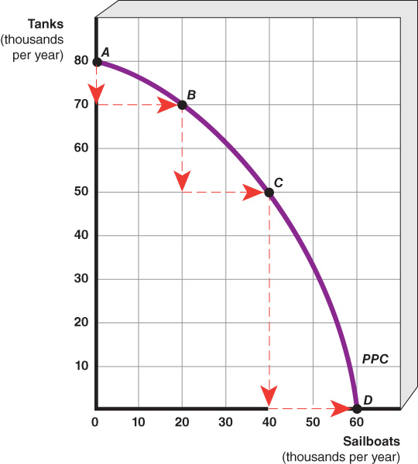

A hypothetical economy produces only tanks and sailboats requiring making a choice between production of these two goods. With available resources, the economy can produce different combinations of sailboats and tanks (combinations A, B, C and D). Consider expanding production of sailboats in 20,000- unit increments.

When moving from point A to point B, the economy increases production of sailboats from 0 to 20,000 units but it must decrease (give up) production of tanks by 10,000 units, from 80,000 to 70,000 units. Thus, the opportunity cost of producing 20, 000 sailboats is **10,000 tanks** (the amount of tanks that had to be sacrificed, given up).

Moving from point B to point C, the opportunity cost of producing an additional 20,000 sailboats is **20,000 tanks**. Moving from C to D, the opportunity cost of producing another 20,000 sailboats is **50,000** tanks.

As demonstrated, our hypothetical economy sacrifices (gives up) increasing amounts of tanks to produce each additional 20,000 sailboats. This occurs because resources, such as workers, are not equally suited to producing both goods. Increasing the production of sailboats requires the use of workers who are less suited to producing sailboats than producing tanks. Initially, the least -skilled tank workers are transferred to making sailboats resulting in a smaller sacrifice of tank production (10,000 tanks are sacrificed -point B). As the economy moves to point C and then D, more highly skilled tank workers are shifted to sailboat production, resulting in a larger and larger reduction in tank production (20,000 tanks-point C, 50,000tanks-point D)

This scenario illustrates the Law of Increasing Opportunity Cost which states that opportunity cost increases as production of one output expands. Under the assumptions that resources and technology are constant (fixed), the law of increasing opportunity cost causes the production possibilities frontier (PPF) to have a bowed-out shape.

Note: If resources could be perfectly substituted and the opportunity cost remains constant, then PPF would be a straight line. This model which will be discussed further when we will cover international trade.

**Production Possibilities Curve and Economic Growth**

Economic growth is the ability of an economy to produce greater levels of output (in other words more goods and services). This is represented by an outward of the production possibilities frontier.

An economy can achieve economic growth through various means including:

1) Gaining **additional resources**. For example: Increasing the labor force through immigration can provide more workers contributing to higher production levels. The discovery of new oil reserves can increase an economy’s energy supply, supporting growth in various industries.

2) Through research and development of **new technologies**. For example, advancements in information technology have improved productivity in sectors such as manufacturing, finance, and healthcare.

3) **Investment** in capital goods. Investment consists of factories, machines (capital as a resource) produced in the present that are used to shift the PPC outward in the future. For example robotics in factories can improve production speed, leading to higher output and lower costs.

Let’s look at the figure below that illustrates how PPF is used to show economic growth.

The economy starts with the capacity to produce combinations along the first production possibilities curve. A technological advance that increases production of both goods shifts the production possibilities curve outward (from the first PPC to the second PPC). Points along the second PPC represent new production possibilities that were previously unattainable (impossible). This outward shift indicates that the economy can now produce greater quantities of output.

For example, instead of producing at combination A, the economy can now produce at combination B (more computers than at point A) or combination C (more pizzas than at point A).

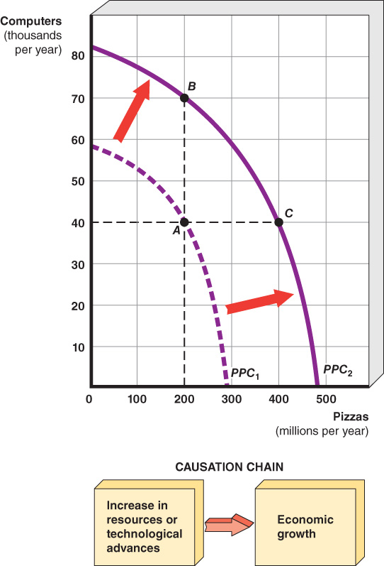

Summary:

Circular Flow Diagram is a basic model that shows how firms and households and firms interact in the market of goods and services and in the market of factors of production

Scarcity limits an economy to points on or below its PPF

An economy can produce more of one good only by producing less of the other good.

Some resources are better suited for producing one good over another is the cause of the Law of Increasing Opportunity Cost which explains the bowed- out shape of the PPF

Economic growth is illustrated by an outward shift of PPF.

I hope you enjoyed the reading.

I have posted additional material to illustrate the key concepts we covered.

Please feel free to email me with any questions or concerns you may have.