2026-05-21 21:11:37.365381: E external/local_xla/xla/stream_executor/cuda/cuda_fft.cc:467] Unable to register cuFFT factory: Attempting to register factory for plugin cuFFT when one has already been registered
WARNING: All log messages before absl::InitializeLog() is called are written to STDERR
E0000 00:00:1779397897.645341 57 cuda_dnn.cc:8579] Unable to register cuDNN factory: Attempting to register factory for plugin cuDNN when one has already been registered
E0000 00:00:1779397897.731293 57 cuda_blas.cc:1407] Unable to register cuBLAS factory: Attempting to register factory for plugin cuBLAS when one has already been registered
W0000 00:00:1779397898.402383 57 computation_placer.cc:177] computation placer already registered. Please check linkage and avoid linking the same target more than once.
W0000 00:00:1779397898.402427 57 computation_placer.cc:177] computation placer already registered. Please check linkage and avoid linking the same target more than once.
W0000 00:00:1779397898.402430 57 computation_placer.cc:177] computation placer already registered. Please check linkage and avoid linking the same target more than once.
W0000 00:00:1779397898.402433 57 computation_placer.cc:177] computation placer already registered. Please check linkage and avoid linking the same target more than once.
2026-05-21 21:12:08.452470: E external/local_xla/xla/stream_executor/cuda/cuda_platform.cc:51] failed call to cuInit: INTERNAL: CUDA error: Failed call to cuInit: UNKNOWN ERROR (303)
Навчання FeedForward (10 нейронів)...
Навчання FeedForward (20 нейронів)...
Навчання Cascade (20 нейронів)...
WARNING:tensorflow:5 out of the last 15 calls to <function TensorFlowTrainer.make_predict_function.<locals>.one_step_on_data_distributed at 0x7f1b502327a0> triggered tf.function retracing. Tracing is expensive and the excessive number of tracings could be due to (1) creating @tf.function repeatedly in a loop, (2) passing tensors with different shapes, (3) passing Python objects instead of tensors. For (1), please define your @tf.function outside of the loop. For (2), @tf.function has reduce_retracing=True option that can avoid unnecessary retracing. For (3), please refer to https://www.tensorflow.org/guide/function#controlling_retracing and https://www.tensorflow.org/api_docs/python/tf/function for more details.
Навчання Cascade (2x10 нейронів)...
WARNING:tensorflow:5 out of the last 15 calls to <function TensorFlowTrainer.make_predict_function.<locals>.one_step_on_data_distributed at 0x7f1b396ccb80> triggered tf.function retracing. Tracing is expensive and the excessive number of tracings could be due to (1) creating @tf.function repeatedly in a loop, (2) passing tensors with different shapes, (3) passing Python objects instead of tensors. For (1), please define your @tf.function outside of the loop. For (2), @tf.function has reduce_retracing=True option that can avoid unnecessary retracing. For (3), please refer to https://www.tensorflow.org/guide/function#controlling_retracing and https://www.tensorflow.org/api_docs/python/tf/function for more details.
Навчання Elman (15 нейронів)...
Навчання Elman (3x5 нейронів)...
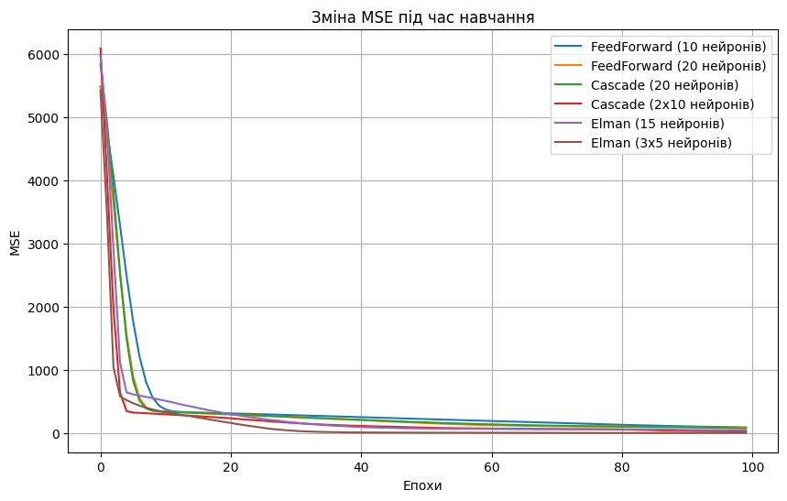
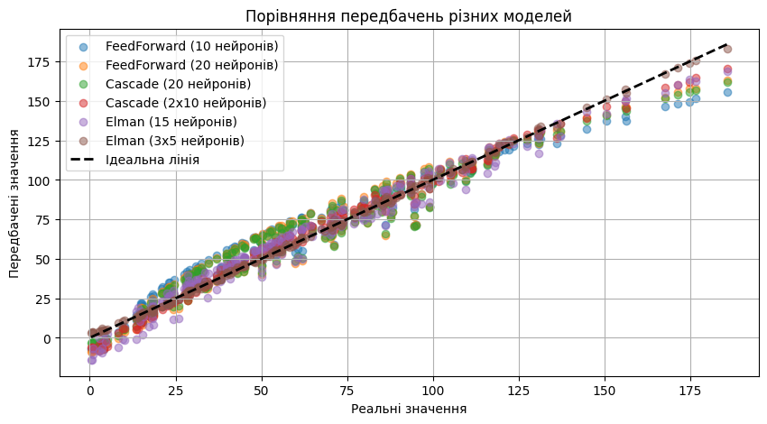
=== Результати дослідження ===
FeedForward (10 нейронів): середня відносна помилка = 0.4946, R² = 0.9426
FeedForward (20 нейронів): середня відносна помилка = 0.5568, R² = 0.9469
Cascade (20 нейронів): середня відносна помилка = 0.3245, R² = 0.9531
Cascade (2x10 нейронів): середня відносна помилка = 0.3844, R² = 0.9865
Elman (15 нейронів): середня відносна помилка = 0.6137, R² = 0.9715
Elman (3x5 нейронів): середня відносна помилка = 0.1198, R² = 0.9989

