Downloading data from https://storage.googleapis.com/tensorflow/tf-keras-datasets/mnist.npz
11490434/11490434 ━━━━━━━━━━━━━━━━━━━━ 0s 0us/step
2026-05-21 23:42:56.369631: E external/local_xla/xla/stream_executor/cuda/cuda_platform.cc:51] failed call to cuInit: INTERNAL: CUDA error: Failed call to cuInit: UNKNOWN ERROR (303)
Початок навчання моделі...
Epoch 1/10
1875/1875 ━━━━━━━━━━━━━━━━━━━━ 9s 4ms/step - accuracy: 0.8746 - loss: 0.4288 - val_accuracy: 0.9540 - val_loss: 0.1522
Epoch 2/10
1875/1875 ━━━━━━━━━━━━━━━━━━━━ 7s 4ms/step - accuracy: 0.9670 - loss: 0.1073 - val_accuracy: 0.9691 - val_loss: 0.0973
Epoch 3/10
1875/1875 ━━━━━━━━━━━━━━━━━━━━ 7s 4ms/step - accuracy: 0.9777 - loss: 0.0713 - val_accuracy: 0.9745 - val_loss: 0.0843
Epoch 4/10
1875/1875 ━━━━━━━━━━━━━━━━━━━━ 7s 4ms/step - accuracy: 0.9832 - loss: 0.0525 - val_accuracy: 0.9761 - val_loss: 0.0811
Epoch 5/10
1875/1875 ━━━━━━━━━━━━━━━━━━━━ 7s 4ms/step - accuracy: 0.9880 - loss: 0.0394 - val_accuracy: 0.9769 - val_loss: 0.0747
Epoch 6/10
1875/1875 ━━━━━━━━━━━━━━━━━━━━ 7s 4ms/step - accuracy: 0.9894 - loss: 0.0317 - val_accuracy: 0.9784 - val_loss: 0.0791
Epoch 7/10
1875/1875 ━━━━━━━━━━━━━━━━━━━━ 7s 4ms/step - accuracy: 0.9912 - loss: 0.0254 - val_accuracy: 0.9790 - val_loss: 0.0789
Epoch 8/10
1875/1875 ━━━━━━━━━━━━━━━━━━━━ 8s 4ms/step - accuracy: 0.9932 - loss: 0.0204 - val_accuracy: 0.9712 - val_loss: 0.1157
Epoch 9/10
1875/1875 ━━━━━━━━━━━━━━━━━━━━ 7s 4ms/step - accuracy: 0.9937 - loss: 0.0186 - val_accuracy: 0.9768 - val_loss: 0.0876
Epoch 10/10
1875/1875 ━━━━━━━━━━━━━━━━━━━━ 7s 4ms/step - accuracy: 0.9944 - loss: 0.0172 - val_accuracy: 0.9791 - val_loss: 0.0942

Точність на тестових даних (Accuracy): 97.91%
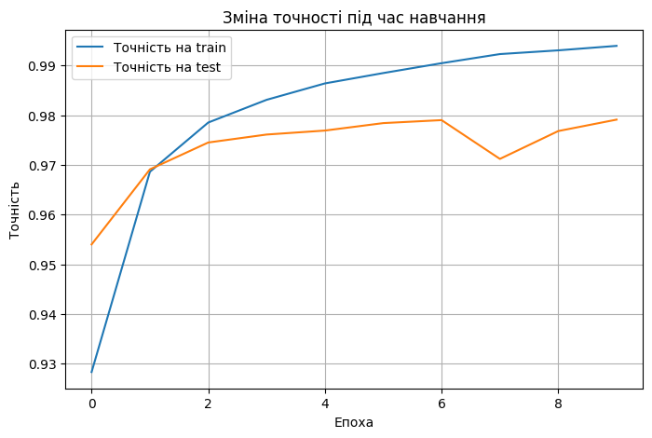
313/313 ━━━━━━━━━━━━━━━━━━━━ 1s 2ms/step
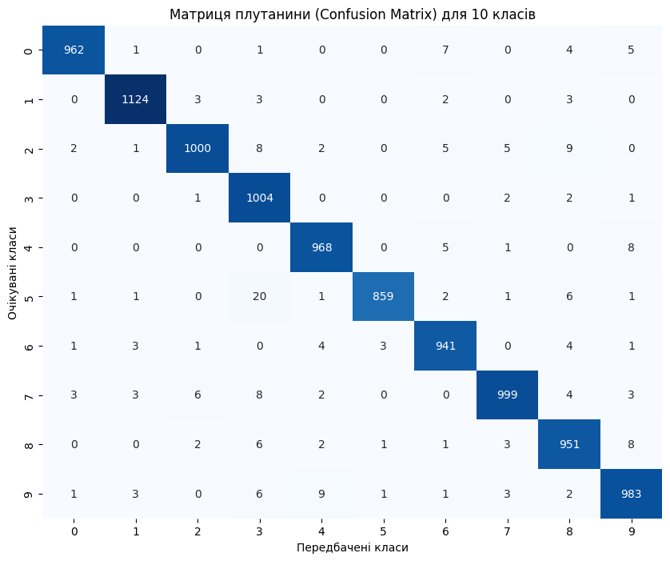
--- Звіт про класифікацію (Precision, Recall, F1-Score) ---
precision recall f1-score support

0 0.9918 0.9816 0.9867 980
1 0.9894 0.9903 0.9899 1135
2 0.9872 0.9690 0.9780 1032
3 0.9508 0.9941 0.9719 1010
4 0.9798 0.9857 0.9827 982
5 0.9942 0.9630 0.9784 892
6 0.9761 0.9823 0.9792 958
7 0.9852 0.9718 0.9785 1028
8 0.9655 0.9764 0.9709 974
9 0.9733 0.9742 0.9737 1009

accuracy 0.9791 10000
macro avg 0.9793 0.9788 0.9790 10000
weighted avg 0.9793 0.9791 0.9791 10000

