Running on Kaggle
Kaggle: датасет знайдено у /kaggle/input/datasets/irustandi/yelp-review-polarity/yelp_review_polarity_csv. Завантаження не потрібне.
Loading Yelp review data...
Successfully loaded 50001 entries.
Cleaning review content...
Text preprocessing complete.
Label distribution:
label
0 26832
1 23169
Name: count, dtype: int64
Splitting dataset into training and test sets...
Train size: 40000, Test size: 10001
Converting text to sequences...
Tokenization and padding completed.
Vocabulary size : 10000
X_train_pad shape: (40000, 100)
X_test_pad shape : (10001, 100)
Constructing LSTM model...
/usr/local/lib/python3.12/dist-packages/keras/src/layers/core/embedding.py:97: UserWarning: Argument `input_length` is deprecated. Just remove it.
warnings.warn(
2026-05-22 23:01:47.761733: E external/local_xla/xla/stream_executor/cuda/cuda_platform.cc:51] failed call to cuInit: INTERNAL: CUDA error: Failed call to cuInit: UNKNOWN ERROR (303)
Model: "sequential"
┏━━━━━━━━━━━━━━━━━━━━━━━━━━━━━━━━━┳━━━━━━━━━━━━━━━━━━━━━━━━┳━━━━━━━━━━━━━━━┓
┃ Layer (type) ┃ Output Shape ┃ Param # ┃
┡━━━━━━━━━━━━━━━━━━━━━━━━━━━━━━━━━╇━━━━━━━━━━━━━━━━━━━━━━━━╇━━━━━━━━━━━━━━━┩
│ embedding (Embedding) │ ? │ 0 (unbuilt) │
├─────────────────────────────────┼────────────────────────┼───────────────┤
│ lstm (LSTM) │ ? │ 0 (unbuilt) │
├─────────────────────────────────┼────────────────────────┼───────────────┤
│ dropout (Dropout) │ ? │ 0 │
├─────────────────────────────────┼────────────────────────┼───────────────┤
│ lstm_1 (LSTM) │ ? │ 0 (unbuilt) │
├─────────────────────────────────┼────────────────────────┼───────────────┤
│ dropout_1 (Dropout) │ ? │ 0 │
├─────────────────────────────────┼────────────────────────┼───────────────┤
│ dense (Dense) │ ? │ 0 (unbuilt) │
├─────────────────────────────────┼────────────────────────┼───────────────┤
│ dense_1 (Dense) │ ? │ 0 (unbuilt) │
└─────────────────────────────────┴────────────────────────┴───────────────┘
Total params: 0 (0.00 B)
Trainable params: 0 (0.00 B)
Non-trainable params: 0 (0.00 B)
Training the model...
Epoch 1/5
625/625 ━━━━━━━━━━━━━━━━━━━━ 135s 209ms/step - accuracy: 0.6220 - loss: 0.6243 - val_accuracy: 0.8917 - val_loss: 0.2727
Epoch 2/5
625/625 ━━━━━━━━━━━━━━━━━━━━ 130s 207ms/step - accuracy: 0.9127 - loss: 0.2443 - val_accuracy: 0.9087 - val_loss: 0.2323
Epoch 3/5
625/625 ━━━━━━━━━━━━━━━━━━━━ 129s 206ms/step - accuracy: 0.9461 - loss: 0.1602 - val_accuracy: 0.9020 - val_loss: 0.2577
Epoch 4/5
625/625 ━━━━━━━━━━━━━━━━━━━━ 129s 207ms/step - accuracy: 0.9625 - loss: 0.1137 - val_accuracy: 0.8996 - val_loss: 0.2969
Epoch 4: early stopping
Restoring model weights from the end of the best epoch: 2.
Evaluating on test data...
313/313 ━━━━━━━━━━━━━━━━━━━━ 16s 52ms/step - accuracy: 0.9130 - loss: 0.2250
Test Set Accuracy: 0.9087
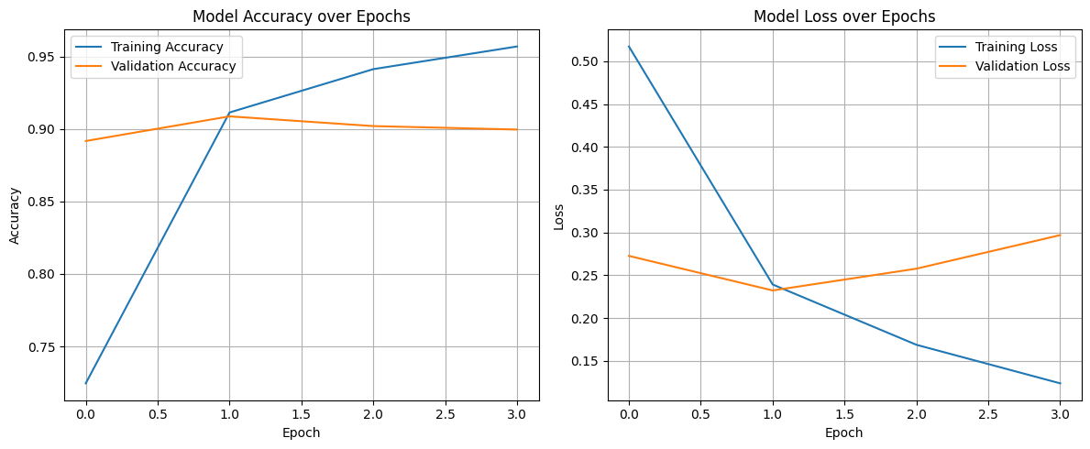
313/313 ━━━━━━━━━━━━━━━━━━━━ 16s 51ms/step
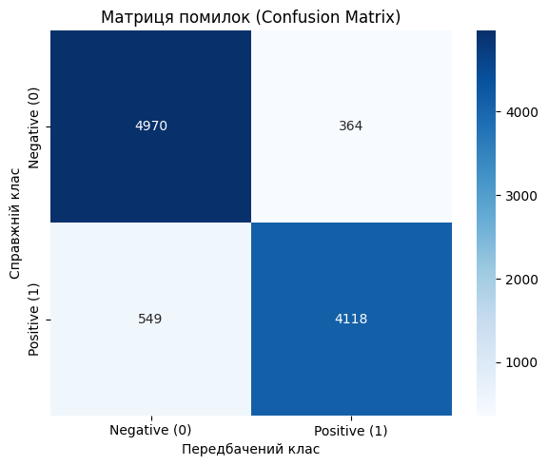
Accuracy : 0.9087
Precision : 0.9188
Recall : 0.8824
F-Score : 0.9002

Детальний звіт:
precision recall f1-score support

Negative (0) 0.90 0.93 0.92 5334
Positive (1) 0.92 0.88 0.90 4667

accuracy 0.91 10001
macro avg 0.91 0.91 0.91 10001
weighted avg 0.91 0.91 0.91 10001

Sample prediction tests:

Review: Absolutely loved the atmosphere and the food was fantastic!
Текст : Absolutely loved the atmosphere and the food was fantastic!...
Настрій : Positive (впевненість: 0.9781)
Sentiment: Positive

Review: I had to wait forever and the service was terrible.
Текст : I had to wait forever and the service was terrible....
Настрій : Negative (впевненість: 0.0167)
Sentiment: Negative

Review: The coffee was okay, nothing special but not bad either.
Текст : The coffee was okay, nothing special but not bad either....
Настрій : Negative (впевненість: 0.0148)
Sentiment: Negative

Review: Best restaurant I have ever visited! Will definitely come back!
Текст : Best restaurant I have ever visited! Will definitely come back!...
Настрій : Positive (впевненість: 0.9628)
Sentiment: Positive

--- Тести на прикладах з датасету ---
Текст : Unfortunately, the frustration of being Dr. Goldberg's patient is a repeat of th...
Настрій : Negative (впевненість: 0.0094)
[✓] Очікувано: Negative, Отримано: Negative
Текст : Been going to Dr. Goldberg for over 10 years. I think I was one of his 1st patie...
Настрій : Positive (впевненість: 0.9868)
[✓] Очікувано: Positive, Отримано: Positive
Текст : Wing sauce is like water. Pretty much a lot of butter and some hot sauce (franks...
Настрій : Positive (впевненість: 0.5287)
[✗] Очікувано: Negative, Отримано: Positive
Текст : After waiting for almost 30 minutes to trade in an old phone part of the buy bac...
Настрій : Negative (впевненість: 0.0363)
[✓] Очікувано: Negative, Отримано: Negative
Текст : Don't waste your time. We had two different people come to our house to give us...
Настрій : Negative (впевненість: 0.0121)
[✓] Очікувано: Negative, Отримано: Negative

[1] Keras Tokenizer → Accuracy: 0.9087

[2] Токенізація за допомогою NLTK word_tokenize...

=======================================================
Метод токенізації: NLTK word_tokenize
=======================================================
/usr/local/lib/python3.12/dist-packages/keras/src/layers/core/embedding.py:97: UserWarning: Argument `input_length` is deprecated. Just remove it.
warnings.warn(
Accuracy : 0.6507
Precision : 0.5847
Recall : 0.8684
F1-Score : 0.6989

[3] Токенізація за допомогою SpaCy...
/usr/local/lib/python3.12/dist-packages/spacy/pipeline/lemmatizer.py:188: UserWarning: [W108] The rule-based lemmatizer did not find POS annotation for one or more tokens. Check that your pipeline includes components that assign token.pos, typically 'tagger'+'attribute_ruler' or 'morphologizer'.
warnings.warn(Warnings.W108)
=======================================================
Метод токенізації: SpaCy tokenizer
=======================================================
/usr/local/lib/python3.12/dist-packages/keras/src/layers/core/embedding.py:97: UserWarning: Argument `input_length` is deprecated. Just remove it.
warnings.warn(
Accuracy : 0.9028
Precision : 0.9101
Recall : 0.8785
F1-Score : 0.8940

[4] BPE токенізація (HuggingFace tokenizers)...

=======================================================
Метод токенізації: BPE (HuggingFace)
=======================================================
/usr/local/lib/python3.12/dist-packages/keras/src/layers/core/embedding.py:97: UserWarning: Argument `input_length` is deprecated. Just remove it.
warnings.warn(
Accuracy : 0.8897
Precision : 0.8953
Recall : 0.8648
F1-Score : 0.8798

============================================================
ПОРІВНЯННЯ МЕТОДІВ ТОКЕНІЗАЦІЇ
============================================================
method accuracy precision recall f1
Keras Tokenizer 0.908709 0.918786 0.882366 0.900208
NLTK word_tokenize 0.650735 0.584680 0.868438 0.698853
SpaCy tokenizer 0.902810 0.910100 0.878509 0.894025
BPE (HuggingFace) 0.889711 0.895297 0.864795 0.879782
