**Test Canbus**

C file test_canbus_9860.c

1. **Set Kconfig**

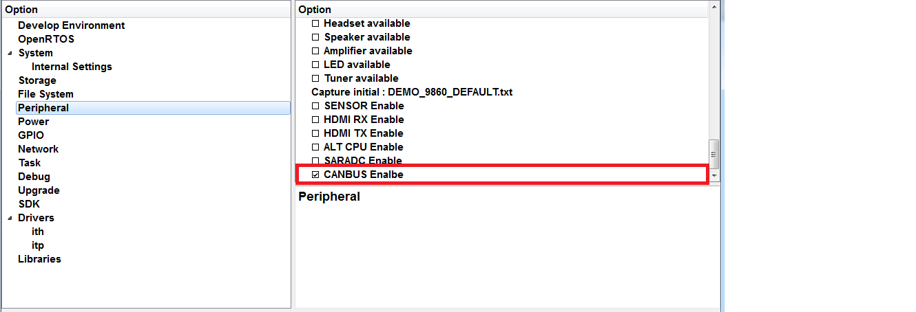

1. **Connect IT9860 to can bus**

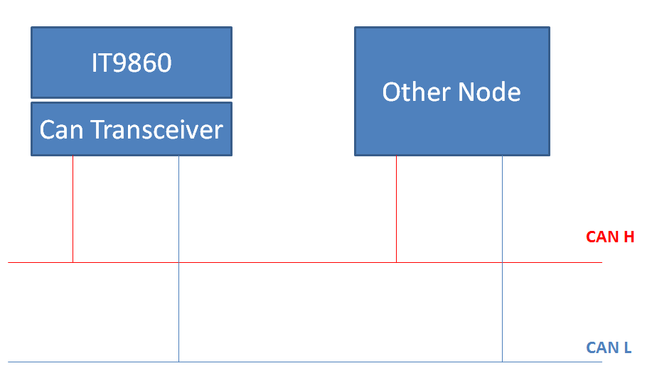

1. **Run test project**

Sdk\project\test_canbus\test_canbus_9860.c

Set Tx RX gpio.

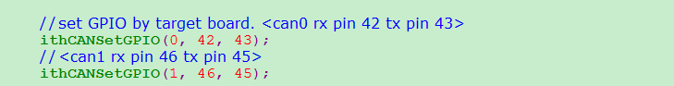

Set buadrate.(CAN_500K_1M => 500K in CANBUS 2.0B protocol)

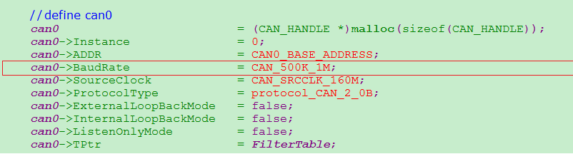

Set Filter Table:

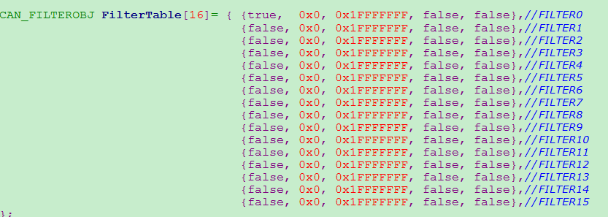

Mem Script Setting:

Copy

project\test_canbus\script\IT9860_360Mhz_DDR2_360Mhz.txt

to

sdk\target\debug\IT9860_360Mhz_DDR2_360Mhz.txt

Spi run(預設行為:接收資料，使用者可以自行修改)

