Q1

For Normal distribution, it is obvious that $\sqrt{n} Y$ will converge to normal distribution, but Y bar will result in lower variance, which will converge to 0 when n close to infinite.

For t(2), since the variance of t(2) doesn’t exist, CLT cannot be directly applied. In practice, t(2) will not converge to any specific distribution when sample size is large. But we can still observe Y bar will converge to single number since its variance will converge to 0 when n close to infinite.

Q2.

(a)

For alpha = 0.05, xdp, xtbl and intecept is rejected

(b)

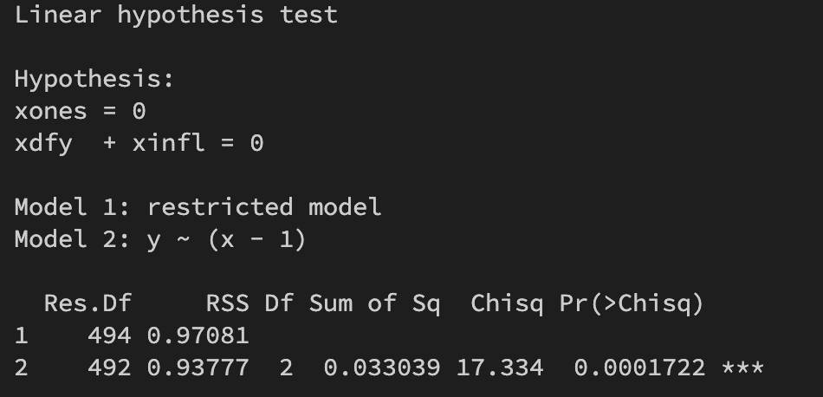

P-value is smaller than 5 %, meaning the hypothesis is rejected. The result is aligned with (a) since intercept = 0 is reject in single wald test. If we set only dfy and infl to 0. Wald test cannot reject the hypothesis.

Code can be found on <https://github.com/YuJu0819/quant-method> in folder hw6