电子科大清水河校区教研室网络方案
2018-01-02
清水河校区电信用的是IEEE 802.1x的认证，目前支持的路由中最好的也就是TP的WR842N了。对于家庭/寝室还行，但是对于教研室几十号人高强度使用网络环境来说还是遭不住的。本人用PC做网关代替了路由，目前测试来看：稳定、高可定制，推荐教研室用（当然也可以找性能好点的路由刷openwrt之类的）

硬件需求：闲置pc一台（双网卡）、二层交换机
考虑到对驱动的支持，本人机器装的是ubuntu14.04，网卡分别为eth0(对外拨号)、eth1(对内网关，接交换机)，子网段为192.168.1.0/24
本配置仅仅是针对个人情况，如果你的软硬件有特别之处，大同小异
首先为了让网关能基本工作，需要配置iptables转发
修改/etc/sysctl.conf，net.ipv4.ip_forward=1
sysctl -p
iptables -t nat -A POSTROUTING -s 192.168.1.0/24 -j MASQUERADE
service iptables save
上面save可能不能执行，可以装个iptables-persistent代替，用法跟iptables基本一样，后面的iptables修改都要记得save下

自动拨号
拨号使用的是wpa_supplicant，一般发行版都默认安装的
cat /etc/network/interfaces
Introduction
IEEE 802.1x is a standard for authenticating a computer on the network. It is often used for gaining access to large networks with a variety of users, such as a university network or a community network. This authentication protocol can be used on both wireless and wired networks.
Windows users might be familiar with the SecureW2 software, which provides 802.1x authentication for the Microsoft Windows 2000, XP and Vista operating systems.
Basic configuration
To authenticate to a network with the 802.1x protocol, the WPA-Supplicant software can be used. Despite the software’s heavy focus on wireless networking, it can be used for the authentication of wired networks as well. Ubuntu comes with WPA-Supplicant installed by default.
To configure our computer for using WPA-Supplicant, two configuration files need to be edited. First, create a new text file in /etc with your favourite editor or, if you are logged in to a graphical environment, by typing in a terminal:
sudo gedit /etc/wpa_supplicant.conf
Copy the following basic configuration into the new file:
# Where is the control interface located? This is the default path:
ctrl_interface=/var/run/wpa_supplicant

# Who can use the WPA frontend? Replace "0" with a group name if you
# want other users besides root to control it.
# There should be no need to chance this value for a basic configuration:
ctrl_interface_group=0

# IEEE 802.1X works with EAPOL version 2, but the version is defaults
# to 1 because of compatibility problems with a number of wireless
# access points. So we explicitly set it to version 2:
eapol_version=2

# When configuring WPA-Supplicant for use on a wired network, we don’t need to
# scan for wireless access points. See the wpa-supplicant documentation if
# you are authenticating through 802.1x on a wireless network:
ap_scan=0
Next we need to add the authentication configuration for the network we are authenticating to. We add this network definition to the same file (wpa_supplicant.conf).
There is no single configuration that will work for every network, so check with your network administrator or institution for the specific settings and protocols needed for your situation. Multiple networks can be configured in the WPA-Supplicant configuration file. A basic setup might look like the following.
Example for a wired network with:
- Network access authentication through IEEE 802.1x.
- EAP-Tunnelled Transport Layer Security, using PAP and MD5 as the authentication protocol.
- No certificates.
network={
key_mgmt=IEEE8021X
eap=TTLS MD5
identity="myloginname"
anonymous_identity="myloginname"
password="mypassword"
phase1="auth=MD5"
phase2="auth=PAP password=mypassword"
eapol_flags=0
}
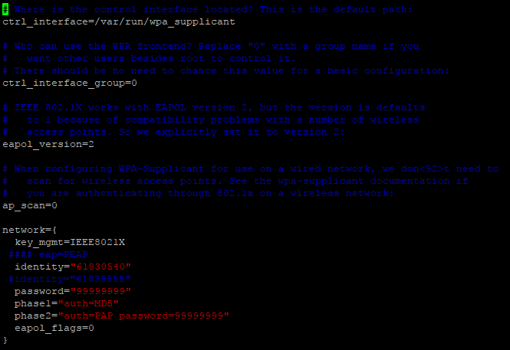
To test the authentication process, we can call WPA-Supplicant directly with our new configuration file. For example, in case of a wired network, execute the following command:
sudo wpa_supplicant -c /etc/wpa_supplicant.conf -D wired -i eth0
See WifiDocs/WPAHowTo for more information on configuring WPA-Supplicant for wireless networks.
If WPA-Supplicant can authenticate our computer to the network, we can add it to the global network configuration. By doing this WPA-Supplicant is automatically run when we boot up the computer or restart its network.
Open the network interface configuration file:
sudo gedit /etc/network/interfaces
There should already be a number of network interfaces configured in this file. Below we add 802.1x authentication for a wired network, be sure to select the proper driver for WPA-Supplicant if you want to authenticate to a wireless network:
# The loopback interface, this is the default configuration:
auto lo
iface lo inet loopback

# The first network interface.
# In this case we want to receive an IP-address through DHCP:
auto eth0
iface eth0 inet dhcp

# In this case we have a wired network:
wpa-driver wired

# Tell the system we want to use WPA-Supplicant with our configuration file:
wpa-conf /etc/wpa_supplicant.conf
To test our new configuration, we stop the network on our system before saving the above configuration file:
sudo /etc/init.d/networking stop
After saving this file, we should be able to start the network with 802.1x authentication enabled:
sudo /etc/init.d/networking start
For most cases, this is all that is required to automatically authenticate our computer to the network using the IEEE 802.1x protocol.
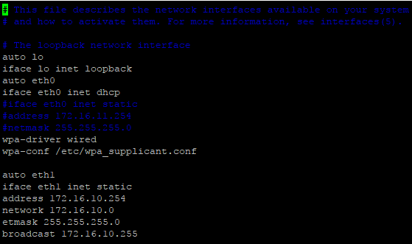

dhcp服务器
apt-get install isc-dhcp-server
cat /etc/dhcp/dhcpd.conf
ddns-update-style none;
option domain-name "xxoo.com";# DNS地址
option domain-name-servers 192.168.1.1, 114.114.114.114;# 地址释放时间，亲测不要太小
default-lease-time 604800;
max-lease-time 2419200;
authoritative;
log-facility local7;
subnet 192.168.1.0 netmask 255.255.255.0 {# DHCP范围: 160-254
range 192.168.1.160 192.168.1.254;
option domain-name-servers 192.168.1.1;
option domain-name "xxoo.com";
option routers 192.168.1.1;#option routers应该设置为对内网卡eth1的IP
option broadcast-address 192.168.1.255;
default-lease-time 604800;
max-lease-time 2419200;}# 静态区，逐个添加即可
host yyy {
hardware ethernet 74:A4:B5:00:14:24;
fixed-address 192.168.1.xxx;}
