|  |
| --- |
| CIRCUMSTANCE VITAE  Quyen Nguyen  Contact address:  **Mobile:** 0793121093  **E-mail:** [**nguyenquyen19193@gmail.com**](mailto:nguyenquyen19193@gmail.com)  **Position**: Java Software Engineer |

Personal Profile

|  |  |
| --- | --- |
| * Date of birth: 19/01/1993 | * Gender: Female |
| * Place of birth: Dong Thap | * 2nd email: [yunguyen1210@gmail.com](mailto:yunguyen1210@gmail.com) |
| Introduction |  |

5+ years of experience in software development:

* CSC Company , product domain: Insurance.
* DXC: product domain: Insurance.
* T2P Travel2Pay Germany Company – NTC Team : Travel and Payment Management System.
* System EXE Viet Nam, product domain: Manufacturing Management System.

I am continuously enhancing my skills to advance my career as a Professional Java

developer.

Education

**[2012-2016]** [Software Engineering] [Van Lang University]

**[2018]** [Java Web Application] [Trung Tâm TH Đại Học Khoa Học Tự Nhiên]

**Work Experience**

[**June 2016 - 2018**] [**CSC/DXC Company**] [**Associate Software Engineer**]

**Project Description:**

Integral is a comprehensive administration suite for life insurance and annuities/pensions, property and casualty (P&C)/general insurance, and group insurance that provides end-to-end policy/group management, product configuration and business analytics capabilities. Its portable Java-based architecture enables companies to implement Integral quickly and operate cost-effectively, either in-house or through CSC’s business process outsourcing service.

**Role / Responsibilities:**

* Investigating and resolving issues of UI and functions for Integral project.
* Implement batch jobs to extract data, enhencement batch jobs to create Receipt, Payment, Direct Journal base on framework which was converted from COBOL to JAVA.
* Implementation and writing TSD ( Technical Specification Document).
* Implementation for XML data extraction. Working with XML Team to generate XML report (BSIB: Group and Polisy).

**Experience in:** **Java J2EE, HTML/CSS, JSP/Servlet, Hibernate, JDBC, Apache Tomcat, SQL Server, Git, SVN, Jira.**

**Operating System:** Windows.

[**June 2018 – 2019**] [**System EXE Company**] [**Java Developer**]

**Project Description:**

Manufacturing Management System is a web application.

Front end: Using Actionscript and Flex framework.

Back end: Java.

The web app has main function called MRP.

Material requirements planning (MRP) is a production planning, scheduling, and inventory control system used to manage manufacturing processes. When company want to make new product they will using our application to caculate how many materials can be used and also has a total view about all materials in stock.

**Role / Responsibilities:**

* Investigating and resolving issues of UI and functions.
* Implement new function as user requirements or work on tasks from BrSE (Japanese side).
* Research and document new tool (GIT) which plan to use in the project.
* Translation document from Vietnamese or Japanese (with helping from BrSE, she will help to translate to Vietnamese) to English to support Myanmar Team.
* Investigating and optimizing SQL queries to improve system performance.

**Experience in:** **Java, Apache Tomcat, Postgresql, SVN, Redmine, Actionscript.**

**Operating System:** Windows.

[All of year **2020 – EOY 2021**] [**T2P Travel2Pay Company**] [**Java Developer**]

**Project Description:**

Implement web and mobile application for travel and payment management system. NTC Team.

Front end: VueJS.

Back end: Java.

Payment product empower hundreds of mid and large size customers in Germany and all around Europe to grow their businesses with our smart fully-digitalized solutions and inspiring content. We provide solution for the company manage their members travel trip : budget, manage receipt, invoices, expenses…

**Role / Responsibilities:**

* Investigating and resolving issues of UI and functions.
* Implement new function as user requirements or work on tasks from BA (product owner in Germany).

**Experience in:** **VueJS, Java, MySQL, Git, Docker, Microservice project.**

**Operating System:** Windows.

[**2022 – 2023]** [**System EXE Company**] [**Middle** **Java Developer**]

**Project Description:**

Manufacturing Management System is a web application. [Maintenance Projects]

The web app has main function called MRP.

Material requirements planning (MRP) is a production planning, scheduling, and inventory control system used to manage manufacturing processes. When company want to make new product they will using our application to caculate how many materials can be used and also has a total view about all materials in stock.

**Role / Responsibilities:**

* Investigated and resolved issues related to UI and backend functions.
* Developed and implemented new features based on user requirements.
* Project Leader for a system update project over a 3-months period. Team size 3 members.
* **Analyzed and optimized SQL queries to enhance system performance.**
* Designed improvements for customized UI components.
* **Proposed solutions to meet user requirements effectively.**
* Optimize existing project code and improve coding quality.

**Experience in:** **Java, Apache Tomcat, Postgresql, SVN,Git, Redmine, Angular.**

**Operating System:** Windows.

[**2024 – 5/2025]**

Took an extended leave for maternity and family care while continuously developing professional skills:

* **Udemy Certification** – Master Microservices with Spring Boot, Docker, and Kubernetes.

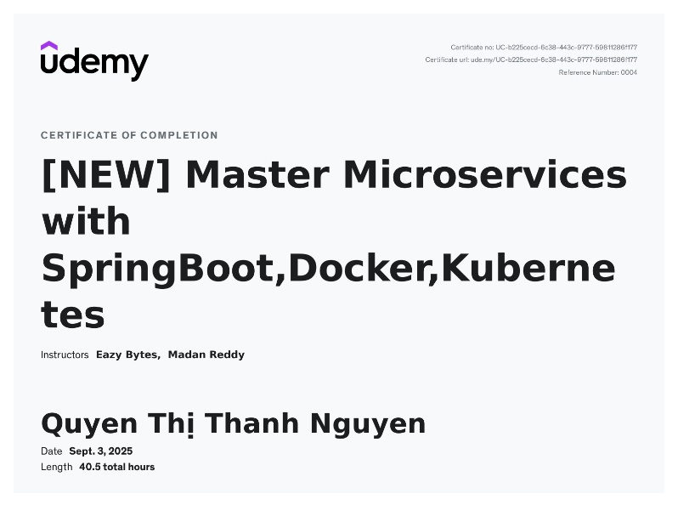

* **Freelancer projects:**
* **Brand Development Project** – Designed and delivered a **new logo** and **uniform concept** for **Trieu Thanh Milk Tea**, a well-known brand in Ca Mau Province, achieving **high client satisfaction**.  
  <https://github.com/YuNguyen/design_doc/tree/main/TrieuThanh_MilkTea>
* **IT Infrastructure Consulting** – Proposed and presented a **cloud-based storage solution** to **Nafaco Company’s design team**, recommending **Microsoft Azure Storage** to optimize website infrastructure and manage product design assets more efficiently.  
  Reference: Mr. Tran Thai My – Design Team | 0937 913 030

**Skills**

* Basic design using Adobe Photoshop and Adobe illustrator tools.
* I’ve worked with moving spirit and sense of responsibility.
* I am good at teamwork, good at presentation and express ideas.