At this stage, the map can display information about the location of the fire and the camping site. Have not completed the search, area filtering and other functions (most of the code has been put in, but due to the poor effect, I have commented it out)

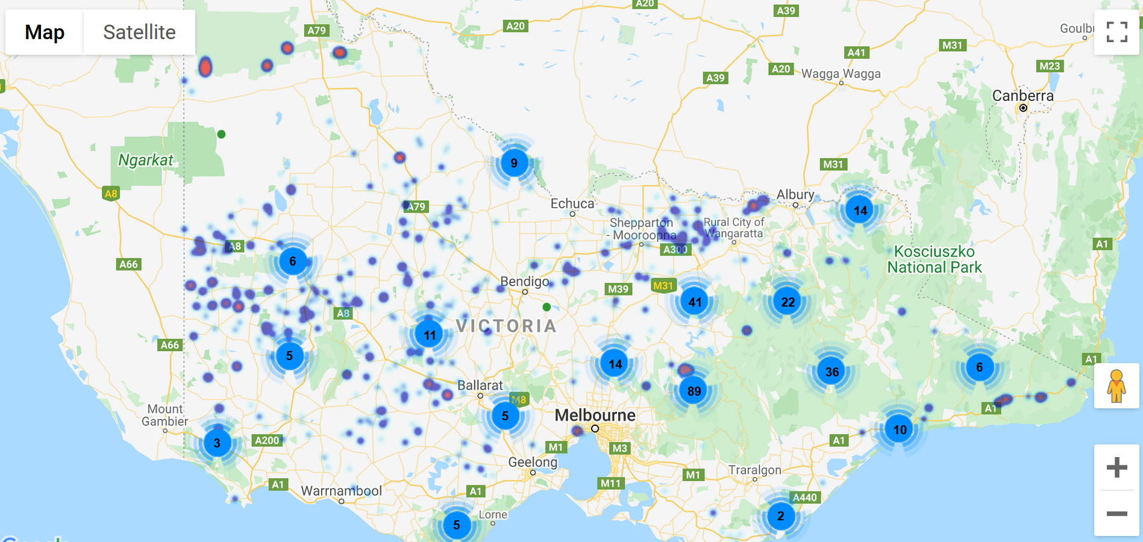

The first is the program process, the general flow is shown in the figure below:

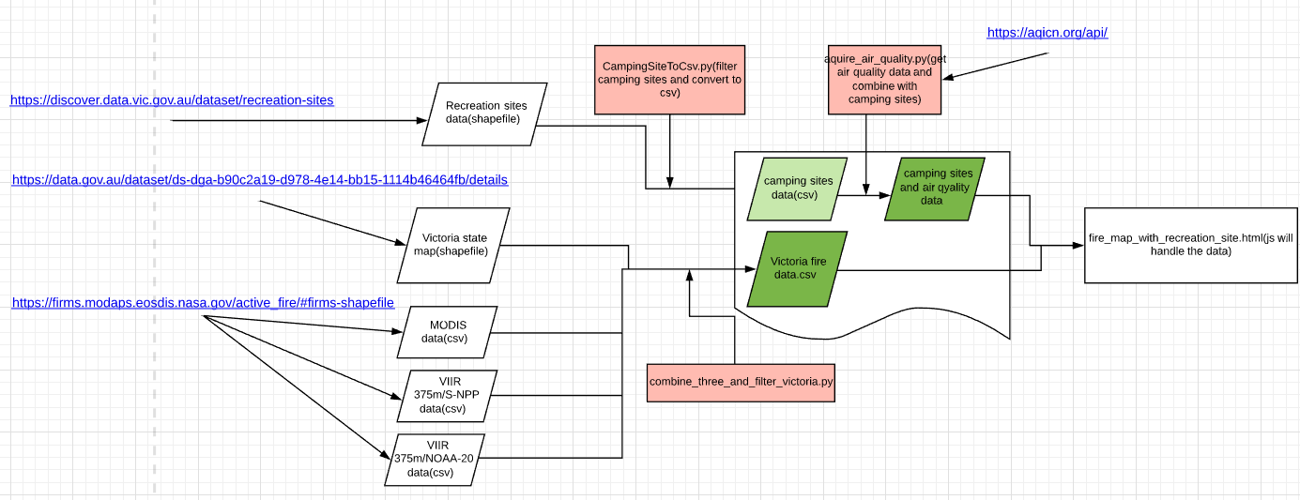

What you need to do next:

1. Automatic acquisition of fire data (daily)
2. All scripts are deployed to the server, modify the path inside and debug to ensure normal use.
3. Set the combine_three_and_filter_victoria.py script to run automatically every 24 hours (after fire data acquisition)
4. Set the aquire_air_quality.py script run automatically every 12 hours.
5. Embed the map into our website.