3D Registration Pipeline

# 2.0 version

Ferran Roure

ViCOROB Research Group

Universitat de Girona

# Introduction

3D registration is an open problem for the computer vision community and it is an active field of research. Due to the complexity of the problem, a pipelined division is done, and each step can be raided with different methods. Often, testing becomes tedious because there are no many benchmarks available, or it is difficult to integrate your own methods to these systems.

With this project, we want to provide a useful tool for researchers to help test the methods. With our project, the user only has to create an adapter class in order to transform his data type to our data type.

# Overview

We divided the registration process in 4 different steps.

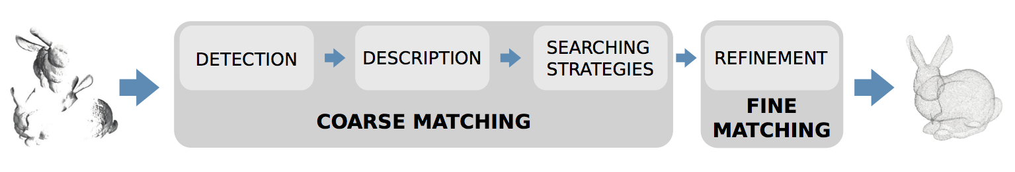

Given two different views of the same object we **detect** the most representative keypoints in the point cloud. We **describe** these keypoints obtaining a certain descriptor values. Then, a **searching strategy** is applied in order to find correspondences between both views, using these descriptor values. Finally a **refinement** is applied to finish the alignment process. Not all steps are essential to find a good alignment.

# Input type

Our system works only *.ply files as input data. Triangulation is not necessary because only point information is used.

# Parameters

In order to make more easy the testing process we provide a system based on XML syntax.