ECE227 Project Guidelines

Winter 2026
If you had any questions contact: raman@ucsd.edu

Introduction
This document is prepared so that you can get an idea of what kind of projects are within the scope of this class. Using these guidelines as an inspiration, each group is supposed to define their own project. These notes only give you a head start and we expect you to define your own questions and make additional investigative steps. For the projects sections of the course you must:
- Form teams of three or four students (if you don’t know anyone or have a team of two, we will assign you to a project or add a team member to your team);
- Send the names, emails, and PID of team members to the TA;
- Collaborate on choosing an intriguing project for your team and pushing it forward to learn exciting stuff from the project!

Network Analysis and Visualization using NetworkX and Gephi
- Download the Collaboration (Erdo¨s), Facebook and Enron networks.
- Analyze the nodes centrality in each graph using different notions of centrality (e.g. degree centrality, betweenness centrality, eigenvector cen- trality etc.). What are the most central nodes in each graph? Why might that be the case?
- Most central (top by degree / degree centrality): 430, 342, 442, 313, 297, 421, 79, 484, 222, 266
- They have many direct connections, meaning they collaborated with many different authors. In collaboration graphs, these tend to be prolific researchers or people who coauthor widely.
- How many nodes are among the top 10% in terms of degree centrality AND betweenness centrality? How does this overlap change for each of these networks?
- Top 10% degree centrality: 506 nodes, betweenness 500 nodes, Both: 404 nodes
- Overlap / top-degree set = 0.798
About 79.8% of the high-degree nodes are also high-betweenness. Overlap / top-betweenness set = 0.808
About 80.8% of the high-betweenness nodes are also high-degree.
- Perform community detection on these graphs. Investigate different com- munity detection algorithms (e.g. “Louvain algorithm.” )Experiment with bounded and unbounded approaches. Visualize results.
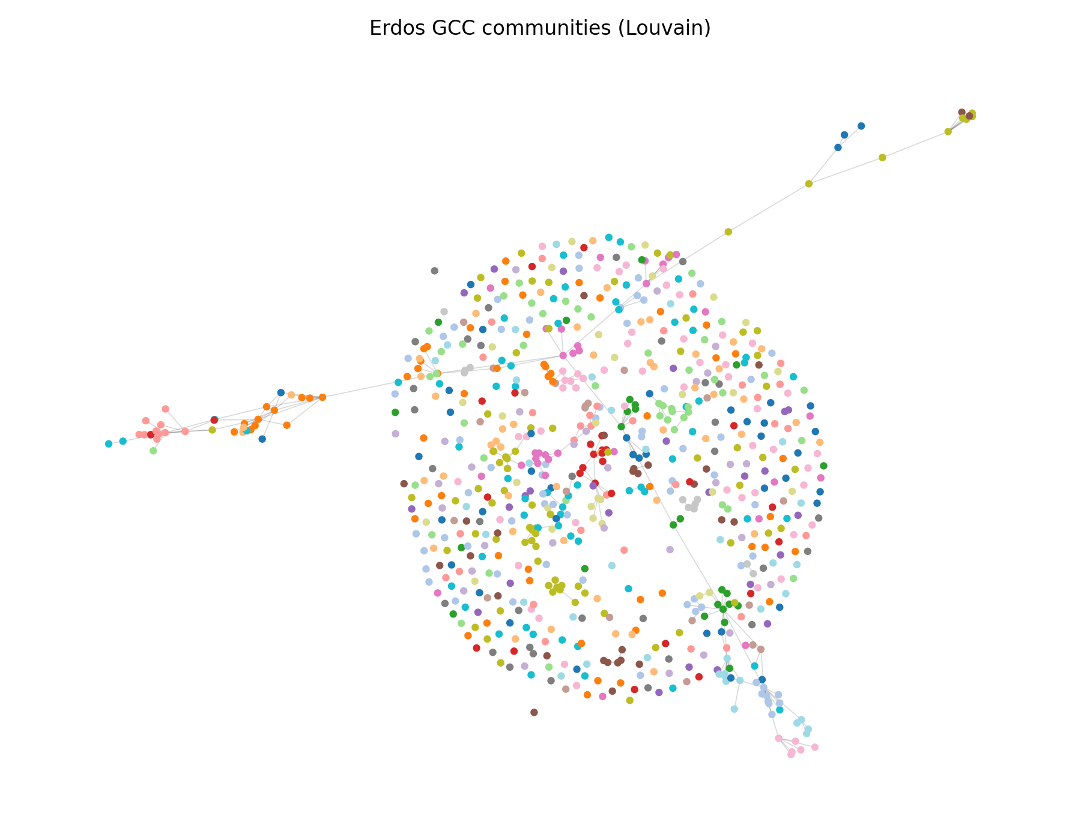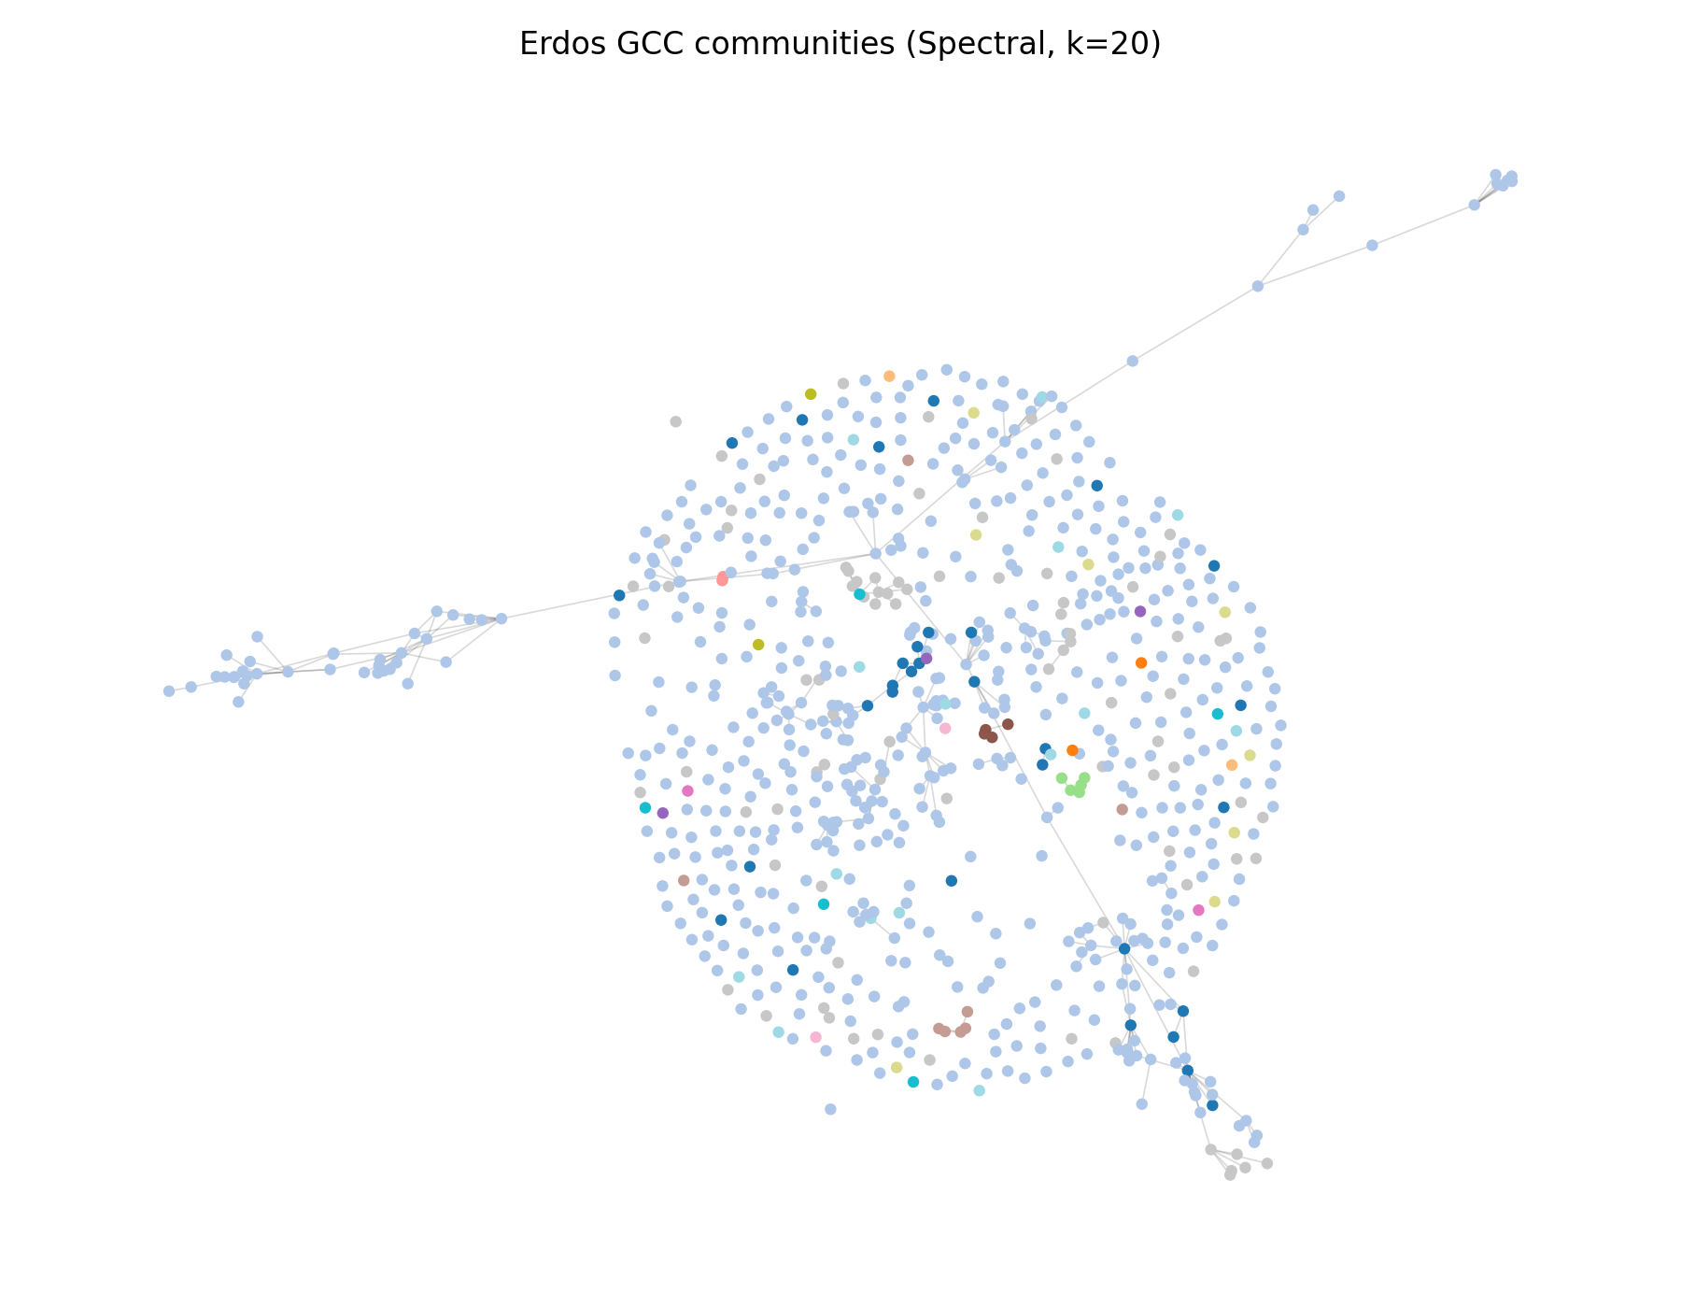
- Analyze the communities formed as a result of the community detection algorithms. Why do certain nodes belong to the same community? For example, for the Erd¨os graph, one can analyze the top 5 authors with highest degree from the largest communities and check their research areas to see if they indeed have shared research interests.
- We performed community detection on the Erdős collaboration network using algorithms discussed in class: Louvain modularity optimization (unbounded) and Laplacian spectral clustering (bounded by specifying kkk).On the largest connected component (4991 nodes, 7428 edges), Louvain produced 36 communities with several large groups (largest sizes ≈ 343, 318, 300, 298, 280), indicating multiple meaningful collaboration circles. Spectral clustering with fixed k∈{5,10,20} produced one dominant cluster (e.g., 4831 nodes for k=5, 3873 nodes for k=20) and many small clusters, suggesting that forcing a fixed number of communities does not match the network’s natural modular structure as well as Louvain. Visualizations of both partitions show Louvain separating many groups across the core, while spectral clustering colors most of the core as one community with small peripheral clusters.
- Communities group nodes that have dense coauthorship ties and many shared neighbors, resulting in far more edges within a community than across communities. For the five largest Louvain communities (sizes 460, 380, 273, 252, 246), we extracted the top-5 nodes by degree within each community; each community contains its own high-degree hubs (e.g., community 5 is centered around nodes 442/421/79; community 2 around 342; community 9 around 313; community 4 around 222/125/459). These hub nodes likely represent prolific authors within the same collaboration circle, explaining why they are grouped together. (Because this dataset provides numeric node IDs without author names, validating shared research areas would require an external ID-to-author mapping.)
- Analyze the degree distribution of these graphs. Do they follow a power law or a Poisson degree distribution? Why or why not?
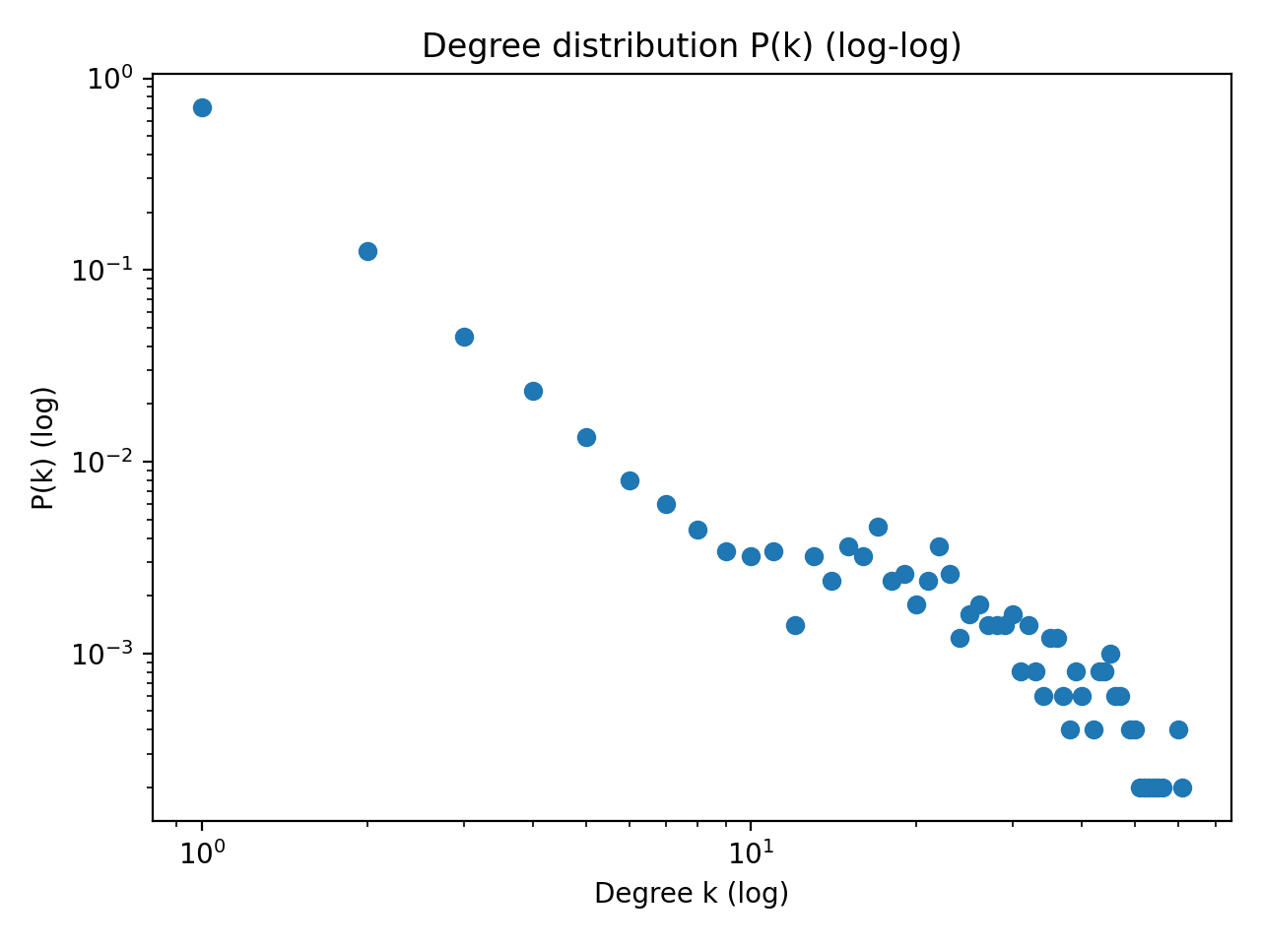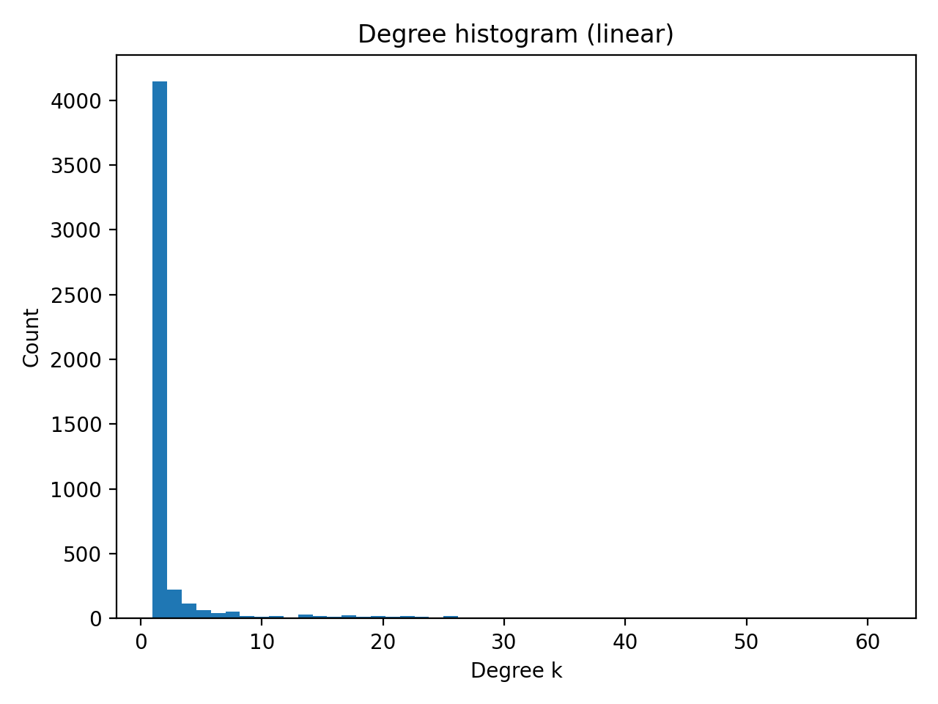
The Erdős collaboration graph has a highly skewed degree distribution. The degree histogram shows that most nodes have very small degree, while a small number of nodes have very large degrees (up to 61), producing a heavy tail. The variance of the degree (~40.15) is far larger than the mean (~2.98), which strongly contradicts a Poisson degree distribution (Poisson would satisfy var ≈ mean). A power-law fit estimates α ≈ 2.18 and is strongly favored over an exponential alternative (log-likelihood ratio R ≫ 0 with extremely small p-value), indicating the degree distribution is heavy-tailed and power-law-like rather than Poisson.
- Calculate the diameter and the average shortest path for these graphs. What can you notice?
On the largest connected component (4991 nodes), the average shortest path length is about 5.51 and the (approximate) diameter is about 14. Despite the network being large, typical distances remain small, consistent with “small-world” behavior where hubs and bridging authors create short paths between many pairs of nodes.
- In terms of similarity and performance, how would you compare these graphs to Barabasi-Albert, Watts-Strogatz and Erdo¨s-Renyi graphs? Jus- tify your reasoning.
The Erdős collaboration network differs strongly from an Erdős–Rényi random graph because its degree distribution is heavy-tailed: the variance of degrees far exceeds the mean and a small number of nodes act as hubs (max degree 61), which is inconsistent with the Poisson-like degree distribution expected in ER graphs. In contrast, its hub structure and power-law-like tail (α ≈ 2.18, and power law strongly preferred to an exponential baseline) make it most similar to a Barabási–Albert preferential-attachment graph. In terms of distances, the graph exhibits small-world behavior (average shortest path ≈ 5.51 and diameter ≈ 14), consistent with BA/WS-style networks where a few highly connected nodes shorten paths. However, compared to basic BA and Watts–Strogatz models, the collaboration graph shows stronger community structure (Louvain finds 36 sizeable communities), likely reflecting real research-field clustering and repeated coauthorship circles, which is not captured by the simplest synthetic models.

