# 工具列座標

|  |  |  |  |  |  |  |
| --- | --- | --- | --- | --- | --- | --- |
|  | 起始x | 起始y | 結束x | 結束y | 寬 | 高 |
| 1 | 1492 | 11 | 1908 | 45 | 416 | 34 |
| 2 | 1536 | 98 | 1862 | 337 | 326 | 239 |
| 3 | 1510 | 409 | 1612 | 496 | 102 | 87 |
| 4 | 1510 | 500 | 1612 | 589 | 102 | 89 |
| 5 | 1510 | 594 | 1612 | 683 | 102 | 89 |
| 6 | 1647 | 381 | 1794 | 419 | 147 | 38 |
| 7 | 1654 | 420 | 1716 | 711 | 62 | 291 |
| 8 | 1724 | 420 | 1787 | 711 | 63 | 291 |
| 9 | 1813 | 412 | 1907 | 464 | 94 | 52 |
| 10 | 1813 | 471 | 1907 | 518 | 94 | 47 |
| 11 | 1813 | 523 | 1910 | 572 | 97 | 49 |
| 12 | 1810 | 579 | 1910 | 627 | 100 | 48 |
| 13 | 1810 | 638 | 1910 | 684 | 100 | 46 |
| 14 | 1508 | 736 | 1890 | 1015 | 382 | 279 |
| 15 | 1500 | 1045 | 1907 | 1075 |  |  |
|  |  |  |  |  |  |  |
|  |  |  |  |  |  |  |
|  |  |  |  |  |  |  |

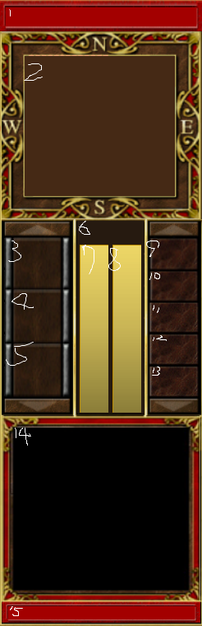

# 圖片代碼

p[0]=readBMP("pic//地板.bmp", dc1);

p[11]=readBMP("pic//牆壁.bmp", dc1);

p[13]=readBMP("pic//破牆.bmp", dc1);

p[14]=readBMP("pic//破牆(按).bmp", dc1);

p[19]=readBMP("pic//小遊戲轉移點1.bmp", dc1);

p[20]=readBMP("pic//怪物產生器.bmp", dc1);

for(i=21;i<=32;i++) //玩家

{

sprintf(display,"pic//%d.bmp",i);

p[i]=readBMP(display, dc1);

}

p[30]=readBMP("pic//玩家小圖.bmp", dc1);

p[131]=readBMP("pic//怪物正面齊步.bmp", dc1);

p[40]=readBMP("pic//怪物小圖.bmp", dc1);

p[50]=readBMP("pic//範圍.bmp", dc1);

p[51]=readBMP("pic//爆炸.bmp", dc1);

p[53]=readBMP("pic//爆炸(按).bmp", dc1);

p[54]=readBMP("pic//炸彈.bmp", dc1);

p[55]=readBMP("pic//炸彈(按).bmp", dc1);

p[52]=readBMP("pic//背景1.bmp", dc1);

p[71]=readBMP("pic//邊界左.bmp", dc1);

p[72]=readBMP("pic//邊界上.bmp", dc1);

p[73]=readBMP("pic//邊界右.bmp", dc1);

p[74]=readBMP("pic//邊界下.bmp", dc1);

p[75]=readBMP("pic//邊界左(按).bmp", dc1);

p[76]=readBMP("pic//邊界上(按).bmp", dc1);

p[77]=readBMP("pic//邊界右(按).bmp", dc1);

p[78]=readBMP("pic//邊界下(按).bmp", dc1);

p[80]=readBMP("pic//文字視窗.bmp", dc1);

p[81]=readBMP("pic//黑底.bmp", dc1);

p[82]=readBMP("pic//工具列2.bmp", dc1);

p[91]=readBMP("pic//物品一.bmp", dc1);

p[92]=readBMP("pic//物品二.bmp", dc1);

p[93]=readBMP("pic//物品三.bmp", dc1);

p[101]=readBMP("pic//A6.bmp", dc1);

p[102]=readBMP("pic//A6開.bmp", dc1);

# 陣列代碼

|  |  |
| --- | --- |
| Map_1[i][j]>=0&&Map_1[i][j]<=4 | p[0] |
| Map_1[i][j]<=20)&&(Map_1[i][j]>=11) | p[11] |
| Map_1[i][j]==21 | p[mover[21].ws |
| Map_1[i][j]<=40)&&(Map_1[i][j]>=31) | p[131].dc |
| Map_1[i][j]>=51 && Map_1[i][j]<=56 | p[51].dc |
|  |  |