* 1. Data Structure Quiz 2

1. Draw the Max-heap after the following operations are performed beginning with an empty heap: insert 34, insert 39, insert 24, delete-max, insert 5, insert 35, insert 17, delete max. Draw the result according to the above operation. (4%)
2. Find a binary tree whose nodes appear in the same sequence in both orders.
3. Preorder and inorder (2%)
4. Preorder and postorder (2%)
5. Inorder and postorder. (2%)
6. Let B(n) be the number of distinct binary trees constructed from n nodes. For example, B(0) = 1, B(1) = 1, B(2) = 2, B(3) = 5.
7. What is the value for B(4)? (1%)
8. Please write a recursive formula to define B(n) based on a combination of B(i) where 0 <= i < n. (9%)
9. True or false? Please describe the reason if the answer is false.
10. In a min heap, every subtree is also a min heap. (2%)
11. In the worst case, initializing a min heap with n nodes takes O(log n) time. (2%)
12. In the average case, initializing a min heap with n nodes takes O(log n) time. (2%)
13. In the worst case, popping an element from a min heap with n nodes takes O(log n) time. (2%)

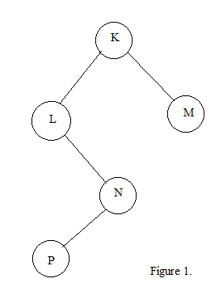

1. The binary tree is shown in Figure 1.
2. The tree can be represented as an array, please express the tree using array form. (2%)
3. The tree can be represented as a linked list, please express the tree using linked list form.(2%)
4. Draw the expression tree of the infix expression a / b – c ^ d * e ^ f ^ g + (h + i) / j. (c ^ d means $c^{d}$) (4%)
5. This is the Loser Tree. Fill in A1~A8 to complete this tree. (8%)

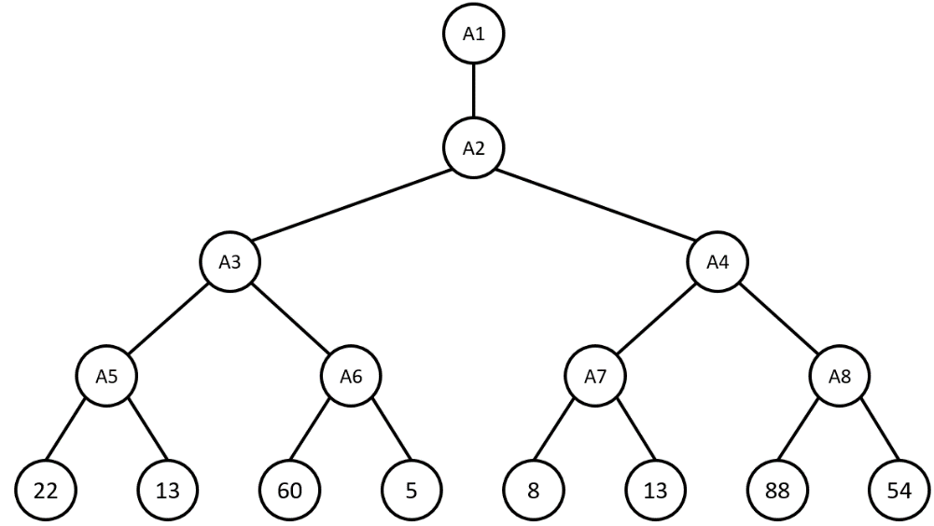

1. Consider the following undirected graph.
2. Write the depth first spanning tree starting at node 0 (visit the smaller number first). (2%)
3. Write the breadth first spanning tree starting at node 0 (visit the smaller number first). (2%)

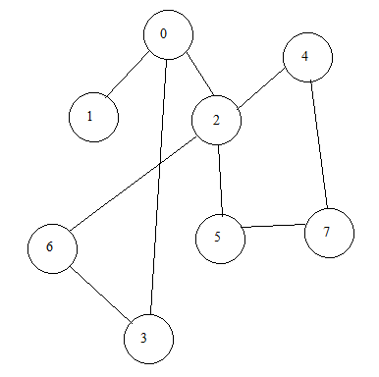

1. Let *G* = (*V , E*) be a connected directed graph with a weight function *w: E -> R*, where *R* is the set of real numbers, and *V* = {1, 2, 3, …, *n*} is the set of vertices. For convenience, we assume that there is a weight matrix *W =* ($w_{ij}$) where $w_{ij}$ is 0 if *i = j*; $w_{ij}$ is the weight of the directed edge (*i, j*) if *i ≠ j* and (*i, j*) *∈ E*; $w_{ij}$ is ∞ if *i ≠ j* and (*i, j*) *∉ E*. A vertex *v* in a simple path *p = ($v_{1}$, $v_{2}$, $v_{3}$, …, $v_{i}$)* is said to be intermediate node if *v ∈* {$v_{2}$*, $v_{3}$, …, $v_{i-1}$* }. Let $d_{ij}^{(k)}$ be the weight of a shortest path from vertex *i* to vertex *j* for all intermediate vertices are in the set {1, 2, 3, …, *k*}. Then it is easy to say that $d_{ij}^{(k)}$ = $w_{ij}$. Give a recursive definition of $d_{ij}^{(k)}$ for *0 ≤ k ≤ n*. (10%)
2. Use Dijkstra’s algorithm to show the shortest path from node 1 to all other nodes in this graph step by step. (3%)

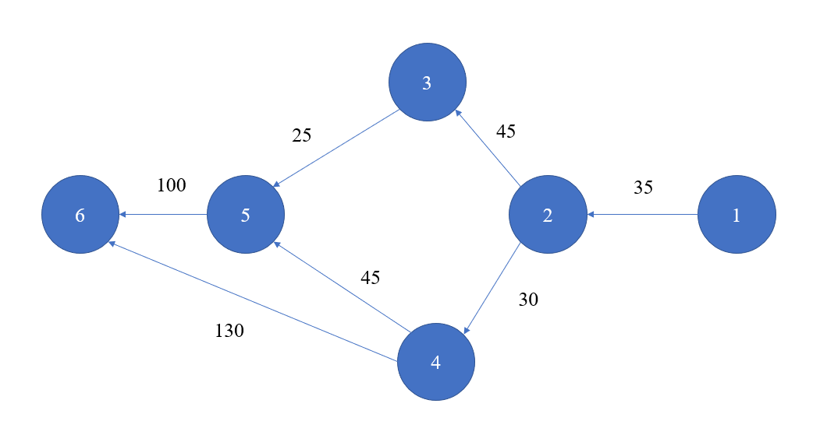

1. Compute the lengths of all-pair shortest paths for the directed graph with 5 vertices represented by the following matrix. For each entry $a_{ij}$ = *t* represents that there is an directed edge from vertex *i* to vertex *j* with weight *t*. Use your computation result to find a shortest path from vertex 1 to vertex 3. Please describe which algorithm you use to find the length of the shortest path. (3%)
$$\begin{matrix}0 & 3 & 8 & ∞ & -4 \\ ∞ & 0 & ∞ & 1 & 7 \\ ∞ & 4 & 0 & ∞ & ∞ \\ 2 & ∞ & -5 & 0 & ∞ \\ ∞ & ∞ & ∞ & 6 & 0\end{matrix}$$

2. Please fill out the blank. (10%)

//Searching a Binary Search Tree:

typedef struct node *treePointer;

typedef struct node {

int data;

treePointer leftChild, rightChild;

};

tree_pointer search(tree_pointer root, int key)

{

/* return a pointer to the node that contains key. If there is no such node, return NULL */

if (!root) return NULL;

if (key == root->data) return root;

if (key < root->data)

return search( _____ , key); (1)

return search( _____ , key); (2)

}

//Algorithm for All Pairs Shortest Paths:

void allcosts(int cost[][MAX_VERTICES], int distance[][MAX_VERTICES], int n)

{

int i, j, k;

for (i=0; i<n; i++)

for (j=0; j<n; j++)

_____ ; (3)

for(k=0; k<n; k++)

for (i=0; i<n; i++)

for (j=0; j<n; j++)

if ( _____ < distance[i][j]) (4)

distance[i][j] = _____ ; (5)

}

1. Consider the following weighted graph.
2. Show the order in which the edges are added to the minimum cost spanning tree using Prim’s algorithm. (Use weight to represent edges in your answer and just show the order.) (3%)
3. Show the order in which the edges are added to the minimum cost spanning tree using Kruskal’s algorithm. (Use weight to represent edges in your answer and just show the order.) (3%)

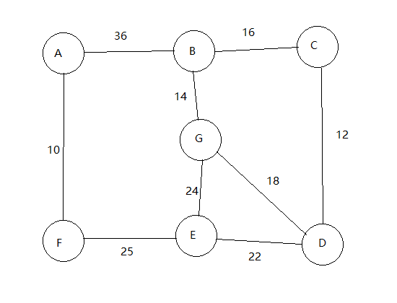

1. A binary tree is defined as follows. Each node of the tree has three fields, data, LeftChild, and RightChild, where LeftChild and RightChild are pointers to the left subtree and the right subtree, respectively. The function Ifno is a recursive function. What is the returned value by Ifno(tree1) and Ifno(tree2) for tree1 and tree2 given below? (6%)

Struct TreeNode{

char data;

struct TreeNode *LeftChild;

struct TreeNode *RightChild;

}

int Ifno(struct TreeNode *root)

{

int leftn, rightn;

if (root == NULL)

return 0;

else{  
 leftn = Ifno(root -> LeftChild);

right = Ifno(root -> RightChild);

if ((leftn + rightn) > 0)

return leftn + rightn;

else

return 1;

}

}

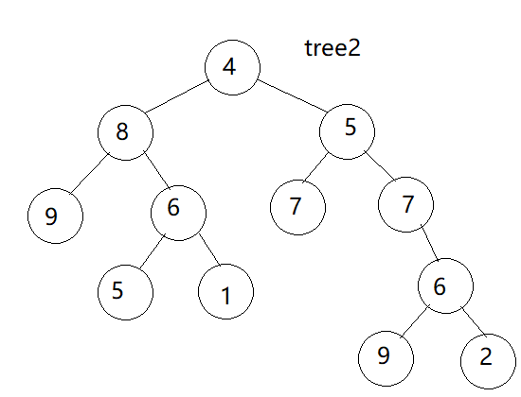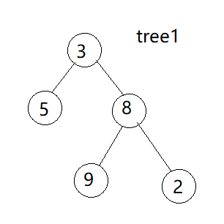

1. Consider the following extension of a binary heap, called a minmax heap: The key of a node at an even level is less than or equal to the keys of its children and grandchildren; the key of a node at an odd level is greater than or equal to the keys of its children and grandchildren. The root of the minmax heap is at level 0.
2. What is the running time for finding the maximum key in this data structure? Briefly justify your answer. (7%)
3. What is the running time for inserting a new key in a minmax heap? Briefly justify your answer. (7%)