* 1. Data Structure Quiz 2解答

1.

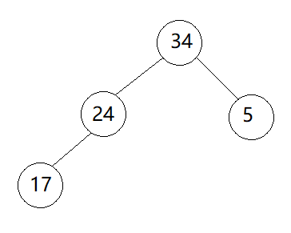

2.

(1)

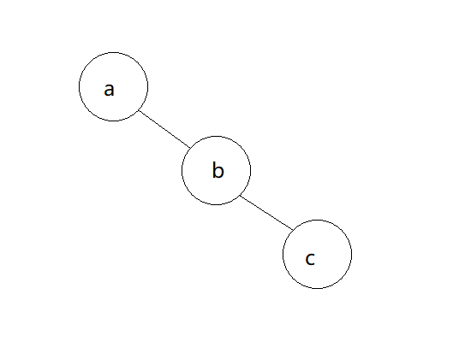

只要是right skewed binary tree 或 一個node的tree就算對

(2)

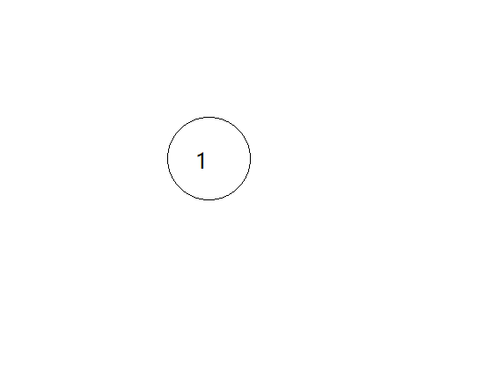

只要一個node的tree就算對

(3)

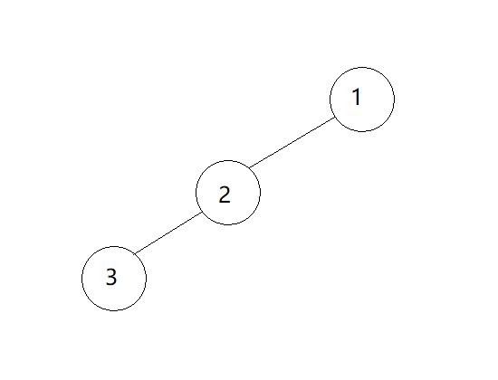

只要是left skewed binary tree 或 一個node的tree就算對

3.

(1)14

(2)B(n) = $\sum_{i=0}^{n-1}{B\left(i\right)*B(n-1-i)}$

4.

(1)T

(2)F 因為min heap一個node的insert需要O($\log_{2}n)$, initializing a min heap with n node 就是插入n個node, 故需要O $(n\log_{2}n)$

(3)F 與worst case一樣也是O $(n\log_{2}n)$

(4)T

5.(1)

|  |  |  |  |  |  |  |  |  |  |  |  |  |  |  |  |  |  |  |  |
| --- | --- | --- | --- | --- | --- | --- | --- | --- | --- | --- | --- | --- | --- | --- | --- | --- | --- | --- | --- |
| 1 | 2 | 3 | 4 | 5 | 6 | 7 | 8 | 9 | 10 | 11 | 12 | 13 | 14 | 15 |  |  |  |  |  |
| K | L | M |  | N |  |  |  |  | P |  |  |  |  |  |  |  |  |  |  |

(2)

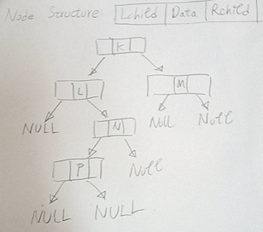

6.

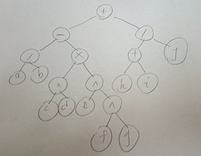

7.

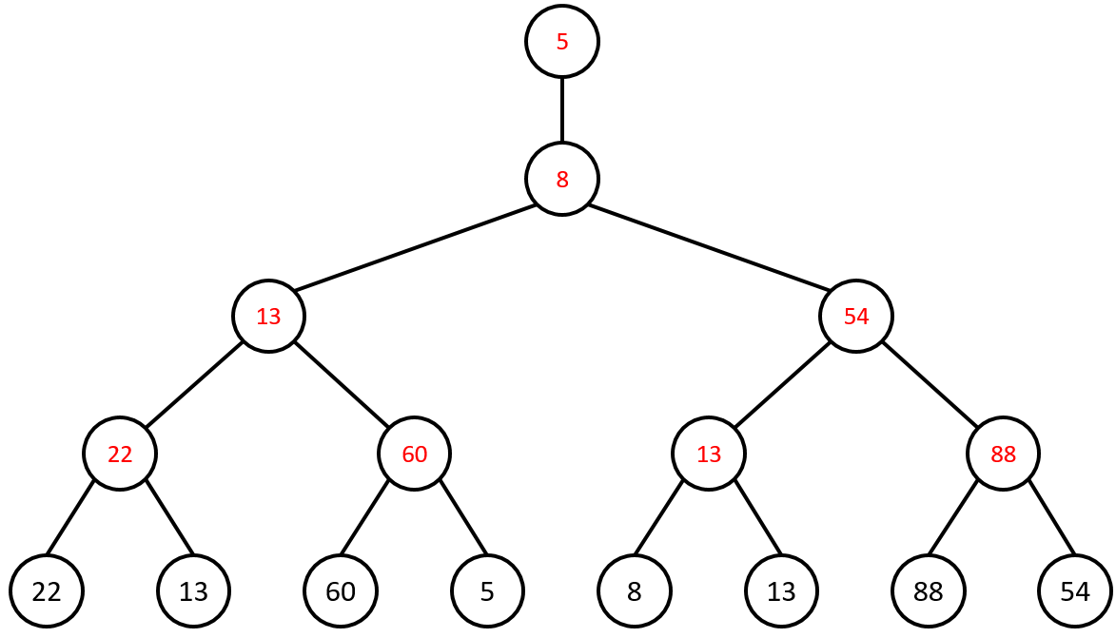

8.

(1) (2)

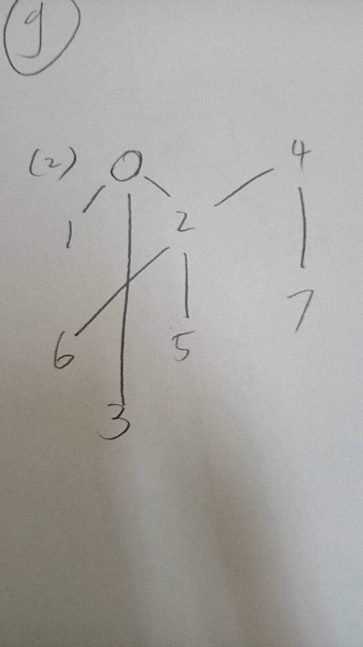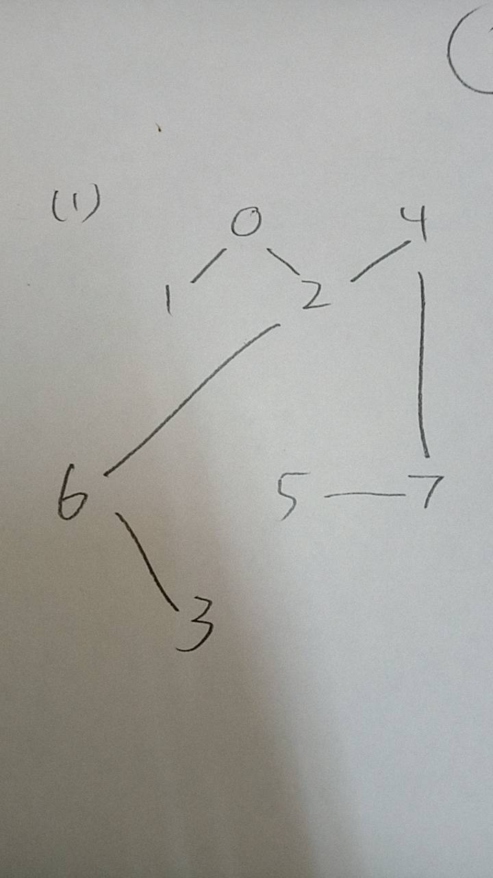

9.

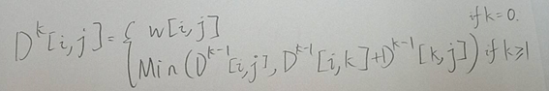

10.

|  |  |  |  |  |  |  |  |  |  |
| --- | --- | --- | --- | --- | --- | --- | --- | --- | --- |
|  |  |  |  | [1] | [2] | [3] | [4] | [5] | [6] |
| init |  |  |  | 0 | 35 | ∞ | ∞ | ∞ | ∞ |
| 1 | {1} | 2 |  | 0 | 35 | 80 | 65 | ∞ | ∞ |
| 2 | {1,2} | 4 |  | 0 | 35 | 80 | 65 | 110 | 195 |
| 3 | {1,2,4} | 3 |  | 0 | 35 | 80 | 65 | 105 | 195 |
| 4 | {1,2,3,4} | 5 |  | 0 | 35 | 80 | 65 | 105 | 195 |

11.

-3

Bellman and Ford algorithm

12.

(1) root->left_child

(2) root->right_child

(3) distance[i][j] = cost[i][j]

(4) distance[i][k]+distance[k][j]

(5) distance[i][k]+distance[k][j]

13.

(1)

10,25,22,12,16,14

(2)

10,12,14,16,22,25

14.

Tree1 3

Tree2 6

15.

(1)

Big O(1)

因為最大值只有可能是在level1的兩個node中的一個,因此只要比較兩者大小就好.

(2)

Big O($\log{n})$

因為插入的新node位置在原tree的最後一層的最後一個node的後面,所以要調整這個tree時要向上逐層比大小,所以時間複雜度就是這個tree的高度