**R10922196 方郁婷**

**Description**

* Calculate theoretical values (FOV, 視野) and compare with measured values
* Use lens of focal length: 18mm, 53mm, 135mm 鏡頭的焦距(f)
* Object displacement of: 1mm, 5mm, 10mm, 20mm 物體每張照片的位移(實際位移, 由照片檔名可知)
* Object distance of: 0.6m, 1.2m, 1.8m 相機與物體的距離 (object distance, 由照片檔名可知)
* Camera : Pentax K-7, 18-135mm 相機的型號
* Sensor size : 23.4 x 15.6 mm => sensor wisth = 23.4

位移的pixel可用小畫家去計算  
mm per pixel = 實際位移/pixel位移

套用以下公式可計算理論數值與實際數值

使用excel去計算

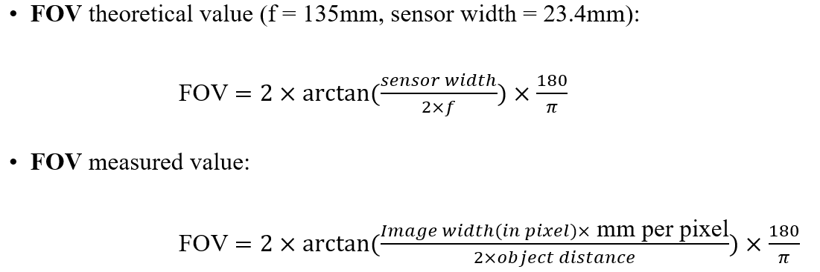

**Result**

|  |  |  |  |  |  |  |  |
| --- | --- | --- | --- | --- | --- | --- | --- |
| 18mm |  | 實際位移 | x | 位移 Pixel | mm/pixel | FOV 估計 | FOV理論 |
| 600mm_0mm | 600 | 0 | 2255 |  |  |  |  |
| 600mm_1mm | 600 | 1 | 2260 | 5 | 0.2 | 75.81341 | 66.04774 |
| 600mm_5mm | 600 | 5 | 2279 | 24 | 0.208333 | 78.09179 | 66.04774 |
| 600mm_10mm | 600 | 10 | 2307 | 52 | 0.192308 | 73.64571 | 66.04774 |
| 600mm_20mm | 600 | 20 | 2354 | 99 | 0.20202 | 76.37237 | 66.04774 |
| 1200mm_0mm | 1200 | 0 | 2324 |  |  |  |  |
| 1200mm_1mm | 1200 | 1 | 2327 | 3 | 0.333333 | 65.95818 | 66.04774 |
| 1200mm_5mm | 1200 | 5 | 2340 | 16 | 0.3125 | 62.62709 | 66.04774 |
| 1200mm_10mm | 1200 | 10 | 2355 | 31 | 0.322581 | 64.25411 | 66.04774 |
| 1200mm_20mm | 1200 | 20 | 2380 | 56 | 0.357143 | 69.617 | 66.04774 |
| 1800mm_0mm | 1800 | 0 | 2317 |  |  |  |  |
| 1800mm_1mm | 1800 | 1 | 2319 | 2 | 0.5 | 65.95818 | 66.04774 |
| 1800mm_5mm | 1800 | 5 | 2328 | 11 | 0.454545 | 61.07262 | 66.04774 |
| 1800mm_10mm | 1800 | 10 | 2336 | 19 | 0.526316 | 68.66935 | 66.04774 |
| 1800mm_20mm | 1800 | 20 | 2362 | 45 | 0.444444 | 59.95185 | 66.04774 |
|  |  |  |  |  |  |  |  |
|  |  |  |  |  |  |  |  |
| 53mm |  | 實際位移 | x | 位移 Pixel | mm/pixel | FOV 估計 | FOV理論 |
| 600mm_0mm | 600 | 0 | 2221 |  |  |  |  |
| 600mm_1mm | 600 | 1 | 2244 | 23 | 0.043478 | 19.21538 | 24.89732 |
| 600mm_5mm | 600 | 5 | 2284 | 63 | 0.079365 | 34.34174 | 24.89732 |
| 600mm_10mm | 600 | 10 | 2350 | 129 | 0.077519 | 33.58855 | 24.89732 |
| 600mm_20mm | 600 | 20 | 2485 | 264 | 0.075758 | 32.86679 | 24.89732 |
| 1200mm_0mm | 1200 | 0 | 2362 |  |  |  |  |
| 1200mm_1mm | 1200 | 1 | 2372 | 10 | 0.1 | 22.03162 | 24.89732 |
| 1200mm_5mm | 1200 | 5 | 2406 | 44 | 0.113636 | 24.94729 | 24.89732 |
| 1200mm_10mm | 1200 | 10 | 2442 | 80 | 0.125 | 27.35236 | 24.89732 |
| 1200mm_20mm | 1200 | 20 | 2526 | 164 | 0.121951 | 26.70941 | 24.89732 |
| 1800mm_0mm | 1800 | 0 | 2382 |  |  |  |  |
| 1800mm_1mm | 1800 | 1 | 2395 | 13 | 0.076923 | 11.40179 | 24.89732 |
| 1800mm_5mm | 1800 | 5 | 2420 | 38 | 0.131579 | 19.38075 | 24.89732 |
| 1800mm_10mm | 1800 | 10 | 2440 | 58 | 0.172414 | 25.22492 | 24.89732 |
| 1800mm_20mm | 1800 | 20 | 2484 | 102 | 0.196078 | 28.55367 | 24.89732 |
|  |  |  |  |  |  |  |  |
|  |  |  |  |  |  |  |  |
| 135mm |  | 實際位移 | x | 位移 Pixel | mm/pixel | FOV 估計 | FOV理論 |
| 600mm_0mm | 600 | 0 | 2120 |  |  |  |  |
| 600mm_1mm | 600 | 1 | 2177 | 57 | 0.017544 | 7.814934 | 9.906515 |
| 600mm_5mm | 600 | 5 | 2277 | 157 | 0.031847 | 14.13623 | 9.906515 |
| 600mm_10mm | 600 | 10 | 2382 | 262 | 0.038168 | 16.90466 | 9.906515 |
| 600mm_20mm | 600 | 20 | 2622 | 502 | 0.039841 | 17.6341 | 9.906515 |
| 1200mm_0mm | 1200 | 0 | 2427 |  |  |  |  |
| 1200mm_1mm | 1200 | 1 | 2465 | 38 | 0.026316 | 5.865177 | 9.906515 |
| 1200mm_5mm | 1200 | 5 | 2490 | 63 | 0.079365 | 17.56521 | 9.906515 |
| 1200mm_10mm | 1200 | 10 | 2570 | 143 | 0.06993 | 15.50411 | 9.906515 |
| 1200mm_20mm | 1200 | 20 | 2740 | 313 | 0.063898 | 14.18094 | 9.906515 |
| 1800mm_0mm | 1800 | 0 | 2270 |  |  |  |  |
| 1800mm_1mm | 1800 | 1 | 2275 | 5 | 0.2 | 29.10072 | 9.906515 |
| 1800mm_5mm | 1800 | 5 | 2304 | 34 | 0.147059 | 21.60989 | 9.906515 |
| 1800mm_10mm | 1800 | 10 | 2357 | 87 | 0.114943 | 16.96849 | 9.906515 |
| 1800mm_20mm | 1800 | 20 | 2480 | 210 | 0.095238 | 14.09181 | 9.906515 |