# DIP Homework Assignment #4

# Name: 方郁婷

# ID #: r10922196

# email: [r10922196@ntu.edu.tw](mailto:r10922196@ntu.edu.tw)

Problem 1: DIGITAL HALFTONING  
(a) (10 pt) According to the dither matrix I2, please perform dithering to obtain a binary image result1.png.

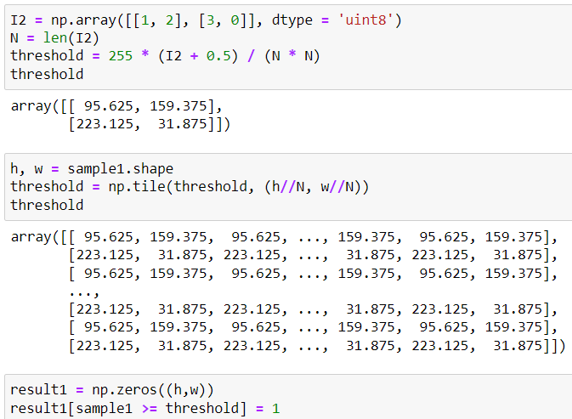

將I2擴大成與圖片一樣大後，判斷有無過Threshold，有過的話就設為1

|  |  |
| --- | --- |
| input | output |

看起來相當粗糙

(b) (15 pt) Expand the dither matrix I2 to I256 (256 × 256) and use it to perform dithering. Output the result as result2.png. Compare result1.png and result2.png along with some discussions.

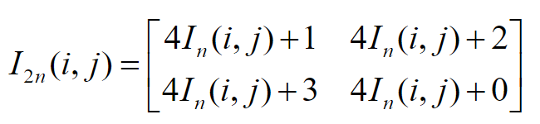

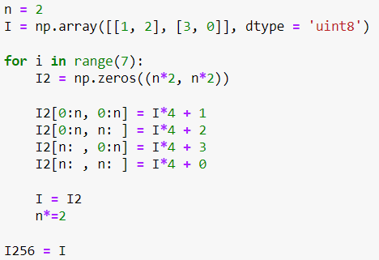

將原矩陣擴充到(256X256)後再使用跟上一題一樣的方法

|  |  |
| --- | --- |
| input | output |

有變比較精緻一點

|  |  |
| --- | --- |
| Result1 | Result2 |

Result1看起來還是會有四四方方的網格樣

Result2的網格有較多變化

(c) (25 pt) Perform error diffusion with Floyd-Steinberg and Jarvis’ patterns on sample1.png. Out- put the results as result3.png and result4.png, respectively. You may also try more patterns and show the results in your report. Discuss these patterns based on the results.

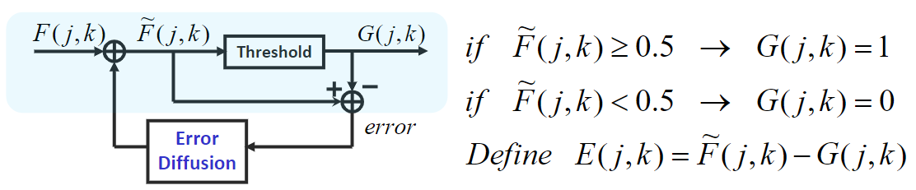

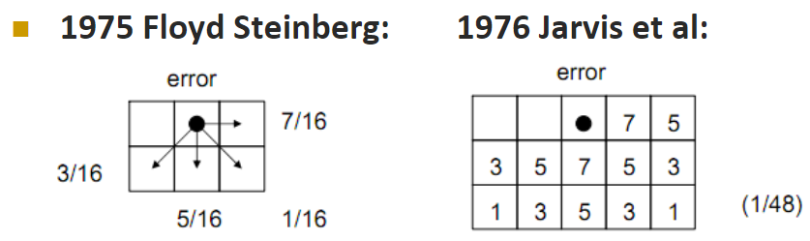

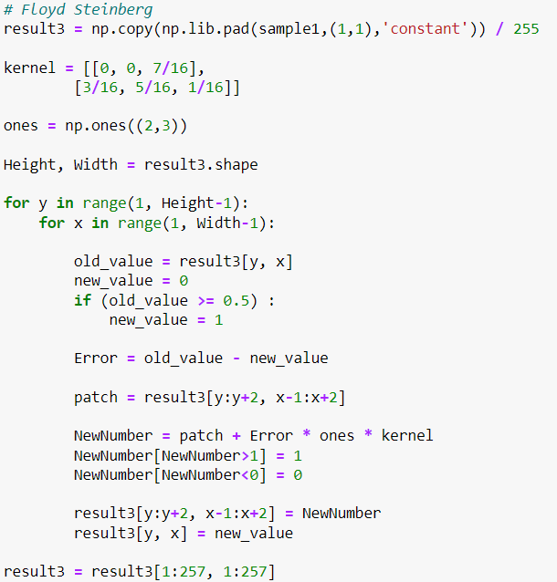

以Floyd-Steinberg為例

首先先判斷有無過Threshold給出new_value，之後計算Error，再將Error擴散給周邊pixel(使用kernel計算)，擴散完後再將超過1的設為1，小於0的設為0

Jarvis’的算法同上，只是改變kernel矩陣裡的值

|  |  |
| --- | --- |
| input |  |
| Floyd-Steinberg | Jarvis’ |

Discuss:

Jarvis’的眼白還有右邊鬍鬚比較明顯，空格與對比較大，Floyd-Steinberg比較暗比較糊。

Problem 2: Image Sampling  
(a) (25 pt) By analyzing sample2.png, please explain how to perform image sampling on it to avoid aliasing. Please also perform ’inappropriate’ image sampling which results in aliasing in the sampled image. Output the result as result5.png, specify the sampling rate you choose and discuss how it affects the resultant image.

老實說我在上課時一直半聽半懂的，因為那些公式看起來真的好可怕，不是很好理解，所以我就重新學了一下一維的sample

以一維的波為例

|  |  |
| --- | --- |
| 原波 | |
| 剛好不失真  Sample rate = 2倍頻率 | aliasing  Sample rate < 2倍頻率 |

之後又突然想到這跟老師之前在課堂上講過的圖片sampling很像，就一瞬間茅塞頓開了。

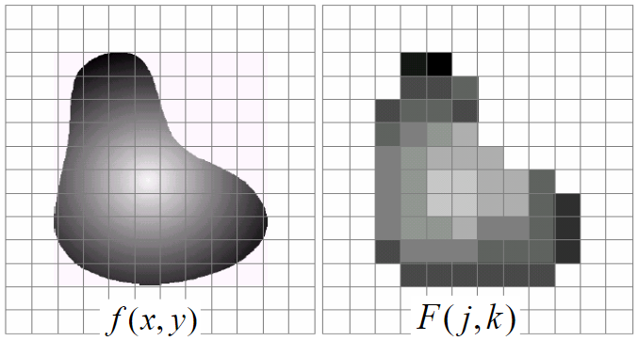

在空間域上可以把sample的頻率視為圖片解析度，sample後跟原圖比有很明顯的aliasing，我想在頻率域上也是一樣的原理吧。

以二維的例子來說



當你的ratio設為0.5時，你其實只保留了二分之一的col與row，因此你的圖片喪失了一半的資訊，所以會有aliasing，如同一維的例子一樣

|  |  |
| --- | --- |
| input | output |

Sample後的條紋變網格了

以這張圖來說，ratio設0.8以下就會產生明顯的aliasing，要避免產生aliasing就要讓Sample rate >= 2倍頻率

(b) (25 pt) Given sample3.png, please perform the unsharp masking mentioned in the lecture in the frequency domain and transform the result back to the pixel domain by inverse Fourier transform.  
Save the resultant image as result6.png and describe your steps in detail.

我使用的是高斯的mask，因為比較不會有水波紋

|  |  |
| --- | --- |
| 這是low pass 的mask | 這是1 - low pass 的mask = high pass |

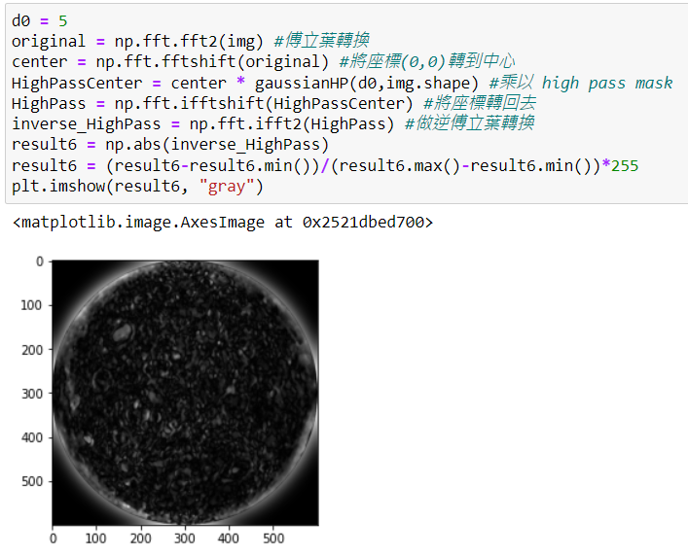

|  |  |  |
| --- | --- | --- |
| D = 100 | D=50 | D=30 |
| D=20 | D=10 | D=5 |

D越小，月球表面越明顯

我最後選擇D=5的mask(如下圖)，因為他能把月球的凹凸輪廓變得比較明顯

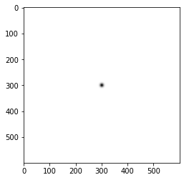

|  |  |
| --- | --- |
| input | output |