Name: Ying Fei Zang

Student ID: 261054638

Mail: ying.zang@mail.mcgill.ca

Charter: Todo_List_Manager_Projects_001

Session Time: 2024-02-06 1:00am to 2024-02-06 1:45am

Goal:   
-Identify capabilities and areas of potential instability of the “rest api todo list manager”.

-Identify documented and undocumented “rest api todo list manager” capabilities.

-For each capability create a script or small program to demonstrate the capability.

-Exercise each capability identified with data typical to the intended use of the application.

Explore “Project” page 1:00am

-------------------------------------------------------------

Click on Project instance ID

- shows JSON and XML Example of the project instance  
- As List appears  
- Click on As List shows fields as HTML table. (As List does not show clearly that it is clickable)

Browsing “API Documentation” page 1:10am  
-------------------------------------------------------------

- Learn how to send request using Rest API

Modifying Project Instance 1:18 – 1:45am

-------------------------------------------------------------

1. Add instance using Postman:

- Shows in list manager:  
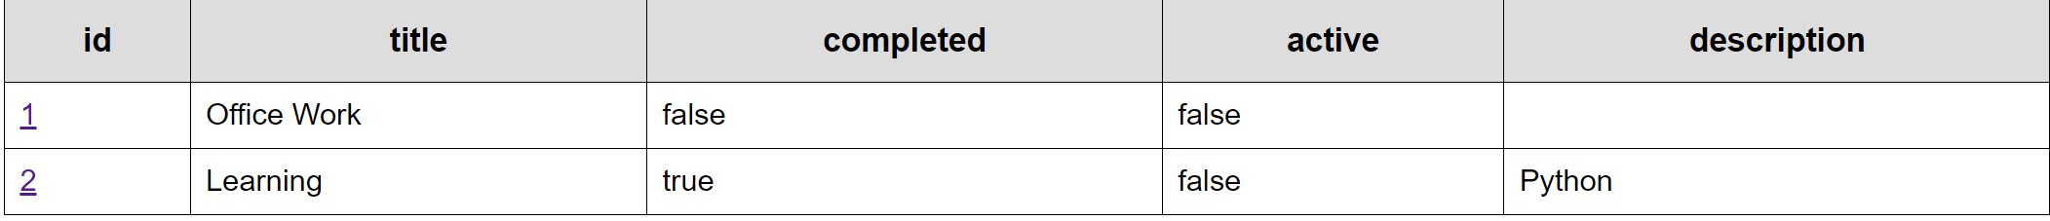

1. Delete the instance using:  
   

** After the delete of this instance, when click on go back in browser (Chrome) to go from API Documentation to the list table, the deleted instance with id 2 are still shown.

1. Attempt to send JSON with bad syntax ( “completed”: “true”):  
   A computer screen shot of a computer code

   Description automatically generated  
   - This made the ID number to plus 1. Before, we were at ID 4. After this error, I tried to add new project instance, its ID becomes:  
   A screenshot of a computer code

   Description automatically generated
2. Modify Existing Instance:  
   A screenshot of a web page

   Description automatically generated  
   - Get 200 ok code back, successfully modified description:  
   A screenshot of a computer

   Description automatically generated

** ID not in order

1. Test Get tasks:  
   

Return:

1. Relate Todos to project tasks:  
   A screenshot of a computer

   Description automatically generated

** Use title to refer Todos, if the title of Todos does not exist, create a Todo and refer to this Project. 🡪 Difficult to know if the project is linked with the Todo I wanted. (API Doc did not specify this)

*** API Doc also did not specify which field I needed to use to link Project tasks with a Todo.  
Here I knew I need to use “title” field because I tried to send the request with empty body: an error was returned to me giving me the correct way to do it.