Databases
Laboratory Work 2
Normalization & DDL
Prepared by: Nurakhaev Zangar

Part 1. Normalization

Task 1. Which normal form does Booking_receipt violate?
The table Booking_receipt(booking_id, passenger_full_name, passenger_passport_number, flight_number, departure_airport_name, departure_city, arrival_airport_name, arrival_city, airline_name, seat_numbers, ticket_price) violates 1NF.
Reason: the column seat_numbers stores multiple values in a single cell (e.g. "12A, 12B") when a booking covers several passengers/seats on the same reservation. A cell must hold a single atomic value for a table to be in 1NF, so seat_numbers is the column responsible for the violation.
Additionally, if 1NF were fixed, the table would still violate 3NF: attributes such as airline_name (determined by flight_number) and departure_city / arrival_city (determined by departure_airport_name / arrival_airport_name) depend on non-key attributes rather than directly on the key — these are transitive dependencies.

Task 2. Step-by-step normalization
Step 1 — 1NF: remove the repeating group by giving each seat its own row.
Booking_receipt_1NF(booking_id, seat_number, passenger_full_name, passenger_passport_number, flight_number, departure_airport_name, departure_city, arrival_airport_name, arrival_city, airline_name, ticket_price)
Primary key (underlined): booking_id, seat_number (composite key).
Step 2 — 2NF: remove partial dependencies (non-key attributes depending on only part of the composite key).
Booking(booking_id [PK], passenger_full_name, passenger_passport_number, flight_number, departure_airport_name, departure_city, arrival_airport_name, arrival_city, airline_name, ticket_price)
Booking_Seats(booking_id [PK, FK → Booking], seat_number [PK])
Step 3 — 3NF: remove transitive dependencies (non-key attributes depending on other non-key attributes).
- Passenger(passport_number [PK], passenger_full_name)
- Airport(airport_name [PK], city)
- Airline(airline_name [PK])
- Flight(flight_number [PK], departure_airport_name [FK → Airport], arrival_airport_name [FK → Airport], airline_name [FK → Airline])
- Booking(booking_id [PK], passport_number [FK → Passenger], flight_number [FK → Flight], ticket_price)
- Booking_Seats(booking_id [PK, FK → Booking], seat_number [PK])

Task 3. Functional dependencies used
booking_id -> passenger_passport_number, flight_number, ticket_price
passenger_passport_number -> passenger_full_name
flight_number -> departure_airport_name, arrival_airport_name, airline_name
departure_airport_name -> departure_city
arrival_airport_name -> arrival_city
(booking_id, seat_number) -> [nothing else; this is the full key for Booking_Seats]

Task 4. Is Flights (from the DDL section) in 3NF?
Primary key: flight_id (simple, non-composite).
Functional dependency: flight_id → all other attributes (sch_departure_time, sch_arrival_time, departing_airport_id, arriving_airport_id, departing_gate, arriving_gate, airline_id, act_departure_time, act_arrival_time, created_at, updated_at).
Since the key is simple (not composite), no partial dependency can exist — 2NF is automatically satisfied.
Checking for transitive dependencies between non-key attributes: departing_airport_id does not determine departing_gate (the gate is assigned per flight, not fixed per airport); airline_id does not determine any other Flights attribute (the airline's name/country is stored separately in the airline table, not duplicated here). No non-key attribute determines another non-key attribute.
Conclusion: Flights is in 3NF.

Task 5. Implement 3NF tables and populate with sample data
SQL executed in schema "normalization" inside the airport_db database:
CREATE SCHEMA normalization;
CREATE TABLE normalization.passenger (
passport_number VARCHAR(20) PRIMARY KEY,
passenger_full_name VARCHAR(100) NOT NULL
);
CREATE TABLE normalization.airline (
airline_name VARCHAR(100) PRIMARY KEY
);
CREATE TABLE normalization.airport (
airport_name VARCHAR(100) PRIMARY KEY,
city VARCHAR(50) NOT NULL
);
CREATE TABLE normalization.flight (
flight_number VARCHAR(20) PRIMARY KEY,
departure_airport_name VARCHAR(100) NOT NULL REFERENCES normalization.airport(airport_name),
arrival_airport_name VARCHAR(100) NOT NULL REFERENCES normalization.airport(airport_name),
airline_name VARCHAR(100) NOT NULL REFERENCES normalization.airline(airline_name)
);
CREATE TABLE normalization.booking (
booking_id INT PRIMARY KEY,
passport_number VARCHAR(20) NOT NULL REFERENCES normalization.passenger(passport_number),
flight_number VARCHAR(20) NOT NULL REFERENCES normalization.flight(flight_number),
ticket_price DECIMAL(7,2) NOT NULL
);
CREATE TABLE normalization.booking_seats (
booking_id INT NOT NULL REFERENCES normalization.booking(booking_id),
seat_number VARCHAR(5) NOT NULL,
PRIMARY KEY (booking_id, seat_number)
);
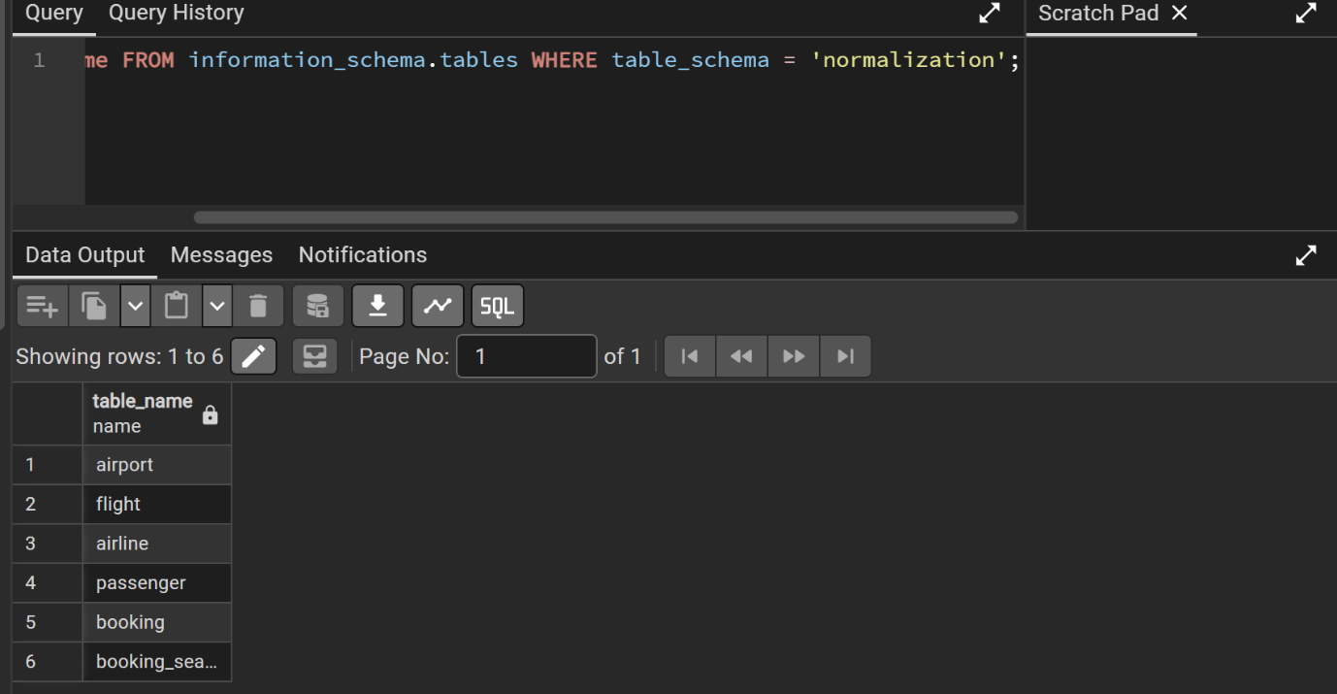
Sample data (5+ rows per table):
INSERT INTO normalization.airport (airport_name, city) VALUES
('Almaty International Airport', 'Almaty'),
('Astana International Airport', 'Astana'),
('Dubai International Airport', 'Dubai');
INSERT INTO normalization.airline (airline_name) VALUES
('Air Astana'), ('FlyDubai');
INSERT INTO normalization.flight (flight_number, departure_airport_name, arrival_airport_name, airline_name) VALUES
('KC101', 'Almaty International Airport', 'Astana International Airport', 'Air Astana'),
('KC205', 'Astana International Airport', 'Almaty International Airport', 'Air Astana'),
('FZ300', 'Dubai International Airport', 'Almaty International Airport', 'FlyDubai'),
('FZ301', 'Almaty International Airport', 'Dubai International Airport', 'FlyDubai');
INSERT INTO normalization.passenger (passport_number, passenger_full_name) VALUES
('A1234567', 'John Smith'),
('N7654321', 'Aigerim Bekova'),
('B2233445', 'Ivan Petrov'),
('N1122334', 'Aidana Serik'),
('C5566778', 'Marat Tolegen');
INSERT INTO normalization.booking (booking_id, passport_number, flight_number, ticket_price) VALUES
(1001, 'A1234567', 'KC101', 150.00),
(1002, 'N7654321', 'KC205', 120.00),
(1003, 'B2233445', 'FZ300', 300.00),
(1004, 'N1122334', 'KC101', 150.00),
(1005, 'C5566778', 'FZ301', 310.00);
INSERT INTO normalization.booking_seats (booking_id, seat_number) VALUES
(1001, '12A'), (1001, '12B'),
(1002, '5C'),
(1003, '1A'), (1003, '1B'), (1003, '1C'),
(1004, '14D'),
(1005, '3A'), (1005, '3B');
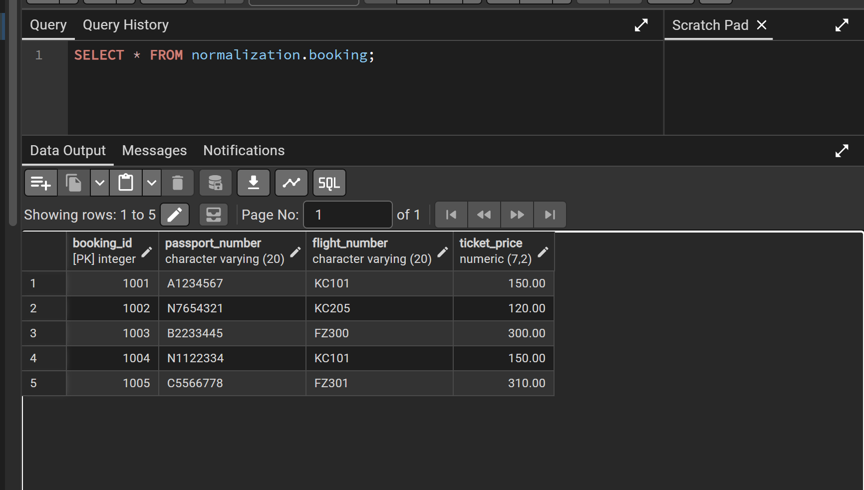

Part 2. DDL

Task 1. Create tables
10 tables created: airline_info, airport, passengers, flights, booking, booking_flight, boarding_pass, baggage, baggage_check, security_check.

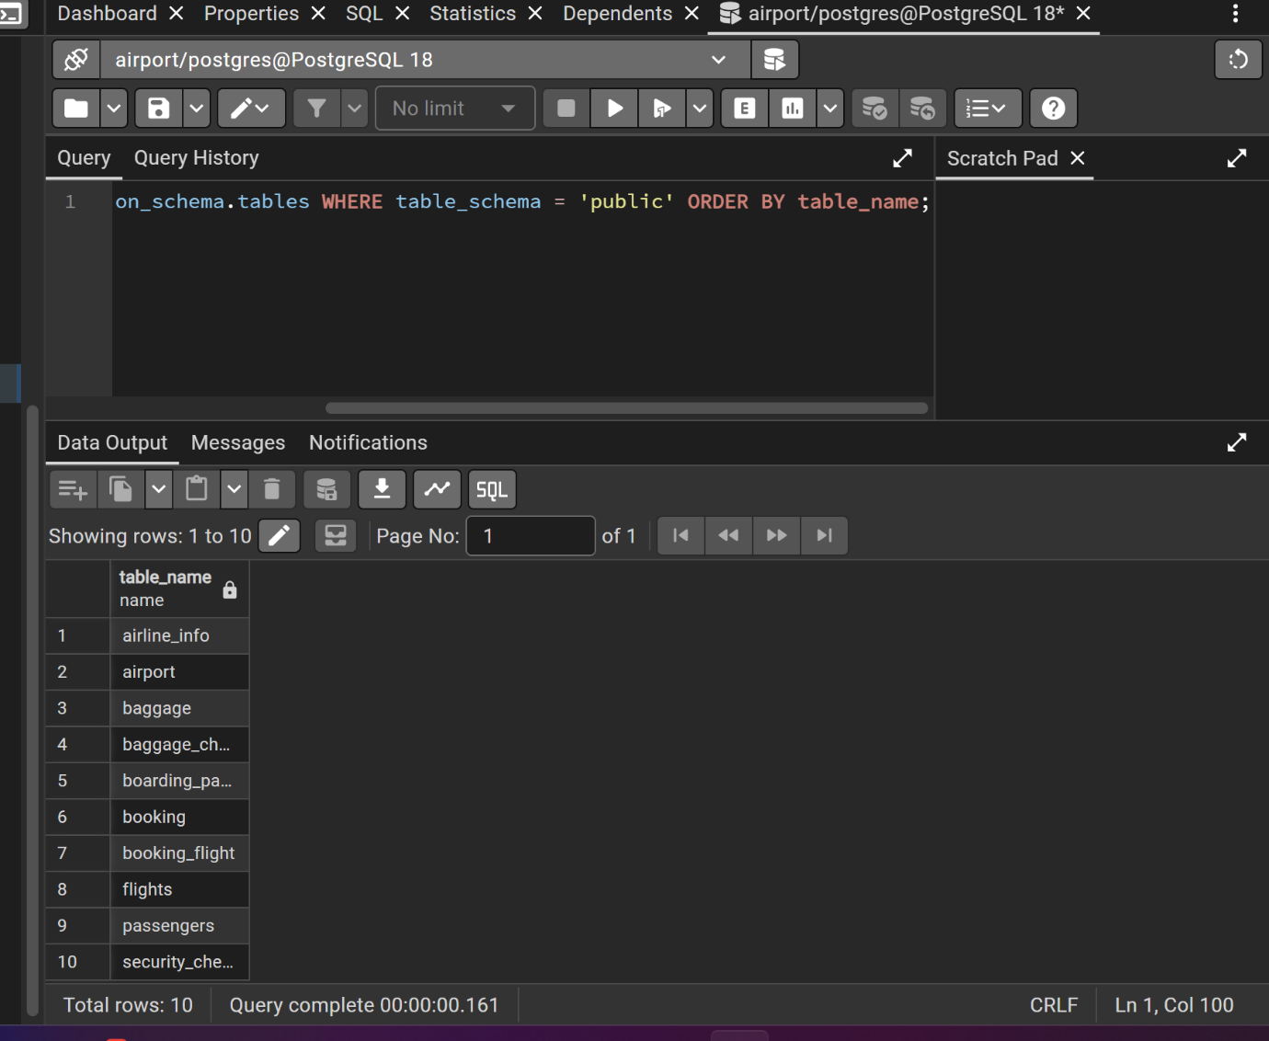

Task 2. Primary Keys
PRIMARY KEY constraint added to each table on its *_id column.

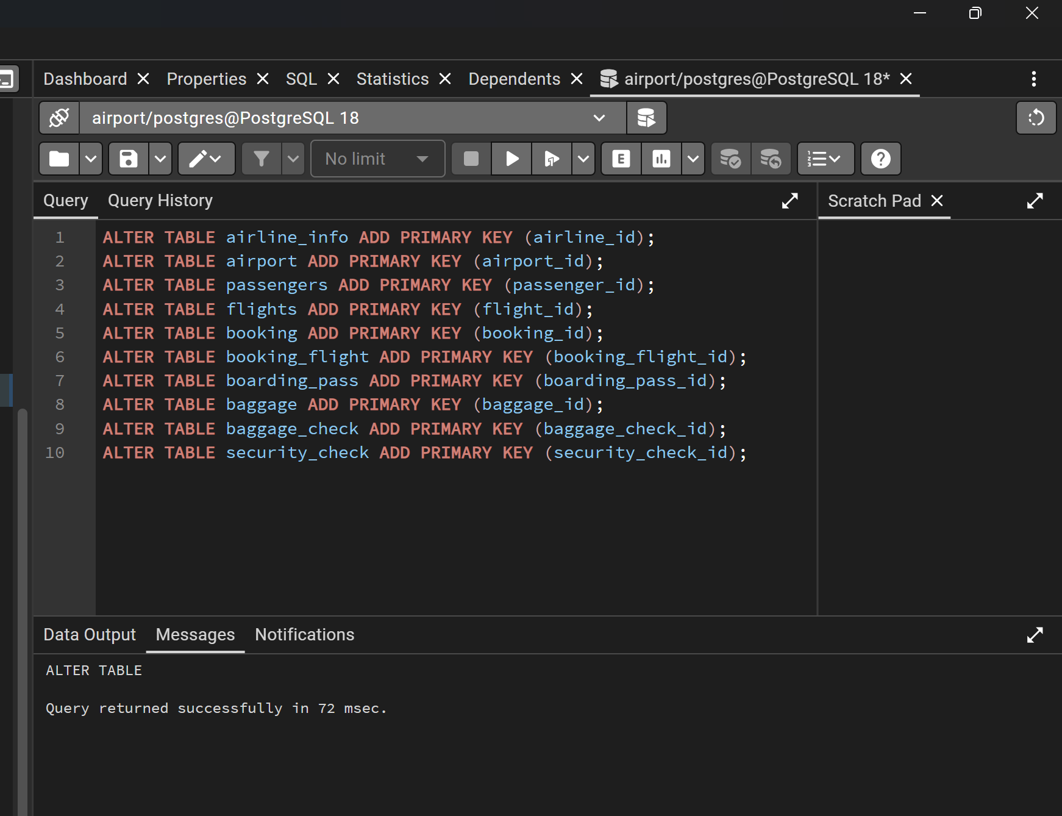

Task 4. NOT NULL constraints
NOT NULL applied to every attribute in every table.

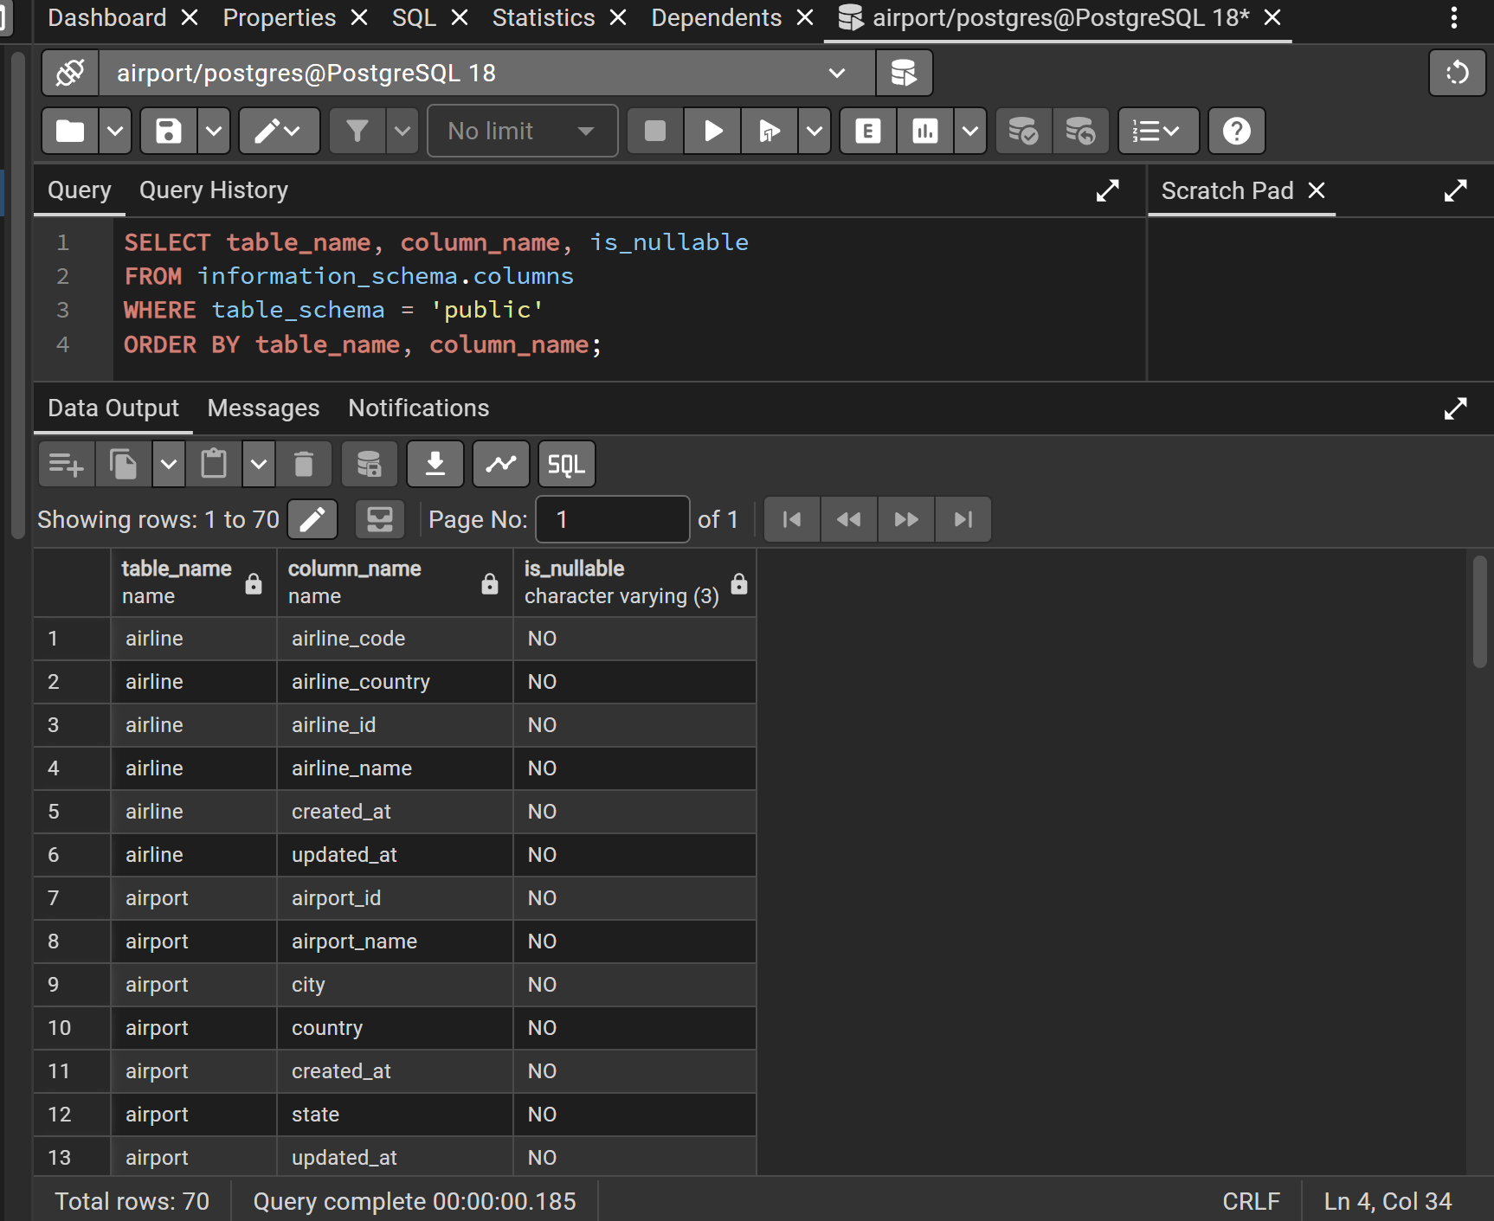

Task 5. Rename table airline_info → airline
ALTER TABLE airline_info RENAME TO airline;

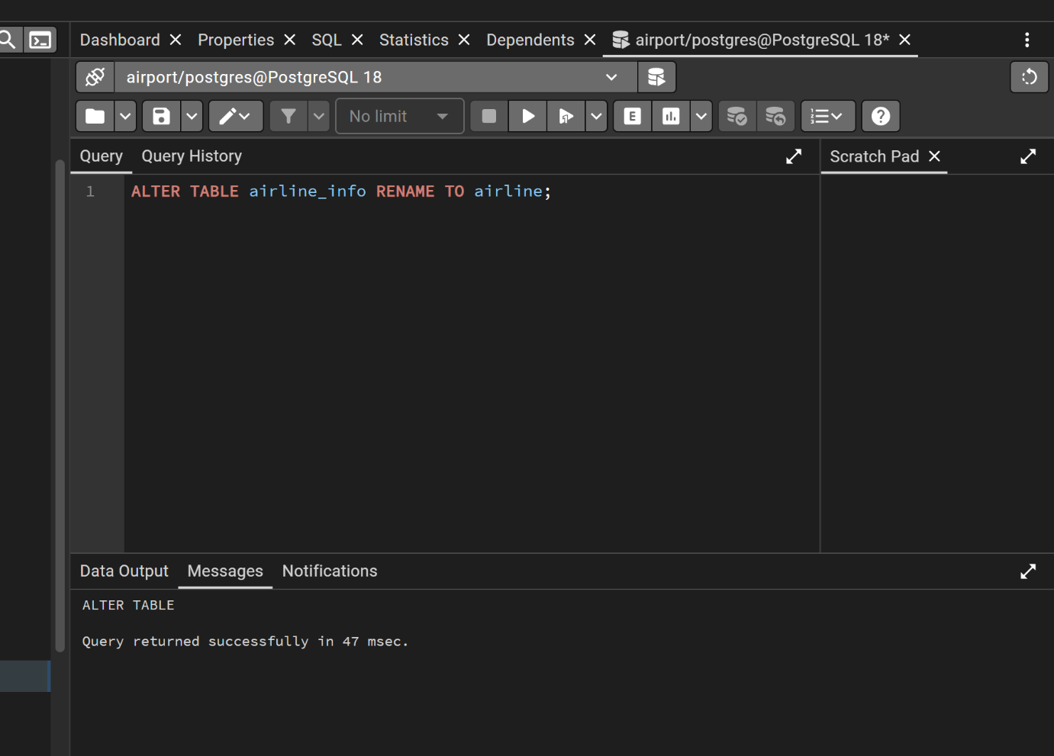

Task 6. Rename column price → ticket_price (booking table)
ALTER TABLE booking RENAME COLUMN price TO ticket_price;

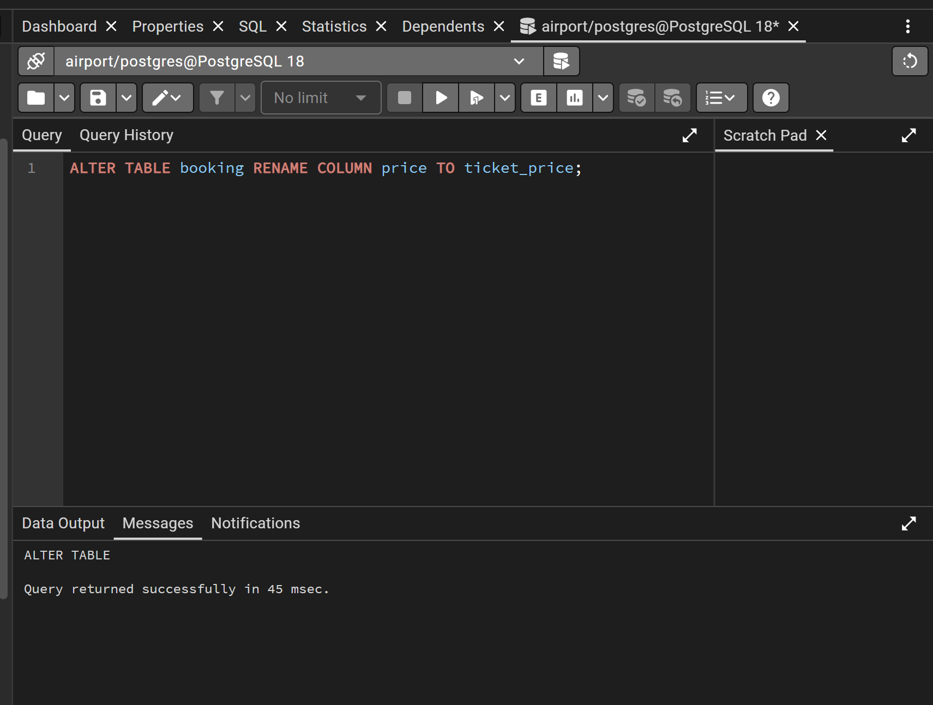

Task 7. Change data type of departing_gate
ALTER TABLE flights ALTER COLUMN departing_gate TYPE text;

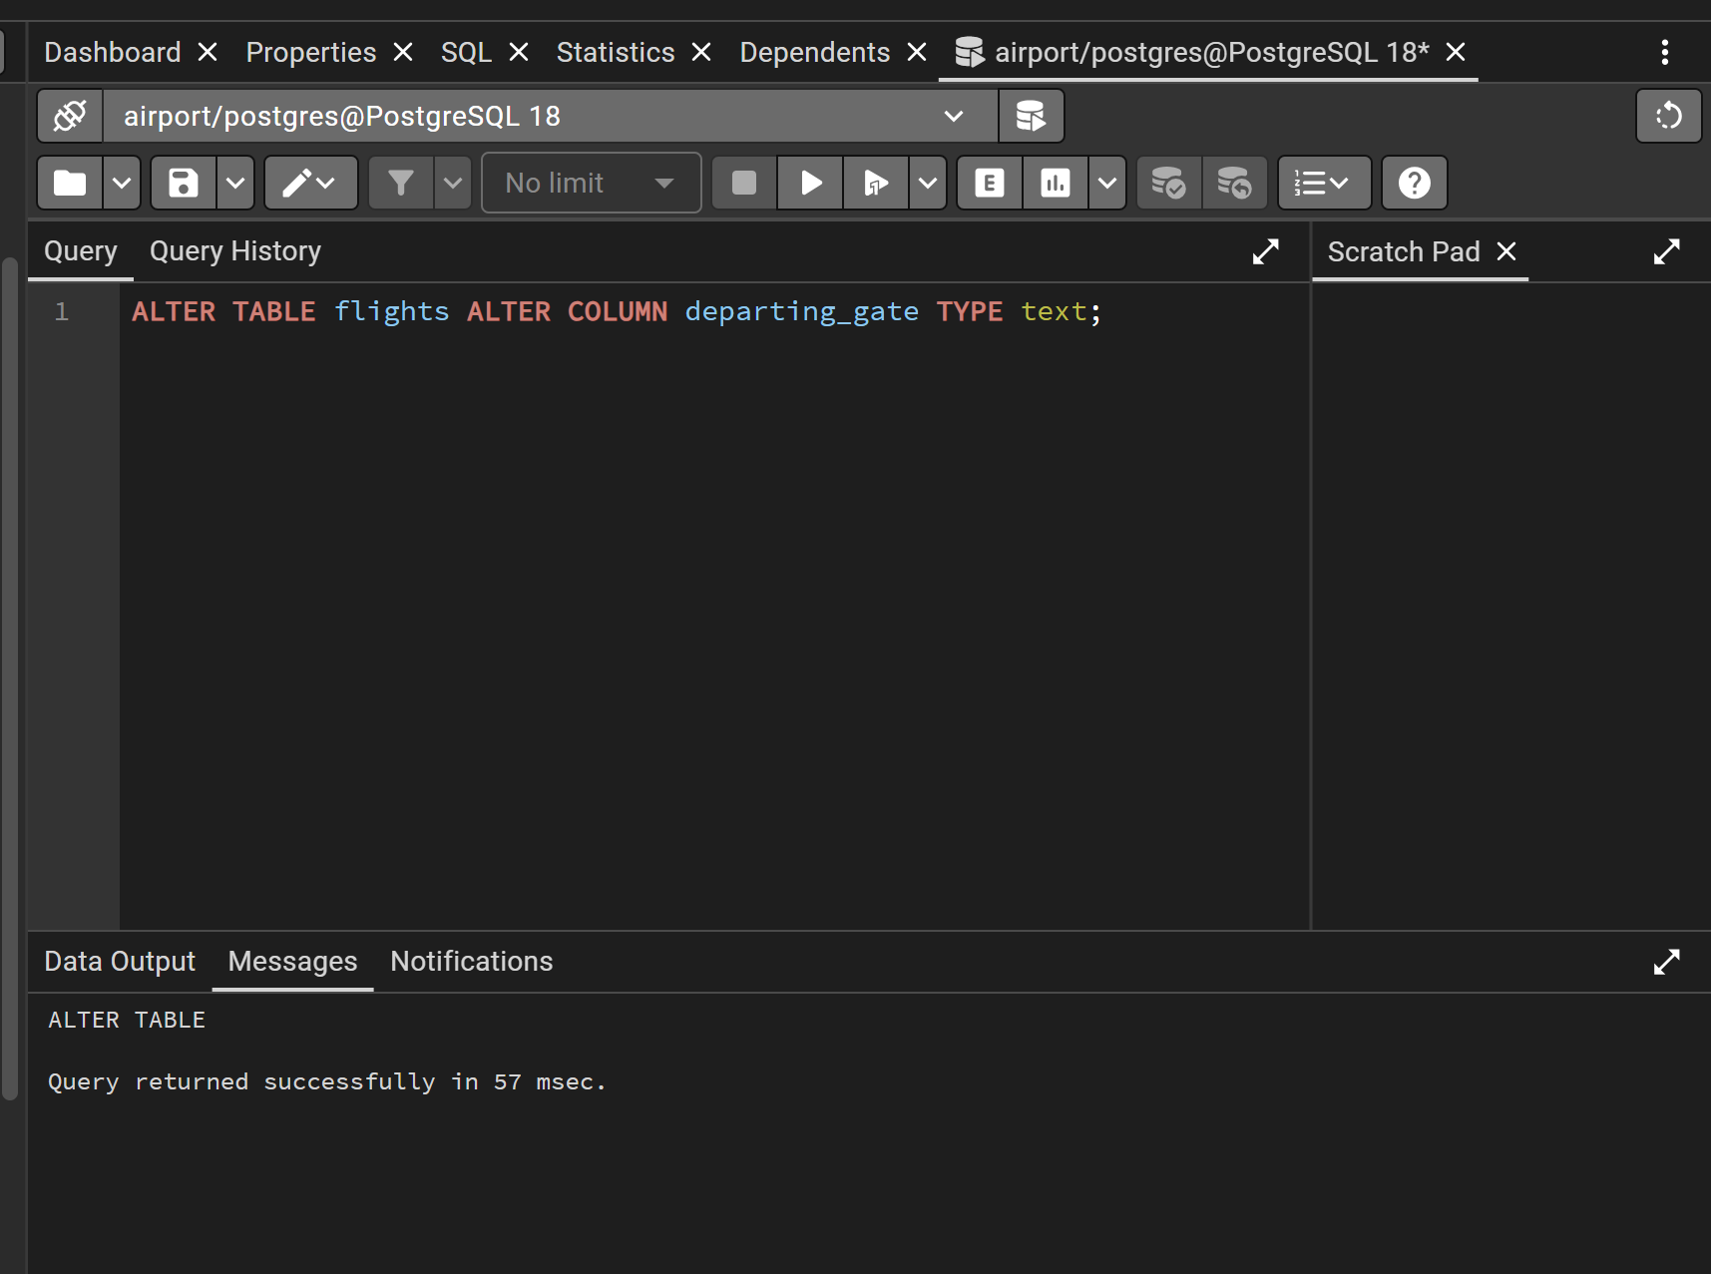

Task 8. Drop column info from airline table
ALTER TABLE airline DROP COLUMN info;

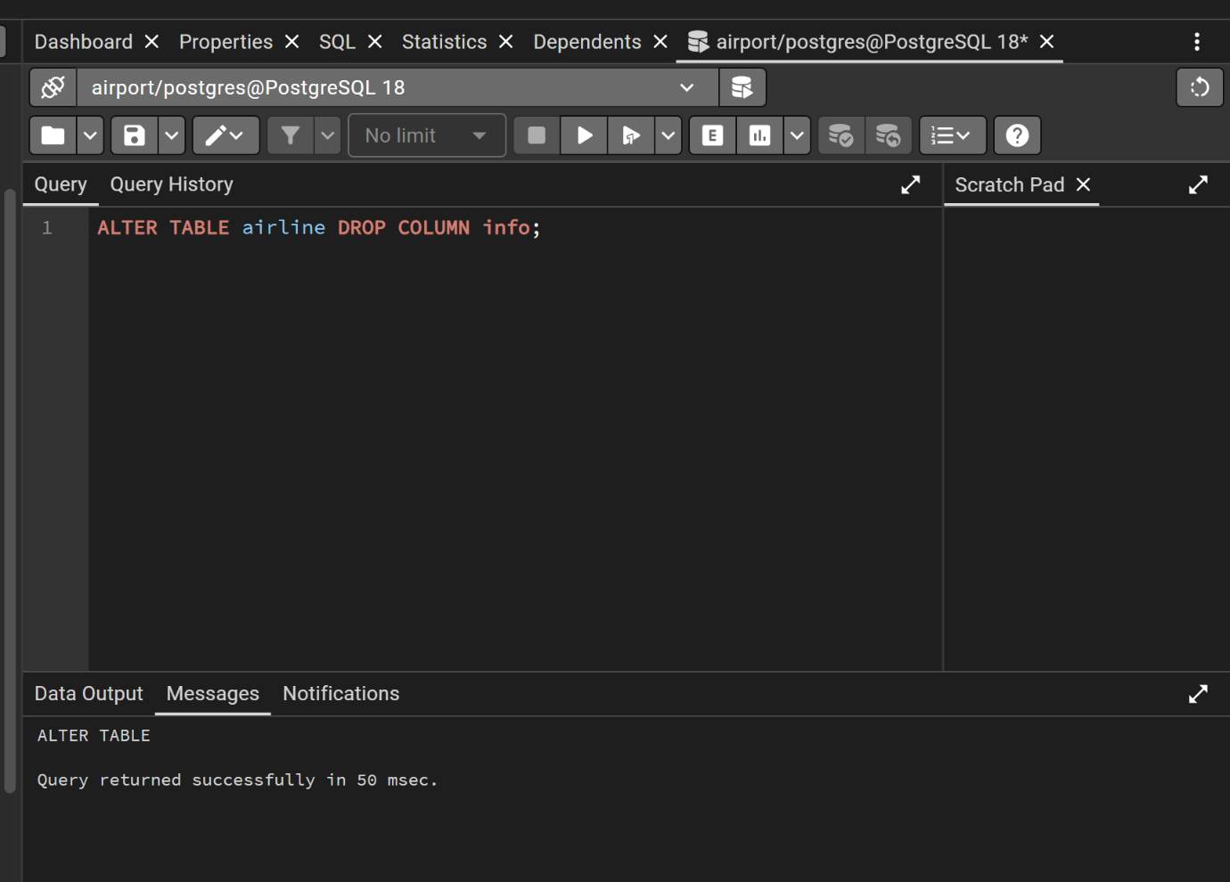

Task 9. Foreign key relationships

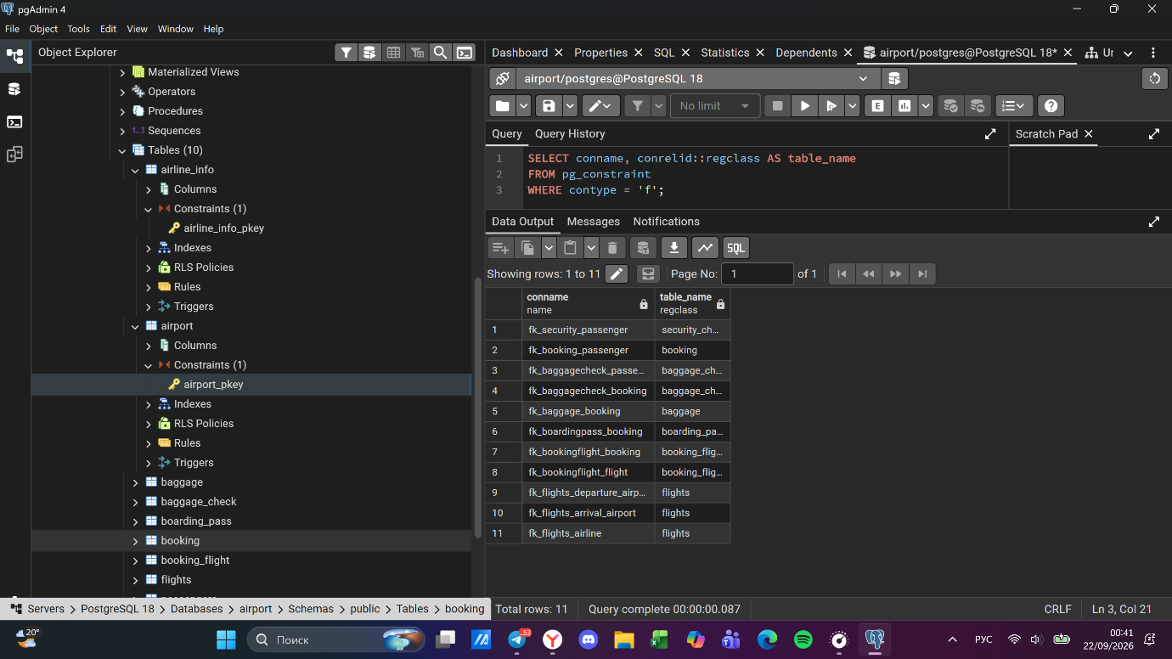
Optional additional screenshot: pgAdmin ERD Tool (Generate ERD) showing the full schema with all relationships.
