Databases
Laboratory Work 4
DQL / String & Date Functions
Prepared by: Nurakhaev Zangar

Tasks

Task 1. Airline names in uppercase

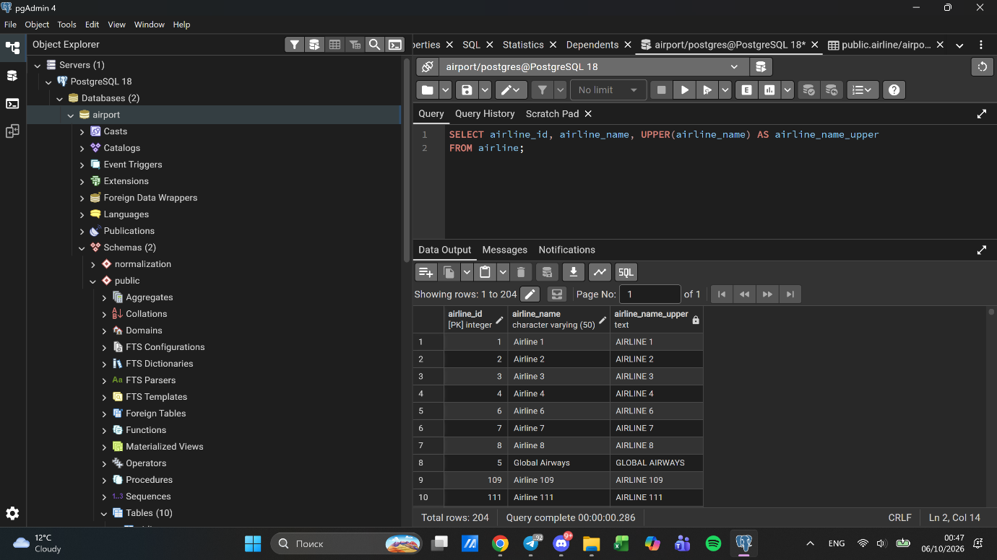

Task 2. Replace "Air" with "Aero" in airline names

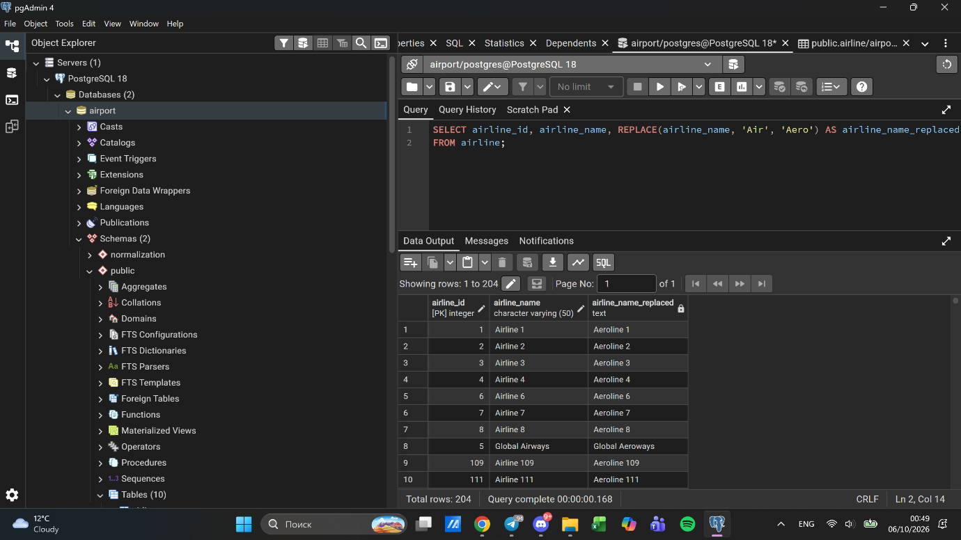

Task 3. Flight numbers associated with airline 1 and airline 2
Each flight has exactly one airline_id in this schema, so a single flight cannot belong to two airlines at once. Interpreted as: flights belonging to either airline 1 or airline 2.

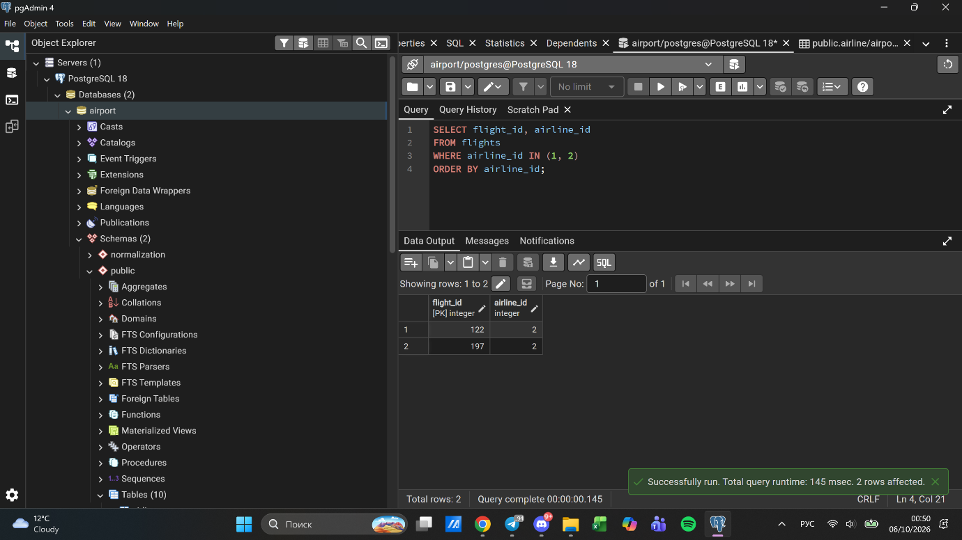

Task 4. Airports containing "Regional" and "Air" in their name
Random test data did not contain such names, so one row was adjusted to demonstrate the filter.

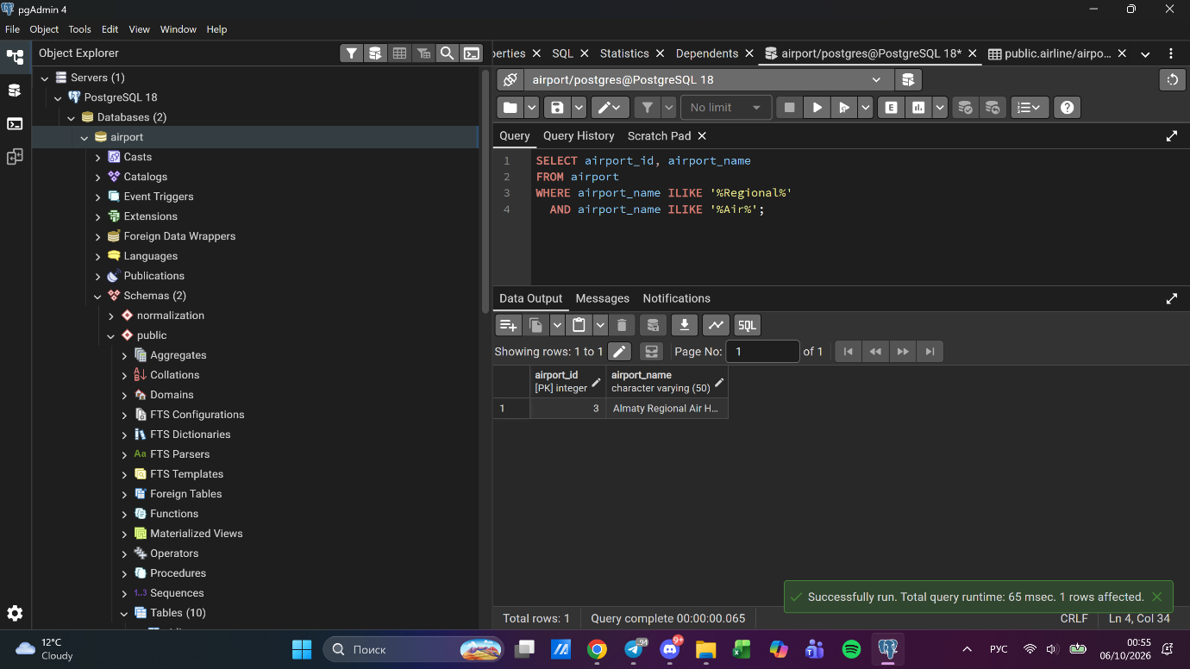

Task 5. Passenger full names with birth date formatted as 'Month DD, YYYY'

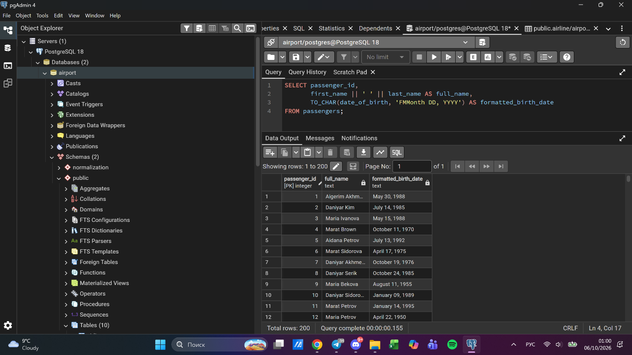

Task 6 & 7. Delayed / late-arriving flights
In this schema act_arrival_time is NOT NULL for every flight, so "delayed" (Task 6) and "arrived late" (Task 7) cannot be distinguished by a missing actual time. Both tasks were answered with the same comparison between actual and scheduled arrival time.

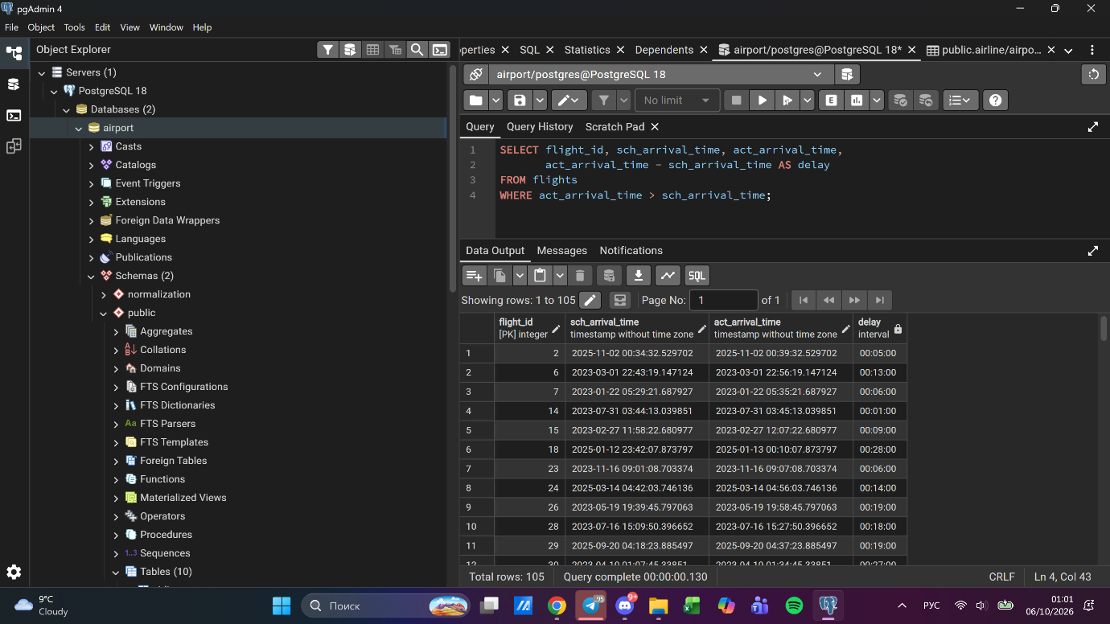

Task 8. Airlines from France/Portugal/Poland created between 2023-11-01 and 2024-03-31
All airline_country values were converted to uppercase in Lab 3 Task 12. Also, all generated created_at values fall after November 2024, outside the range given in the task, so one row was adjusted to demonstrate the filter.

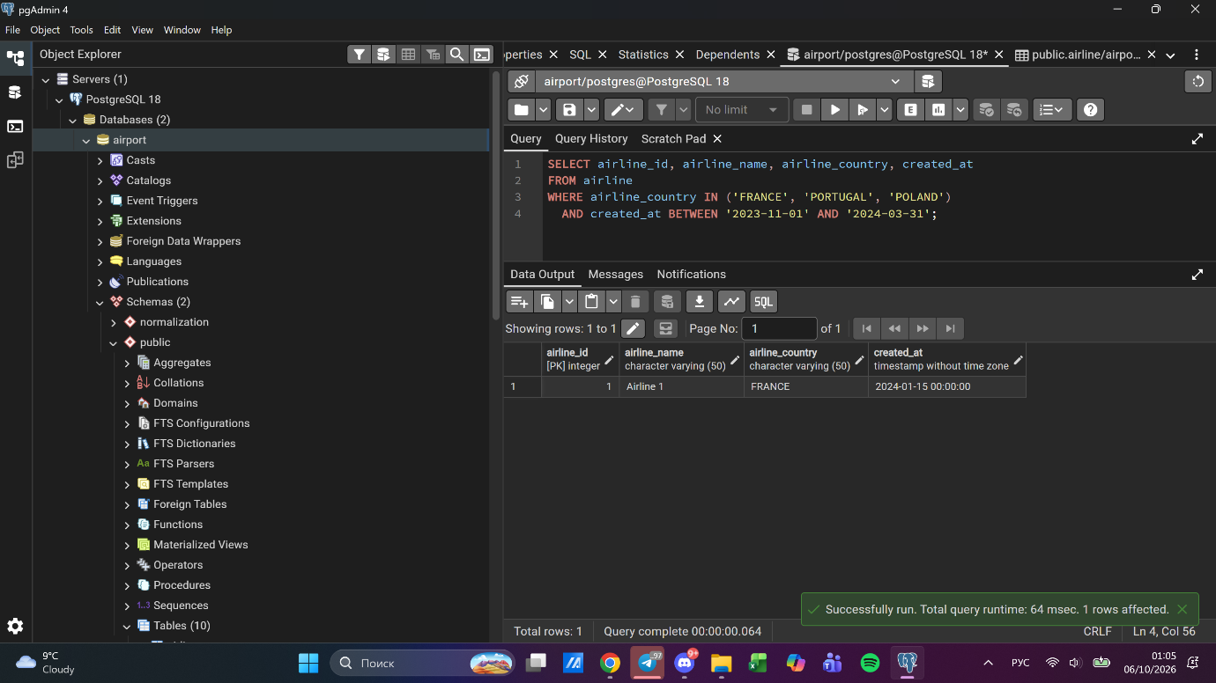

Task 9. Top 3 overweight baggage items (more than 25kg)

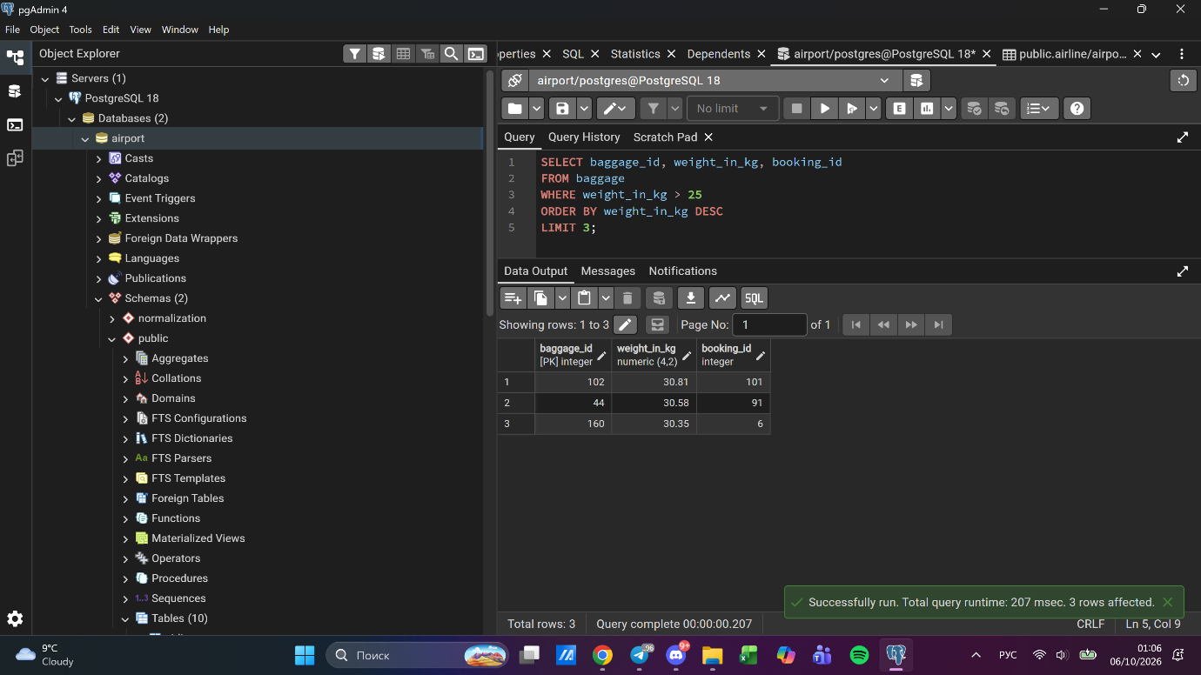

Task 10. Youngest passenger's full name

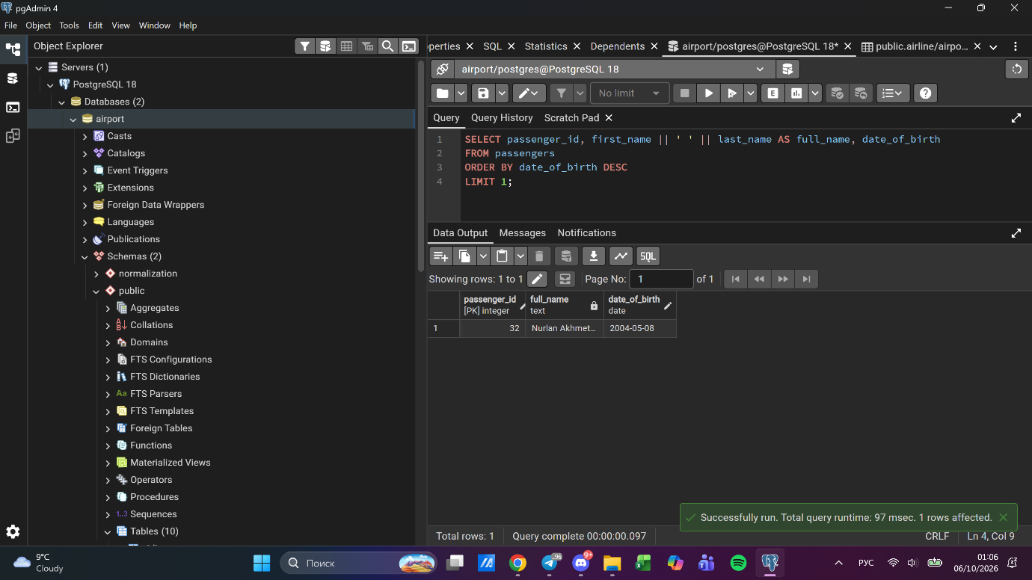

Task 11. Cheapest booking price on each booking platform

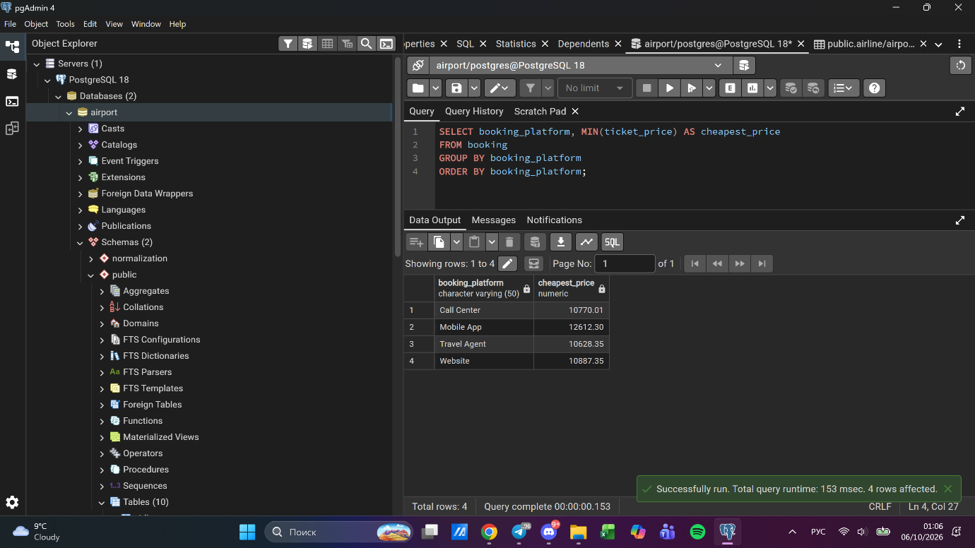

Task 12. Airlines whose airline_code contains a digit
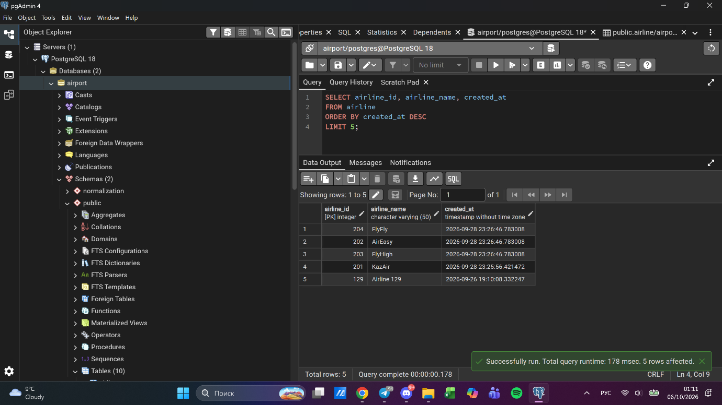

Task 13. Top 5 most recently created airlines

Task 14. Rows where booking_id is between 200 and 300 and check_result <> 'Checked'
After Lab 3 deletions (tickets under 10000, flights arriving in 2024), booking_id in the database ranges from 1 to 201. The range from the task was adapted to the actual data (1 to 201) while keeping the same filter logic.
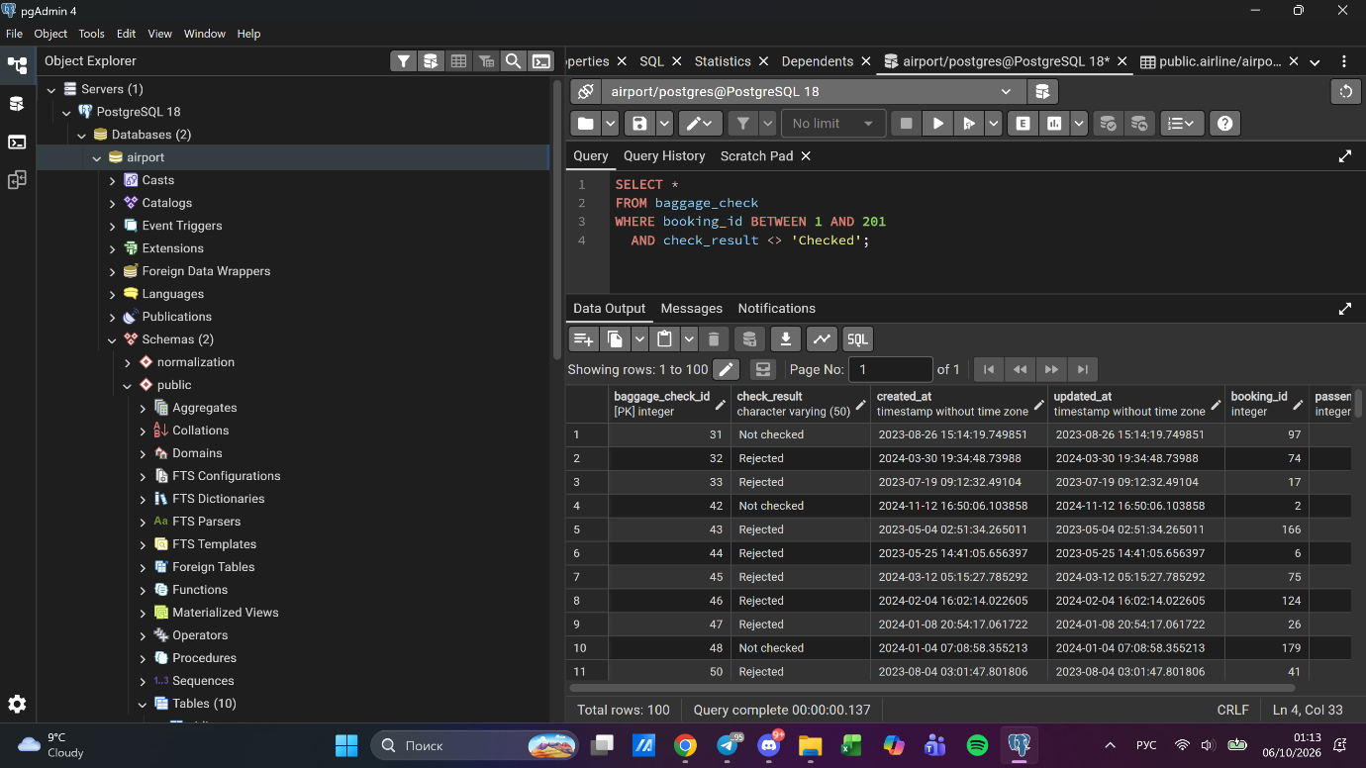

Task 15. Baggage checks where updated_at is in the same month as created_at but earlier
updated_at is normally set equal to or later than created_at, so one row was adjusted to demonstrate the filter.
