Databases
Laboratory Work 3
DML
Prepared by: Nurakhaev Zangar
Database: airport_db (continuation of Laboratory Works 1-2)

Preparation
Before starting, NOT NULL was dropped from airline.airline_code and airport.state (needed for Tasks 8 and 10), and foreign keys were recreated with ON DELETE CASCADE (needed for Tasks 5, 7 and 10).
ALTER TABLE airline ALTER COLUMN airline_code DROP NOT NULL;
ALTER TABLE airport ALTER COLUMN state DROP NOT NULL;
-- FKs recreated with ON DELETE CASCADE, e.g.:
ALTER TABLE baggage DROP CONSTRAINT fk_baggage_booking;
ALTER TABLE baggage ADD CONSTRAINT fk_baggage_booking
FOREIGN KEY (booking_id) REFERENCES booking(booking_id) ON DELETE CASCADE;

DML Tasks

Task 1. Generate and insert 200 random rows
200 rows were generated in each of the 10 tables using generate_series() and random(), in the order that respects foreign keys (airline, airport, passengers, flights, booking, booking_flight, boarding_pass, baggage, baggage_check, security_check).
INSERT INTO airline (airline_id, airline_code, airline_name, airline_country, created_at, updated_at)
SELECT i,
CASE WHEN i % 10 = 0 THEN NULL ELSE 'AL' || lpad(i::text, 3, '0') END,
'Airline ' || i,
(ARRAY['Kazakhstan','Germany','Turkey','France','Brazil','Poland','Japan','Canada','Italy','Spain'])[1 + floor(random()*10)::int],
now() - random() * interval '700 days', now()
FROM generate_series(1, 200) AS i;
-- ... same pattern for the other 9 tables (see screenshots)
SELECT 'airline' AS table_name, count(*) FROM airline
UNION ALL SELECT 'airport', count(*) FROM airport
UNION ALL SELECT 'passengers', count(*) FROM passengers
UNION ALL SELECT 'flights', count(*) FROM flights
UNION ALL SELECT 'booking', count(*) FROM booking
UNION ALL SELECT 'booking_flight', count(*) FROM booking_flight
UNION ALL SELECT 'boarding_pass', count(*) FROM boarding_pass
UNION ALL SELECT 'baggage', count(*) FROM baggage
UNION ALL SELECT 'baggage_check', count(*) FROM baggage_check
UNION ALL SELECT 'security_check', count(*) FROM security_check;

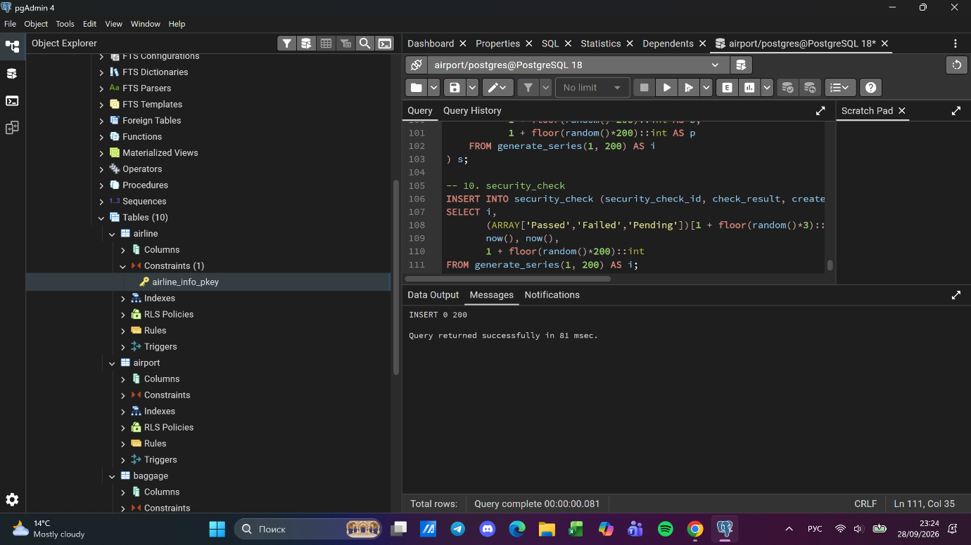

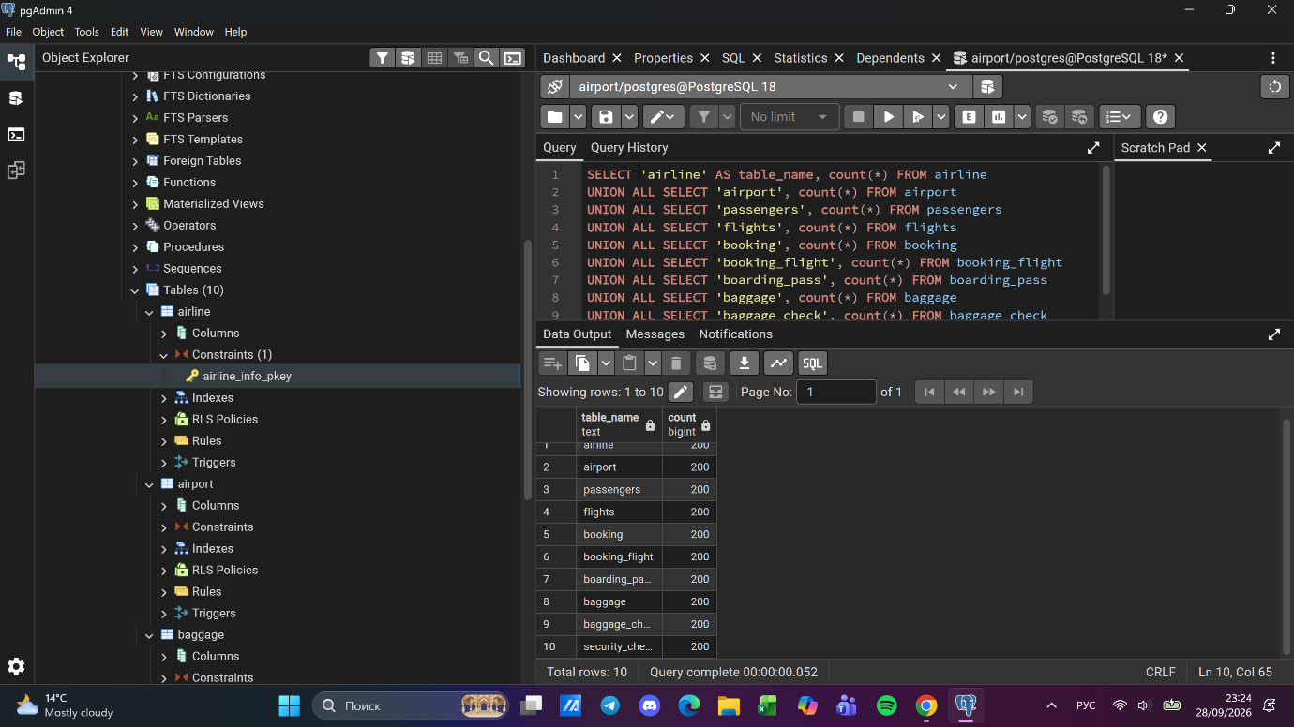

Task 2. Add airline KazAir (Kazakhstan)
INSERT INTO airline (airline_id, airline_code, airline_name, airline_country, created_at, updated_at)
VALUES (201, 'KZA', 'KazAir', 'Kazakhstan', now(), now());
SELECT * FROM airline WHERE airline_name = 'KazAir';

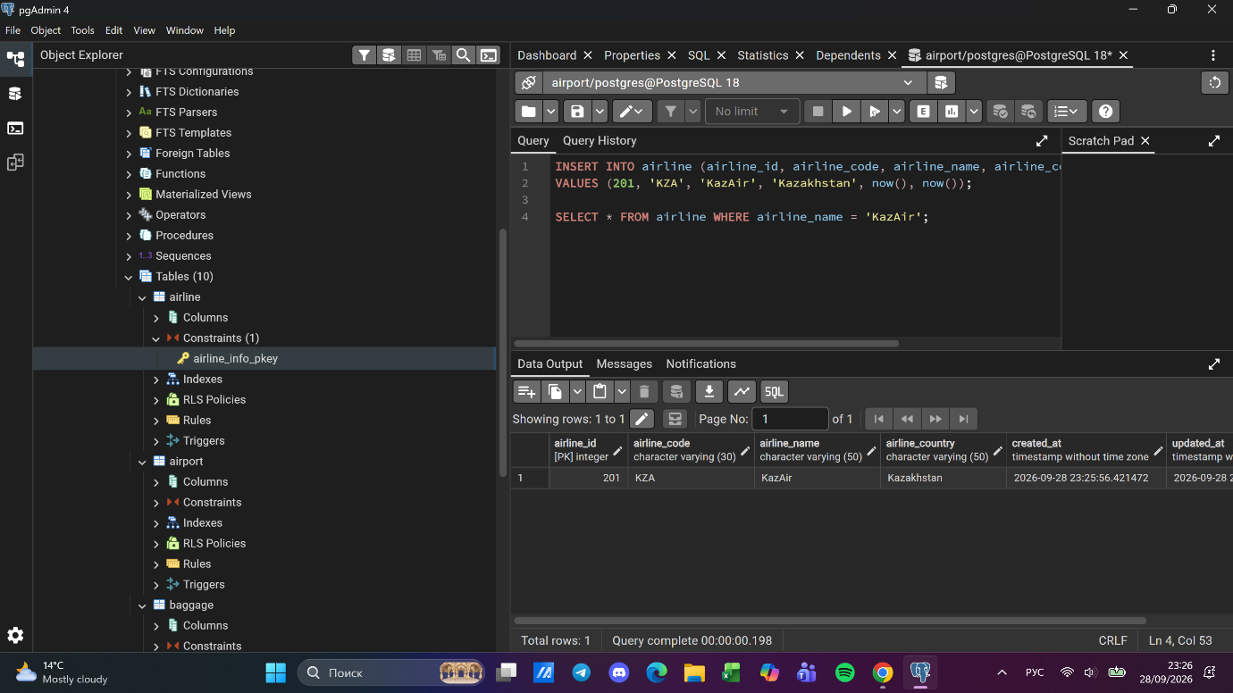

Task 3. Update KazAir country to Turkey
UPDATE airline
SET airline_country = 'Turkey', updated_at = now()
WHERE airline_name = 'KazAir';
SELECT * FROM airline WHERE airline_name = 'KazAir';

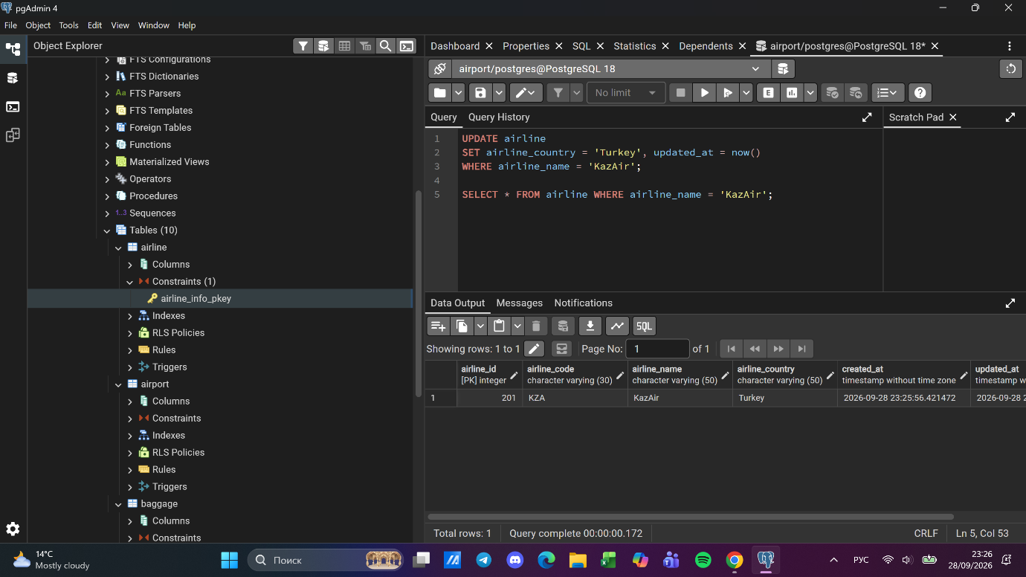

Task 4. Add three airlines at once
INSERT INTO airline (airline_id, airline_code, airline_name, airline_country, created_at, updated_at)
VALUES
(202, 'AEZ', 'AirEasy', 'France', now(), now()),
(203, 'FHG', 'FlyHigh', 'Brazil', now(), now()),
(204, 'FFL', 'FlyFly', 'Poland', now(), now());
SELECT * FROM airline WHERE airline_id >= 202;

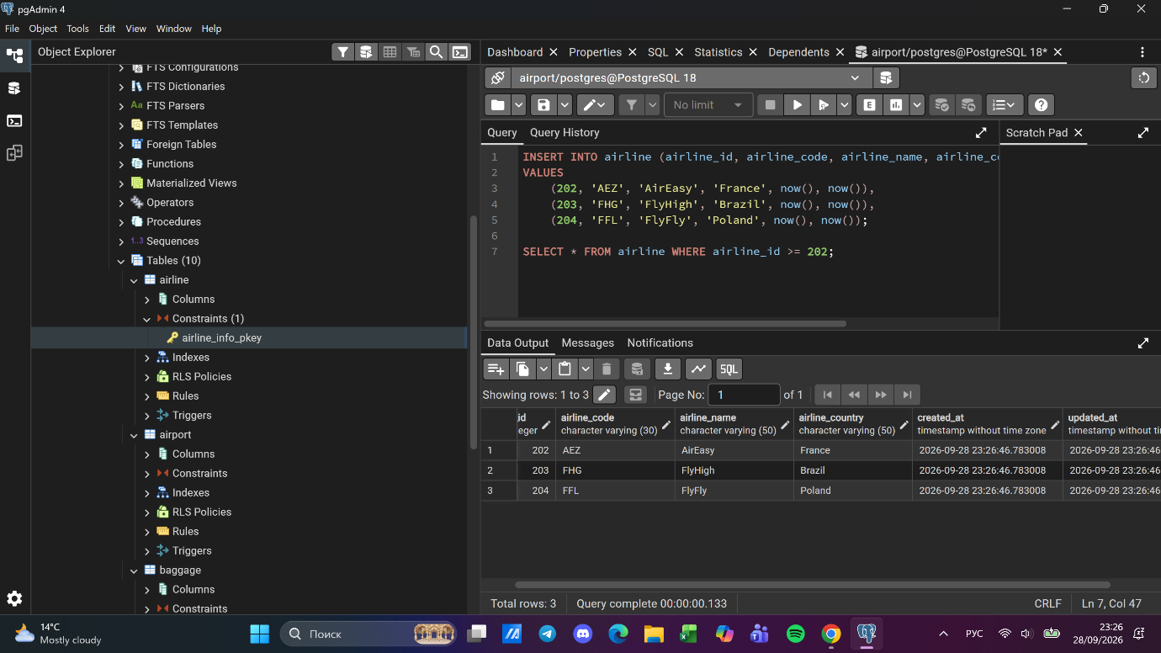

Task 5. Delete flights arriving in 2024
Related rows in booking_flight are removed by ON DELETE CASCADE.
DELETE FROM flights
WHERE EXTRACT(YEAR FROM sch_arrival_time) = 2024;
SELECT count(*) AS after_delete FROM flights
WHERE EXTRACT(YEAR FROM sch_arrival_time) = 2024;

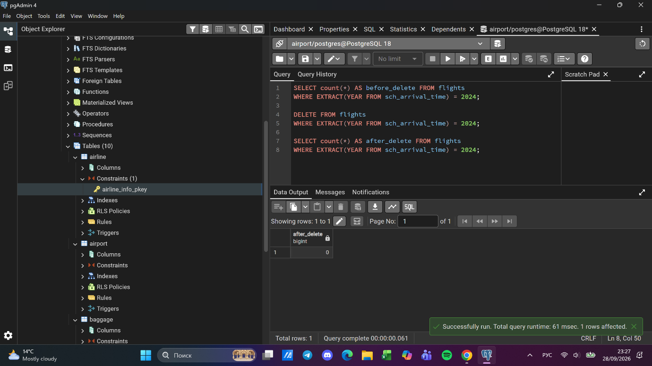

Task 6. Increase all ticket prices by 15%
UPDATE booking
SET ticket_price = round(ticket_price * 1.15, 2), updated_at = now();
SELECT booking_id, ticket_price FROM booking ORDER BY booking_id LIMIT 5;

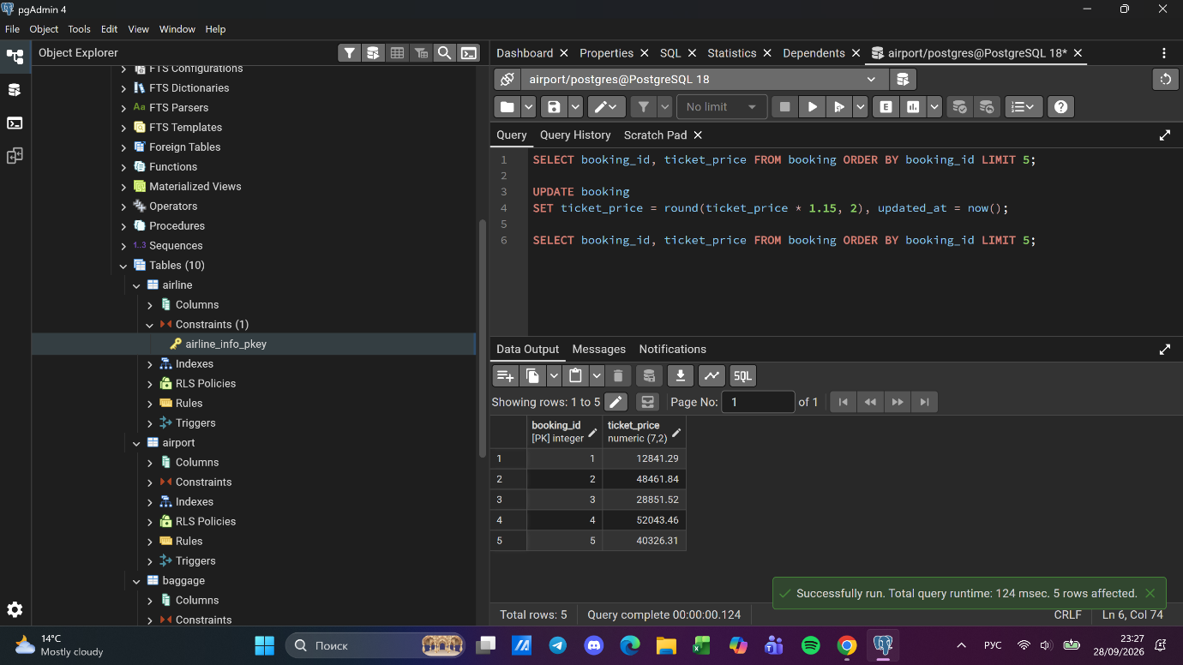

Task 7. Delete tickets with price less than 10000
Dependent rows (baggage, boarding_pass, etc.) are removed by ON DELETE CASCADE.
DELETE FROM booking WHERE ticket_price < 10000;
SELECT count(*) AS remaining, min(ticket_price) AS min_price FROM booking;

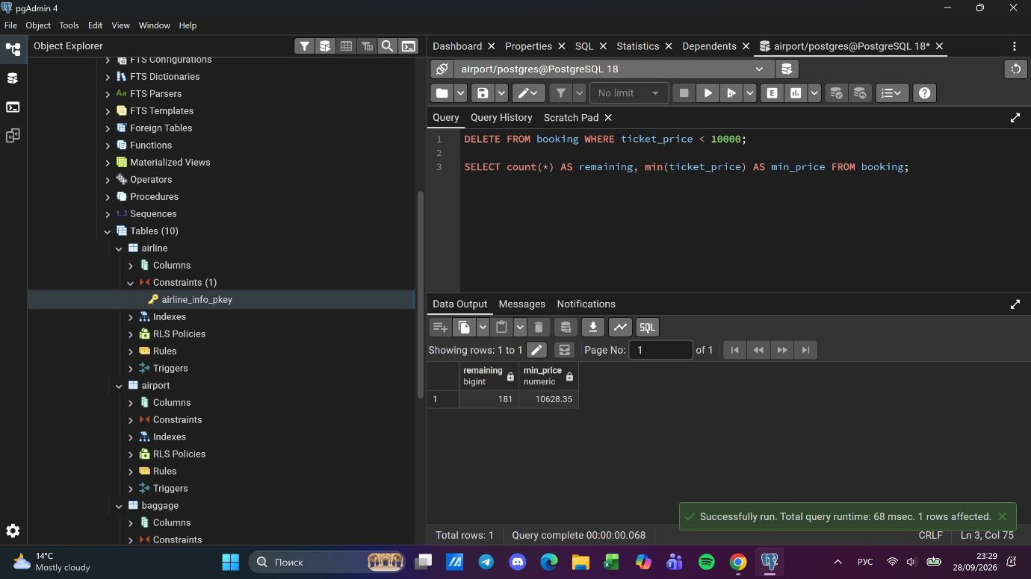

Task 8. Set default airline code 'UNK'
UPDATE airline
SET airline_code = 'UNK', updated_at = now()
WHERE airline_code IS NULL;
SELECT count(*) AS null_codes FROM airline WHERE airline_code IS NULL;

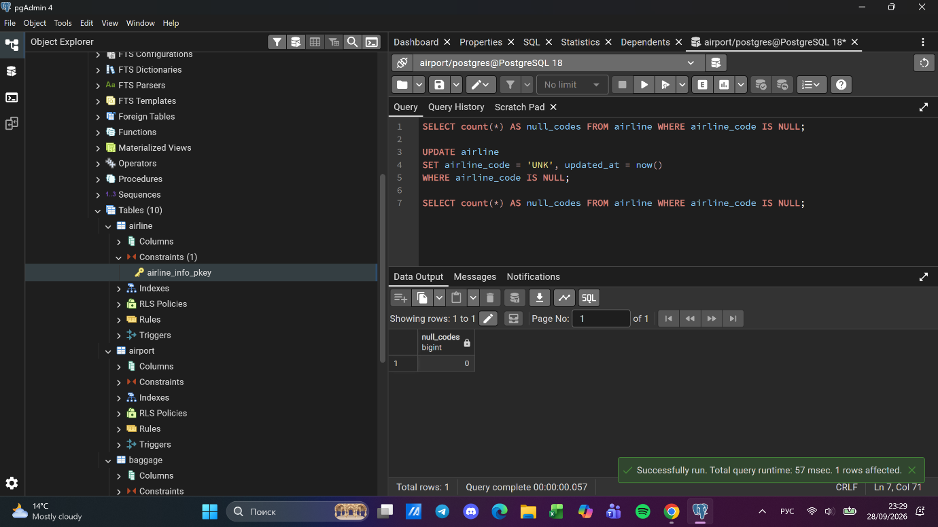

Task 9. Delete unchecked baggage checks before 1 June 2023
DELETE FROM baggage_check
WHERE created_at < '2023-06-01'
AND check_result = 'Not checked';
SELECT count(*) AS left_rows FROM baggage_check
WHERE created_at < '2023-06-01' AND check_result = 'Not checked';

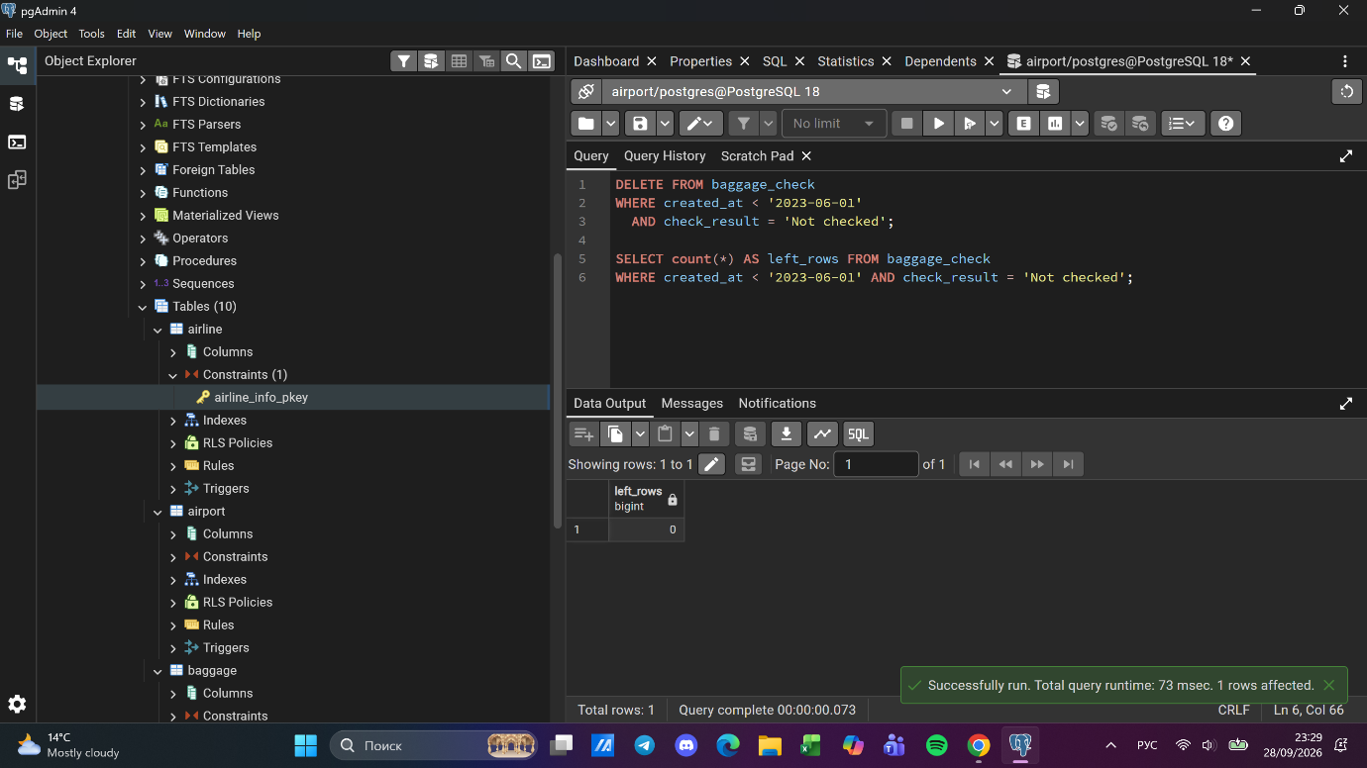

Task 10. Delete airports with NULL state in Mlawe / Kepuh
DELETE FROM airport
WHERE state IS NULL AND city IN ('Mlawe', 'Kepuh');
SELECT count(*) AS left_rows FROM airport
WHERE city IN ('Mlawe', 'Kepuh') AND state IS NULL;

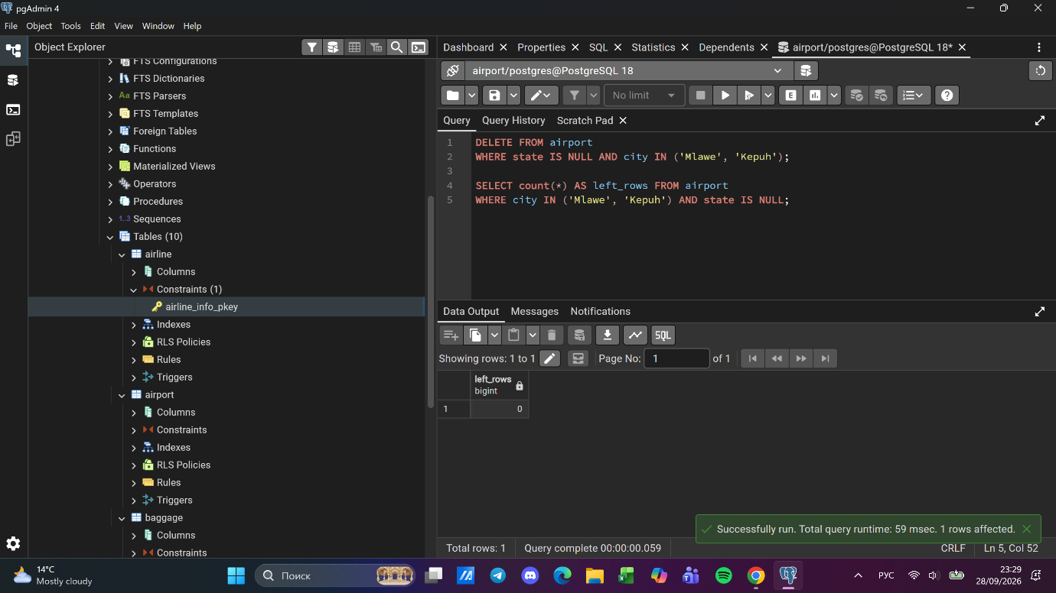

Task 11. Insert unchecked baggage check and return id and timestamp
INSERT INTO baggage_check (baggage_check_id, check_result, created_at, updated_at, booking_id, passenger_id)
VALUES (
(SELECT max(baggage_check_id) + 1 FROM baggage_check),
'Not checked', now(), now(),
(SELECT min(booking_id) FROM booking),
(SELECT min(passenger_id) FROM passengers)
)
RETURNING baggage_check_id, created_at;

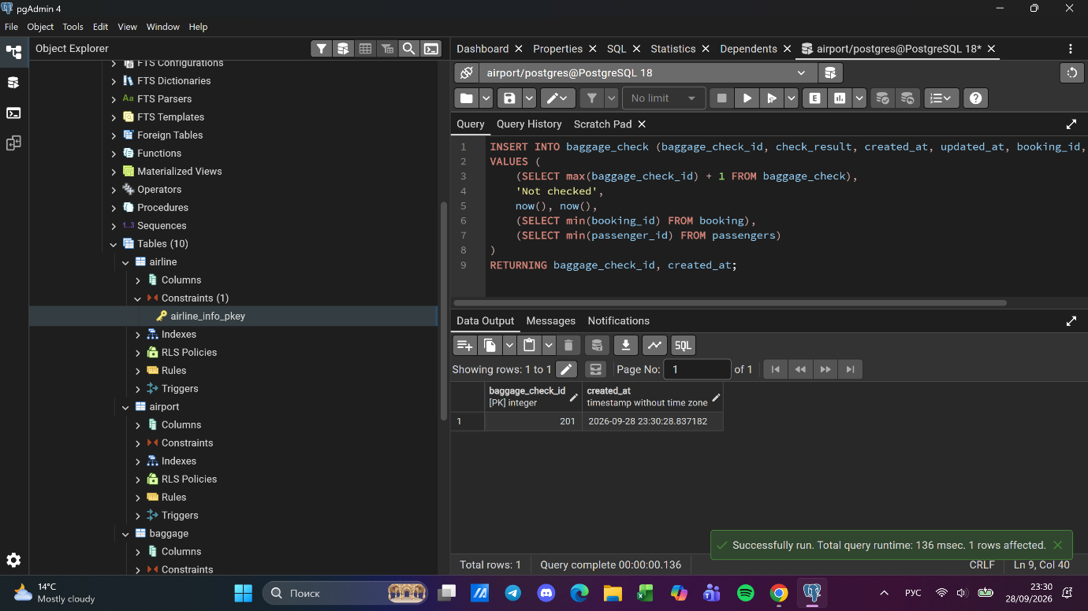

Task 12. Convert airline countries to uppercase
UPDATE airline
SET airline_country = UPPER(airline_country);
SELECT airline_id, airline_name, airline_country FROM airline ORDER BY airline_id LIMIT 10;

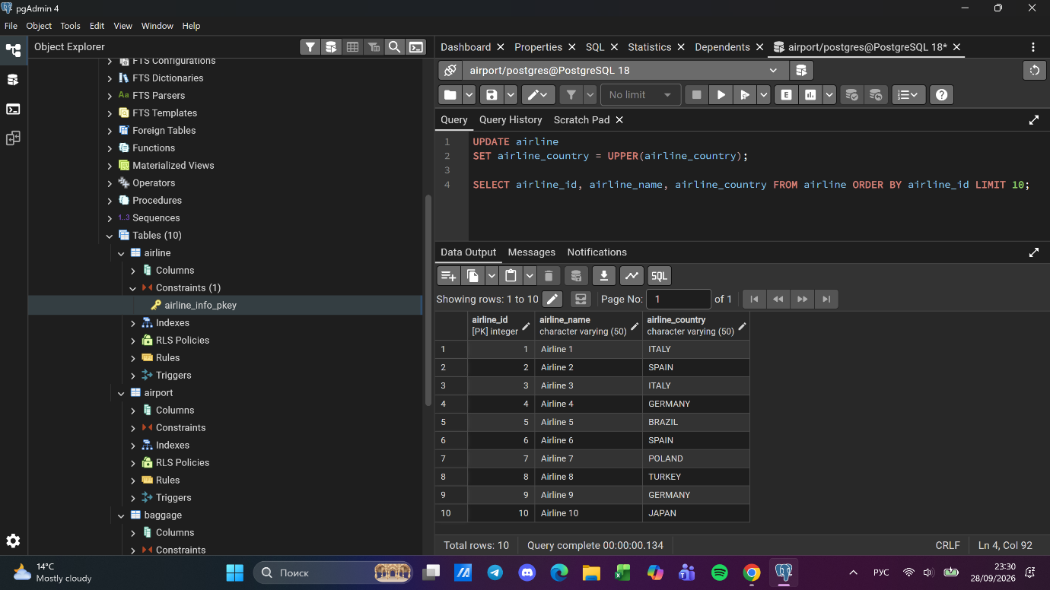

Task 13. Update airline_id = 5
The task mentions update_at; the actual column name is updated_at.
UPDATE airline
SET airline_name = 'Global Airways',
airline_country = 'United Kingdom',
updated_at = CURRENT_DATE
WHERE airline_id = 5;
SELECT * FROM airline WHERE airline_id = 5;

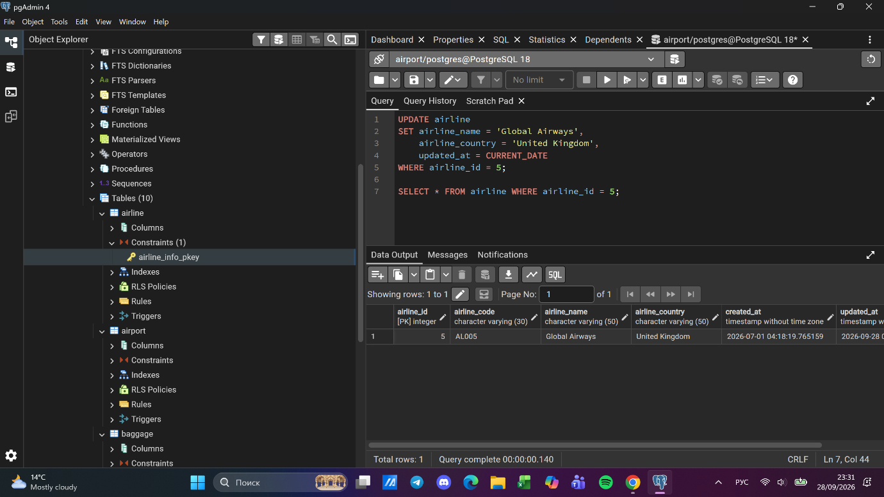

Task 14. Set state 'Capital District' for Astana, London, Tokyo
UPDATE airport
SET state = 'Capital District', updated_at = now()
WHERE city IN ('Astana', 'London', 'Tokyo');
SELECT city, state, count(*) FROM airport
WHERE city IN ('Astana', 'London', 'Tokyo')
GROUP BY city, state;

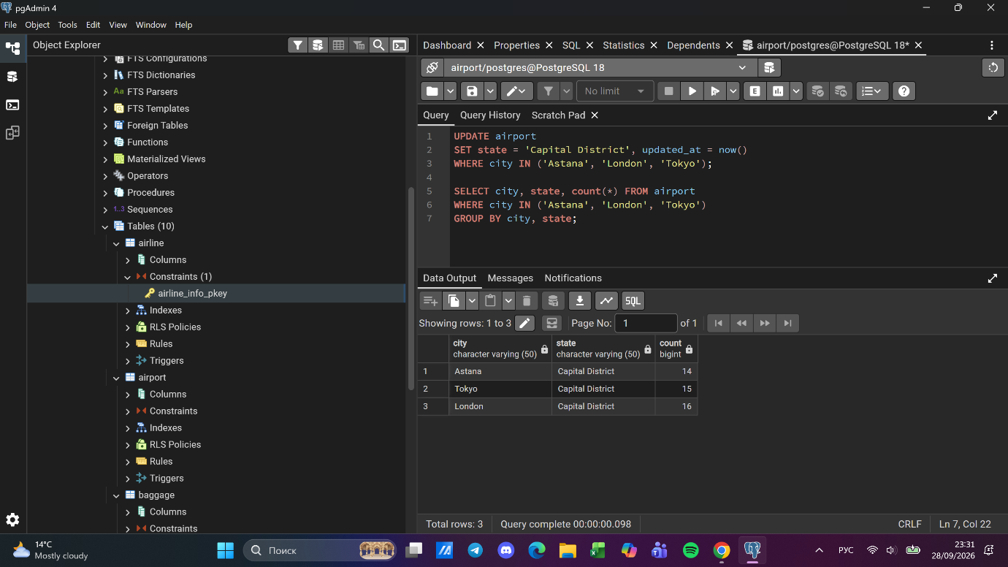

Task 15. Mark March 2024 'Not checked' baggage checks as 'Checked'
UPDATE baggage_check
SET check_result = 'Checked', updated_at = now()
WHERE check_result = 'Not checked'
AND created_at >= '2024-03-01' AND created_at < '2024-04-01';
SELECT count(*) AS still_not_checked FROM baggage_check
WHERE check_result = 'Not checked'
AND created_at >= '2024-03-01' AND created_at < '2024-04-01';
