Databases
Laboratory Work 5
Constraints: CHECK, UNIQUE, DEFAULT
Prepared by: Nurakhaev Zangar

Tasks

Task 1. CHECK: passengers must be at least 10 years old
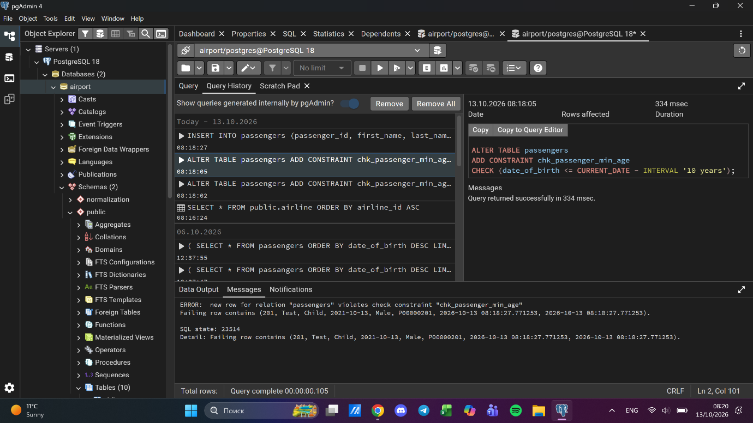

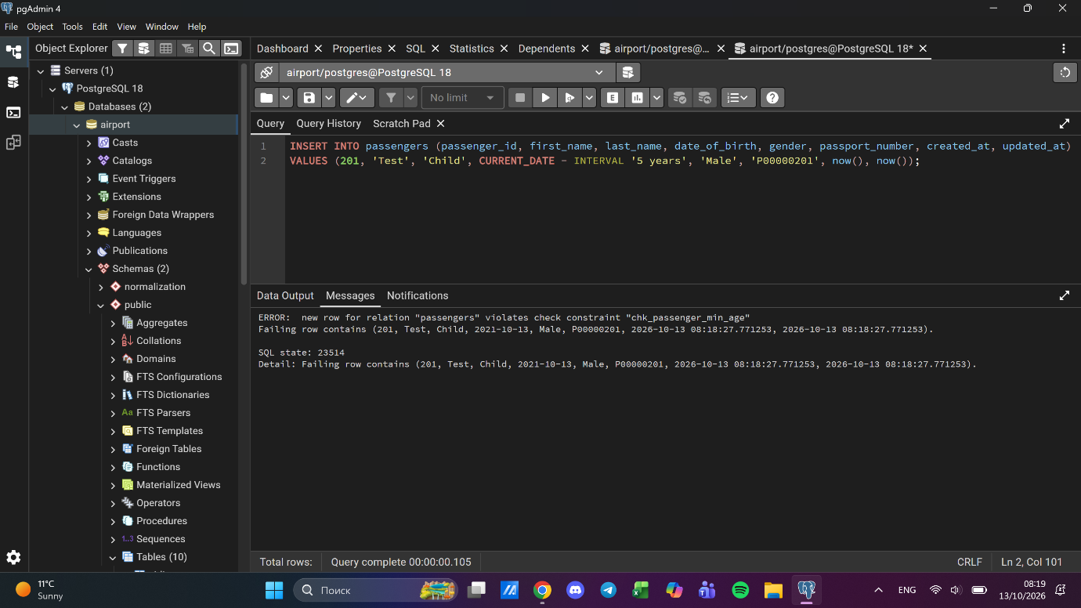

Task 2. CHECK: booking price from 0 to 50000
Existing prices above 50000 were first reduced to 50000, otherwise the constraint could not be added.
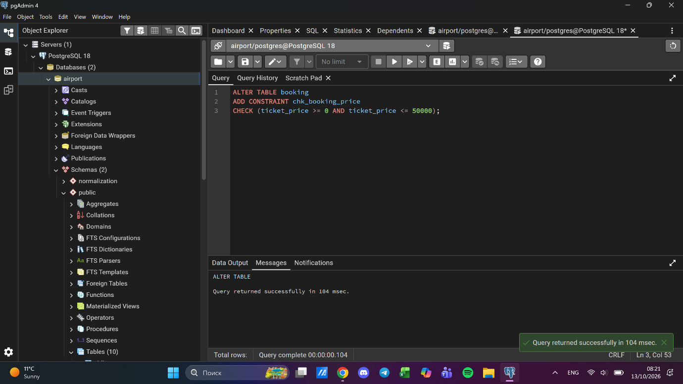

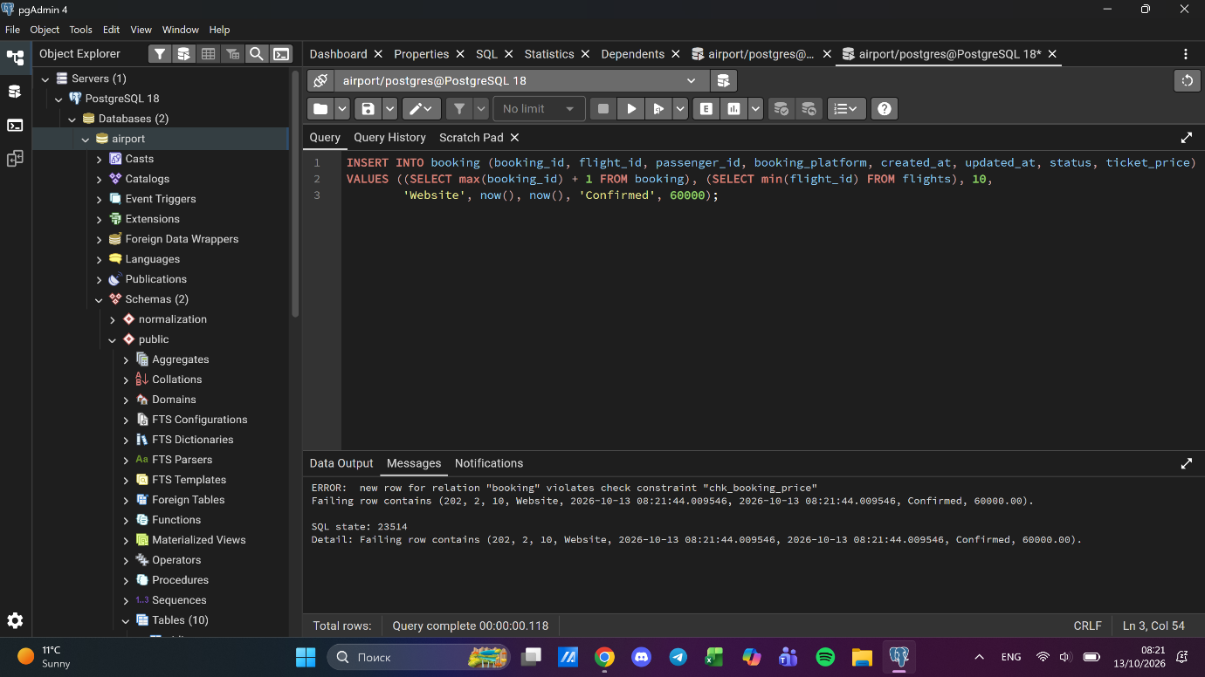

Task 3. CHECK: baggage weight between 1 and 23 kg
Existing weights outside the range were first adjusted to the nearest boundary.
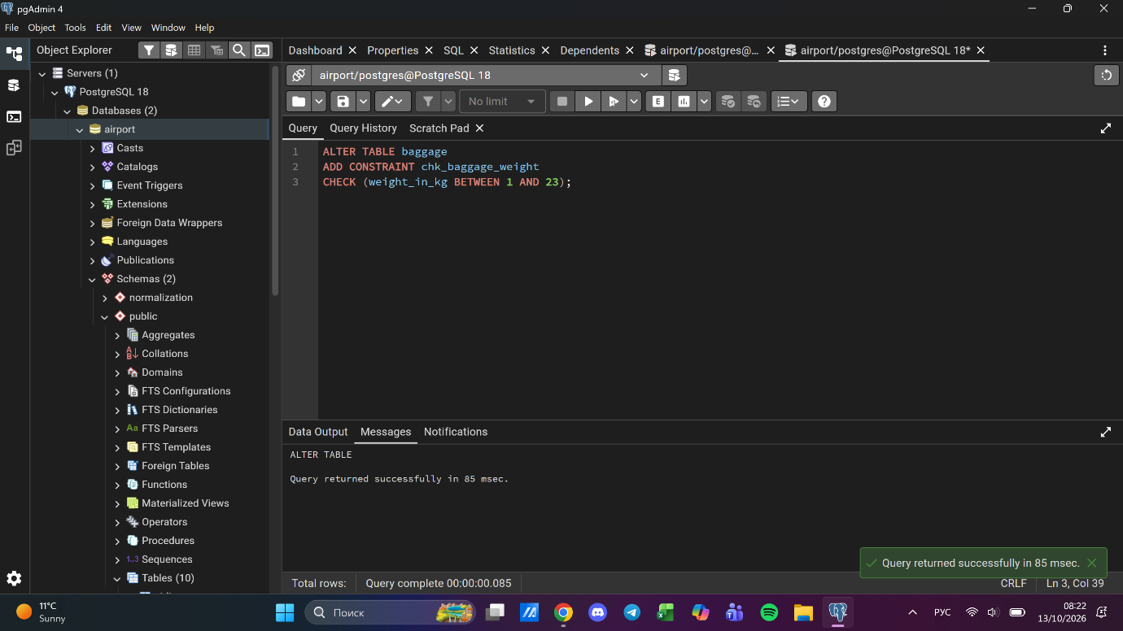

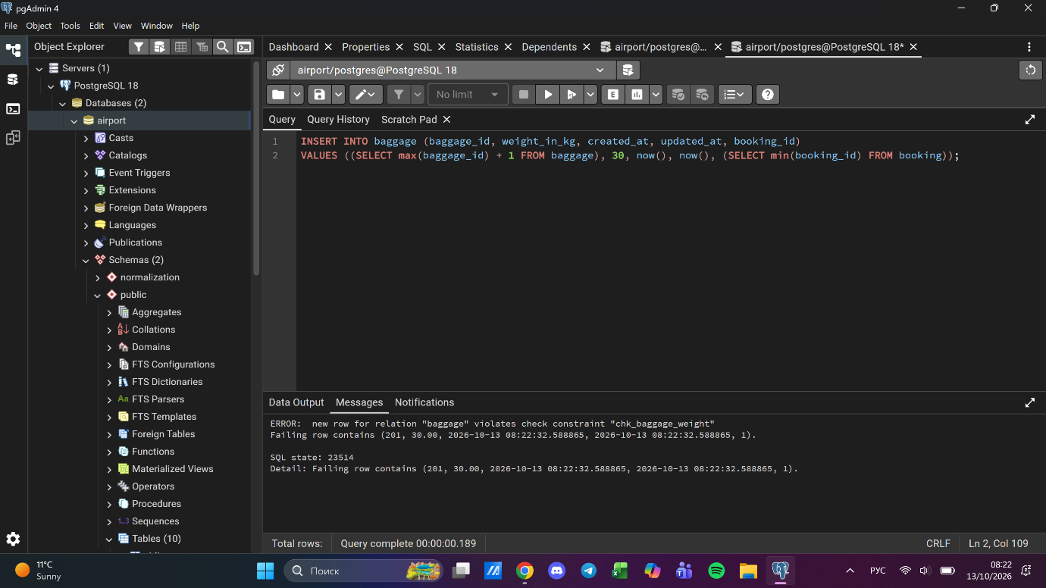

Task 4. CHECK: airport_name has at least 10 characters
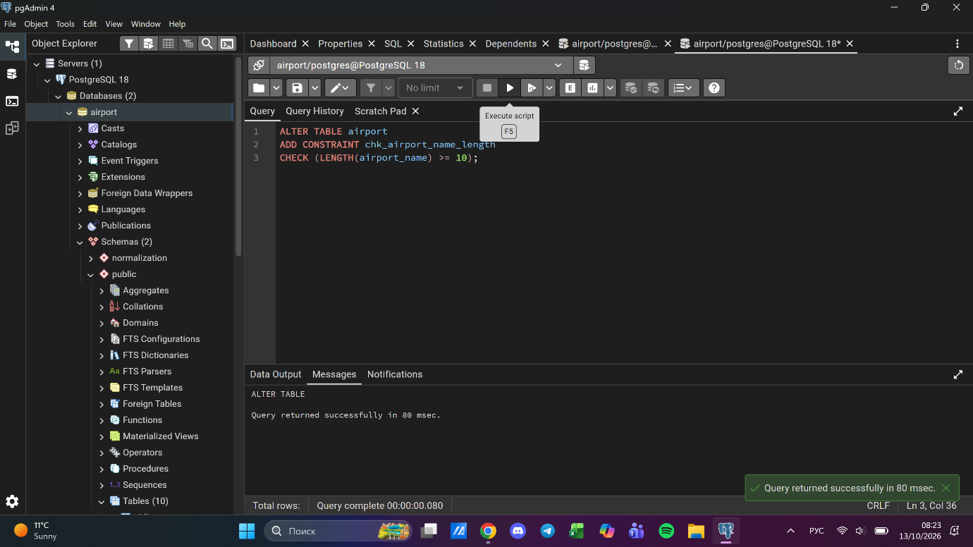

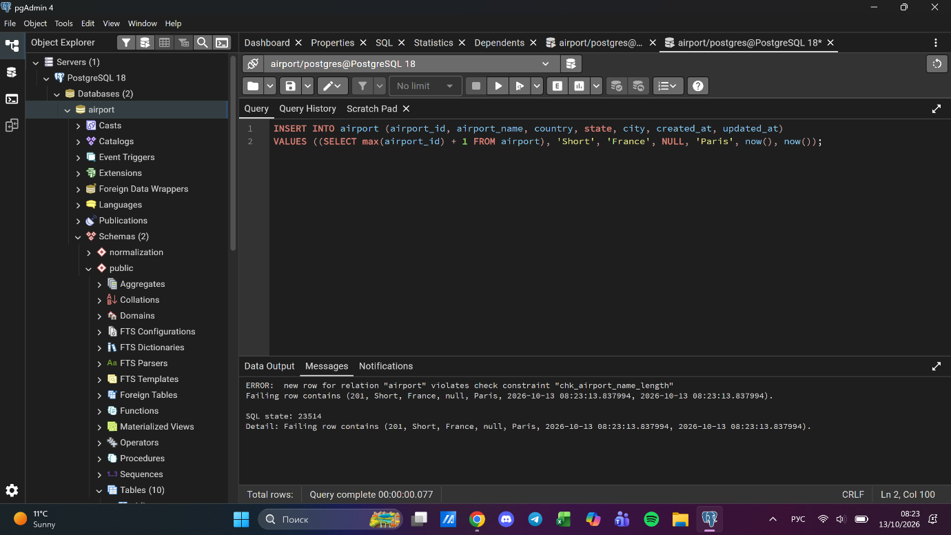

Task 5. UNIQUE constraints in each table
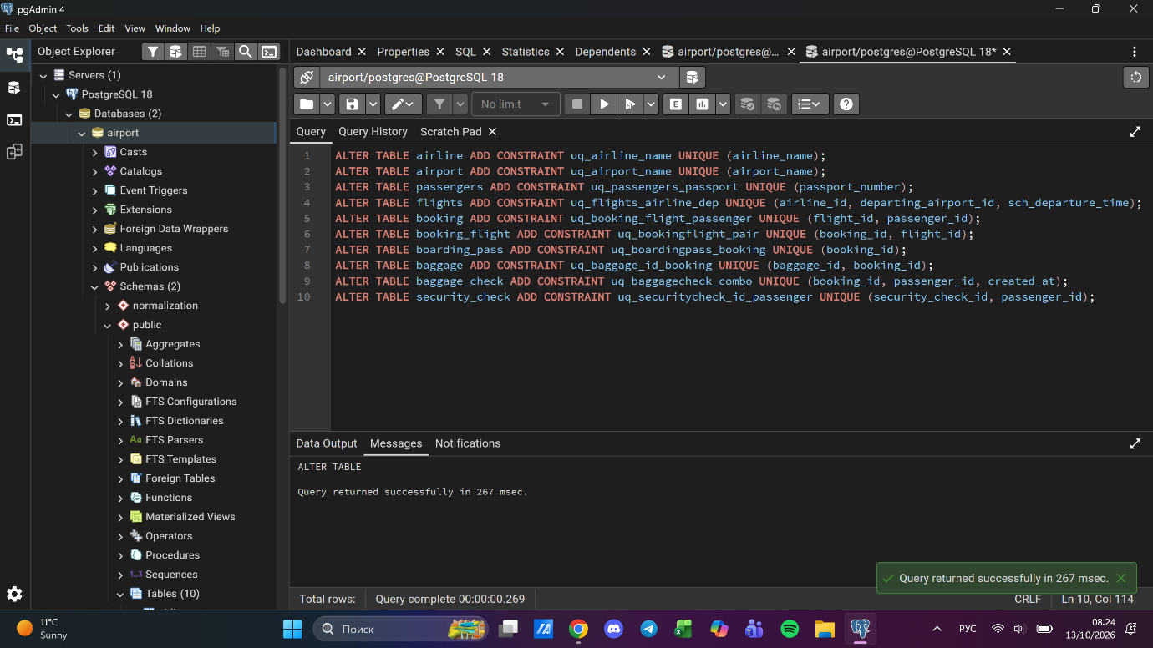
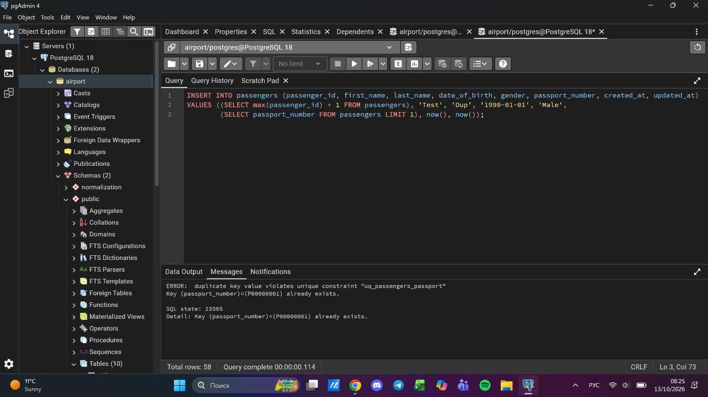

Task 6. CHECK: males at least 18, females at least 19
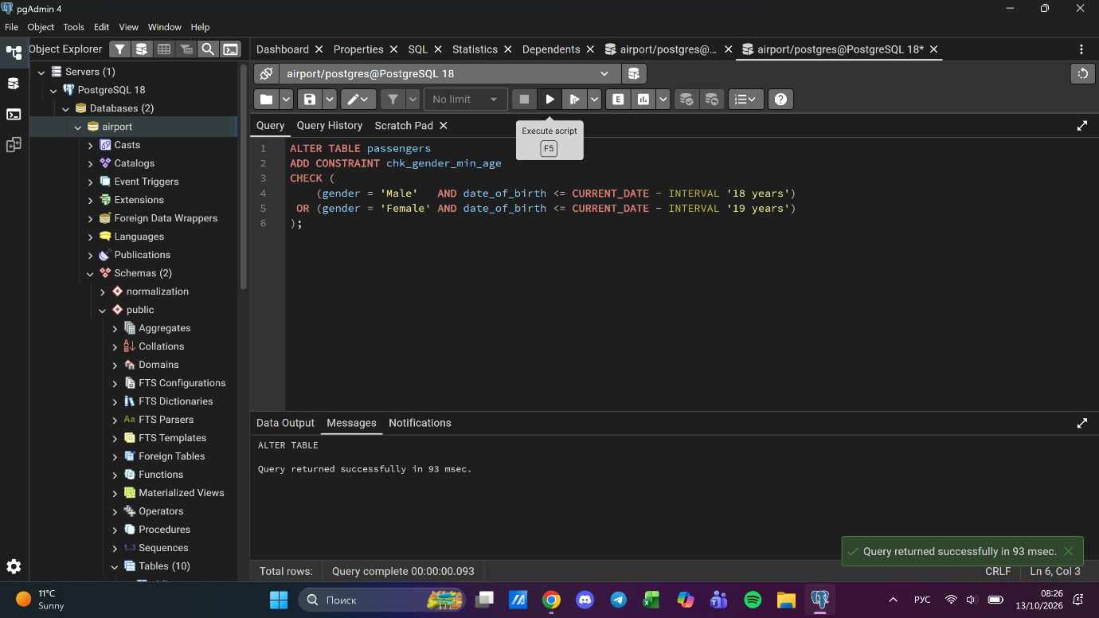

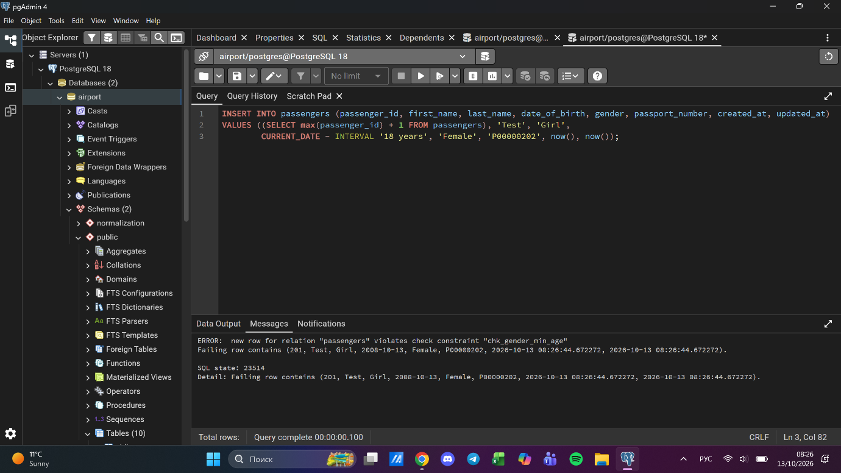

Task 7. CHECK: minimum age depends on country_of_citizenship
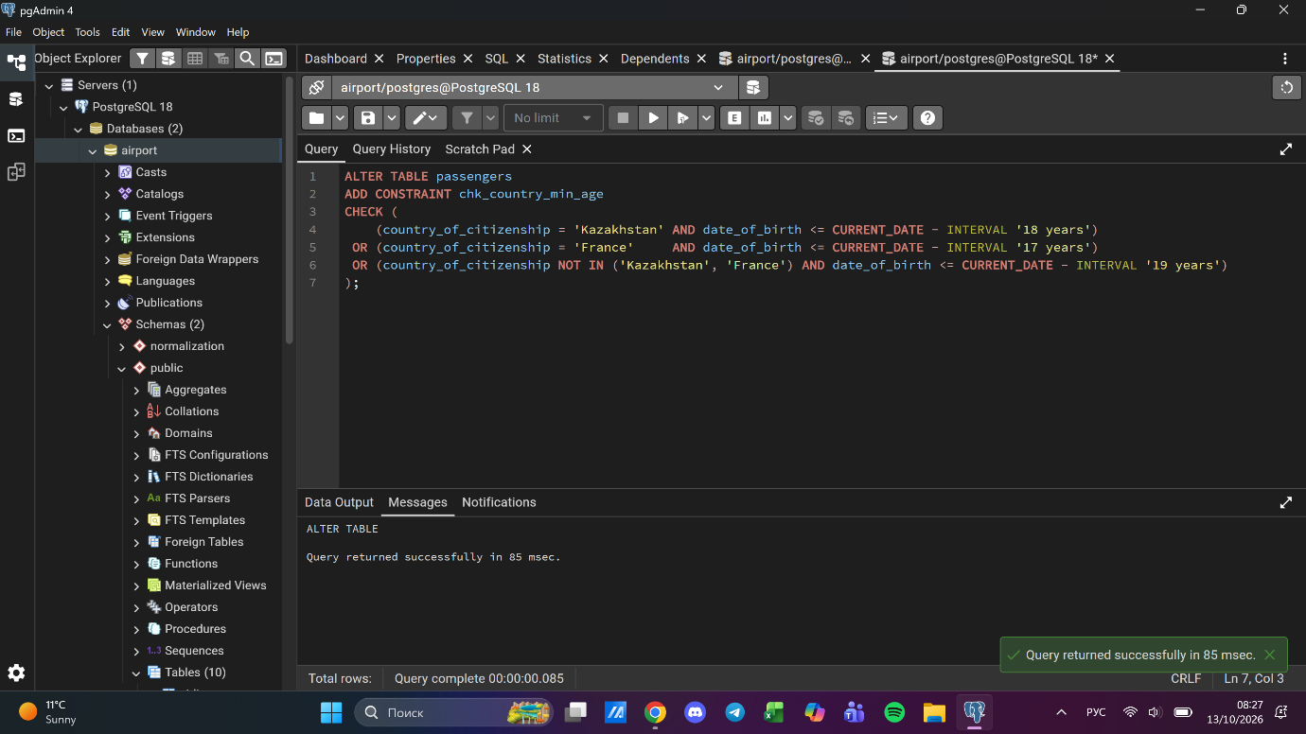

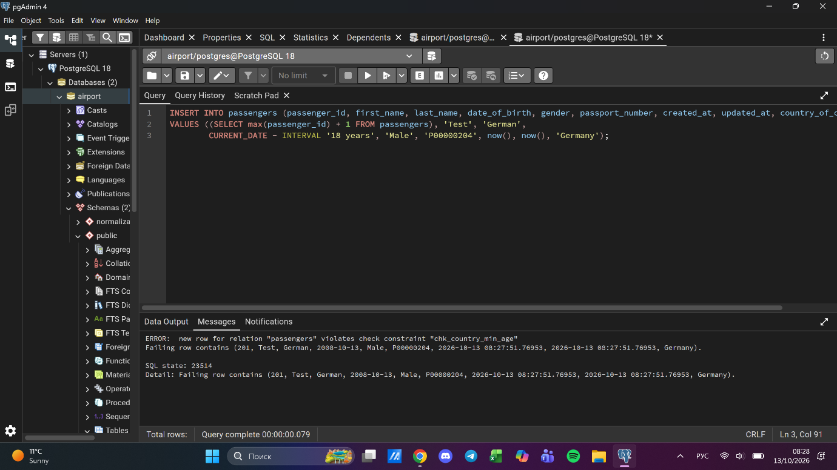

Task 8. ticket_discount column and CHECK by creation date
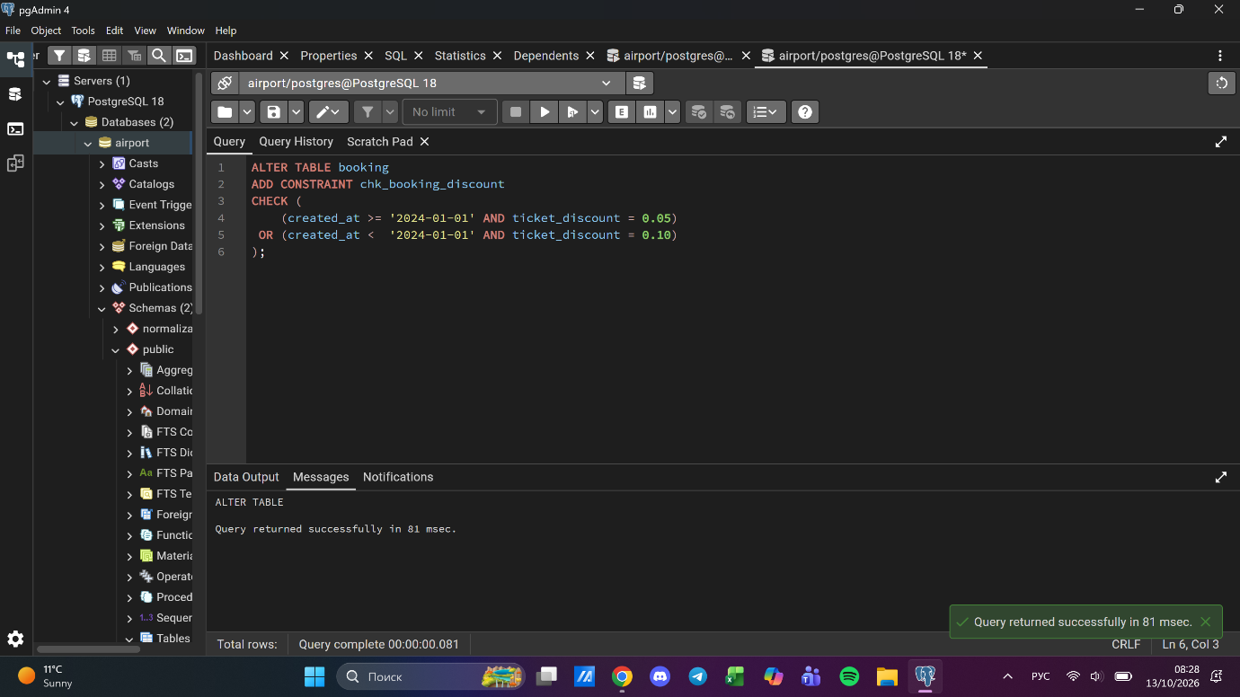

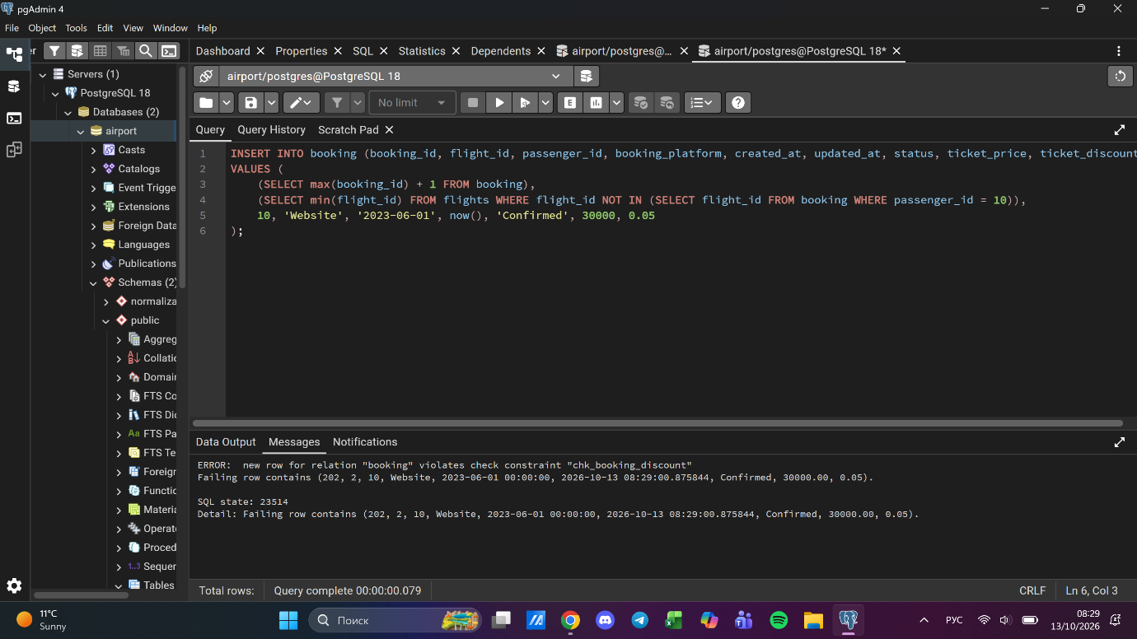

Task 9. DEFAULT 'Confirmed' for booking status
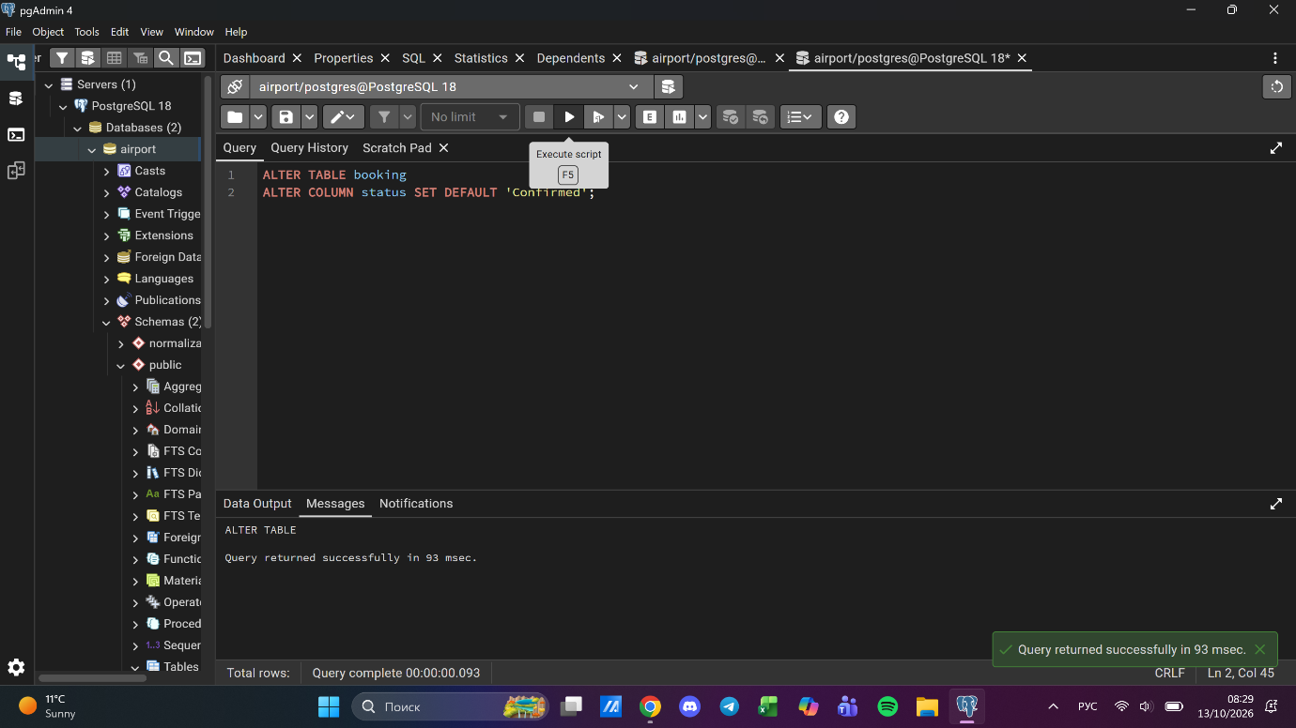

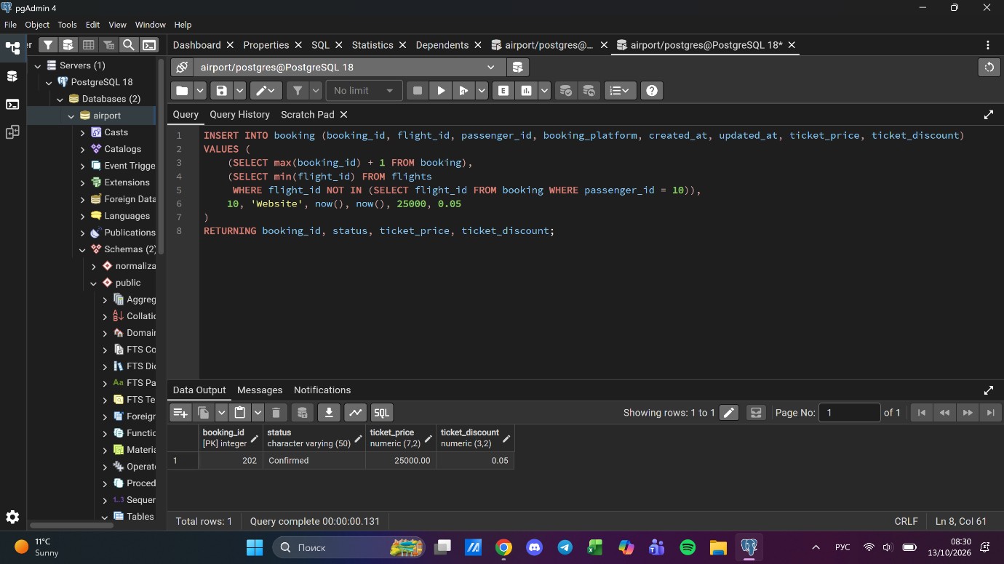

Task 10. Automatic current date on insert
