## I) Team member’s names, Student IDs and Group name

Bryan Chua Hwa Zhe, S10223076, P02

Tee Yu Zet, S10221991, P02

## II) Brief Description of Application

This application is a discussion forum coded in the programming language C++. This forum allows for users to discuss about different topics that interest them, post what their thoughts are on topics that intertest them, reply to other’s posts for that topic as well as delete and edit their pre-existing posts on a topic. The application makes use of data structures such as arrays, classes and sorting algorithms to achieve the user’s desires and make the app smooth flowing. The application also allows for users to sign up and log in into their accounts to help with data management and for the algorithms to carry out their processes. Additionally, the application also allows the user to sort the posts and topics as well as stick certain posts.

## III) Roles and Contributions of each Member

Bryan Chua Hwa Zhe – Report, code comments

Tee Yu Zet – Main Program, code comments, class diagram

## IV) Instructions on how to run Application

1 – Sign Up for an account and login into the application

2 – Press 1 to create a new topic that can contain multiple posts relating to the topic,

Press 2 to view all the topics that the application already contains.

Press 3 to view a specific topic and all the posts within the chosen topic.

Press 4 to create a post, following by choosing the topic to create the post in. Following which, the user will be prompted to enter the post title, and finally, the post’s content.

Press 5 to edit a post that you have already made. Firstly, select the topic that the post you want to edit is in, then, enter the title of the post you want to edit, if the post is found, the application will prompt you to enter and new post title and enter the new post’s content.

Press 6 to delete a previous post you have made. The application will prompt you for the topic the post is in, followed by the title of the post you want to delete. If successful, the post will be deleted, else, an error message will be displayed.

Press 7 to reply to a post that has already been made. The application will prompt the user for the topic the post has been made in, followed by the title of the post. The user will then have to decide the title and the content of the reply it wants to make. If the post of topic if not found, an error message will be displayed.

Press 8 to sort topics. The algorithm will sort the topics according to ascending or descending value.

Press 9 to sort the posts. The application will prompt the user to select a topic and sort the posts within the chosen topic.

Press 10 to stick a topic. Sticking a topic re-arranges the topic order, with the “sticked” topic being at the top. The post will prompt the user to enter the topic which they want to stick If unsuccessful, the program will display an error message.

Press 11 to unstick a topic. The post will prompt the user to enter the topic which they want to unstick, returning to the topic to the original position it was in. If unsuccessful, the program will display an error message.

Press 12 to stick a post. If unsuccessful, the program will display an error message.

Press 13 to unstick a post. If unsuccessful, the program will display an error message.

Press 14 to exit to the program and close the application.

## V) Class Diagram

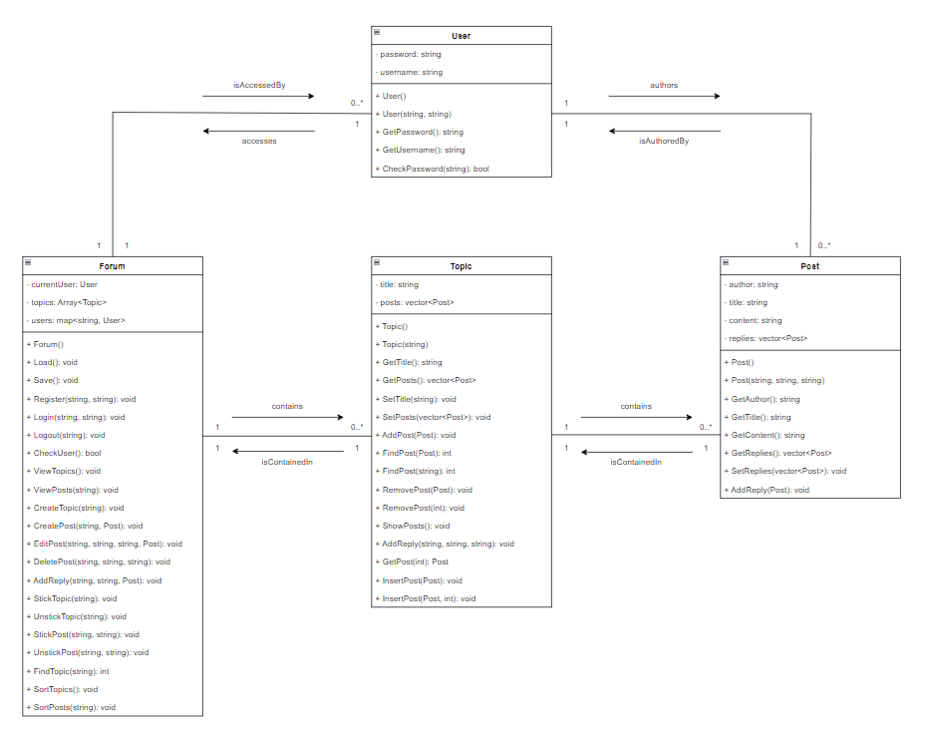

## VI & VII) Description of data structures and algorithms implemented

### Data Structure - Array

The Array data structure was implemented using a template class, which allows it to be used with any type of data. The class contains a private member variable for the size of the array, and a pointer to the data stored in the array. The class contains several constructors, assignment operators, and a destructor for creating, copying, and deleting the array. Additionally, the class contains several methods for manipulating the array, such as resize(), size(), operator[], push_back(), begin(), end(), erase(), and insert(). Each of these methods allow for different operations to be performed on the array, such as adding and removing elements, resizing the array, and accessing elements.

### Data Structure - Class

A class data structure is a template used to create objects which define a set of attributes and methods that the objects can have. This model allows for easy organization of code and reuse of code for similar objects, as the data and behaviours of these items can be included in the class declaration.

### Algorithm – Merge Sort

The merge sort algorithm is a divide and conquer approach to sorting a list of elements. It starts by dividing the list into two halves and sorting each half recursively. After both halves are sorted, the merged step is executed, which involves comparing the first element of each half and adding the smaller element to the final sorted list. Merge sort is an efficient sorting method with a time complexity of O(n log n). Furthermore, it is stable, meaning that elements with equal values retain their relative order. This makes it suitable for sorting messages in our forum application.

## Detailed explanation of why the data structures and algorithms are selected

### Data Structure - Array

The Array data structure was selected as it provides a simple and efficient way to store and access data. It allows for fast random access to data, as each element can be accessed in O(1) time. Additionally, it provides efficient methods for adding and removing elements, as the array can be easily resized to accommodate new elements. Furthermore, the Array data structure is well suited for storing objects of a specific type. This makes them easier to work with as all the elements can be treated the same way and the data is more organized.

### Data Structure - Class

Classes were chosen as the ideal data structure in the forum application as it allows simulation of the forum constructs of users, topics, and posts. It is simple to arrange the code and reuse code for similar objects since the data and behaviours of these objects may be enclosed within the class declaration. In the future, the program may be easily expanded and modified thanks to the usage of inheritance and polymorphism.

### Algorithm – Merge Sort

The forum program utilized the merge sort method since it is a reliable, effective, and recursive sorting technique. Merge sort is effective because it is ideally suited for huge data sets and has an average and worst-case time complexity of O(n log n). In addition, merge sort preserves the relative order of equal elements in the sorted data set. Merge sort is a suitable option for sorting messages in the forum application because of its recursive structure, which makes it simple to comprehend and use.