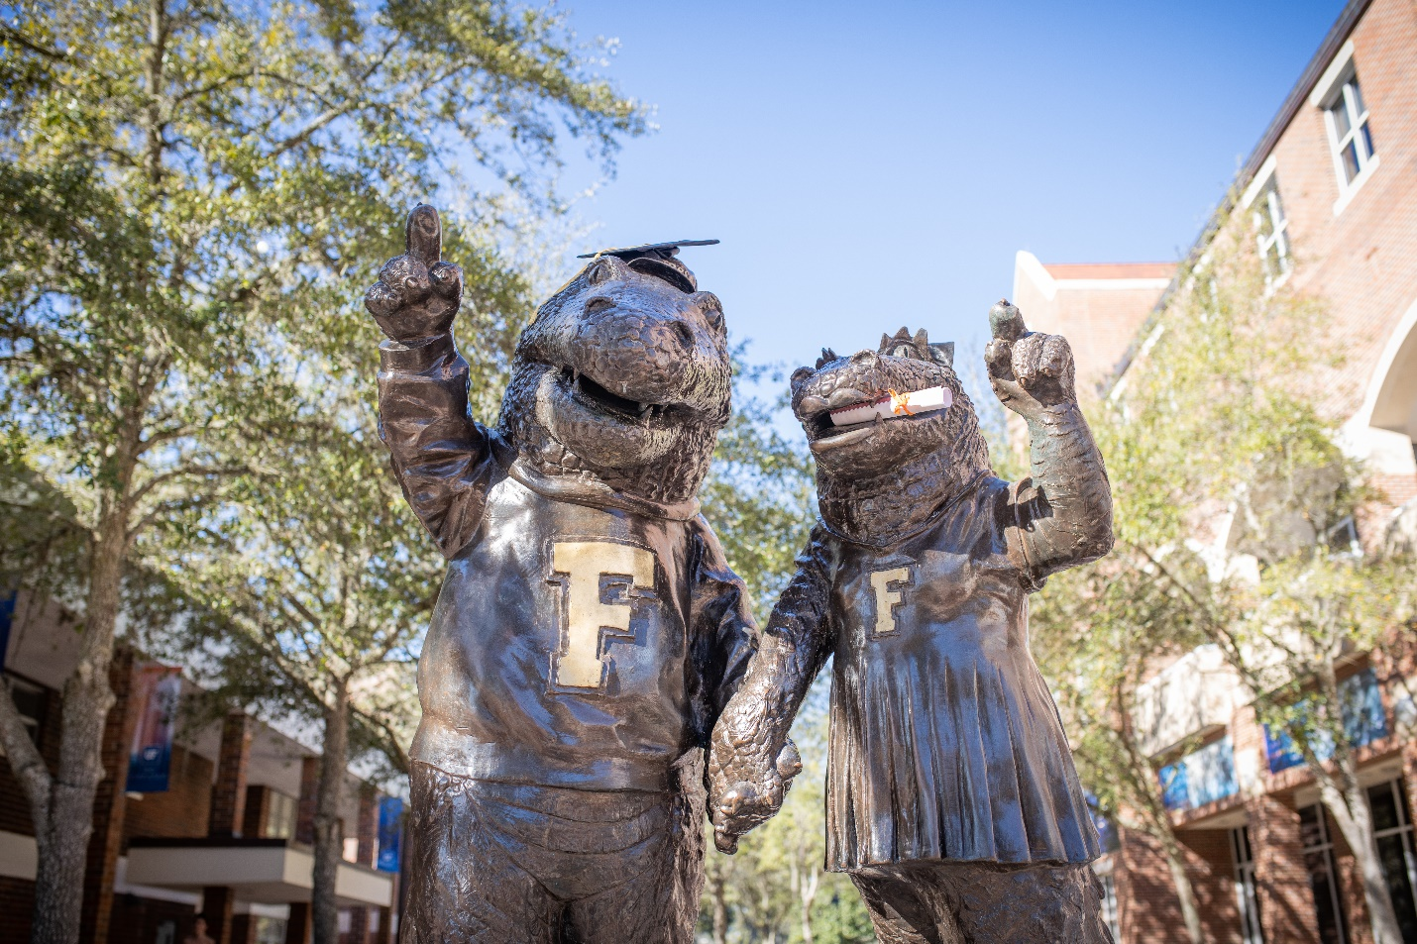

Figure 2-2. Anthropomorphized alligator statue of Albert and Alberta at Emerson Hall.

