INTRODUCTION TO

NEURAL NETWORKS

類神經網路簡介

Final Project 2

~ Function Approximation ~

|  |  |
| --- | --- |
| 組員 : | N16041422 陳友政 |
|  | N16041448 黃子軒 |
|  | N16054629 張元睿 |
|  | N16041749 侯均憲 |

授課老師 : 王振興 教授

Network Structure:

**MISO Network**

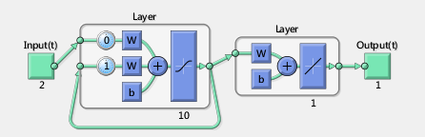

1. Type: Elman backpropagation network
2. Function of Nodes:  
   10 nodes in the hidden layer. The output of each node will be one of the input to the same node in the next train iteration.  
   1 node in the output layer. It gives a linearly summation of all outputs from the hidden layer.
3. Reason of choosing Elman backpropagation network:  
   The structure of Elman backpropagation network can provide a satisfying result in this function approximation problem with a very simple structure.

**MISO Network**

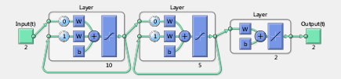

1. Type: Elman backpropagation network
2. Function of Nodes:  
   10 nodes in the first hidden layer and 5 nodes in the second hidden layer.   
   1 node in the output layer. It gives a linearly summation of all outputs from the second hidden layer.
3. Reason of choosing Elman backpropagation network:  
   Same as MISO.

Learning Performance

**MISO Network**

**Learning curve:**

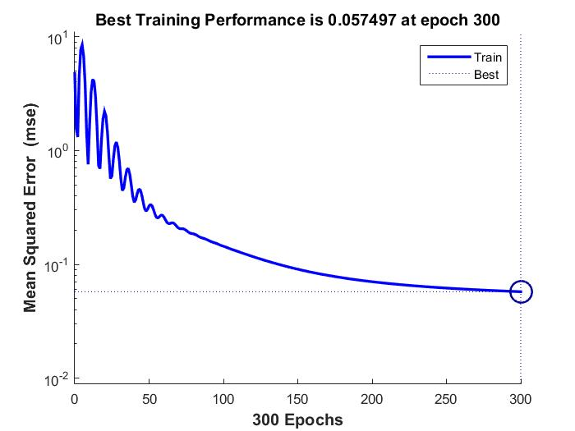

**Test Result:**

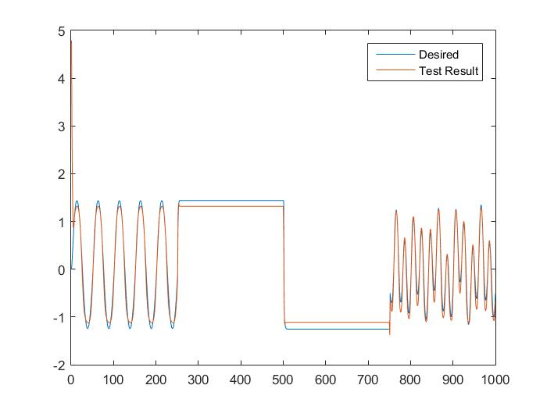

**MSE: 0.1274**

**MIMO Network**

**Learning curve:**

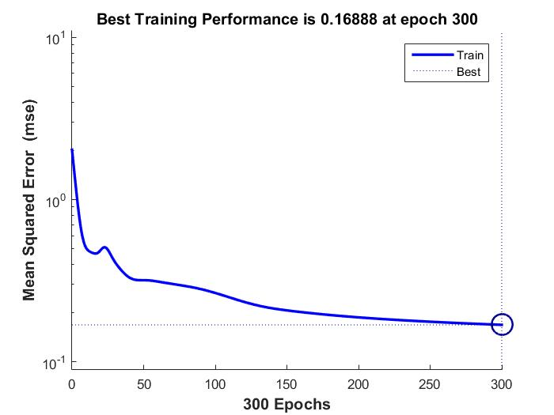

**Test Result of output 1:**

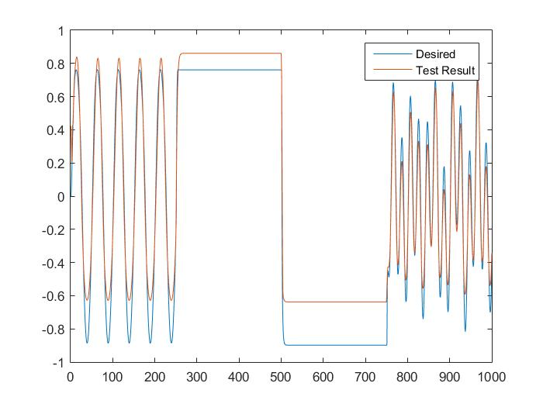

**MSE of output 1: 0.1370**

**Test Result of output 2:**

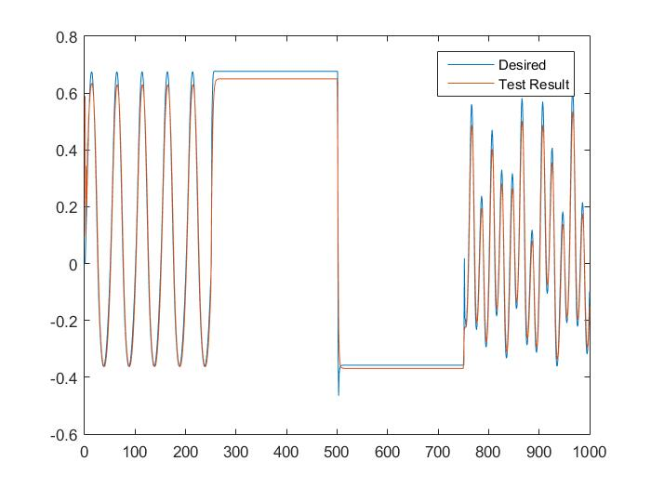

**MSE of output 2: 0.0312**