**MEMO**

Mechanical Engineering Department

National Cheng Kung University

DATE: March 8th, 2016

TO: Prof. Chi-Lun Lin

FROM: 張元睿 E14013344

SUBJECT: Homework 1 Results

**(BRIEFLY DECRIBE THE PROBLEM AND METHOD)**

Use material 1 and 3, and rod 2 to design two hollow torsion rods that satisfy the following requirements. (1)The calculated shear stress shall not exceed the allowable shear stress. (2)The calculated angle of twist shall not exceed the allowable twist. (3)The member shall not buckle. Determine the inside and outside diameters for a minimum-mass rod. Use graphical optimization method.

**(CONCISELY DECRIBE YOUR RESULT AND OBSERVATION)**

Figure 1 shows the feasible region of material 1, the optimum point is at (0.414 , 0.999). The outer diameter is 0.414 m and the inner diameter is 0.4136 m. The mass of the hollow rod will be 1.584 Kg. Figure 2 shows the feasible region of material 3, the optimum point is at (0.5 , 0.99827). The outer diameter is 0.5 m and the inner diameter is 0.4991 m. The mass of the rod will be 0.916 Kg. When the rods are solid with the same outer diameter, the mass of rods using material 1 and 3, will be 792.5 Kg and 265.1 Kg respectively.

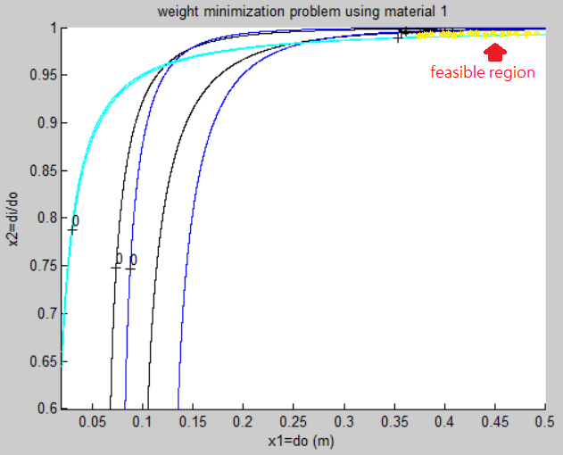 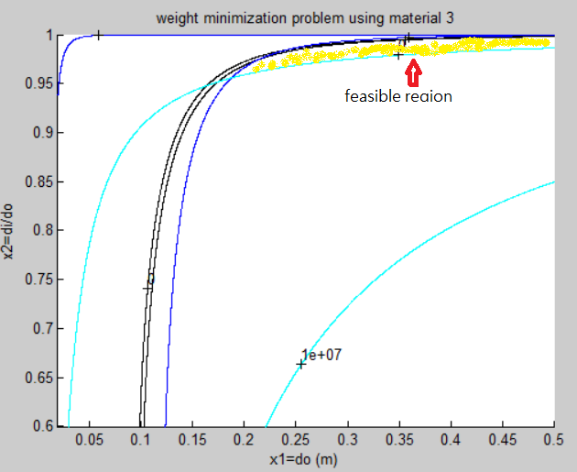

Figure 1: material 1 Figure 2: material 3

Figure 1, 2 were generated using the matlab program “HW1.m” (See Appendix A). Yellow regions are approximately the feasible regions.

**(LIST OF SUPPLEMENTAL FILES AND THEIR DESCRIPTIONS)**

Attachments

Appendix A: HW1_E14013344.m matlab program