**MEMO**

Mechanical Engineering Department

National Cheng Kung University

DATE: March 25th, 2016

TO: Prof. Chi-Lun Lin

FROM: 張元睿 & E14013344

SUBJECT: Homework 2 Results

**(BRIEFLY DECRIBE THE PROBLEM AND METHOD)**

First we need to develop a Lagrange Multiplier solver, and we can test it by test_fun.m to make sure it works. Use the solver to solve the following two problems:

1.  2. 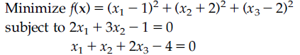

Use Lagrange Multiplier method and graphical method to solve problem 1. Use Lagrange Multiplier method to solve problem 2.

**CONCISELY DECRIBE YOUR RESULT AND OBSERVATION)**

The test function works. For problem 1, the result is shown in Figure 1. By using Lagrange Multiplier method, it can only find the minimum point, which is at ( $\frac{13}{6},\frac{11}{6})$. The minimum value is -8.333. I cannot tell the point is the maximum point or minimum point unless I plot the contour of the objective function out. But, by using graphical method, I know that the maximum value of the objective function is infinite.

For problem 2, the minimum point is at $(1.717, -0.811, 1.547)$, the minimum value of the objective function is 2.132. Lagrange Multiplier method can find the solution very fast, but need further check to know if it is the minimum or maximum point. For Graphical method, it is too slow since we have to find the optimum point by our eyes.

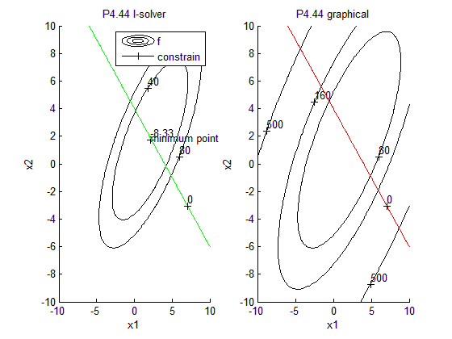

Figure 1: contour of objective function and constrain function by Lagrange and graphical method

Figure 1 was generated using the matlab program “p444.m” (See Appendix A).

**(LIST OF SUPPLEMENTAL FILES AND THEIR DESCRIPTIONS)**

Attachments

Appendix A: p444.m, p447.m, l_solver.m matlab program