**MEMO**

Mechanical Engineering Department

National Cheng Kung University

DATE: April 17th, 2016

TO: Prof. Chi-Lun Lin

FROM: 張元睿 E14013344

SUBJECT: Homework 3 Results

**Background**

The main problem is to analyze the mechanical advantage (MA) of the cutter, which is a four bar slider crank mechanism. The first task is to obtain the MA throughout a given range of motion and given configuration of link length and offset. The second task is to obtain the average MA over the duty cycle, which is cutting through a thickness of 12 mm. All possible duty cycle should be found out automatically at all kinds of configuration. The third task is design a user interface, so the user can change the configuration. Besides, there are also some subtasks. Implementing three numerical methods, which are Equal-interval search method, Alternate equal-interval search method and Golden section search method, to obtain the maximum MA and average MA of the first and second tasks above-mentioned.

**Results**

**a.**

Link2 and offset are both 10 mm is the best design configuration in terms of best MA.

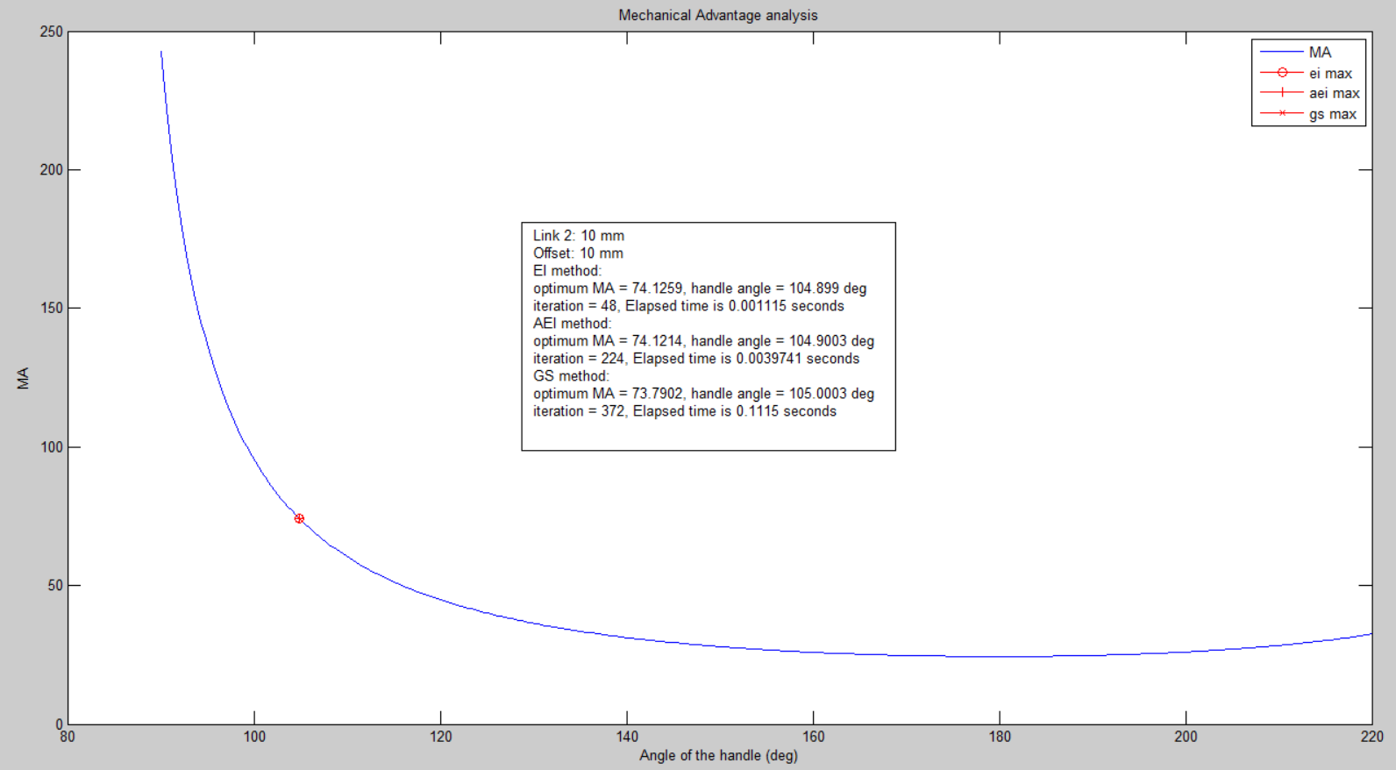

Figure 1: MA vs. Angle of handle

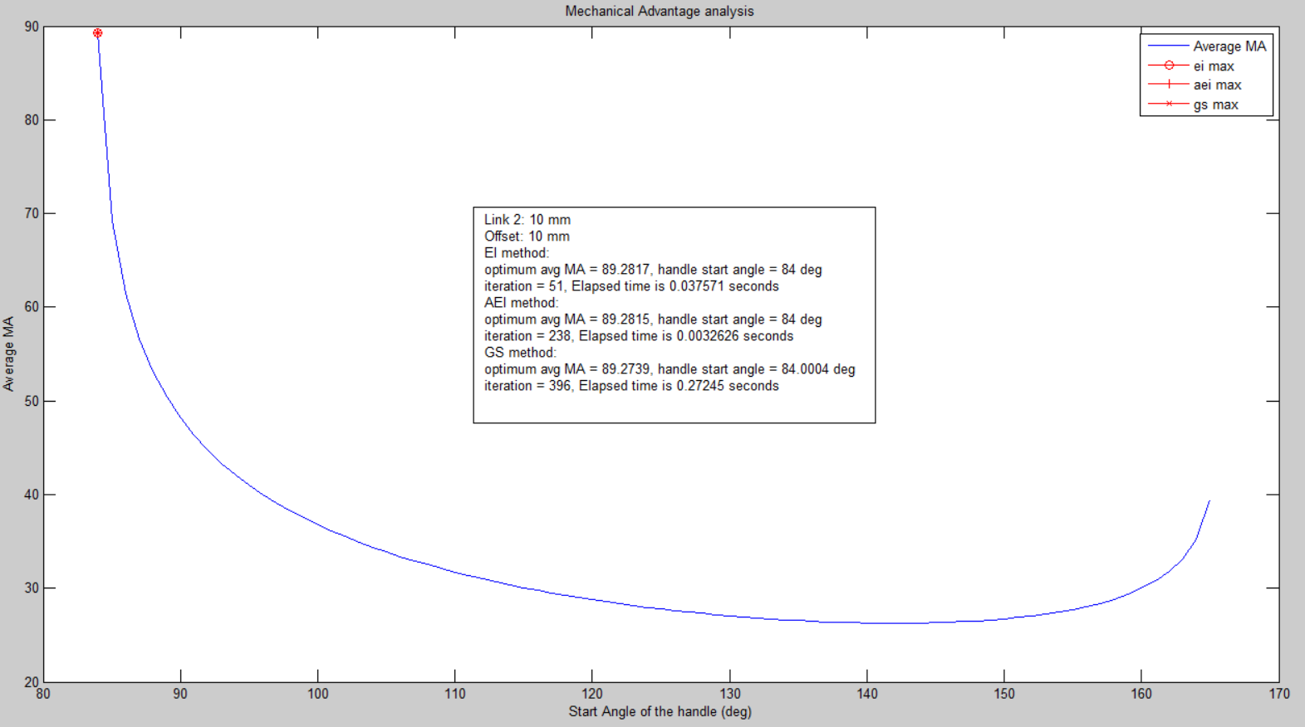

Figure 2: average MA vs. Start Angle of handle

**b.**

Link2 equals to 10 mm and offset equals to 40 mm is the best design configuration in terms of best average MA.

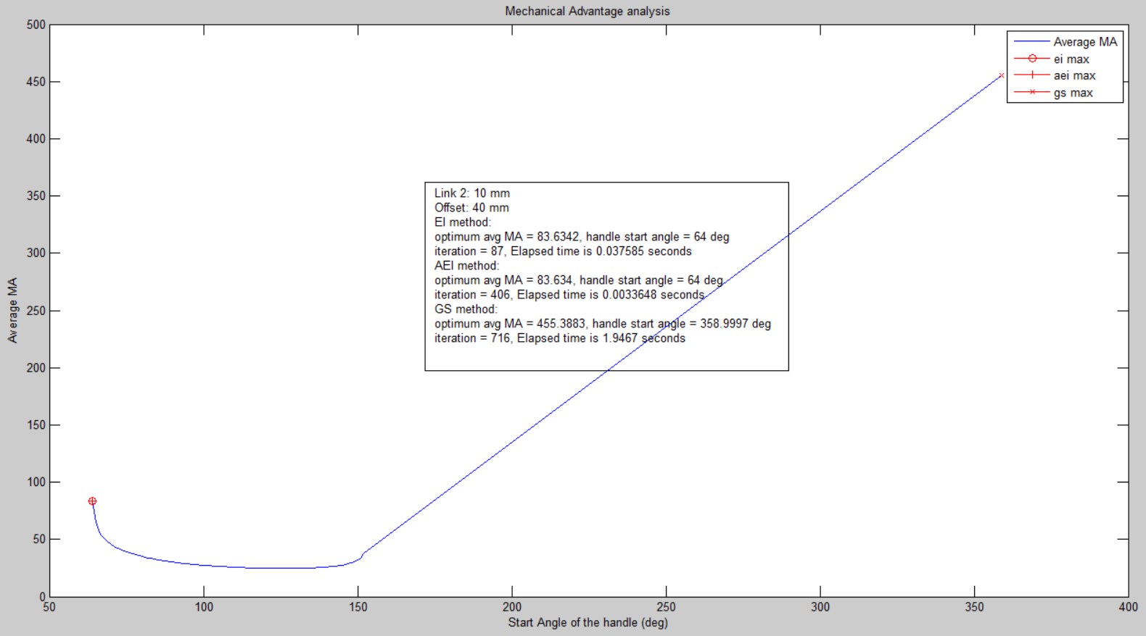

Figure 3: average MA vs. Start Angle of handle

**c.**

|  |  |  |
| --- | --- | --- |
|  | iteration | cpu time (s) |
| EI | 3 | 0.06806 |
| AEI | 14 | 0.03053 |
| GS | 21 | 0.00912 |

Table 1: unimodal function

|  |  |  |
| --- | --- | --- |
|  | iteration | cpu time (s) |
| EI | 15 | 0.03754 |
| AEI | 70 | 0.00345 |
| GS | 120 | 1.9457 |

Table 2: non-unimodal function

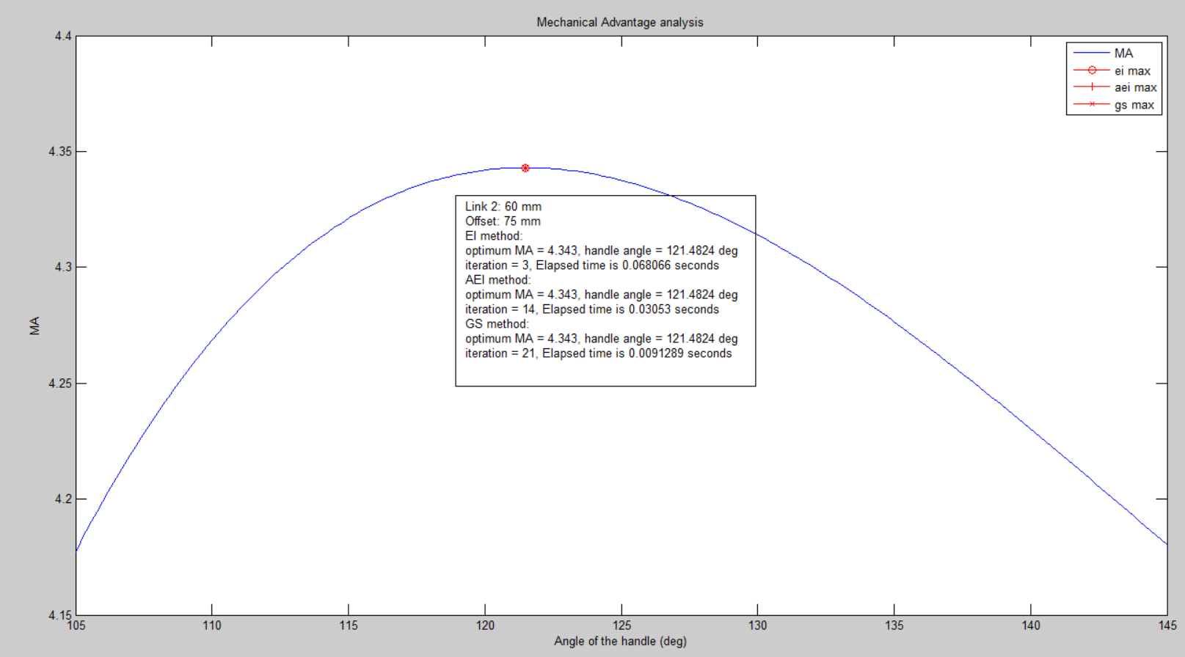

Figure 4: unimodal function

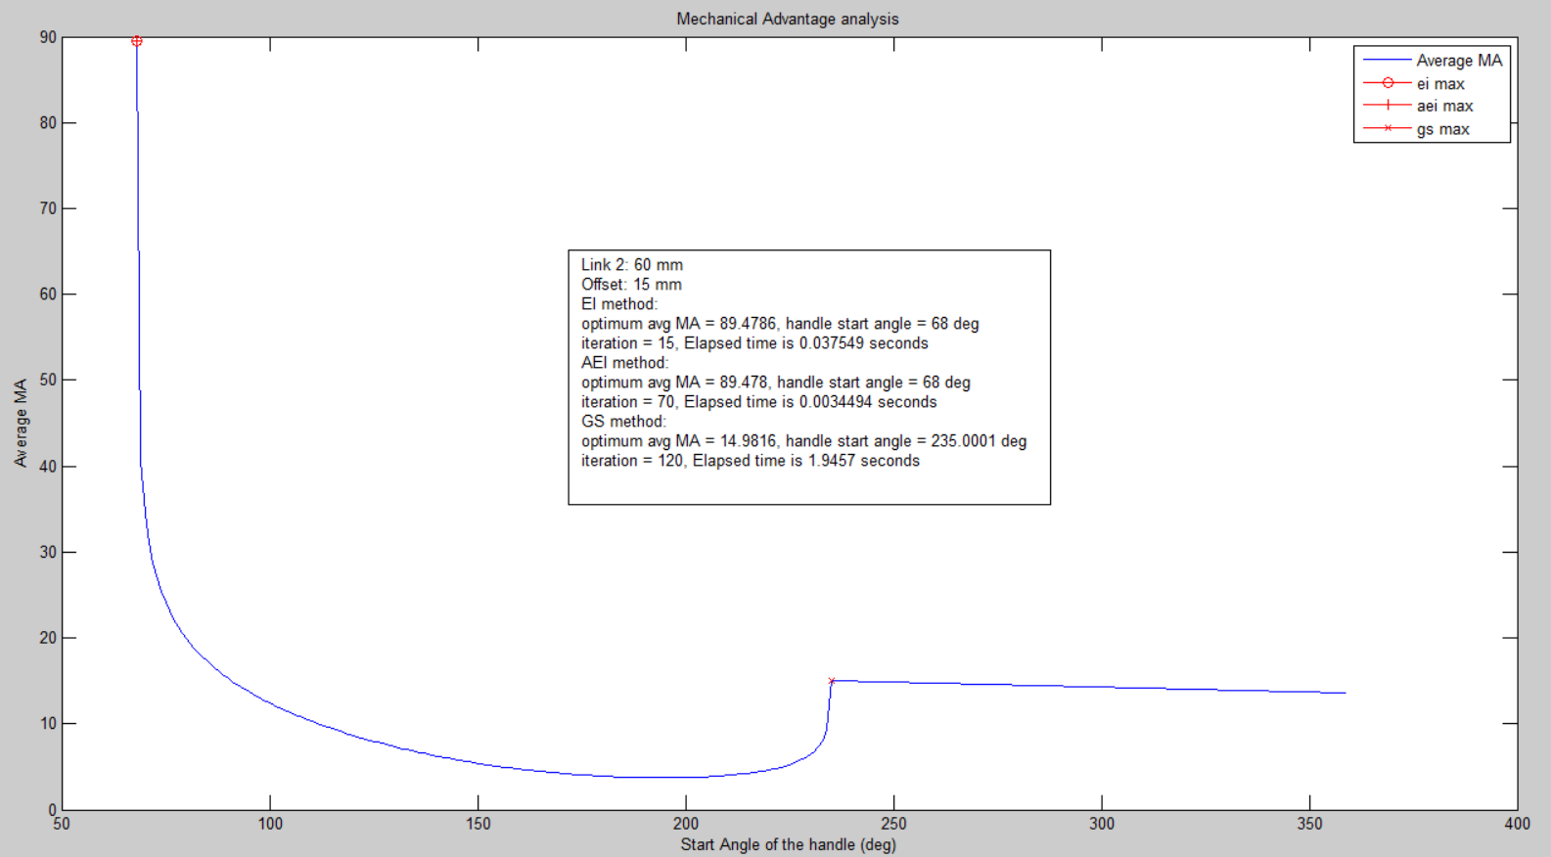

Figure 5: non-unimodal function

**Discussion & Conclusion**

**a.**

Link2 and offset are both 10 mm is the best design configuration in terms of best MA. From Figure 1, the function is quite flat, and has high MA from 120 degree to 220 degree. Compared to other configurations, this one has higher MA, and the curve of the function is flatter. Which means the user can cut things by same force throughout the process. From Figure 2, it proves that it is possible to cut down 12 mm from 120 degree to 165 degree. Thus, it saves a lot of strength from 120 degree to 165 degree to cut something.

Link2 equals to 10 mm and offset equals to 40 mm is the best design configuration in terms of best average MA. From Figure 3, in this configuration, it is obvious that the average MA is very high throughout all possible start angle. I think what makes the average MA so high is because of encountering the toggle position, which has infinite MA.

These two designs have one common thing, short link2, to make MA very high.

**b.**

When searching an unimodal function, GS method needs the most iterations, EI method needs the least iterations. But GS method needs the least time, EI method needs the most time. Figure 4 shows this phenomenon.When searching a non-unimodal function, GS method needs the most iterations, EI method needs the least iterations. GS method needs the most time, AEI method needs the least time. GS method has the best efficiency when searching an unimodal function, but when searching a non-unimodal function, GS method might have some problem. AEI method has better performance than EI method all the time, but too slow compared with GS method. The reason that causes EI and AEI method so slow is because of too many evaluations.

**c.**

In the Matlab 2013 program, function “tic, toc” were used to count the time, since function “cputime” has poor resolution. When the time cost is less than 0.0156 seconds, “cputime” returns 0 second.

**d.**

When checking the possibility of cutting down 12 mm, I found that in some starting angles the knife went up first, then went down. For example, first went up 1 mm, and then went down 13 mm. I did not count those start angles as the possible start angles since I thought this was not a typical cutting movement.

Figure 1,2,3,4,5 were generated using the Matlab program “cutter_analysis.m” (See Appendix A).

**(LIST OF SUPPLEMENTAL FILES AND THEIR DESCRIPTIONS)**

Attachments

Appendix A: cutter_analysis.m, cutter_ma.m, cutter_avg_ma.m, ei_max.m, aei_max.m, gs_max.m Matlab programs