|  |
| --- |
| COMP 2121  **DISCRETE MATHEMATICS** |
| Lecture 2 |

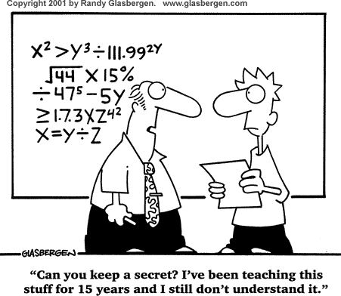Permutations

**Example 1.** Consider passwords made up from the letters: C, O, M, P, U, T, E, R.

1. What is the total number of passwords of length 12?
2. How many passwords in part a) have all distinct letters?
3. What is the total number of passwords of length 8?
4. How many passwords in part c) have all distinct letters?
5. How many passwords of length 5 have all distinct letters?

**Definition:** *Given a set of n distinct objects, a permutation is an ordered arrangement of these objects.*

**Theorem:** *For any integer n, n* *1, the number of permutations of all n elements of the set is equal to n!*

**Definition:** *If we order only some (say r*  *n ) elements of a set then we say we have an r-permutation. The number of r-permutations of a set of n elements is denoted P(n, r).*

**Theorem:**

*The number of r-permutations of a set with n distinct elements is denoted by P(n, r) and is equal to*

*n*!

*P*(*n*, *r*)  *n*  (*n* 1)  (*n*  2)  (*n*  *r* 1) 

*\*Note: By definition 0!=1 and hence P*(*n*, *n*)  *n*!

(*n*  *r*)!

**Example 2.** Generating a random permutation.

* Function Random(x, y) returns a random integer, which satisfies xRandom(x, y)y
* Function swap(i, j, X) swaps elements X[i] and X[j] in the array X
* Rnd is an integer array of size 5

Consider the following programming segment written in *pseudocode.*

For k = 0 to 4 {

Rnd[k] = k

}

For k = 0 to 4 {

swap(k, Random(k, 4), Rnd)

}

1. Show the final content of the array Rnd if the function Random(x,y) returns 4, 4, 4, 4, 4 during the program execution?
2. Show the final content of the array Rnd if the function Random(x,y) returns 2, 4, 2, 4, 4 during the program execution?
3. Show the final content of the array Rnd if the function Random(x,y) returns 2, 4, 3, 1, 2 during the program execution?

**Example 3.** What is the number of arrangements of the six letters in the word CANADA?

**Theorem**:

*If there are n items with n1 alike, n2 alike, …, nk alike, the number of permutations of all n items is*

n! n1!n2!☹nk!

**Example 4.** From among ten employees, three are to be selected to travel to plants A, B, and C, one to each plant. In how many ways can the assignment be made?

**Example 5.** Find the number of permutations of the letters in the word MISSISSIPPI.

**Example 6.** Find the number of different strings of length 8 that have five underscore characters and three distinct letters of English alphabet.