|  |
| --- |
| COMP 2121  **DISCRETE MATHEMATICS** |
| Lecture 4 |

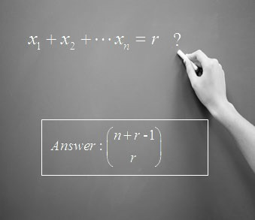**Combinations with Repetition Allowed**

**Example 1.** (Review problem): Consider the following program segments. What value does a variable counter have after the following code execution?

counter = 15

for i = 1 to 5

for j = 1 to 5

counter = counter + 8 next j

counter = counter + 9 next i

counter = 15

for i = 1 to 5

for j = i+1 to 5

counter = counter + 8 next j

counter = counter + 9 next i

counter = 15

for i = 1 to 6

for j = i+1 to 10 counter = counter + 8

next j

counter = counter + 9 next i

**Example 2.** In how many ways can one distribute 12 identical blue marbles among three math instructors: Andrew, David and Scott?

**Theorem:**

*When we wish to select, with repetition, r of n distinct objects, we find that we are considering all arrangements of r ‘x’s and n* 1 *|’s and thus their number is:*



 *n*  *r* 1  (*n*  *r* 1)!



*r*





*r* !(*n* 1)!

**Example 3.** How many arrangements of the letters in CANADIAN have at least two letters between the N’s? (Similar to example from Lecture 3)

**Example 4.** Consider the following program segments. How many times is the print statement executed?

for i = 1 to 5

for j = i to 5

print i, j next j

next i

for i = 1 to 5

for j = 1 to i

print i, j next j

next i

**Summary:**

|  |  |  |
| --- | --- | --- |
| balance | Order matters | Order does not matter |
| Repetition is allowed | *nk* |  *n*  *k* 1   *k*     |
| Repetition is Not allowed | *P*(*n*, *k*)   *n*!  (*n*  *k* )! |  *n*   *n*!   *k*  *k* !(*n*  *k* )!    |

