|  |
| --- |
| COMP 2121  **DISCRETE MATHEMATICS** |
| Lecture 5 |

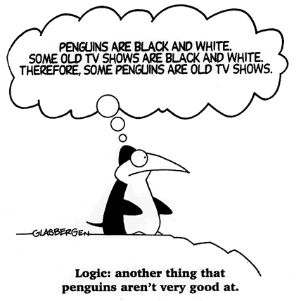1

Logic

Formal Logic is a set of rules for determining the truth value of a statement. It generally parallels intuitive logic but has no ambiguities.

**Definition:** *A statement (or proposition) is a sentence that is true or false but not both.*

We introduce following connectives to build more complicated logical expressions:

* Negation
* Conjunction
* Disjunction
* Implication
* Biconditional

# Evaluating the Truth of General Compound Statements

The truth table for a given statement form displays the truth values that correspond to the different combinations of truth values for the variables.

1 <http://penguingeek.files.wordpress.com/2007/08/humor-penguin-logic.jpg>

**Example 1.** Build truth table for (p  q)  ➢ (r  q).

|  |  |  |  |  |  |  |
| --- | --- | --- | --- | --- | --- | --- |
| p | q | r | p  q | r  q | ➢ (r  q) | (p  q)  ➢ (r  q) |
| 0 | 0 | 0 |  |  |  |  |
| 0 | 0 | 1 |  |  |  |  |
| 0 | 1 | 0 |  |  |  |  |
| 0 | 1 | 1 |  |  |  |  |
| 1 | 0 | 0 |  |  |  |  |
| 1 | 0 | 1 |  |  |  |  |
| 1 | 1 | 0 |  |  |  |  |
| 1 | 1 | 1 |  |  |  |  |

# Tautology and Contradiction

**Definition:** *A tautology is a statement form that is always true regardless of the truth values of the individual statements substituted for its statement variables. It is called a tautological statement.*

We often use the letter T0 as a variable to represent a tautological statement.

**Definition:** *A contradiction is a statement form that is always false regardless of the truth values of the individual statements substituted for its statement variables. It is called a contradictory statement.*

We often use the letter F0 as a variable to represent a contradictory statement.

**Example 2.** Consider statements:

|  |  |  |  |
| --- | --- | --- | --- |
| *p* | ➢*p* | *p*  ➢*p* | *p*  ➢*p* |
| 0 | 1 |  |  |
| 1 | 0 |  |  |

A: *p*  ➢*p*

B: *p*  ➢*p*

# Logical Equivalence

**Definition:** *Two statements s and t are said to be logically equivalent, and we write s*  *t , when the statement s is true (respectively, false) if and only if the statement t is true (respectively, false).*

**Example 3.** Consider statements A: ➢( *p*  *q*) , B: ➢*p*  ➢*q*

*A*  *B* ? Is it true that *A*  *C* ?

and C : ➢*p*  ➢*q* . Is it true that

|  |  |  |  |  |  |  |  |
| --- | --- | --- | --- | --- | --- | --- | --- |
| *p* | *q* | *p*  *q* | ➢( *p*  *q*) | ➢*p* | ➢*q* | ➢*p*  ➢*q* | ➢*p*  ➢*q* |
| 0 | 0 |  |  |  |  |  |  |
| 0 | 1 |  |  |  |  |  |  |
| 1 | 0 |  |  |  |  |  |  |
| 1 | 1 |  |  |  |  |  |  |

**Example 4.** A group of students is working on a project that involves writing a merge sort program. Alice and Bob have each written an algorithm for a function that takes two lists List1 and List2, of lengths p and q, respectively, and merges them into a third list, List3. Parts of the algorithms are shown below. Do Alice’s and Bob’s algorithm do the same thing?

(1) If **(((**i+j  p+q**)**&&**(**i p**)**&&**(**j>q**))**

|| **((**i+j  p+q**)**&&**(**i p**)**&&**(**List1[i]  List2[j]**)))**

(2) List3[k]=List1[i]

(3) i=i+1

1. else
2. List3[k]=List2[j]

(6) j=j+1

(7) k=k+1

(1) If **((**i+j  p+q**)**&&**(**i p**)**&&**((**j>q**)**||**(**List1[i]  List2[j]**)))**

(2) List3[k]=List1[i]

(3) i=i+1

1. else
2. List3[k]=List2[j]

(6) j=j+1

(7) k=k+1



Alice



Bob

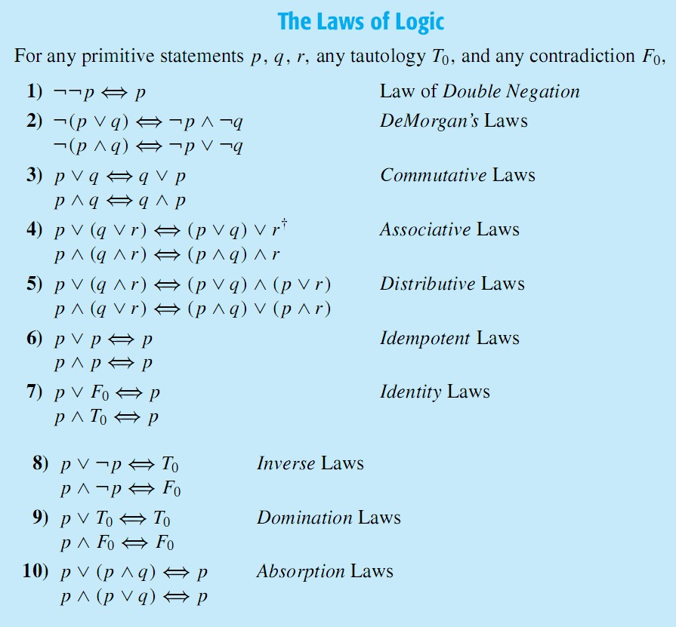

# Conditional Statements

**Example 5.** Use logical equivalences to show:

➢*p*  *q*  ➢ *p*  *q*  ➢*p*

A conditional statement is a statement with the form “*If* such and such is true, *then* something else must be true.” Conditional statements are used in logic to show that one thing follows from an earlier thing. Conditional statements are also used in most programming languages to indicate that an action will happen only if a condition is true. In this section, we will only be discussing the condition statement as used in logic. If we let *p* and *q* represent statements, then we write a conditional statement as *p*  *q.* In this conditional statement, we call *p* the *hypotheses*, and *q* the *conclusion*. Conditional statements are frequently used in common English. For example, “if today is Monday, then I have a math class”. Since a conditional statement is a logical statement, it too has a value of *true* or *false*. The statement *p*  *q* is *true* if *p* and *q* are both *true*, or if *p* is *false*. Thus it has the following truth table:

Note that the conditional statement *p*  *q* is true when *p* is *false*. This is called being vacuously true, or true by default. For example, the statement “if instructors can levitate, then all students will get grades of 100%” is vacuously true. As long as instructors cannot levitate, students can be given any grade.

|  |  |  |
| --- | --- | --- |
| p | q | *p*  *q* |
| 0 | 0 | 1 |
| 0 | 1 | 1 |
| 1 | 0 | 0 |
| 1 | 1 | 1 |

**Example 6.** Fill in truth table for  *p*  ➢*q*  ➢*p* .

|  |  |  |  |  |  |
| --- | --- | --- | --- | --- | --- |
| *p* | *q* | ➢*q* | *p*  ➢*q* | ➢*p* |  *p*  ➢*q*  ➢*p* |
| 0 | 0 |  |  |  |  |
| 0 | 1 |  |  |  |  |
| 1 | 0 |  |  |  |  |
| 1 | 1 |  |  |  |  |

**Example 7.** It is often handy to use the representation of the conditional statement defined using the *or* operation: *p*  *q*  ➢*p*  *q .* Verify this using a truth table.



|  |  |  |  |  |
| --- | --- | --- | --- | --- |
| *p* | *q* | *p*  *q* | ➢*p* | ➢*p*  *q* |
| 0 | 0 | 1 | 1 |  |
| 0 | 1 | 1 | 1 |  |
| 1 | 0 | 0 | 0 |  |
| 1 | 1 | 1 | 0 |  |

# Contrapositive

An important law of logic is the equivalence between a conditional statement and its contrapositive. A conditional statement *p*  *q* is logically equivalent to its contrapositive

➢*q*  ➢*p* . It is often useful to replace a conditional with its contrapositive when solving logic problems. Proof: (Using a truth table)



|  |  |  |  |  |  |
| --- | --- | --- | --- | --- | --- |
| p | q | ➢ p | ➢ q | p  q | ➢ q  ➢ p |
| 0 | 0 | 1 | 1 |  |  |
| 0 | 1 | 1 | 0 |  |  |
| 1 | 0 | 0 | 1 |  |  |
| 1 | 1 | 0 | 0 |  |  |

# Converse and Inverse of a Conditional Statement

Suppose we have a conditional statement of the form “if *p* then *q*”. Then *converse* is “if *q* then *p*” and *inverse* is “if ➢ *p* then ➢ *q*.” It is important to note that conditional statement is not necessarily equivalent to its converse and inverse. The converse and inverse of a conditional statement are equivalent to each other.

# Negation of a conditional statement

It is important to remember that the negation of a conditional statement is NOT another conditional statement.

**Example 8.** Write negation of the following statement: If today is Monday then I have COMP2121 class.

# Biconditional

Given variables *p* and *q* , the biconditional of *p* and *q* is “ *p* if, and only if, *q* ” and is denoted

*p*  *q* . It is true if both *p* and *q* have the same truth values and is false if *p* and *q* have

opposite truth values. The truth table for *p*  *q* is given below.

|  |  |  |
| --- | --- | --- |
| p | q | p  q |
| 0 | 0 | 1 |
| 0 | 1 | 0 |
| 1 | 0 | 0 |
| 1 | 1 | 1 |

**Example 9.** Use truth table to show that *p*  *q*  (*p*  *q*)  (*q*  *p*).

|  |  |  |  |  |  |
| --- | --- | --- | --- | --- | --- |
| p | q | p  q | p  q | q  p | (p  q)  (q  p) |
| 0 | 0 | 1 |  |  |  |
| 0 | 1 | 0 |  |  |  |
| 1 | 0 | 0 |  |  |  |
| 1 | 1 | 1 |  |  |  |