|  |
| --- |
| COMP 2121  **DISCRETE MATHEMATICS** |
| Lecture 6 |

**1**

Logical Implication: Rules of Inference

* **Logical Implication: Rules of Inference**

In mathematics, an argument is defined to be a sequence of statements that reach a conclusion. If the argument is *valid*, then the conclusion follows from the earlier statements in the argument. All of the statements, except the final one are called premises (or assumptions, or hypotheses). The final statement is called the conclusion. We often use the symbol  (read “therefore”) just before the conclusion.

An argument form is an argument involving statement variables (such as *p* and *q*). An argument form is valid when any substitution of statements for the statement variables that leaves the premises true also results in the conclusion being true. To say an argument is valid means that its form is valid.

**Example 1.** The following is the classic argument:

If Socrates is a human being, then Socrates is mortal; Socrates is a human being;

Socrates is mortal.

This argument has the abstract form:

if *p* then *q*; *p*;

*q*.

In general, we can have n premises, p1, p2, …, pn. The argument

( *p*1  *p*2  *p*3 ☹  *pn* )  *q* is

called valid if whenever each of premises p1, p2, …, pn is true, the conclusion q is likewise true.

1 <http://img522.imageshack.us/img522/4043/clipboard3781kr2.jpg>

Therefore, we can test an argument form for validity by following these steps:

1. Identify the premises and conclusion of the argument.
2. Construct a truth table showing the truth values of all the premises and the conclusion.
3. Find the rows (*critical rows*) for which all of the premises are true.
4. For each critical row, check if the conclusion is also true.
   * If the conclusion is true for all critical rows, the argument form is valid.
   * If one or more critical rows have a false conclusion, then the argument form is invalid.

**Example 2**. Show that the following argument form is valid:

*p*  (*q*  r)

➢ *r*

 *p*  *q.*

|  |  |  |  |  |  |  |
| --- | --- | --- | --- | --- | --- | --- |
| p | q | r | q  r | p  (q  r) | ➢ r | p  q |
| 0 | 0 | 0 | 0 | 0 | 1 | 0 |
| 0 | 0 | 1 | 1 | 1 | 0 | 0 |
| 0 | 1 | 0 | 1 | 1 | 1 | 1 |
| 0 | 1 | 1 | 1 | 1 | 0 | 1 |
| 1 | 0 | 0 | 0 | 1 | 1 | 1 |
| 1 | 0 | 1 | 1 | 1 | 0 | 1 |
| 1 | 1 | 0 | 1 | 1 | 1 | 1 |
| 1 | 1 | 1 | 1 | 1 | 0 | 1 |

**Modus Ponens – Rule of Detachment**. There are several standard argument forms used. See the text for several additional examples. The one we saw above, with Socrates, is called modus ponens. It is extremely common:

if *p* then *q*; *p*;

*q*.

**Modus Tollens - Method of Denying.** A related form is modus tollens, which takes the form:

if *p* then *q*;

➢ *q*;

 ➢ *p*.

An example of this is

1. If Zeus is human, then Zeus is mortal
2. Zeus is not mortal
3. Therefore, Zeus is not human. (Identify *p* and *q* here).

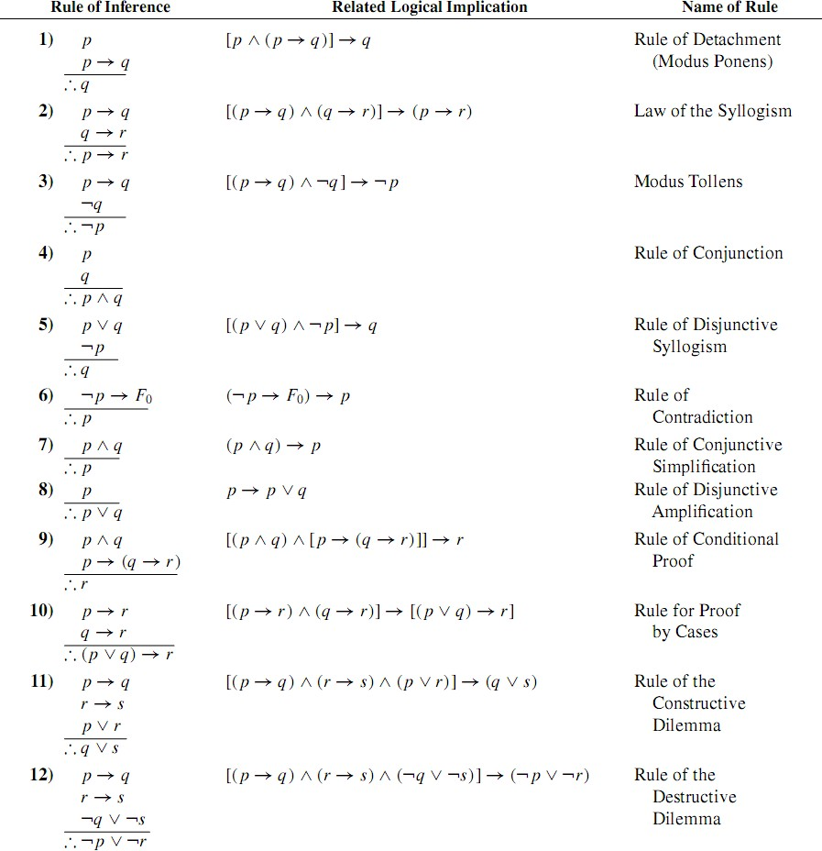

**Example 3.** Show that the following argument is valid using our known argument forms:

p  x

p  w  x

➢ q p  q

 w

**Example 4.** Prove that the following argument is valid:

➢ p  (r  ➢ s) x  s

u  ➢ p

➢ w u  w

 ➢ x  w

*\*\*\*Note: To show that argument is invalid you need to find one assignment of truth values such that conclusion is false while the premises are all true.*

**Example 5.** Is the following argument valid or invalid? p

p  q

q  (r  s) t r

 ➢ s  ➢ t

The final frequently used rule is called proof by contradiction. If you assume conclusion is false (assuming the contradiction of what you want to deduce), and manage to validly argue something as true which you know to be false, then you know that your assumption must be false. Therefore conclusion must be true. This is because valid arguments can only produce true conclusions from true premises. Another way of saying this is that if you can show that supposing *q* is false leads logically to a contradiction, then you can conclude *q* is true.

The argument form is as follows:

➢ *q*  *F0*, where F0 is a contradiction.

*q.*

Sometimes the contradiction will be several steps after the assumption of ➢ *q*.

**Example 6.** Prove the following argument using Proof by Contradiction:

➢ p→ q

q→ r

➢ r

p