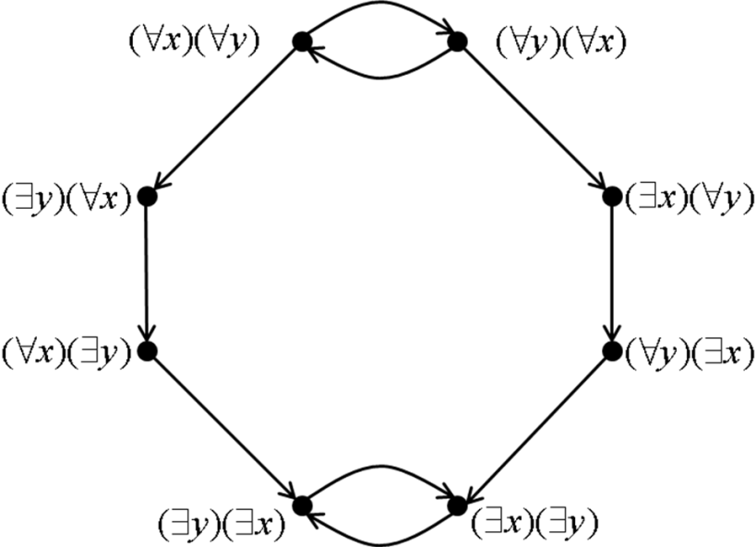

|  |
| --- |
| COMP 2121  **DISCRETE MATHEMATICS** |
| Lecture 7 |

# The Logic of Quantified Statements

Recall that statement has a truth value, either true of false. Consider statement “*x* is divisible by 5.” This statement is false for *x* = 3 and true for *x* = 5 (there are of course many other examples). We see that the truth value of this statement depends on *x*. So, we can write something like:

*p*(*x*): *x* is divisible by 5.

**Definition:** *A declarative sentence is an open statement that*

1. *contains one or more variables,*
2. *is not a statement, but it becomes a statement when the variables in it are replaced by certain allowable choices.*

Referring to the previous example, we can say that *p*(10) is true and *p*(12) is false. Therefore, we can make the following true statement:

We do not need to make a restriction to a single variable only. In fact, an open statement can involve many variables.

*q*(*x,y*): *x+y* = 100

There are many numbers that satisfy this, for example *x* = 99 and *y* = 1. So *q*(99,1) is true, but

*q*(55,55) is false. However, the following is a true statement

In math we use symbol **** to denote “for some” or “for at least one”. Hence, quantifier **** is called existential quantifier. The sentence above can be written as *****x*,**** *y*,*q*(*x*, *y*) or simply *****x*, *y*, *q*(*x*, *y*).

Similarly, the universal quantifier **** is used to denote “for all” or “for any”.

We always make restriction to allowable choices for variables. These allowable choices constitute what is called the *universe* or *universe of discourse* for an open statement.

If our universe is negative integers, then statement “*q*(*x*,*y*): *x* + *y* = 100” is false for every choice of *x* and *y* (or ➢ *q* (*x*, *y*) is always true).

# Truth and Falsity of Statements involving Universal quantifier

1. All human beings are mortal. True/False ?
2. For the universe of positive integers  *x* , *x*2  *x* True/False ?
3. For the universe of all integers  *x* , *x*2  *x* True/False ?
4. For the universe of real numbers  *x* , *x*2  *x* True/False ?
5. For the universe of real numbers, if *n*2 is even then *n* is even. True/False ?

We have seen that it is usually easier to show that a universal statement is false than it is to show that it is true.

# Truth and Falsity of Statements involving Existential quantifier

1. For the universe of integers,  *x*, *x*2 = *x* True/False ?
2. For the universe of all integers,  *x*, *x* + 100 = 8.5 True/False ?

Similarily, it is usually easier to show an existential statement is true than it is to show that it is false.

**Example**. Consider the universe of real numbers. What quantifier should be used for the next 2 sentences?

*p*(*x*): (*x* + 1)2 = *x*2 +2*x* +1

*q*(*x*): (*x* + 2)2 = 25

# Negations of Quantified Statements

Consider the statement: “All students like mathematics”. What would make this statement false? Hence, the negation is:

The negation of a universal statement (“all are”) is logically equivalent to an existential statement (“some are not”). In general, the negation of a statement of the form “ *x*, Q(*x*)” is logically equivalent to a statement of the form:  *x* ➢ Q(*x*)”. Symbolically:

➢ ( *x*, Q(*x*))   *x*, ➢ Q(*x*)

Consider the statement “Some computer hackers are over 40”. The negation of this statement is:

Hence, the negation of an existential statement (“some are”) is logically equivalent to a universal statement (“all are not”). The negation of a statement of the form “ *x*, Q(*x*)” is logically equivalent to a statement of the form “ *x*, ➢ Q(*x*)” Symbolically:

➢ ( *x* Q(*x*))  *x*, ➢ Q(*x*) 

**Example**: Negate the following statement: *For all the people on the planet, if a person has blue eyes, then that person is blonde.*

# Statements Containing Multiple Quantifiers

Consider the following statements: Everybody loves somebody. Somebody loves everybody.

Are the two statements equivalent? Use quantifiers to give formal representation for each statement.

**Example.** Determine the truth value of the following statements (T or F) and justify your answer.

Universe for *x* is 1, 4, 9 and universe for *y* is 2, 3, 6.1, 8.

1. *x*,  *y x*  *y*
2. *x*,  *y x*  *y*
3. *x*,  *y x*  *y*

Universe for *x*: 1, 4, 9

Universe for *y*: 2, 3, 6.1, 8

1. *y*, *x x*  *y*
2. *x*,  *y x*  *y*

is even

1. *y*,  *x x*  *y*

is even

Universe for *x*: 1, 4, 9

Universe for *y*: 2, 3, 6.1, 8

g) *x*, *y* 2  *x*  *y*  20