|  |
| --- |
| COMP 2121  **DISCRETE MATHEMATICS** |
| Lecture 9 |

# Chapter 3 - Set Theory

This chapter introduces the structures of set and ordered set and illustrates them with examples. Together with logic and quantifiers, it provides a strong base for set properties discussion and introduces to the notation of formal languages (computer languages).

**Definition:** *A set is a collection of objects.*

If a set is finite and not “too large”, we can describe it by listing the elements.

**Example 1.** A = {1, 2, 3, 4}

B = {} = 

C = {1, 2, 3, 1, 2}

D = {1, 2, 3, {1}, {1, 2}}

***Note that {1}  1

For a finite set A, |A| denotes the number of elements of A and is referred to as the ***cardinality***, or *size*, of A. For example, set A={1, 2, 3, 4, 7, 10} has a cardinality 6; another words |A| = 6.

The order in which the elements are listed is irrelevant, as is the fact that some elements may be listed more than once.

*x*  A expresses that the element *x* is in set A

If the set is infinite or too big, the set is described by defining a property. For example: A = {*x*  S | P(*x*)} reads as “A is the set of all *x* in S such that P(*x*) is true”

**Example 2.**

*A*  *x*  *R* | 7  *x*  2 *B*  *x*  *Z* | 7  *x*  2 *C*  *x*  *Z*  | 7  *x*  2

**Definition**: *If A and B are sets, A is called a subset of B, written A * *B, if and only if, every element of A is also an element of B*.

A  B  x, if x  A then x  B

*** Note distinction between  and 

It follows that

A  B  x, x  A and x  B

**Definition**: *Let A and B be sets. A is a proper subset of B if, and only if, every element of A is in B but there is at least one element of B that is not in A.*

A  B  x, if x  A then x  B and A  B

Sets can be represented with Venn diagrams:

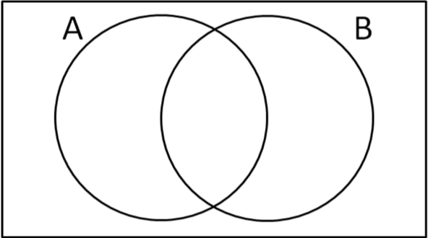

**Definition:** *Given sets A and B, A equals B (A = B), if, and only if, every element of A is in B and every element in B is in A.*

A = B  A  B and B  A

# Power Set:

**Definition:** *Given a set A, the power set of A, denoted by (A), is the set of all subsets of A.*

For all integers *n*  0, if a set A has *n* elements then (A) has 2n elements.

**Example 3.** Find the power set of {*x*, *y*}.

# Operations on Sets

Consider A and B to be subsets of a universal set U

1. The union of A and B (A  B) is the set of all elements in U such that *x* is in A OR *x* is in B.
2. The intersection of A and B (A  B) is the set of all elements in U such that *x* is in A AND *x* is in B.
3. The difference B minus A (B  A) is the set of all elements in U such that *x* is in B AND

*x* is not in A.

1. The symmetric difference A ∆ B is the set of all elements in U such that *x* is in A OR *x* is in B, but not in both A and B.
2. The complement of A ( A ) is the set of all elements in U such that *x* is not in A.

Formally:

A  B =

A  B = *x* *U* | *x*  *A*  *x*  *B*

A  B = *x* *U* | *x*  *A*  *x*  *B*

A ∆ B = *x* *U* |  *x*  *A*  *x*  *B*  *x*  *A*  *B*

A =

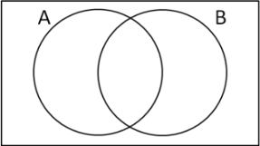



**Example 4.** With U = {1, 2, 3, 4, 5, 6}, A= {1, 2, 3}, B = {2, 3, 4} and C={1, 5} we have: A  B =

A  B =

B  C =

A ∆ B =

A =

A – B =

# Properties of Sets

A statement regarding a relation between sets can have a value of true or false. Note that the Laws of Set Theory are closely related to the Laws of Logic.

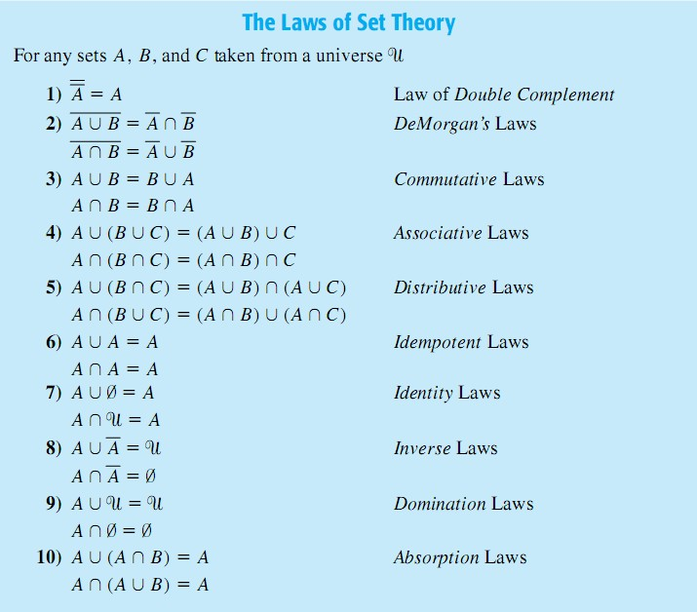

Another method for proving set properties is by using Venn diagrams. Note: As the number of sets increases the loss of symmetry in the diagrams is unavoidable.

**Example 5.** a) Use Venn’s diagrams to show that the following identity is false:

(A – B)  (B – C) = A – C

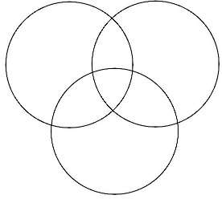

b) Even though the given identity is false in general, find one example of nonempty sets A, B and C that satisfies the identity

(A – B)  (B – C) = A – C Use universe U = {1, 2, 3, 4}.

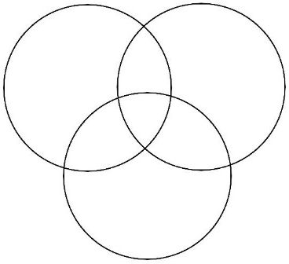

A = { }

B = { }

C = { }

**Example 6.** Provide one example of nonempty sets A, B and C that satisfies all of the following:

* ( C  ( A  B ) )  B

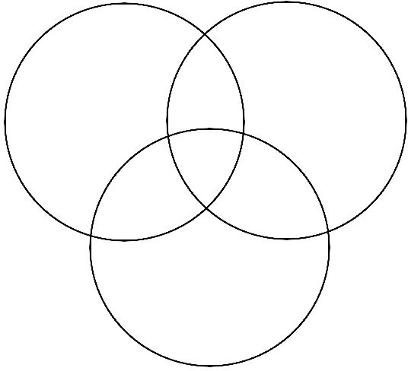

* ( B  C )  ( A  C )
* ( B  C )  A
* | B | = 2
* 2  B

Universe U = {1, 2, 3, 4, 5}.

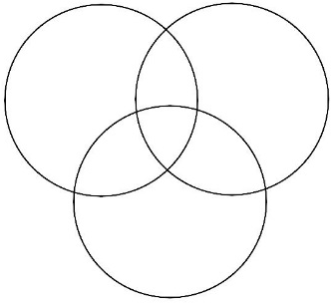

Write your answer:

A = { }

B = { }

C = { }