# Focus

The purpose of this task is to develop experience in producing and analysing Relational Mapping based on an Entity Relationship diagram from a real-world scenario. This case study will also focus on the ability to critique and analyse relational mapping and its effect on database implementation.

# Task

Using the correspondence on the pages below, complete the following tasks. Please ask your tutors for help if you require clarification on any aspects of the brief.

## Section A – Analysis and Discussion

### Please read Correspondence 1 and Correspondence 2 before attempting this section.

The incomplete relational schema mapping produced by the junior system administrator contains several mistakes which could impact the functionality of this database system. Please find the five mistakes in the schema provided and for each:

1. Identify the mistake
2. Provide the correct mapping/foreign key constraint
3. Explain briefly how this error would negatively impact useability of the database (this must not exceed 125 words)

**Note: Do NOT provide “missing a table” as a mistake. You must only identify mistakes in the** **schema** **from** **the** **correspondence** **below.** An example has been provided below, do not use this example as one of your identified mistakes.

|  |  |
| --- | --- |
| **Example** | |
| **Mistake** | User [id, dob, firstName, middleName, lastName] |
| **Correction** | User [id, dob, firstName, middleName, lastName] |
| **Explanation** | If dob was included as part of the primary key for the User table, then two users with the same *id* but a different *dob* could potentially exist in the database system. This would then make it impossible to distinguish which user is allocated to a specific trip. |

## Section B – EER Diagram to Relational Mapping

### Please read Correspondence 1 before attempting this section.

Using the EER diagram provided in Correspondence 1, please provide the relational mapping for the entire database system. **Note:** **You** **do** **not** **need** **to** **show** **each** **step** **in** **the** **mapping** **process,** **just** **providing** **the** **final** **database** **schema** **and** **foreign** **keys** **is** **sufficient.**

The University of Queensland Brisbane QLD 4072 Australia



ABN: 63 942 912 684

CRICOS PROVIDER NUMBER 00025B

## Section C – Relational Model and Database Systems

### Please read Correspondence 3 before attempting this section.

In Correspondence 3, Peter introduced the relational schema for the backend system being used to manage Dirt Road Driving’s payroll. **Using** **the** **schema** **and** **sample** **data** **provided** in that email please answer the following questions.

1. Give an example of:
   1. a superkey
   2. a minimal key
   3. a foreign key
2. Peter indicated they have been experiencing some issues with the backend of the payroll system. However, they are unsure whether the issue exists with the UI system or if the operations themselves are incorrect. For each database operation please answer the following:
   1. Does this operation violate an integrity constraint? (Y / N)
   2. If yes, state the type of constraint violated
   3. If yes, briefly describe how the constraint was violated (this must not exceed 100 words)
3. Give an example of a database operations which:
   1. Would result in a domain constraint violation
   2. Would result in a referential integrity constraint violation

**Note:** **You** **must** **provide** **original** **examples,** **not** **copied** **identically** **from** **the** **case** **study.**

# Correspondence

## Correspondence 1:

From: [infs1200@uq.edu.au](mailto:infs1200@uq.edu.au)

To: [peter@dirtroaddriving.com.au](mailto:peter@dirtroaddriving.com.au) Date: 5/4/2020 02:58 PM

Subject: RE: Student Support for Industry Project Hi Peter,

I hope you are having a nice weekend. I just wanted to update you regarding some progress which has been made by our student teams for the Dirt Road Driving Industry project.

After analysing several students’ responses, I have attached the solution we feel would best suit your current situation.

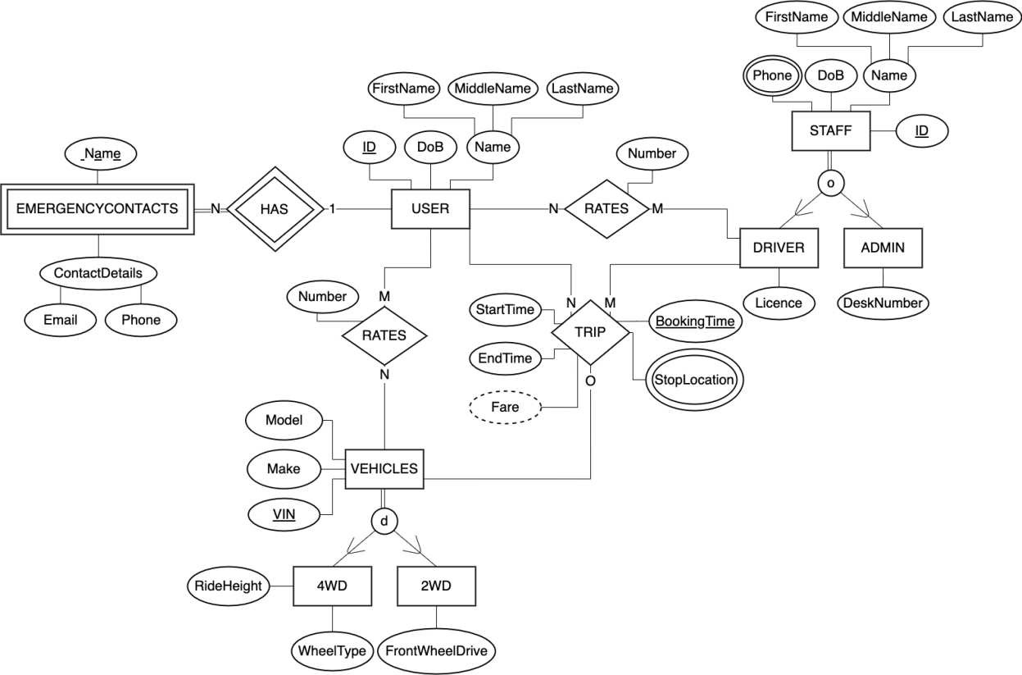

Please feel free to pass on any questions you or your team may have regarding the EER diagram. We really hope this solution will work well for your business!

Your sincerely, Elaine Smith

INFS1200 Student Representative

## Correspondence 2:

From: [peter@dirtroaddriving.com.au](mailto:peter@dirtroaddriving.com.au) To: [infs1200@uq.edu.au](mailto:infs1200@uq.edu.au)

Date: 11/4/2020 09:12 AM

Subject: RE: Student Support for Industry Project Hi Elaine,

On behalf of the Dirt Road Driving team we’d like to thank you and your students so much for your

help with this project. We really appreciate it!

If it’s alright, would we be able to run another thing by your student team? One of our junior system administrators has begun to map the EER diagram into a relational schema for future implementation. We’d love it if you or your team would be able to provide some feedback on the work he has done so far. Please find below his relational mapping so far:

*Tables:*

User [id, dob, firstName, middleName, lastName] Staff [id, dob, firstName, middleName, lastName] Vehicles [vin, make, model]

EmergencyContact [name, userID, email, phone]

Trip [userID, driverID, vin, bookingTime, startTime, endTime] UserRatesDriver [userID, driverID, rating]

Driver [id, licence]

4WD [vin, make, model, rideHeight, wheelType] StaffPhone [id, phone]

*Foreign* *Keys:*

EmergencyContact.userID references User.id Trip.userID references User.id

Trip.driverID references Staff.id Trip.vin references Vehicles.vin

UserRatesDriver.userID references User.id UserRatesDriver.driverID references Driver.id Driver.id references Staff.id

StaffPhone.id references Staff.id 4WD.vin references Vehicles.vin

Thank you and I look forward to your response. Kind regards,

Peter Thompson

Director of Innovation | Dirt Road Driving

## Correspondence 3:

From: [peter@dirtroaddriving.com.au](mailto:peter@dirtroaddriving.com.au) To: [infs1200@uq.edu.au](mailto:infs1200@uq.edu.au)

Date: 15/4/2020 08:09 PM

Subject: RE: Student Support for Industry Project Hi Elaine,

I hope you are having a nice week! I just wanted to discuss the possibility of receiving some student support for another database related project our company is undertaking.

In order to streamline our payroll system, last year we hired an external developer to produce an independent payroll system for our company. Recently, however, we have been experiencing issues with the backend of the system and would like some help. Below is a basic schema of the system and a sample of some of the data. In addition to this, I thought I’d just mention that in accordance with company policy, the system does not allow administration staff to be project leaders.

Employee [id, firstName, lastName, role]

Project [name, description, funding, projectLeader]

TimeLog [employeeID, projectName, date, hoursWorked, approved]

Project.projectLeader references Employee.id TimeLog.employeeID references Employee.id TimeLog.projectName references Project.name

|  |  |  |  |
| --- | --- | --- | --- |
| **Employee** | | | |
| **id** | **firstName** | **lastName** | **role** |
| 1919 | Diluen | Smith | Developer |
| 2014 | Daniel | Johnson | Administration |
| 2019 | Annie | Fang | Developer |
| 2020 | Russell | Turner | Manager |

|  |  |  |  |
| --- | --- | --- | --- |
| **Project** | | | |
| **name** | **description** | **funding** | **projectLeader** |
| Website Setup | Get a functional website setup | 12000 | 2019 |
| 2020 Marketing | Develop a marketing plan for 2020 | 40000 | 2020 |

|  |  |  |  |  |
| --- | --- | --- | --- | --- |
| **TimeLog** | | | | |
| **employeeID** | **projectName** | **date** | **hoursWorked** | **approved** |
| 1919 | Website Setup | 2/1/2020 | 5 | true |
| 2014 | Website Setup | 1/1/2020 | 1 | true |
| 1919 | Website Setup | 2/2/2020 | 8 | true |
| 2019 | Website Setup | 2/2/2020 | 6 | false |
| 2020 | 2020 Marketing | 2/1/2020 | 5 | true |

### SEE NEXT PAGE FOR CONTINUED CORRESPONDENCE

We have recently been having some issues with our UI system which allows us to interact with the database. The following commands have been returning errors; however, we are unsure whether the issue exists with the UI system or if the commands themselves are incorrect.

* Update the tuple (“Website Setup”, “Get a functional website setup”, 12000, 2019) to

(“Website Setup”, “Get a functional website setup”, 20000, 1919) in the relation “Project”

* Insert the tuple (2014, “Rebecca”, “Zhang”, “Administration”) in the relation “Employee”
* Update the tuple (2020, “2020 Marketing”, 2/1/2020, 5, true) to (1919, “Overall Marketing”,

2/1/2020, 5, true) in the relation “TimeLog”

* Insert the tuple (, “Test”, “Test”, “Test”) in the relation “Employee”
* Delete the tuple (2014, “Daniel”, “Johnson”, “Administration”) in the relation “Employee”
* Insert the tuple (“Talent Recruitment Initiative”, “Get the best and brightest UQ graduates to work for us!”, 10000, 2014) in the relation “Project”

Would you please be able to help us determine if these operations should be being processed by the backend system and if not, what the error is?

Thank you again for your help on this project! We really appreciate it! Kind regards,

Peter Thompson

Director of Innovation | Dirt Road Driving