Fall 2024

**Course Project Technical Report**

Version 0.4

Fall 2024

COMP 2714-BCIT

Course Project Technical Report

**Team (Project) Name:**

Project-24

**Team Members:**

|  |  |  |
| --- | --- | --- |
|  | Student Name | Student-ID |
| 1 | Jiarui Xing | A01354731 |
| 2 |  |  |
| 3 |  |  |
| 4 |  |  |

About the Project 3

Project Goal 3

Project Evaluation 3

Project Timeline 3

Milestone1 4

Milestone1-Task1: Universe of Discourse (Mini-World) Description 4

Milestone1-Task2: Conceptual Design using ER/EER Diagram 4

Milestone1-Task3: Conceptual Design using UML Notation [Optional but Recommended] 4

Milestone1-Task4: Defining functional dependencies in your mini-world 4

Milestone2 6

Milestone2-Task1: Updated Universe of Discourse (Mini-World) Description 6

Milestone2-Task2: Updated Conceptual Design 6

Milestone2-Task3: Updating functional dependencies in your mini-world 6

Milestone2-Task4: Creating the relational model of your conceptual model 6

Milestone3 7

Milestone3-Task1: Update your conceptual and relational models 7

Milestone3-Task1: Create your database schema 7

Milestone3-Task2: Populate your tables with some sample data 7

Milestone3-Task3: Write SQL Statement 7

Milestone4 9

Milestone4-Task1:Identify full, partial and transitive functional dependencies in your design 9

Milestone4-Task2: Highest Normal Form 9

Milestone4-Task3: Converting to 3NF 10

Milestone4-Task4: Converting to BCNF 10

# About the Project

## Project Goal

The project activity aims to provide this opportunity to create a database system from the beginning to the database development. In this project, you will:

1. Come up with a universe of discourse and a corresponding conceptual model
2. Convert your conceptual model to a relational model
3. Use a SQL product (such as MySQL) to create your database, populate it with some data and write some DML statements
4. Normalize your database schema

The project could be done in groups of up to 4 people. Depending on the number of people in the group the scope of the project would change.

## Project Evaluation

Each Milestone will be evaluated independently.

Once you join a group, it is expected to stay in the group until the end of the project.

The project final grade for each individual will be based on the following metrics:

1. The completion of the Milestones 1-4 on time and completeness of this technical report
2. Evaluation of teammates in a group

## Project Timeline

|  |  |
| --- | --- |
| **Milestones** | **Due date** |
| Milestone 1 | Please refer to Learning Hub |
| Milestone 2 | Please refer to Learning Hub |
| Milestone 3 | Please refer to Learning Hub |
| Milestone 4 | Please refer to Learning Hub |

# Milestone1

* You need to describe a mini world.
* You can come up with a new idea for the mini-world or describe an existing application.
* A good mini-world is one with a conceptual model including all the topics we have studied in Module 1:
  + Entities, Weak entities, Total and partial participation, Classes and sub-classes, composite attributes, derived attributes, super/subclasses, …
* The conceptual model in 2 formats (ER/EER) and UML Class Notation
  + UML Notation is Optional (for practice only).

**Note:** The scope of the project is adjusted based on how many people work on a project in a group.

If you work individually (in groups of 1) on this project:

* Then, between 8-10+ entity types are expected in your conceptual model.

If you work in a group of 2 on the project:

* Then, it is expected that there will be between 12 and 15+ entity types in your conceptual model.

If you work in a group of 3/4 on the project:

* Then, between 18-20+ entity types are expected in your conceptual model.

## Milestone1-Task1: Universe of Discourse (Mini-World) Description

The library management system is designed to efficiently manage various library resources and services efficiently, ensuring the smooth operation of functions such as book borrowing, returning, inventory management, and member management. The primary users of the system include library administrators and members.

## Milestone1-Task2: Conceptual Design using ER/EER Diagram

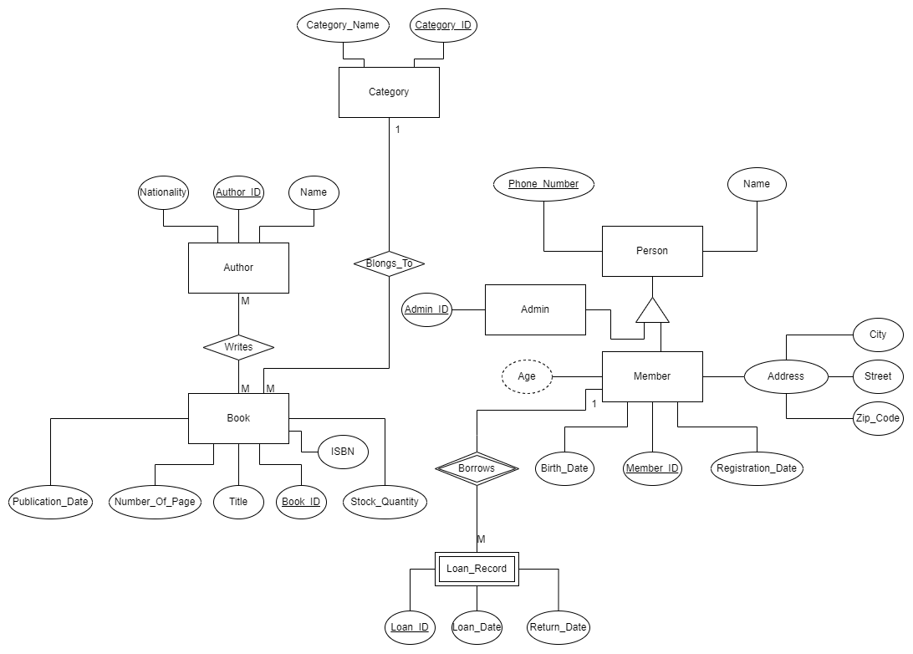

## Milestone1-Task3: Conceptual Design using UML Notation [Optional but Recommended]

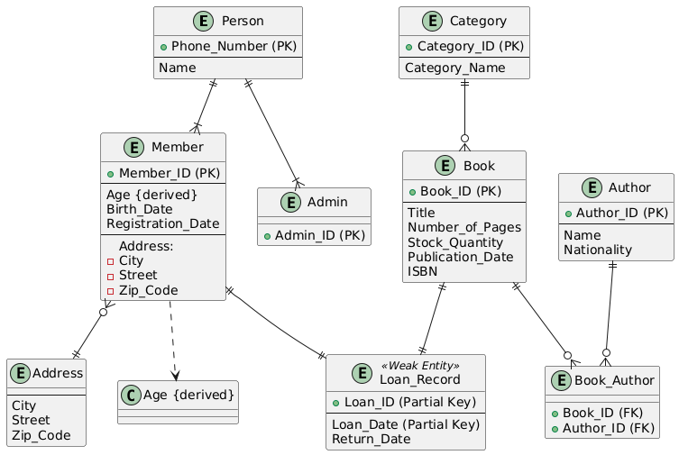

## Milestone1-Task4: Defining functional dependencies in your mini-world

If you work individually (in groups of 1) on this project:

* Then, it is expected to have between 4+ functional dependencies in your mini-world.

If you work in a group of 2 on the project:

* Then, it is expected to have between 6+ functional dependencies in your mini-world.

If you work in a group of 3/4 on the project:

* Then, it is expected to have between 7+ functional dependencies in your mini-world.

**List all functional dependencies here. Make sure to include visuals as discussed during the lecture:**

1. Primary-Key Functional Dependencies: List them here:

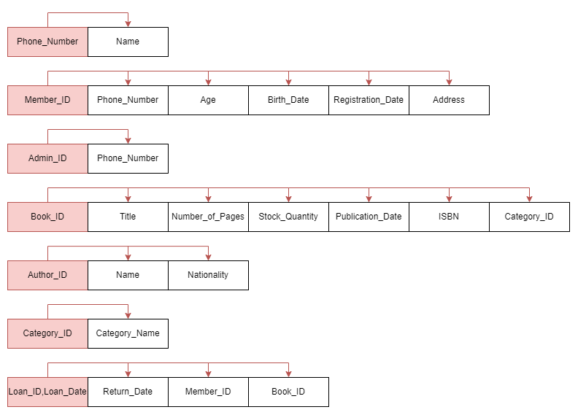

1. Partial Functional Dependencies: List them here

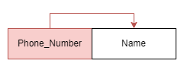

1. Transitive Functional Dependencies: List them here

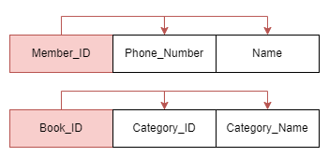

# Milestone2

In Milestone 2, you are going to continue working on what you have done in Milestone1.

## Milestone2-Task1: Updated Universe of Discourse (Mini-World) Description

* [Optional]: If your mini-world needs to be updated for any reasons, you have the chance to update it here. Please notice, if the original version of the mini-World is not comprehensive enough (having different types of entities and relationships and … and enough number of entities), you need to update the original mini-World and submit it in this Milestone.
* The Milestone2-Task1 is not going to be graded, yet an update is a must if needed based on the comment above. Please also see Task 3 below.

**[Write your answer here]**

## Milestone2-Task2: Updated Conceptual Design

* If an update to the Conceptual design is needed, please do it and add it here. (Particularly If you have to update your original mini-world in Task1 above)

**[Write your answer here]**

## Milestone2-Task3: Updating functional dependencies in your mini-world

If you work individually (groups of 1) on this project:

* Then, it is expected to have between 4+ functional dependencies in your mini-world.

If you work in a group of 2 on the project:

* Then, it is expected to have between 6+ functional dependencies in your mini-world.

If you work in a group of 3/4 on the project:

* Then, it is expected to have between 7+ functional dependencies in your mini-world.

**Note**: If you cannot extract enough functional dependencies in your mini-world, you will need to update it and submit it under Milestone2-Task1.

**[Write your answer here]**

## Milestone2-Task4: Creating the relational model of your conceptual model

* You need to create the relational models following the steps we defined in the lecture.

**Relations**  
Person: [Phone_Number, Name]  
Member: [Member_ID, Phone_Number, Birth_Date, Registration_Date, City, Street, Zip_Code]  
Admin: [Admin_ID, Phone_Number]  
Book: [Book_ID, Title, Number_of_Pages, Stock_Quantity, Publication_Date, ISBN, Category_ID]  
Author: [Author_ID, Name, Nationality]  
Category: [Category_ID, Category_Name]  
Loan_Record: [Member_ID, Book_ID, Loan_Date, Return_Date]  
Book_Author: [Book_ID, Author_ID]

**Foreign Keys**  
Member.Phone_Number references Person.Phone_Number  
Admin.Phone_Number references Person.Phone_Number  
Book.Category_ID references Category.Category_ID  
Loan_Record.Member_ID references Member.Member_ID  
Loan_Record.Book_ID references Book.Book_ID  
Book_Author.Book_ID references Book.Book_ID  
Book_Author.Author_ID references Author.Author_ID

# Milestone3

In Milestone 3, In Milestone 3 you are doing to work with the database that you have designed.

**Note:** By the end of Milestone 2, it is expected that you have designed your relational model (database).

## Milestone3-Task1: Update your conceptual and relational models

If you have received any feedback from the evaluator of Milestone 1 and 2, that you need to make some changes in your conceptual and relation models, you need to do it now and insert the updated answer:

## Milestone3-Task1: Create your database schema

* Please use the SQL DDL statements to create your database schema.
* Provide a name for each table.
* Include all attributes
* Define PK and FK.
* Please add a snapshot of the statement you have written and the results
* CREATE DATABASE *LMS*;  
    
  USE *LMS*;  
  CREATE TABLE *Person* (  
   Phone_Number VARCHAR(15) PRIMARY KEY,  
   Name VARCHAR(50) NOT NULL  
  );  
    
  CREATE TABLE *Member* (  
   Member_ID INT PRIMARY KEY,  
   Phone_Number VARCHAR(15) NOT NULL,  
   Birth_Date DATE NOT NULL,  
   Registration_Date DATE NOT NULL,  
   City VARCHAR(50),  
   Street VARCHAR(100),  
   Zip_Code VARCHAR(10),  
   FOREIGN KEY (Phone_Number) REFERENCES *Person*(Phone_Number)  
  );  
    
  CREATE TABLE *Admin* (  
   Admin_ID INT PRIMARY KEY,  
   Phone_Number VARCHAR(15) NOT NULL,  
   FOREIGN KEY (Phone_Number) REFERENCES *Person*(Phone_Number)  
  );  
    
  CREATE TABLE *Category* (  
   Category_ID INT PRIMARY KEY,  
   Category_Name VARCHAR(50) NOT NULL  
  );  
    
  CREATE TABLE *Book* (  
   Book_ID INT PRIMARY KEY,  
   Title VARCHAR(100) NOT NULL,  
   Number_of_Pages INT,  
   Stock_Quantity INT,  
   Publication_Date DATE,  
   ISBN VARCHAR(20),  
   Category_ID INT,  
   FOREIGN KEY (Category_ID) REFERENCES *Category*(Category_ID)  
  );  
    
  CREATE TABLE *Author* (  
   Author_ID INT PRIMARY KEY,  
   Name VARCHAR(50) NOT NULL,  
   Nationality VARCHAR(50)  
  );  
    
  CREATE TABLE *Loan_Record* (  
   Member_ID INT,  
   Book_ID INT,  
   Loan_Date DATE,  
   Return_Date DATE,  
   PRIMARY KEY (Member_ID, Book_ID, Loan_Date),  
   FOREIGN KEY (Member_ID) REFERENCES *Member*(Member_ID),  
   FOREIGN KEY (Book_ID) REFERENCES *Book*(Book_ID)  
  );  
    
  CREATE TABLE *Book_Author* (  
   Book_ID INT,  
   Author_ID INT,  
   PRIMARY KEY (Book_ID, Author_ID),  
   FOREIGN KEY (Book_ID) REFERENCES *Book*(Book_ID),  
   FOREIGN KEY (Author_ID) REFERENCES *Author*(Author_ID)  
  );

## Milestone3-Task2: Populate your tables with some sample data

* Insert some sample data to your tables
* The volume of inserted data is not important. Just insert enough amount of data that makes sense for your project.
* Please add a snapshot of the tables with some data in them

INSERT INTO *Person* VALUES ('1234567890', 'Alice');  
INSERT INTO *Person* VALUES ('0987654321', 'Bob');  
INSERT INTO *Person* VALUES ('1122334455', 'Charlie');  
  
INSERT INTO *Member* VALUES (1, '1234567890', '1990-01-01', '2023-01-01', 'New York', '5th Ave', '10001');  
INSERT INTO *Member* VALUES (2, '0987654321', '1985-05-05', '2023-05-05', 'Los Angeles', 'Sunset Blvd', '90001');  
INSERT INTO *Member* VALUES (3, '1122334455', '1992-07-07', '2023-07-07', 'Chicago', 'Lake Shore Dr', '60601');  
  
INSERT INTO *Admin* VALUES (101, '1234567890');  
INSERT INTO *Admin* VALUES (102, '0987654321');  
  
INSERT INTO *Category* VALUES (1, 'Computer Science');  
INSERT INTO *Category* VALUES (2, 'Literature');  
INSERT INTO *Category* VALUES (3, 'History');  
  
INSERT INTO *Book* VALUES (201, 'Database Systems', 600, 10, '2020-10-10', '123-456-789', 1);  
INSERT INTO *Book* VALUES (202, 'Introduction to Algorithms', 1312, 5, '2019-07-15', '987-654-321', 1);  
INSERT INTO *Book* VALUES (203, 'Pride and Prejudice', 432, 7, '1813-01-28', '111-222-333', 2);  
  
INSERT INTO *Author* VALUES (301, 'Edgar Codd', 'British');  
INSERT INTO *Author* VALUES (302, 'Thomas H. Cormen', 'American');  
INSERT INTO *Author* VALUES (303, 'Jane Austen', 'British');  
  
INSERT INTO *Loan_Record* VALUES (1, 201, '2024-11-25', '2024-12-05');  
INSERT INTO *Loan_Record* VALUES (2, 202, '2024-11-26', NULL);  
INSERT INTO *Loan_Record* VALUES (3, 203, '2024-11-27', '2024-12-07');  
  
INSERT INTO *Book_Author* VALUES (201, 301);  
INSERT INTO *Book_Author* VALUES (202, 302);  
INSERT INTO *Book_Author* VALUES (203, 303);  
  
INSERT INTO *Loan_Record* VALUES (1, 202, '2024-11-28', NULL);  
  
INSERT INTO *Book* VALUES (204, 'The Great Gatsby', 218, 4, '1925-04-10', '444-555-666', 2);  
  
INSERT INTO *Person* VALUES ('2233445566', 'David');  
INSERT INTO *Member* VALUES (4, '2233445566', '1995-03-03', '2024-01-01', 'Houston', 'Main St', '77001');  
  
SELECT b.Title, lr.Loan_Date  
FROM *Loan_Record* lr  
JOIN *Book* b ON lr.Book_ID = b.Book_ID  
WHERE lr.Member_ID = 1 AND lr.Return_Date IS NULL;  
  
SELECT b.Title  
FROM *Book* b  
LEFT JOIN *Loan_Record* lr ON b.Book_ID = lr.Book_ID  
WHERE lr.Book_ID IS NULL;  
  
DELETE FROM *Member*WHERE Member_ID = 4  
AND Member_ID NOT IN (SELECT Member_ID FROM *Loan_Record*);  
  
SELECT *\** FROM *Member* WHERE Member_ID = 4;

## Milestone3-Task3: Write SQL Statement

* You need to define several use-cases and write their corresponding queries.
* At least 10 queries should be written
* For group of 2 or more people, in addition to the first 10 queries, for each group member you need to add extra 3 use-cases.
* Write the SQL Statements, run them and take a snapshot from the results and insert them here.
* So the following items are expected:

1. The usecase
2. The SQL query
3. The screenshot of the data

Example:

1. Use case: As an admin, I need to know the name and SSN of the managers of all department.
2. SQL Statement: Please see below
3. Snapshot: Please see below

1. **As an admin, I need to know the name and Phone Number of all members.**

SELECT m.Member_ID, p.Name, p.Phone_Number  
FROM *Member* m  
JOIN *Person* p ON m.Phone_Number = p.Phone_Number;

1. **As an admin, I need to retrieve the list of all books along with their categories.**

SELECT b.Title, c.Category_Name  
FROM *Book* b  
JOIN *Category* c ON b.Category_ID = c.Category_ID;

1. **As an admin, I need to retrieve the list of all books along with their categories.**

SELECT b.Title, lr.Loan_Date  
FROM *Loan_Record* lr  
JOIN *Book* b ON lr.Book_ID = b.Book_ID  
WHERE lr.Member_ID = 1 AND lr.Return_Date IS NULL;

1. **As an admin, I need to find out how many books each author has written.**

SELECT a.Name AS Author_Name, *COUNT*(ba.Book_ID) AS Books_Written  
FROM *Author* a  
JOIN *Book_Author* ba ON a.Author_ID = ba.Author_ID  
GROUP BY a.Name;

1. **As a librarian, I want to view all loan records including member names and book titles.**

SELECT p.Name AS Member_Name, b.Title, lr.Loan_Date, lr.Return_Date  
FROM *Loan_Record* lr  
JOIN *Member* m ON lr.Member_ID = m.Member_ID  
JOIN *Person* p ON m.Phone_Number = p.Phone_Number  
JOIN *Book* b ON lr.Book_ID = b.Book_ID;

1. **As an admin, I need to list all books with stock quantity below 5.**

SELECT Title, Stock_Quantity  
FROM *Book*WHERE Stock_Quantity < 5;

1. **As a manager, I want to see the number of members in each city.**

SELECT City, *COUNT*(Member_ID) AS Member_Count  
FROM *Member*GROUP BY City;

1. **As an admin, I need to find all books that have never been borrowed.**

SELECT b.Title  
FROM *Book* b  
LEFT JOIN *Loan_Record* lr ON b.Book_ID = lr.Book_ID  
WHERE lr.Book_ID IS NULL;

1. **As a librarian, I want to update the stock quantity of a specific book after a new shipment arrives.**

UPDATE *Book*SET Stock_Quantity = Stock_Quantity + 10  
WHERE Book_ID = 201;

1. **As an admin, I need to delete a member who has not borrowed any books.**

DELETE FROM *Member*WHERE Member_ID = 3  
AND Member_ID NOT IN (SELECT Member_ID FROM *Loan_Record*);

# Milestone4

In Milestone 4, you are going to normalize the database (relational model) you have developed in Milestone 2.

**Note:** It is expected in this Milestone to change the relational model you have completed in Milestone 2 and consequently the database you have developed in Milestone 3. While it is expected to normalize your database schema in this milestone, it is not expected you to re-create your database and update the sql statements you have developed in module 3.

## Milestone4-Task1:Identify full, partial and transitive functional dependencies in your design

* In Module 4, we learned about full, partial and transitive functional dependencies and we discussed how normalization process deals with such functional dependencies.
* The Milestone4-Task1: List all functional dependencies you have identified in Milestone 2. For each functional dependency identify whether it is full, partial or transitive functional dependencies and briefly explain why. Complete the following table. (Expand the table as needed)

|  |  |
| --- | --- |
| Functional Dependency | **Phone_Number → Name**  Full  Phone_Number is PK and uniquely determines Name. |
| Partial, full or transitive? And why |
| Functional Dependency | **Member_ID → Phone_Number, Birth_Date, Registration_Date, City, Street, Zip_Code**  Full  Member_ID is PK and uniquely determines all attributes. |
| Partial, full or transitive? And why |
| Functional Dependency | **Zip_Code → City**  Transitive  Zip_Code determines City, creating a transitive dependency from Member_ID. |
| Partial, full or transitive? And why |
| Functional Dependency | **Admin_ID → Phone_Number**  Full  Admin_ID is PK, and uniquely determines Phone_Number. |
| Partial, full or transitive? And why |
| Functional Dependency | **Category_ID → Category_Name**  Full  Category_ID is PK and uniquely determines Category_Name. |
| Partial, full or transitive? And why |
| Functional Dependency | **Book_ID → Title, Number_of_Pages, Stock_Quantity, Publication_Date, ISBN, Category_ID**  Full  Book_ID is PK and uniquely determines all attributes. |
| Partial, full or transitive? And why |
| Functional Dependency | **ISBN → Title, Number_of_Pages, Publication_Date, Category_ID**  Partial  ISBN is not PK but determines some attributes. |
| Partial, full or transitive? And why |
| Functional Dependency | **Book_ID → ISBN → Title, Number_of_Pages, Publication_Date, Category_ID**  Transitive  Book_ID determines ISBN, which in turn determines other attributes. |
| Partial, full or transitive? And why |
| Functional Dependency | **Author_ID → Name, Nationality**  Full  Author_ID is PK and uniquely determines all attributes. |
| Partial, full or transitive? And why |
| Functional Dependency | **(Member_ID, Book_ID, Loan_Date) → Return_Date**  Full  The composite PK (Member_ID, Book_ID, Loan_Date) uniquely determines Return_Date. |
| Partial, full or transitive? And why |

## Milestone4-Task2: Highest Normal Form

* Take your relational models and test them against the Normalization tests and complete this section:

Relation NOT in 1NF: (List all relations that are NOT even in 1NF, if any):

-

Relation with 1NF as highest normal form: (List all relations that are in 1NF but not 2NF)

-

Relation with 2NF as highest normal form: (List all relations that are in 2NF but not 3NF)

* Member
* Book

Relation with 3NF as highest normal form: (List all relations that are in 3NF but not BCNF)

-

Relation with BCNF as highest normal form:

* Person
* Admin
* Category
* Author
* Loan_Record
* Book_Author

## Milestone4-Task3: Converting to 3NF

In this task you will normalize all your relations to 3NF and BCNF. If a relation is already in BCNF or 3NF, no change is needed.

-

## Milestone4-Task4: Converting to BCNF

In this task you will normalize all your relations to BCNF. If a relation is already in BCNF, no change is needed.

* Check whether there are any functional dependencies that are not preserved as a result of normalization to BCNF.

*-- Member*CREATE TABLE *Zip_Code_Info* (  
 Zip_Code VARCHAR(10) PRIMARY KEY,  
 City VARCHAR(50) NOT NULL  
);  
  
INSERT INTO *Zip_Code_Info* (Zip_Code, City)  
SELECT DISTINCT Zip_Code, City  
FROM *Member*;  
  
ALTER TABLE *Member* DROP COLUMN City;  
  
ALTER TABLE *Member*ADD CONSTRAINT FK_Member_Zip_Code FOREIGN KEY (Zip_Code) REFERENCES *Zip_Code_Info*(Zip_Code);  
  
*-- Book*CREATE TABLE *Book_Details* (  
 ISBN VARCHAR(20) PRIMARY KEY,  
 Title VARCHAR(100) NOT NULL,  
 Number_of_Pages INT,  
 Publication_Date DATE,  
 Category_ID INT,  
 FOREIGN KEY (Category_ID) REFERENCES *Category*(Category_ID)  
);  
  
INSERT INTO *Book_Details* (ISBN, Title, Number_of_Pages, Publication_Date, Category_ID)  
SELECT DISTINCT ISBN, Title, Number_of_Pages, Publication_Date, Category_ID  
FROM *Book*;  
  
ALTER TABLE *Book* DROP FOREIGN KEY *book_ibfk_1*;  
  
ALTER TABLE *Book*DROP COLUMN Title,  
DROP COLUMN Number_of_Pages,  
DROP COLUMN Publication_Date,  
DROP COLUMN Category_ID;  
  
ALTER TABLE *Book*ADD CONSTRAINT FK_Book_ISBN FOREIGN KEY (ISBN) REFERENCES *Book_Details*(ISBN);

